**Assignment 2:**

**Flowchart Creation - Design a  
flowchart that outlines the logic for a user login process. It should include  
conditional paths for successful and unsuccessful login attempts, and a loop  
that allows a user three attempts before locking the account.**

Algorithm:

1. Start

2. Initialize count = 1

3. Loop until count <= 3:

Prompt the user to enter username and password

Read username and password from the user

If username and password are correct:

Display "Login successful"

Exit loop

Else:

Display "Login unsuccessful. Please try again."

Increment attempt_count by 1

4. If count equals 3

a. Display "Account locked. Too many unsuccessful attempts."

5. End

Flowchart:

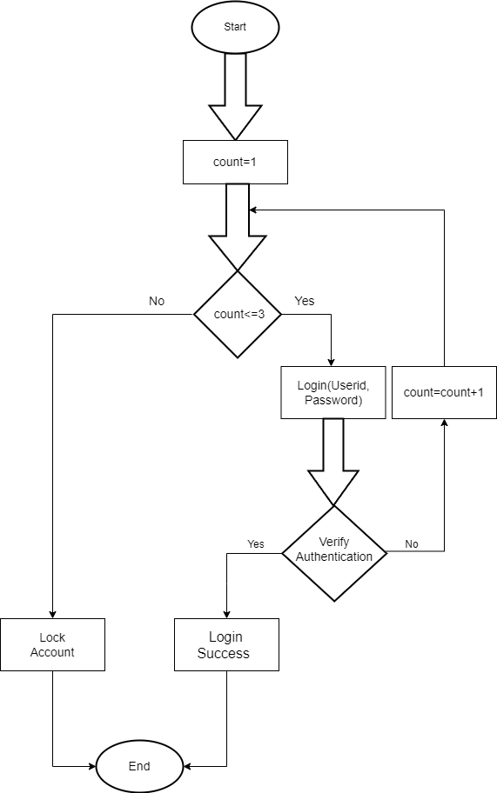

Psedocode:

1. Start
2. count = 1
3. While (count < =3)

Display "Enter username:"

Read username

Display "Enter password:"

Read password

If username is correct and password is correct:

Display "Login successful"

Else

Display "Login Unsuccessful"

Count++

Exit loop

1. Display "Account locked. Too many unsuccessful attempts."
2. End