Example of Algorithm:

Swapping Algorithm:

1. Start

2. Read a, b

3. Display a and b before swapping

4. Set t = a

5. Set a = b

6. Set b = t

7. Display a and b after swapping

8. Stop

Flowchart:

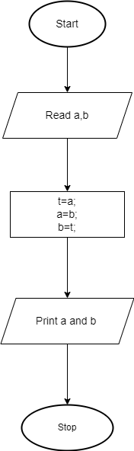

Psedocode:

1. Begin

2. Read a and b

4. Print "Before swapping:” a and b

5. Set t = a

6. Set a = b

7. Set b = t

8. Print "After swapping:” a and b

9. Stop