Linear Search:

Algorithm:

1. Start

2. Define the constant CAP with a value of 10

3. Initialize an array 'a' of size CAP with some initial values

4. Input the key to be searched from the user

5. Initialize a flag variable to 0

6. Repeat steps 7 to 11 for each element in the array

7. If the key matches the current element in the array, set the flag to 1 and go to step 1

8. End loop

9. If the flag is 1, output "Element found at position/index" with the index value; otherwise, output "Element is not present in the list".

10. End.

11. Exit.

Flowchart:

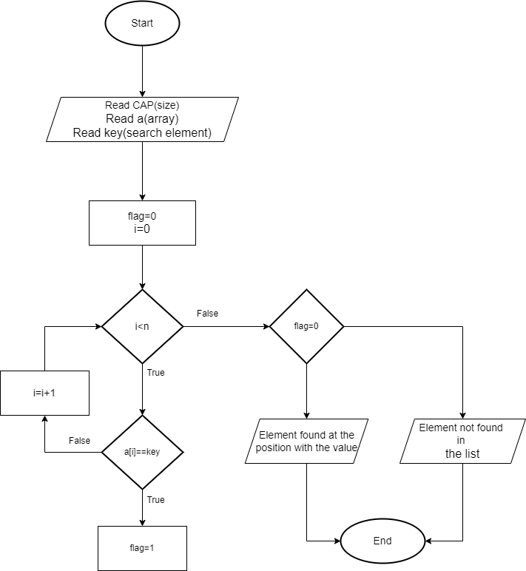

Psedocode:

1. Initialize a constant CAP with a value of 10

2. Create an array a of size CAP and initialize it with some initial values

3. Input the key to be searched from the user

4. Initialize a flag variable to 0

5. Start a loop from i = 0 to CAP - 1

Check if the key matches the element at index i in the array

If there's a match, set the flag to 1 and jump to the Print step

6. If the loop completes without finding a match, proceed to the Print step

7. Print the result:

If the flag is 1, output "Element found @ " followed by the index i where the element was found.

If the flag is 0, output "Element is not present in the list".