.

ORM
(Object Relational Mapping)
• ORM stands for object-relational mapping, where objects are used to connect the programming language on to the database systems

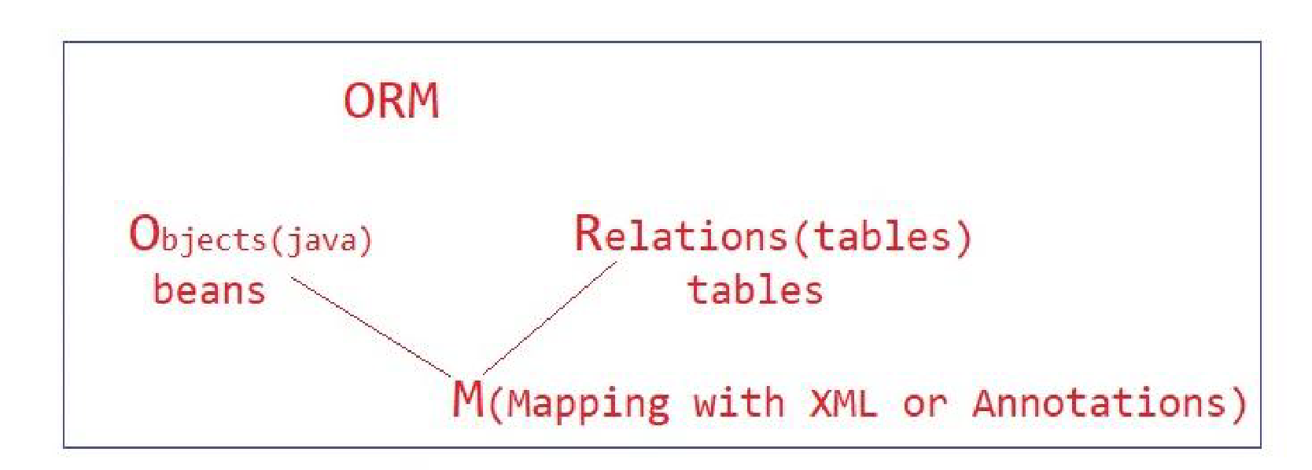

Hiberante Framework

Hibernate (ORM)

• Hibernate is a pure Java object-relational mapping (ORM) and persistence framework that allows you to map bean Java objects to relational database tables using (XML/Annotation) configuration files

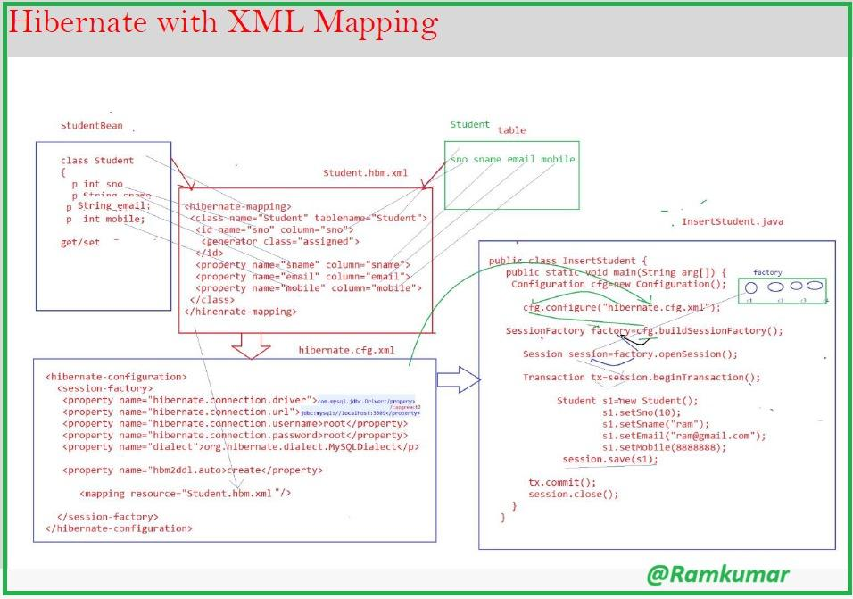

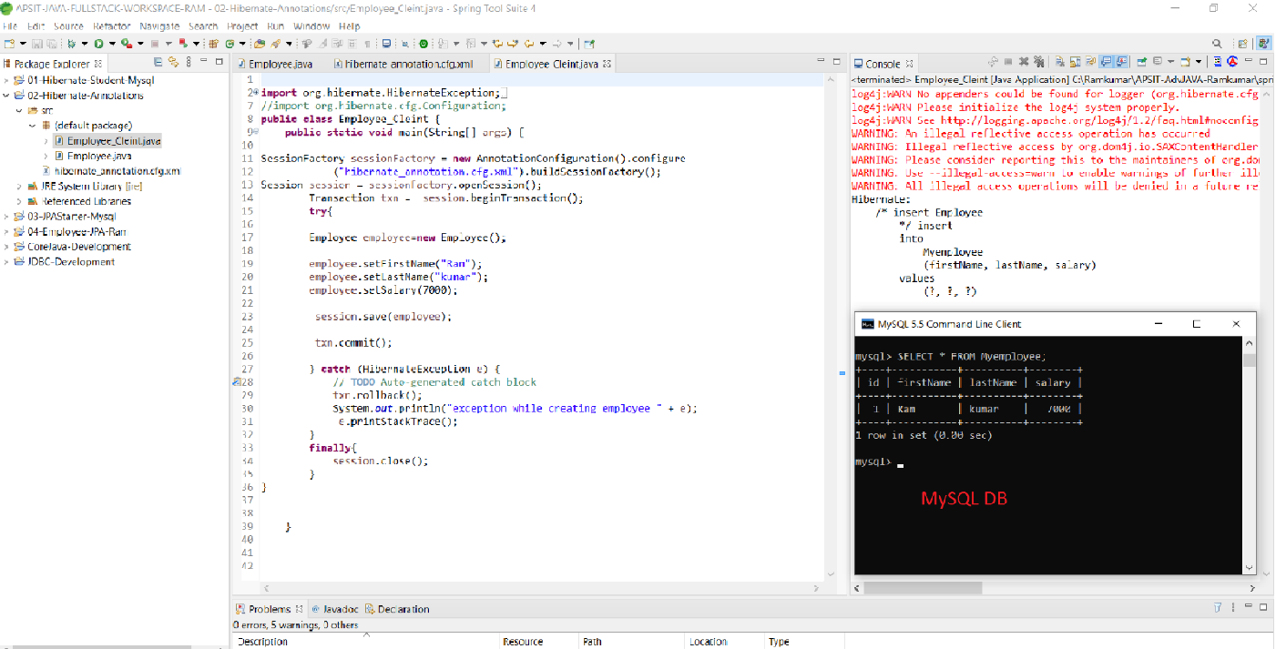

Configuration
public class Configuration
extends Object
implements Serializable
- An instance of Configuration allows the application to specify properties and mapping documents to be used when creating a SessionFactory.
- Usually an application will create a single Configuration, build a single instance of SessionFactory and then instantiate Sessions in threads servicing client requests.
- The Configuration is meant only as an initialization-time object.
- SessionFactorys are immutable and do not retain any association back to the Configuration.

Author: Gavin King

SessionFactory

public interface SessionFactory
extends EntityManagerFactory, Serializable, Closeable

- A SessionFactory represents an "instance" of Hibernate: it maintains the runtime metamodel representing persistent entities, their attributes, their associations, and their mappings to relational database tables, along with configuration that affects the runtime behavior of Hibernate, and instances of services that Hibernate needs to perform its duties.
- This is where a program comes to get sessions.
- Generally, a program has a single SessionFactory instance, and must get a new Session instance from the factory each time it services a client request.
- It is then also responsible for destroying the session at the end of the client request.
- SessionFactory manages the lifecycle of pooled JDBC connections and transactions, or it can work as a client to a connection pool or transaction manager provided by the container environment.
- SessionFactory bbbbbbbbbbbbis threadsafe.
Session
public interface Session
extends Serializable
- The main runtime interface between a Java application and Hibernate.
- This is the central API class abstracting the notion of a persistence service.
- The lifecycle of a Session is bounded by the beginning and end of a logical transaction.
- The main function of the Session is to offer create, read and delete operations for instances of mapped entity classes.
- Instances may exist in one of three states:
transient: never persistent, not associated with any Session
persistent: associated with a unique Session
detached: previously persistent, not associated with any Session
- Transient instances may be made persistent by calling save(), persist() or saveOrUpdate(). Persistent instances may be made transient by calling delete().
- Any instance returned by a get() or load() method is persistent.
- A Session instance is serializable if its persistent classes are serializable.
Session sess = factory.openSession();
Transaction tx;
try {
tx = sess.beginTransaction();
//do some work
...
tx.commit();
}
catch (Exception e) {
if (tx!=null) tx.rollback();
throw e;
}
finally {
sess.close();
}

Serializable |  | save(Object object)  Persist the given transient instance, first assigning a generated identifier.
Object | get(Class clazz, Serializable id)  Return the persistent instance of the given entity class with the given identifier, or null if there is no such persistent instance.
Object | load(Class theClass, Serializable id)  Return the persistent instance of the given entity class with the given identifier, assuming that the instance exists.
Object | merge(Object object)  Copy the state of the given object onto the persistent object with the same identifier.
void | evict(Object object)  Remove this instance from the session cache.
void | flush()  Force this session to flush.

Transaction
public interface Transaction
extends EntityTransaction

- In Hibernate, a transaction is linked to a Session and usually starts when beginTransaction() is called.
- One session can handle multiple transactions one after another, but at any given time, only one transaction can remain active (uncommitted) within a session.

Hibernate Caching
Hibernate caching
Hibernate ORM, caching is used to reduce repeated database access and improve application performance.
Hibernate mainly uses two types:
- first-level cache
- second-level cache.
The first-level cache :
- The first-level cache is automatically available and works at the session level.
- Whenever an object is loaded from the database in a session, Hibernate stores it in the session cache, so if the same object is requested again within the same session.
- Hibernate returns it from memory instead of hitting the database.
In Hibernate, the first-level cache is session-specific and enabled by default
- The first-level cache works within one session
- The first-level cache improves performance within a single session
- Cannot be disabled
- Faster, but limited to one session only

The second-level cache
- The second-level cache is optional and works at the session factory level.
- It allows data to be shared across multiple sessions, meaning once an object is loaded by one session, another session can reuse the same data without accessing the database again, provided second-level caching is enabled and configured.
- Not enabled by default
- Scope: SessionFactory-level (global cache)
- Requires external cache providers (Ehcache, Infinispan)
- Improves performance in multi-user applications

- The second-level cache improves performance across multiple sessions in an application.
- second-level cache is session-factory-specific and optional.
- The second-level cache allows data sharing between multiple sessions.

