.

Capgemini Advance
JDBC Notes

JDBC (Java Database Connectivity)

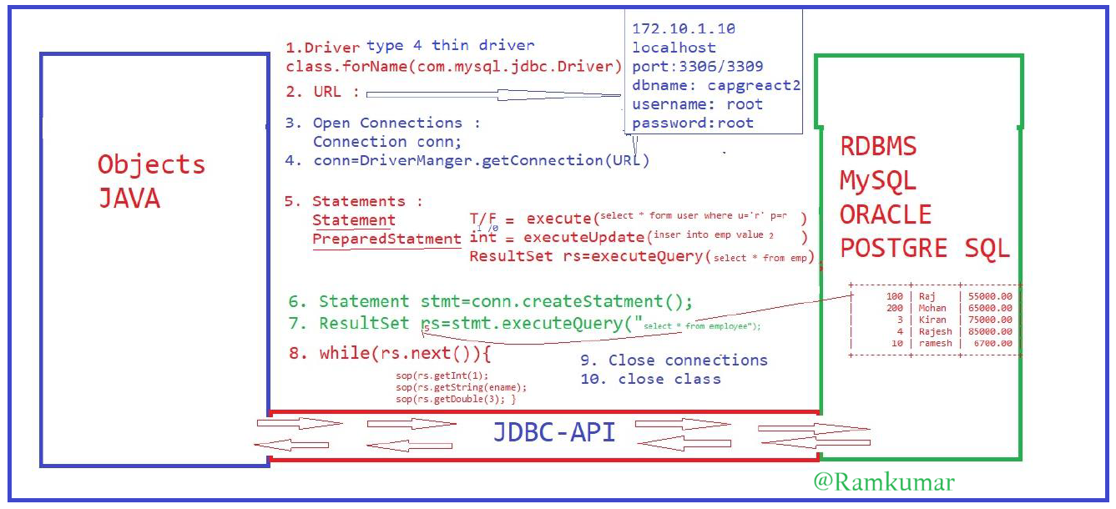

JDBC (Java Database Connectivity)
Java Objects -> JDBC API -> JDBC Driver -> Database (MySQL / Oracle / PostgreSQL)

- Load & Register JDBC Driver
JDBC driver acts as a bridge between Java application and Database.
It loads the database-specific driver into memory.
Example :
Class.forName(oracle.jdbc.driver.OracleDriver)
- Create Database URL
URL contains database location and name.
String url = "jdbc:oracle:thin:@localhost:1521:XE";
- Open Connection
Connection object represents a physical connection to the database.
Connection conn = null;

- Establish Connection :
Use DriverManager to connect Java with DB.
String userName = "capgdb";
String password = "capgdb";
conn = DriverManager.getConnection(url,userName,password);
If connection is successful → Java is connected to DB.
- Create Statement / PreparedStatement
Used to send SQL queries to the database.
a) Statement
Statement stmt = con.createStatement();
b) PreparedStatement
String query="insert into Employeeinfo2 values(?,?,?)";
PreparedStatement pstmt=conn.prepareStatement(query);

- Execute SQL Queries
Depending on the operation:
Method are used for :
executeQuery() :SELECT
executeUpdate() : INSERT, UPDATE, DELETE
execute() : Any SQL

Example (SELECT):
ResultSet rs = stmt.executeQuery("select * from employee");
- Process ResultSet
ResultSet stores the data returned by SELECT query.
rs.next() moves row by row.
while(rs.next()){
System.out.println("Employee No :" + rs.getInt(1));
System.out.println("Employee Name :" + rs.getString("ename"));
System.out.println("Employee sal :"+rs.getInt(3));
}}

- Close ResultSet
Frees memory used by result.
rs.close();

- Close Connection
Always close connection after DB operations.
conn.close();
- Close class
Statement
- Used when executing a SQL query only once
- In SQL, a "statement" is a single line or a group of lines representing a specific action or operation performed on a database.
- SQL statements are used to interact with the database, retrieve data, modify data, create or alter database structures, and more.
- There are different types of SQL statements, including SELECT (used to retrieve data), INSERT (used to add new data), UPDATE (used to modify existing data), DELETE (used to remove data), and DDL (Data Definition Language) statements like CREATE TABLE and ALTER TABLE (used to define or modify the database structure).
- Typically has lower performance

PreparedStatement
- Used when executing a SQL query multiple times
- A PreparedStatement in SQL is a precompiled SQL statement that allows you to execute the same SQL query with different parameter values repeatedly.
- It is a feature provided by database APIs like JDBC, which improves performance and security by separating the SQL query from the user-supplied parameters.
- PreparedStatement helps prevent SQL injection attacks and enhances database query execution efficiency by reducing the need for query recompilation, making it a valuable tool for database interactions in applications.
- Typically has higher performance
In JDBC 4 types of Drivers :
- Type 1: JDBC-ODBC Bridge Driver
- Type 2: Native-API Driver (Partially Java)
- Type 3: Network Protocol Driver (Fully Java Middleware)
- Type 4: Thin Driver (100% Pure Java)

Type 1: JDBC-ODBC Bridge Driver
- It acts as a bridge between JDBC and Microsoft's ODBC (Open Database Connectivity).
- Useful when no other driver is available; connects to any database supporting ODBC.
- Low performance; requires ODBC binary code on every client machine; not supported since Java 8.
Type 2: Native-API Driver (Partially Java)
- Converts JDBC calls into native C/C++ API calls specific to the database (e.g., Oracle OCI).
- Better performance than Type 1 because it eliminates the ODBC overhead.
- Not fully portable (platform-dependent); requires vendor-specific client-side libraries to be installed on each machine.
Type 3: Network Protocol Driver (Fully Java Middleware)
- Uses a three-tier approach where a client communicates with a middleware application server, which then interacts with the database.
- Highly flexible; no client-side installation required; one driver can access multiple databases.
- Maintenance of the middleware server is required; performance may be affected by the extra network layer.
Type 4: Thin Driver (100% Pure Java)
- Communicates directly with the database using its native network protocol.
- Best performance among all types; fully portable (platform-independent); no special software required on client or server.
- Specifically designed for a single database; if the database changes, the driver must also change.

