Spring Framework
Why Spring?
- Spring makes programming Java quicker, easier, and safer for everybody.
- Spring’s focus on speed, simplicity, and productivity has made it the world's most popular Java framework.
What is Spring Framework ?
- The Spring Framework is an open-source Java platform that provides comprehensive infrastructure support for building robust, modular, and easily testable enterprise-level applications.
- It simplifies the complexities of enterprise Java development, primarily through its core principles of Inversion of Control (IoC) and Dependency Injection (DI).
- POJOs: Allows building applications using lightweight Plain Old Java Objects, avoiding heavy application servers.
- Spring enables you to build applications from “plain old Java objects” (POJOs) and to apply enterprise services non-invasively to POJOs. This capability applies to the Java SE programming model and to full and partial Java EE.
- The Spring Framework is essentially a back-end framework designed for the development of robust server-side applications. It handles core back-end-related tasks, such as dependency injection, database integration, security, and API development.

- A Spring Framework container is the core component that manages the lifecycle of application objects (known as "beans") and their dependencies using the principle of Inversion of Control (IoC), also known as Dependency Injection (DI).

- Instead of the developer manually creating and wiring objects, the container handles this automatically based on configuration metadata

Modules :
- Core & MVC: Fundamental IoC/DI features and a robust framework for web applications/RESTful APIs.
- Data & Security: Streamlines database access (JDBC, JPA, NoSQL) and offers comprehensive authentication/authorization.

Types of Containers
- BeanFacotry
- ApplicationContext
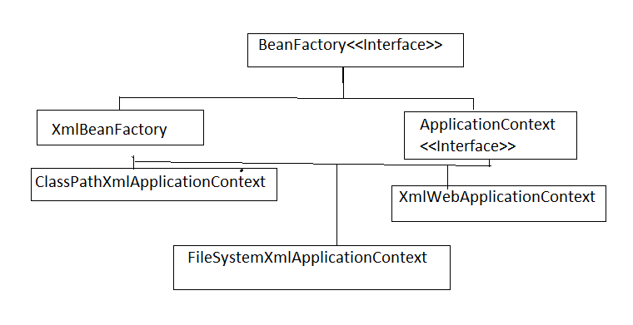
What is the Spring Container?
The Spring Container is the core of the Spring Framework responsible for creating, managing, and injecting the beans (objects) in a Spring application. It follows the principles of Inversion of Control (IoC) and Dependency Injection (DI) to manage the lifecycle and dependencies of the application objects.
The Spring container:
- Creates and manages beans based on the configuration.
- Resolves dependencies between the beans.
- Manages the lifecycle of beans (initialization, destruction).

Types of Spring Containers
Spring provides different types of containers, but the most common ones are:
Container Name | Description
Bean Factory | Basic container that provides basic support for dependency injection. It is lightweight and lazily initializes beans.
Application Context | Advanced container that extends BeanFactory. It provides additional features like event propagation, AOP, internationalization, and more.

How the Spring Container Works
- Configure Beans: You can configure beans using:
  - XML Configuration
  - Java-based Configuration using @Configuration and @Bean.
  - Annotation-based Configuration using annotations like @Component, @Service, @Controller.
- Bean Initialization: When the Spring container starts, it creates and initializes beans based on the configuration.
- Dependency Injection: The container automatically injects the required dependencies (using @Autowired, constructor injection, etc.).
- Lifecycle Management: The container manages the lifecycle of beans (e.g., initialization, destruction).

BeanFactory:
- This is the most basic container interface, providing fundamental IoC functionality, such as managing beans and their dependencies.
- It is lightweight and typically instantiates beans lazily (only when requested), making it suitable for resource-constrained environments.
ApplicationContext:
- This is a sub-interface of BeanFactory that adds more enterprise-specific functionality.
- Spring provides two primary interfaces for its IoC container, with the ApplicationContext being the one recommended for most enterprise applications:
- It includes features like easier integration with Spring's Aspect-Oriented Programming (AOP) features, message resource handling (for internationalization), event publication, and application-
- layer specific contexts for web applications. It generally pre-instantiates singleton beans by default when the application starts, which helps in detecting configuration issues early.

Container
- The org.springframework.context.ApplicationContext interface represents the Spring IoC container and is responsible for instantiating, configuring, and assembling the beans.
- The container gets its instructions on the components to instantiate, configure, and assemble by reading configuration metadata.

ApplicationContext is created and initialized, you have a fully configured and executable system or application.
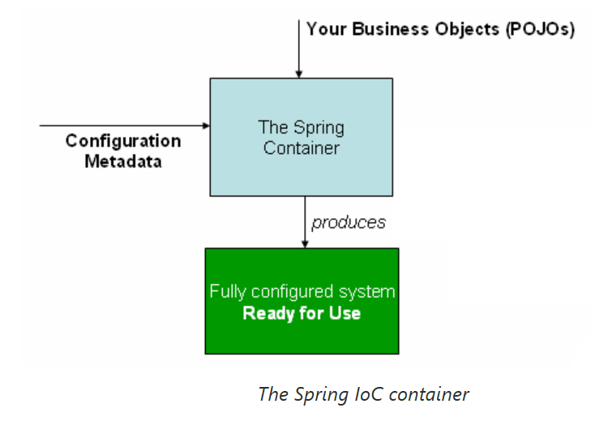

Using the Container
- The ApplicationContext is the interface for an advanced factory capable of maintaining a registry of different beans and their dependencies.
- By using the method T getBean(String name, Class<T> requiredType), you can retrieve instances of your beans.

Spring Framework Architecture :

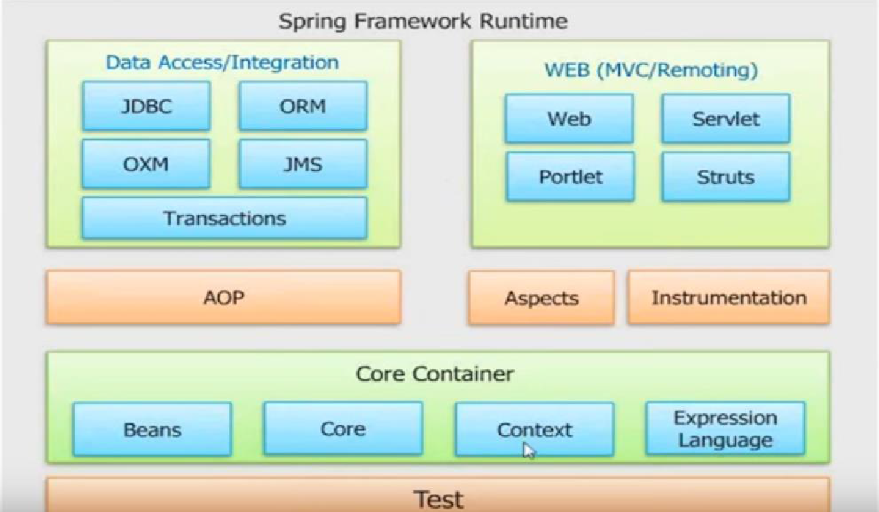
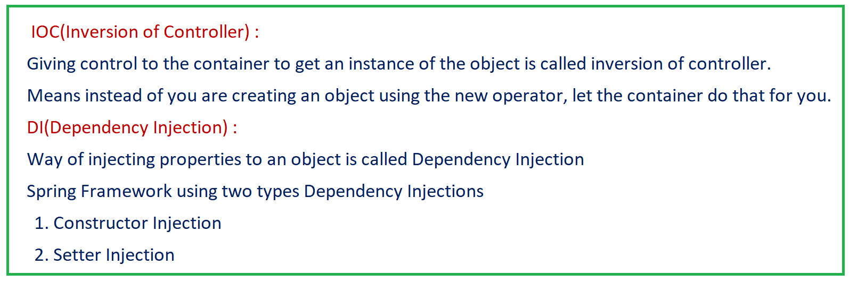

Types of Spring Bean Scopes

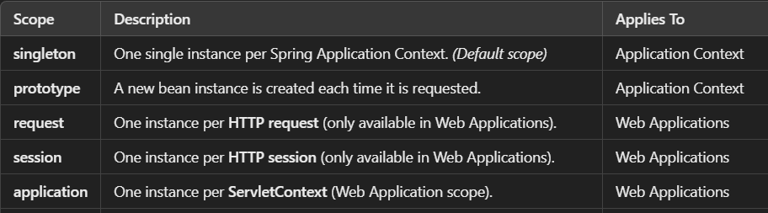

Bean Lifecycle in XML Configuration

In XML, you can also define lifecycle callbacks:

<bean id="user" class="User" init-method="init" destroy-method="cleanup">
<property name="name" value="Ram Kumar K." />
</bean>
- init-method: Called after the bean is fully initialized.
- destroy-method: Called before the bean is destroyed.

Advantages of XML Configuration
- Clear separation of configuration from code.
- Useful in legacy projects or when annotations aren’t allowed.
- Easier to visualize dependencies in one place.
Disadvantages of XML Configuration
- harder to maintain for large applications.
- Less flexible than Java-based or annotation-based configuration.

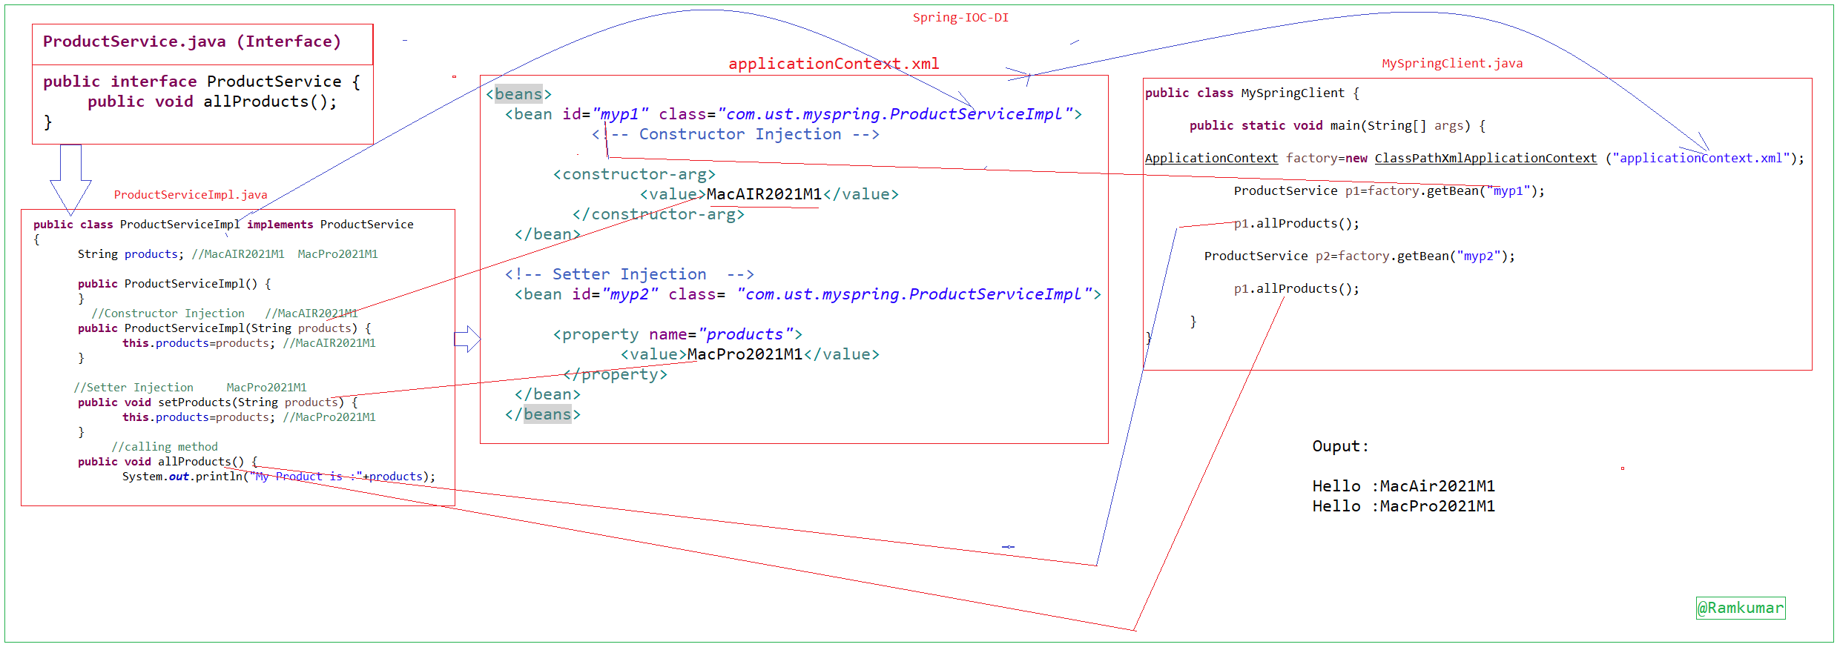
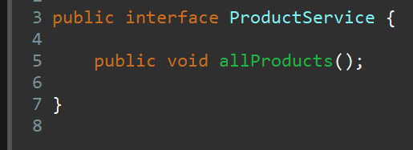
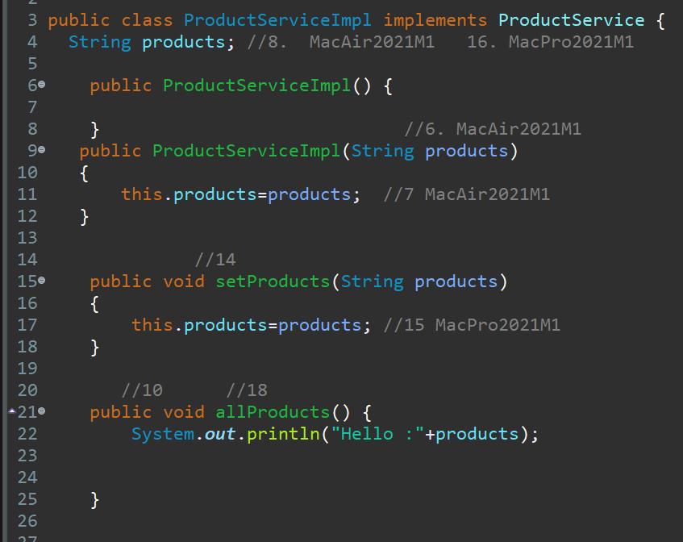
applicationContex.xml
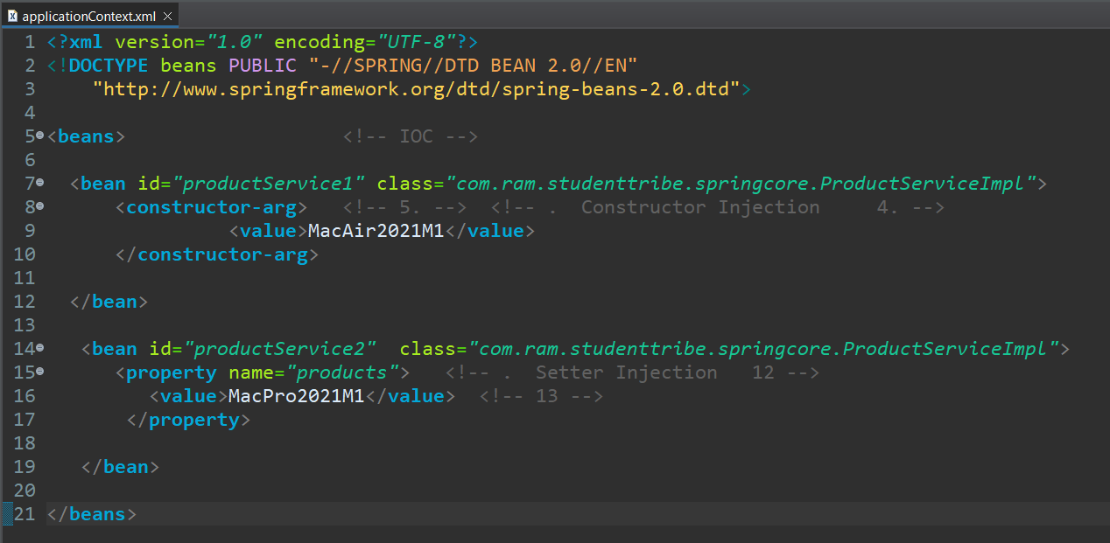
ClientTest.java
