.

JPA (Java Persistence API)

- The Java Persistence API (JPA) is the Java standard for mapping Java objects to a relational database.

- Object-Relational Mapping (ORM) means connecting Java objects with database tables. In ORM, Java classes map to tables, and objects map to rows. ORM helps avoid writing complex SQL code.

- JPA (Java Persistence API) is a standard way to implement ORM in Java. JPA allows Java programs to store, read, update, and delete data from databases using objects.

- JPA the developer can map, store, update and retrieve data from relational databases to Java objects and vice versa.
- JPA can be used in Java-EE and Java-SE applications.

JPA is a specification and several implementations are available.
Popular implementations are:
    - Hibernate,
    - Toplink ,
    - EclipseLink
    - Apache OpenJPA.

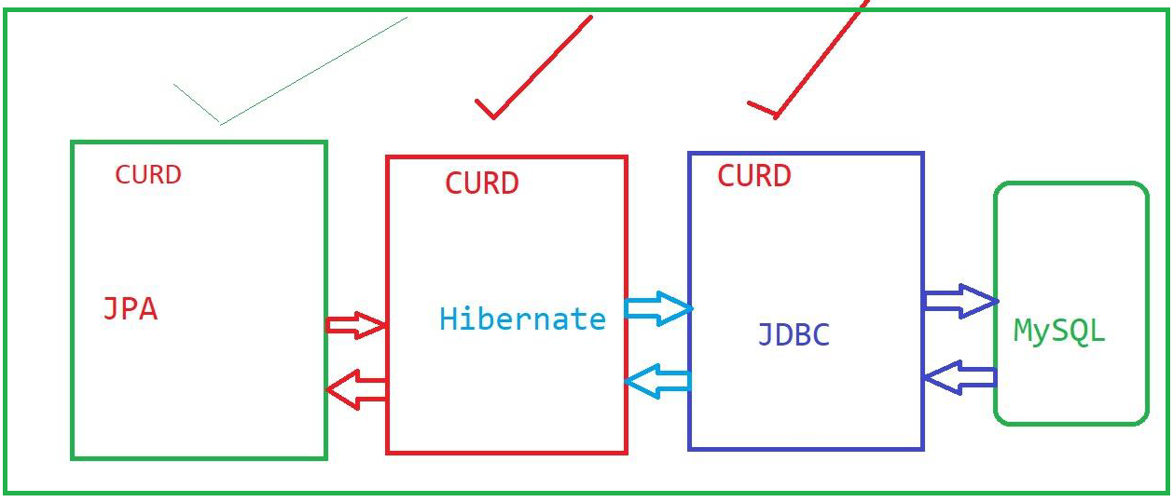

What is JP
Java Persistence API (JPA)
JPA is a standard specification used to manage and store data in relational databases using Java.
It provides a common way for Java applications to perform database operations without depending on a specific ORM tool.

EntityManagerFactory
EntityManagerFactory is thread-safe and usually created once, while EntityManager objects are lightweight and created whenever database interaction is required.
EntityManagerFactory in JPA, providing a safe and efficient way to manage database connections and perform CRUD operations.

Entity Manager
In JPA, the EntityManager is the main interface used to interact with the database. It manages the lifecycle of entity objects and performs basic CRUD operations such as insert, update, delete, and fetch
1. EntityManager
- EntityManager is a JPA interface
  - It is used to manage entity objects in a database.
- Entities cannot save themselves
  - Entity classes (POJOs) cannot directly insert, update, or delete data.
  - Annotations only define mapping (table, columns, relationships).
- EntityManager does database operations
  - It is used to insert, update, delete, and find records in the database.
- EntityManager controls entity lifecycle
  - It manages when an entity is:
    - created
    - saved
    - updated
    - removed
- EntityManager works with a Persistence Unit
  - A persistence unit is defined in persistence.xml.
  - One EntityManager works with entities of that persistence unit.
- Persistence Context
  - Each EntityManager has a persistence context.
  - It is a temporary memory area where entity objects are managed.
- Managed State
  - While an entity is inside the persistence context:
    - EntityManager tracks all changes automatically
    - No need to write update SQL
- Automatic synchronization
  - When a transaction is committed:
    - EntityManager flushes changes to the database
- Detached State
  - When EntityManager is closed:
    - Entities become detached
    - Changes are NOT saved to the database
- Detached entities are not tracked
  - EntityManager will not monitor or update detached objects.

Entities:
1. Entities An entity is a lightweight persistence domain object.
2. Typically, an entity represents a table in a relational database, and each entity instance corresponds to a row in that table.
4. The persistent state of an entity is represented through either persistent fields or persistent properties.
5. These fields or properties use object/relational mapping annotations to map the entities and entity relationships to the relational data in the underlying data store.

JPA ANNOTATIONS
@Entity
The @Entity annotation is used to specify that the currently annotate class represents an entity type.
@Table
The @Table annotation is used to specify the primary table of the currently annotated entity
@Id
In JPA the object id is defined through the @Id annotation and should correspond to the primary key of the object's table. An object id can either be a natural id or a generated id.
@Column
The @Column annotation is used to specify the mapping between a basic entity attribute and the database table column.
@GeneratedValue
The @GeneratedValue annotation specifies that the entity identifier value is automatically generated using an identity column, a database sequence, or a table generator.
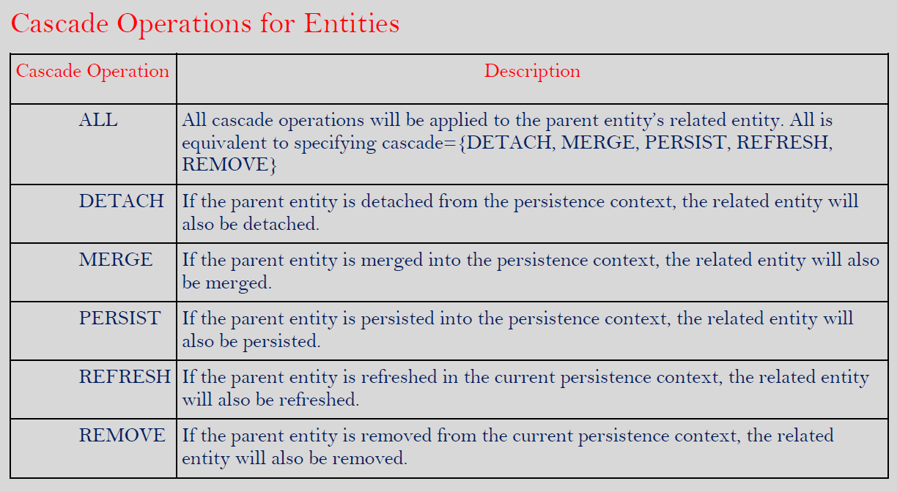

JPA Entity Relationships
In JPA, relationships define how one entity is connected to another entity. These connections are called multiplicities. JPA supports four main types of relationships: one-to-one, one-to-many, many-to-one, and many-to-many.
One-To-One: Each entity instance is related to a single instance of another entity. One-to-one relationships use the javax.persistence.OneToOne annotation on the corresponding persistent property or field.
• One student has only one address
• One address belongs to only one student
@Entity
public class Student {
@Id
private int studentId;
private String name;
@OneToOne
private Address address;
}

One-to-many:
- An entity instance can be related to multiple instances of the other entities.. One-to-many relationships use the javax.persistence.
OneToMany annotation on the corresponding persistent property or field.
- One teacher can teach many students
- Each student is taught by one teacher
One teacher handles many students in a class.

JPA Annotations Used
@OneToMany and @ManyToOne

Simple Code Example
@Entity
public class Teacher {
@Id
private int teacherId;
private String teacherName;

@OneToMany
private List<Student> students;
}

Many-to-one: Multiple instances of an entity can be related to a single instance of the other entity. This multiplicity is the opposite of a one-to-many relationship. Many-to-one relationships use the javax.persistence.ManyToOne annotation on the corresponding persistent property or field.

@Entity
public class Student {
@Id
private int studentId;
private String studentName;

@ManyToOne
private Teacher teacher;
}

Many-to-many: The entity instances can be related to multiple instances of each other. For example, each college course has many students, and every student may take several courses. Therefore, in an enrollment application, Course and Student would have a many-to-many relationship. Many-to-many relationships use the javax.persistence.ManyToMany annotation on the corresponding persistent property or field.

- One student can learn many courses
- One course can be learned by many students

Example :
Students can enroll in multiple courses like Java, Python, SQL,
and each course has many students.

JPA Annotation
@ManyToMany
@Entity
public class Student {
@Id
private int studentId;
private String name;
@ManyToMany
private List<Course> courses;
}
@Entity
public class Course {
@Id
private int courseId;
private String courseName;
@ManyToMany
private List<Student> students;
}

