**Emergency Vehicle Detection using Sound recognition**

**Overview :-**

Ambulance Saves Life. When it gets struck in Traffic, Bad Things can Happen. This Project Gives a Proposal to automatically Prioritize Traffic Lights for the Ambulance Route.

**Implementation :-**

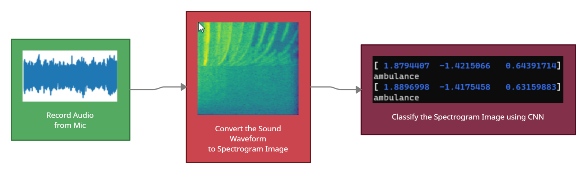

**Components used :-**

|  |  |  |  |  |
| --- | --- | --- | --- | --- |
| **Part Name** | **Thumbnail image** | **Description** | **Quantity** | **Cost** |
| Nvidia Jetson Nano 2gb | Image result for jetson nano | Brain of the System. AI Processing Takes Place Here. | 1 | 4,901 |
| Microphone | Image result for lavalier mic | Captures The Audio For Processing | 1 | 399 |
| USB DAC | Image result for cheap usb dac aliexpress | As Jetson Doesn’t Have a Mic In. We Need to Use this. | 1 | 199 |
| USB-C Power Supply | Image result for usbc charger | Power Supply for Jetson | 1 | 299 |
| Servo | Image result for 360 servo motor | **UNIMPLEMENTED**  Used to Rotate the mic to find directions | 1 | 499 |
| Relays | Image result for Relays | **UNIMPLEMENTED**  To toggle the traffic lights with 5v Signal | As Needed | *99 per piece |
| Connecting Wires | Image result for Cables | To Connect the Parts | As Needed | *<99 per piece |
| Camera | Image result for raspberry pi camera | UNDECIDED  For Image recognition | - | - |
| Total: |  |  |  | Approx Rs. **6,893/-** |

**Schematic Diagram :-**

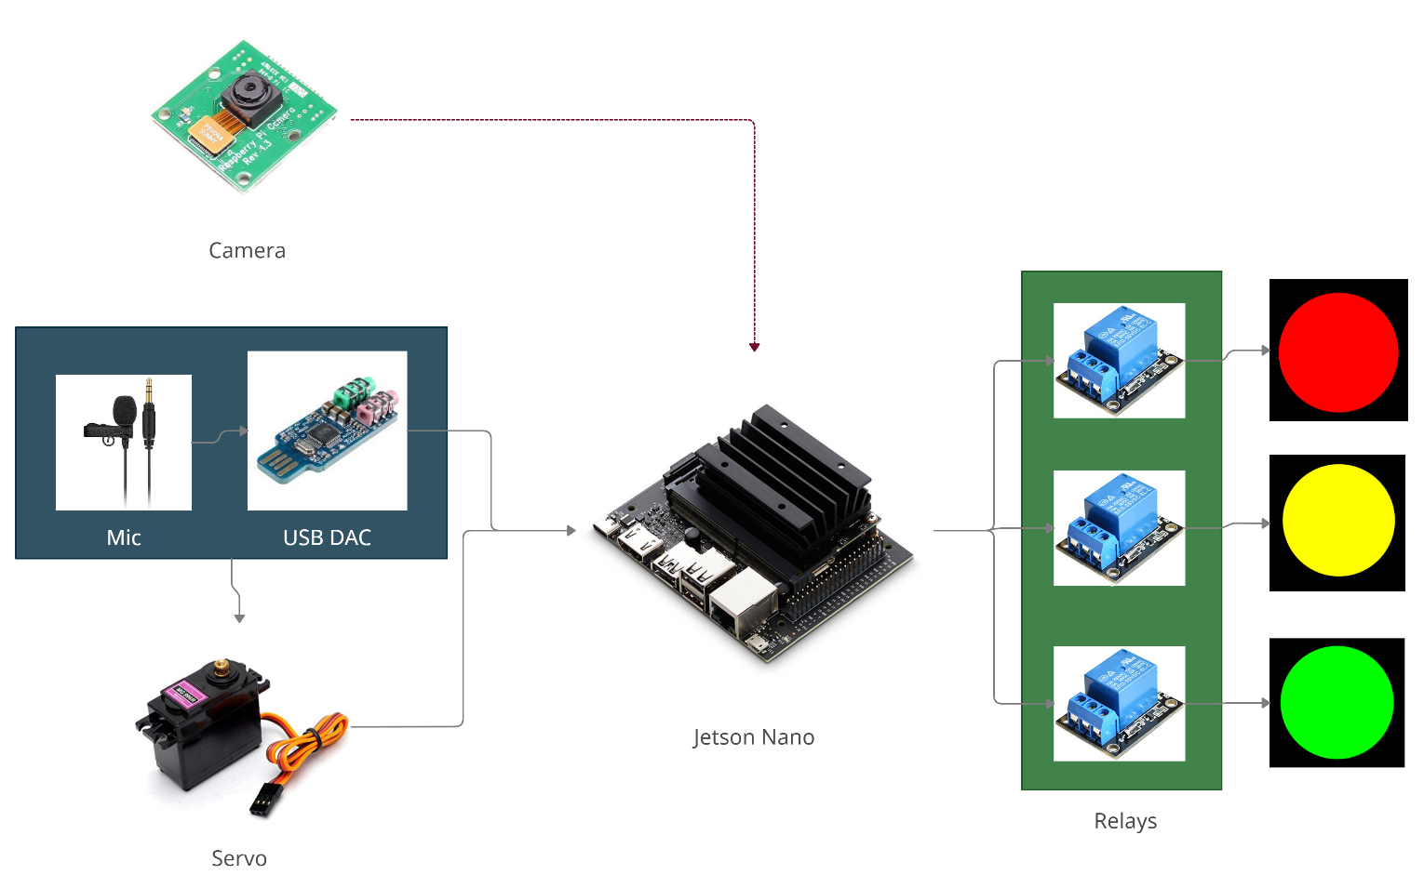

**Description :-**

When an ambulance nears a traffic signal that is fitted with our equipment, it recognizes the ambulance siren and paves way for its uninterrupted passage by changing the respective side’s signal to **green.** The ambulance sound waveform is recorded by the Jetson-Nano through a microphone and then it is converted into a spectrogram image using **Short time Fourier transform** technique. Then the spectrogram image is fed into a pre-trained model. The model recognizes the input and produces the output within fraction of seconds.

The Convolution neural network(CNN) is created using **Tensorflow** and **Keras** (Python libraries) with the following structure

Layer (type) Output Shape Param #

=================================================================

resizing_1 (Resizing) (None, 32, 32, 1) 0

normalization_1 (Normalization) (None, 32, 32, 1) 3

conv2d_2 (Conv2D) (None, 30, 30, 32) 320

conv2d_3 (Conv2D) (None, 28, 28, 64) 18496

max_pooling2d_1 (MaxPooling2D) (None, 14, 14, 64) 0

dropout_2 (Dropout) (None, 14, 14, 64) 0

flatten_1 (Flatten) (None, 12544) 0

dense_2 (Dense) (None, 128) 1605760

dropout_3 (Dropout) (None, 128) 0

dense_3 (Dense) (None, 3) 387

=================================================================

It is trained with a dataset containing three classes each class containing 200 audio files. The three classes are-

* Ambulance sound
* Firetruck sound
* Traffic noise

The Mic is mounted on a rotational mechanism. It is planned to use a Servo

Motor for this. It needs to find the direction of the sound which inturn is the direction of ambulance. A PID System is implemented in which the angle of motor is the control variable, Sound dB level from Mic is the measured variable and the target value for the measured variable is set to a high dB value(say 100dB). The motor rotates(control variable) and finds the angle in which the dB level is nearest to the target value (i.e ) It is finding the direction of maximum sound.

Finally After the Prediction Values from the model are Outputted, it is tested to see if the ambulance probability is higher than a threshold value(say 40) and if the prediction is sustained for say 5 seconds continuous then we can say that an ambulance sound has been detected. And the corresponding route’s green light relay is switched, the traffic light turn green.

**Additional:**

The Model is also partially trained to detect Firetruck Sounds. So it may be used for firetruck detection also. Generally the model can be trained to detect any vehicle sound.

We also tried to implement Image based Ambulance detection by taking pics from a camera to reduce false-postives rate further. But it’s still undecided whether it would end up in the final project.

**Progress Made:**

Currently the sound based model is trained and its successfully detecting the sounds. We did also partially implemented the image recognition model. The techinque’s to use for the rotational mechanism has been decided.