PROJECT REPORT
The Pollution Blame Ledger
Probabilistic source apportionment of Delhi PM2.5 with uncertainty-quantified health-burden attribution
Author: Aryan Arora
Date: 18 October 2026
Code: github.com/Aryan-Arora/pollution-blame-ledger
Status: Research prototype (synthetic data)
Read before citing any number
All data used in this report is synthetic: simulated Delhi-like observations with known ground truth. Health figures use placeholder concentration-response, baseline-mortality and population values. Source-level results are reliable only after the validation-derived interval widening described in Section 6. Nothing in this report is a claim about real Delhi air quality or real deaths.

1. Abstract
Delhi's severe PM2.5 episodes result from several co-varying emission streams acting together under changing meteorology. Public debate about who is responsible is largely anecdotal, and the health burden of each source is not quantified. The Pollution Blame Ledger is an open, probabilistic attribution engine. For an episode it infers source-resolved contributions with credible intervals, converts them into attributable premature deaths and hospital admissions through counterfactual source removal, and reports which sources the data cannot tell apart.
This report describes the prototype: a hierarchical Bayesian receptor model fitted with the No-U-Turn Sampler, tracer-based source fingerprints, identifiability diagnostics, a health-burden module, and a falsification suite that tests the whole pipeline against synthetic episodes whose true source contributions are known. The main findings on synthetic data are that road and construction dust is recovered accurately (8% median error), that vehicular exhaust and crop-residue burning cannot be reliably separated although their sum is recovered accurately (8%), and that the raw model is over-confident, which is corrected by interval calibration on held-out episodes.

2. Problem statement
PM2.5 in Delhi is the superposition of biomass combustion, vehicular exhaust, fugitive construction and road dust, and industrial point sources, modulated by wind and boundary-layer height. Because the streams co-vary, attribution is a severely ill-posed inverse problem. Prevailing narratives cannot be falsified, which weakens evidence-based policy, and the epidemiological burden of each source remains unquantified.

Design goals
- Quantify, do not assert: every figure carries a credible interval.
- State the limits: source pairs the data cannot separate are flagged and reported as a sum.
- Be falsifiable: the pipeline is scored against known synthetic truth and plume injections.
- Speak in harm, not concentration: each source is expressed as attributable deaths and hospital admissions.

3. System overview
The prototype is a Python pipeline with a self-contained HTML dashboard. Its five stages map directly to the original problem statement.
Stage | Module | What it does
1. Data fusion | ledger/ingest.py, features.py | Normalises CPCB station exports, Open-Meteo/ERA5 meteorology and NASA FIRMS fire radiative power into one hourly schema.
2. Fingerprinting | ledger/features.py | CO and NO2 for traffic, SO2 for industry, PM10 minus PM2.5 for dust, wind-advected fire radiative power divided by ventilation for biomass.
3. Receptor model | ledger/model.py | Hierarchical Bayesian decomposition sampled with NUTS (NumPyro).
4. Health burden | ledger/health.py | GEMM mortality and short-term admissions with counterfactual source removal and Monte Carlo uncertainty.
5. Falsification | ledger/validate.py, calibration.py | Synthetic ground truth, held-out calibration, coverage and plume-injection tests.

Because real-data downloads were not reachable from the build environment, a synthetic episode generator (ledger/synth.py) produces six Delhi-like stations over ten days with known per-source contributions, written in exactly the schema the real-data loader emits. The same pipeline code runs on both.

4. Methodology

4.1 Tracer fingerprinting
Each source is represented by a proxy series normalised to unit mean at each station, so that a model coefficient is directly the episode-mean contribution of that source in micrograms per cubic metre.
Source | Proxy | Rationale
Vehicular exhaust | Mean of CO and NO2 | Combustion tracers with strong traffic signatures.
Industrial point sources | SO2 | Dominated by industrial and power-sector sulphur emissions.
Road and construction dust | PM10 minus PM2.5 | Coarse fraction rises with resuspended dust.
Crop-residue burning | Fire radiative power footprint x 1/ventilation | Fires in Punjab and Haryana advected by wind toward Delhi.

4.2 Hierarchical Bayesian receptor model
For station s and hour t, observed PM2.5 is modelled as a regional background plus source terms:
PM2.5[s,t] = B[day(t)] + sum_k theta[k,s] * g[k,s,day(t)] * shape[k,s,t] + eps

- Non-negativity and pooling: theta[k,s] is log-normal and partially pooled across stations.
- Background: B is a non-negative daily log random walk shared by all stations.
- Tracer baselines: each tracer has a non-source baseline, bounded above by its observed minimum (sources only add), learned in the model.
- Cross-talk: a matrix L un-mixes tracers that carry other sources (for example, fires also emit CO, NO2 and SO2), capped at 60% total per tracer.
- Proxy mismatch: a mean-one station-day gain g lets the model absorb timing and transport-lag errors instead of forcing them into the source terms.
Sampling uses NUTS with two chains. The reported run had R-hat 1.025 and no divergences. Minimum effective sample size was 69, below the usual 400 target; longer chains are a planned improvement.

4.3 Identifiability diagnostics
Posterior correlations between source contributions, together with information gain (one minus posterior variance over prior variance) and relative interval width, classify each source as identified, weak or unresolved. A pair with correlation below -0.5 is flagged as a trade-off and its sum is reported as the defensible quantity. In the demonstration episode, vehicular exhaust and crop-residue burning show a posterior correlation of -0.79.

4.4 Health-burden propagation
Exposure at each station is the modelled mean PM2.5. Mortality uses the Global Exposure Mortality Model (non-accidental plus lower respiratory infection) concentration-response form. Hospital admissions use a short-term log-linear function. For each source, counterfactual scenarios remove 50% or 100% of its contribution, and the difference in attributable burden is the burden of that source. Uncertainty in the concentration-response parameter, the baseline rate and the posterior is propagated by Monte Carlo.
Parameter | Value (all placeholders)
GEMM NCD+LRI theta, alpha, mu, nu | 0.1430 (SE 0.01807), 1.6, 15.5, 36.8; counterfactual floor 2.4 ug/m3
Baseline adult mortality rate | 0.0028 per person per year (log-normal, CV 25%)
Adult share of population | 0.65
Admissions relative risk | 1.008 per 10 ug/m3 (SE of ln RR 0.0025)
Baseline admission rate | 0.004 per person per year (CV 30%)

Mortality figures are episode-equivalent: long-term exposure estimates scaled by episode length divided by 365. They express relative burden by source, not a count of people who died during the episode.

4.5 Falsification and calibration
Twenty synthetic episodes with known truth are generated. Twelve calibrate the interval widening: for each component, the factor is the finite-sample 90th percentile of the posterior-mean error measured in half-widths of the raw 90% interval (split-conformal calibration). The other eight episodes, never seen during calibration, measure coverage before and after widening. A separate plume-injection test doubles one source's true emissions with everything else identical and checks that the ledger notices.

5. Results

5.1 Demonstration episode
On a ten-day synthetic episode with a mean population-weighted PM2.5 of 161 ug/m3, the calibrated ledger reports:
Component | Share | Mean (ug/m3) | Status
Vehicular exhaust | 39% | 63.5 (39.3 - 87.7) | Unresolved (trades off with burning)
Crop-residue burning | 19% | 30.9 (10.3 - 51.6) | Unresolved (trades off with traffic)
Traffic + burning (sum) | 58% | 94.4 (84.5 - 104.3) | Reliable
Road and construction dust | 15% | 24.4 (18.7 - 30.1) | Identified
Industrial point sources | 13% | 21.4 (8.3 - 34.5) | Weak
Regional background | 13% | 21.3 (7.1 - 35.4) | Weak

The total health burden of the episode is about 791 episode-equivalent premature deaths (90% interval 446 to 1,135) and 444 hospital admissions (143 to 745), using placeholder parameters. Halving traffic and crop burning together would avert roughly 61 of those deaths.
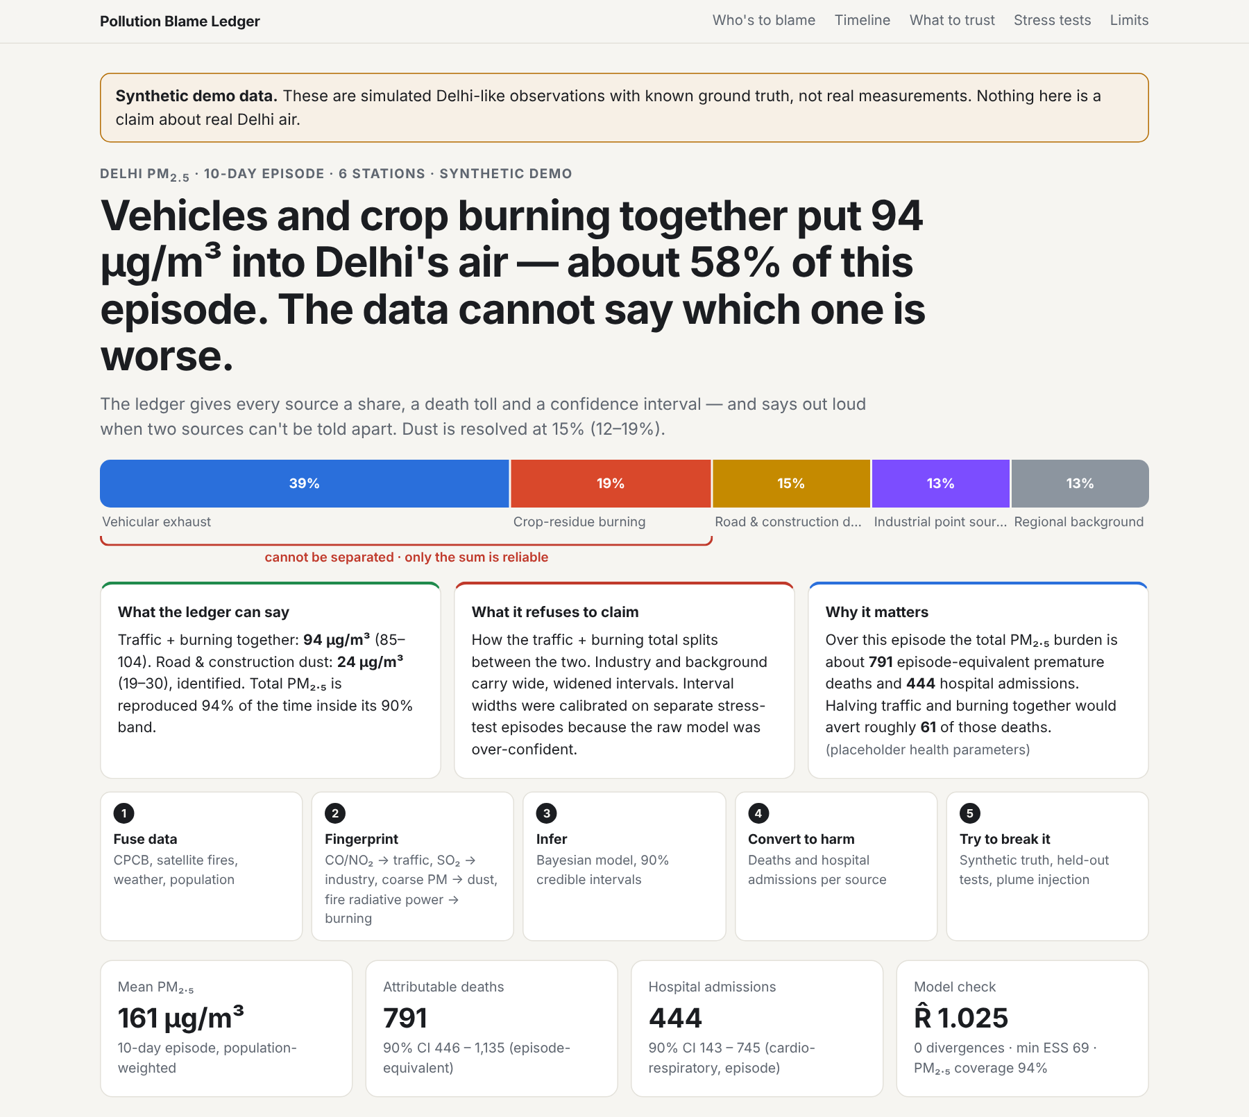
Figure 1. Dashboard overview: headline finding, source-share bar with the unresolved pair bracketed, and key figures.
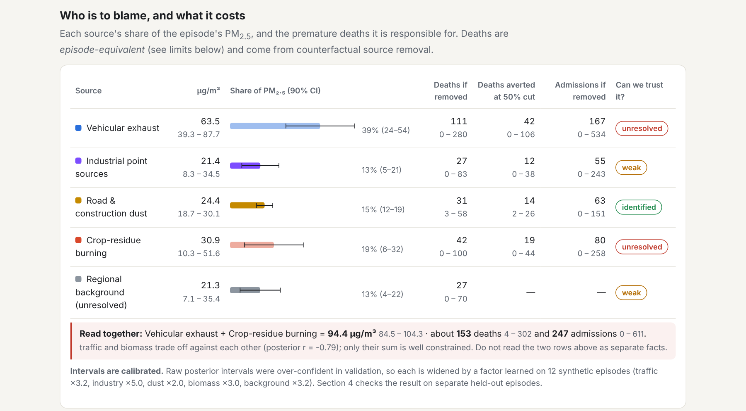
Figure 2. The ledger: share, deaths, admissions and trust label for each source.

5.2 Stress tests on held-out episodes
Component | Median error | Raw coverage | Calibrated | Widening
Dust | 8% | 63% | 88% | x2.0
Traffic + burning (sum) | 8% | 38% | 100% | x2.2
Crop-residue burning | 20% | 25% | 100% | x3.0
Regional background | 27% | 0% | 75% | x3.2
Vehicular exhaust | 41% | 0% | 100% | x3.2
Industrial point sources | 55% | 0% | 100% | x5.0

- Total PM2.5 is reproduced within its 90% predictive band 93% of the time.
- Raw posterior intervals are over-confident; calibration widens them by factors of 2 to 5 so that coverage holds on unseen episodes. This makes the ledger honest, not more precise.
- Plume injection: doubling traffic or biomass emissions is detected in both cases. For biomass the true value still falls outside the calibrated interval.
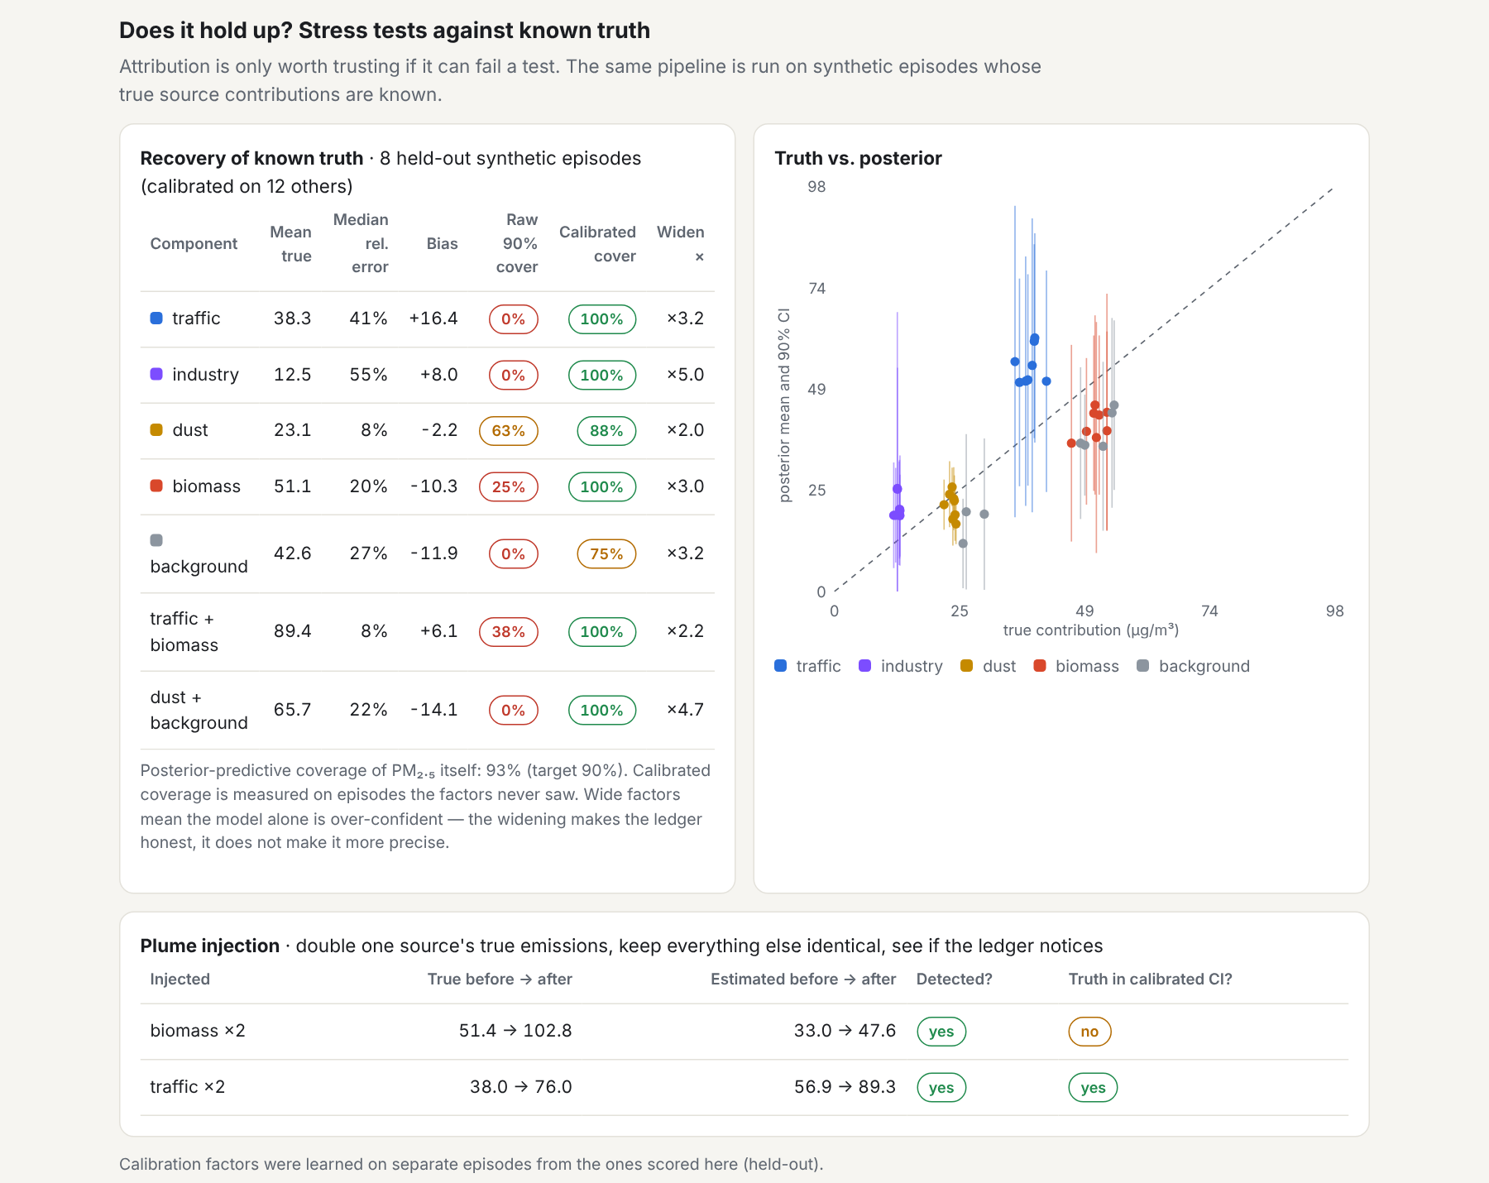
Figure 3. Recovery of known truth, calibration before and after widening, and plume-injection results.

5.3 Interpretation
The model separates dust well because the coarse-particle tracer is distinctive. Traffic and crop burning both rise under the shallow night-time boundary layer, so ventilation drives most of their shared variation; the data pin down their sum but not their split. The ledger reports this directly instead of presenting a precise but unjustified split.
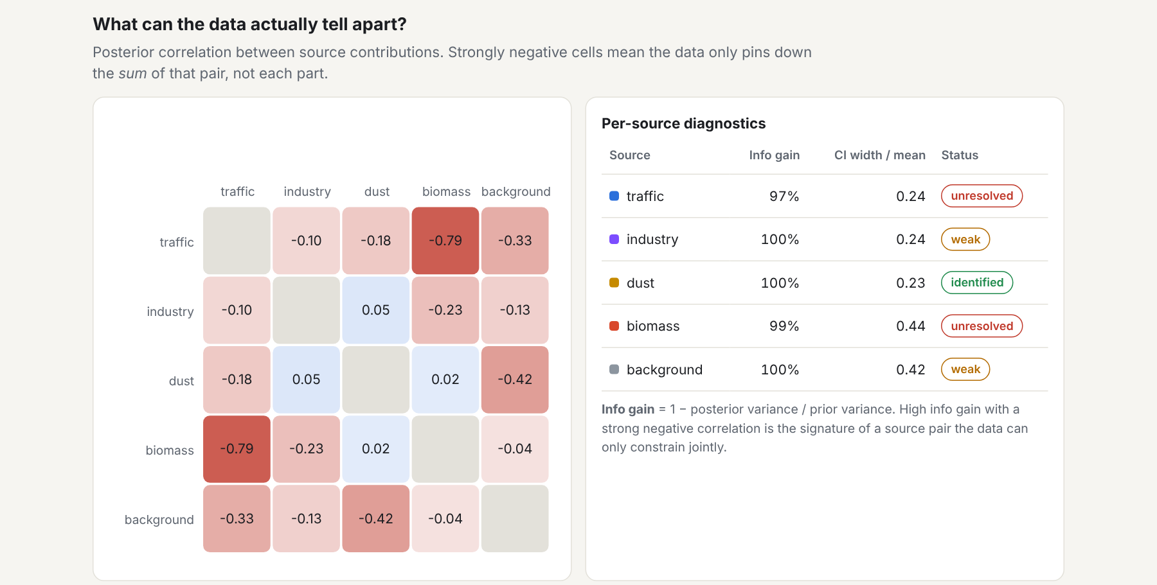
Figure 4. Posterior correlation between sources (left) and per-source diagnostics (right).

6. Limitations
- Synthetic data only. Calibration factors transfer only as far as the simulated world resembles Delhi. They must be re-learned on real episodes with independent ground truth.
- Placeholder health parameters. The GEMM parameters are pooled rather than age-specific; baseline rates, populations and the admissions function are rough values, not Delhi statistics.
- Source separation. Individual traffic, biomass, industry and background estimates are biased in validation (20% to 55% median error); only the traffic-plus-biomass sum and dust are accurate.
- Sampler effort. Minimum effective sample size of 69 indicates short chains.
- Unused inputs. Sentinel-2 land-cover change and OpenStreetMap road and industrial geometries are not yet used.
- Untested ingestion. The real-data loader is unit-tested on fabricated fixtures only; the Open-Meteo fetch and real CPCB and FIRMS files have not been run end to end.

7. Roadmap and expected impact

Next steps
- Run a real episode end to end (CPCB, FIRMS, ERA5) and re-calibrate intervals.
- Replace placeholder health parameters with age-specific GEMM, Delhi baseline rates, WorldPop and a published admissions function.
- Add explicit source profiles (PMF or CMB style) and Lagrangian back-trajectories to separate traffic from crop burning.
- Leave-one-episode-out validation on real episodes and triangulation against published apportionment studies.
- Hosted real-time view with current station readings.

Expected impact
Audience | Benefit
Regulators | Source-specific, season-aware interventions backed by counterfactual benefit estimates, in place of blanket restrictions.
Public and press | Transparent, falsifiable accountability for every severe-air episode.
Health systems | Anticipatory estimates of episode-attributable morbidity.
Researchers | A reproducible, open benchmark portable to other airsheds (SDG 3, 11, 13, 16).

Appendix: reproducing the results
pip install -r requirements.txt
python run.py --demo # full run (~10 min)
python run.py --demo --skip-validation # reuse saved calibration (~30 s)
python -m pytest tests # offline tests
Real data: prepare a stations file (station, lat, lon, pop_m), then run:
python -m ledger.ingest --cpcb data/cpcb/ --firms data/firms.csv --stations data/stations.csv --start 2025-11-01 --end 2025-11-10 --out data/episode
python run.py --csv data/episode/observations.csv --stations data/episode/stations.csv

