AICTE | IBM SkillsBuild
DATA ANALYTICS WITH AI INTERNSHIP 2026
🏠 HOUSE PRICE PREDICTION
USING MACHINE LEARNING
PROJECT REPORT
Student Name : | Guguloth Nithin
Roll No : | 160723733116
Branch : | Computer Science and Engineering
College : | Methodist College of Engineering and Technology
Project Domain : | Data Analytics + Artificial Intelligence

INTERNSHIP PROJECT • 2026
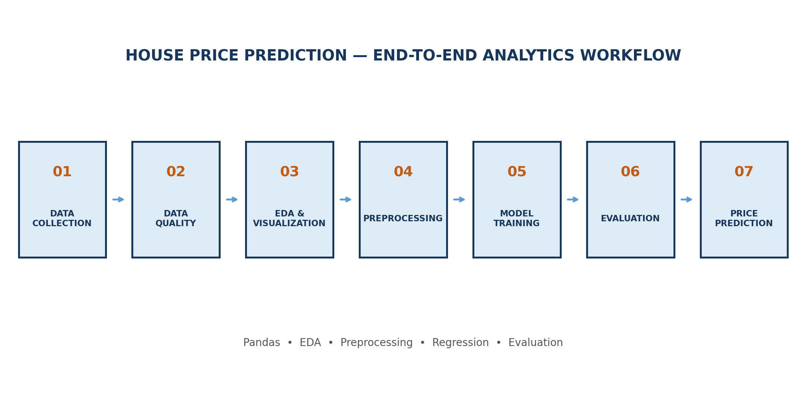

1. Executive Summary
This project presents an end-to-end data analytics and machine-learning solution for predicting residential house sale prices. The Ames Housing / Kaggle House Prices dataset is analyzed through data-quality checks, exploratory visualization, preprocessing, regression modeling and evaluation.
The solution is designed as a reproducible internship project: the Jupyter Notebook contains the complete executable workflow, requirements.txt defines dependencies, and the README documents the project for GitHub.

2. Problem Statement
Predict the sale price of a residential property using historical house characteristics such as quality, area, year built, garage capacity, basement area, rooms and neighborhood.

3. Objectives
- Understand a real-world housing dataset and its data quality.
- Explore relationships between property attributes and sale price.
- Handle missing numerical and categorical observations systematically.
- Transform categorical variables into machine-learning-ready features.
- Train and compare three regression algorithms.
- Evaluate predictions using MAE, RMSE, R² and RMSLE.
- Create visual outputs suitable for analytics interpretation and reporting.

4. Dataset Overview
The Kaggle House Prices: Advanced Regression Techniques dataset contains 1,460 training properties and 79 explanatory variables. The target variable is SalePrice.
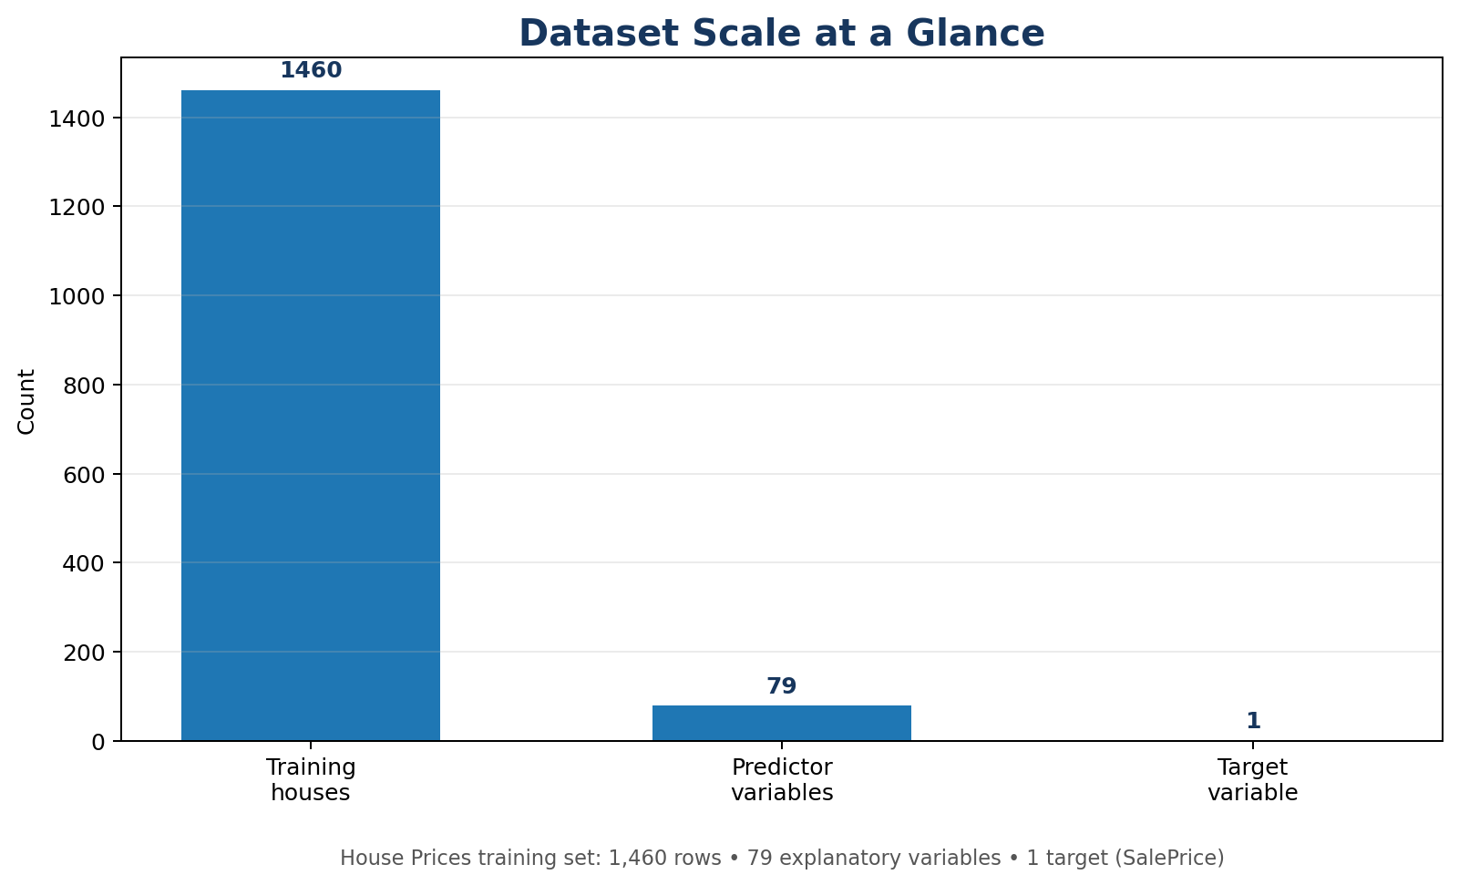
Figure 1. Dataset scale used by the project.
Dataset Item | Value | Purpose
Training properties | 1,460 | Model development
Explanatory variables | 79 | Property characteristics
Target variable | SalePrice | Regression prediction

5. Key Features
- OverallQual — overall material and finish quality
- GrLivArea — above-ground living area
- GarageCars — garage capacity
- TotalBsmtSF — total basement area
- 1stFlrSF — first-floor area
- YearBuilt — original construction year
- FullBath — number of full bathrooms
- TotRmsAbvGrd — rooms above grade

6. Project Workflow
Figure 2. End-to-end analytics and machine-learning workflow.

7. System Architecture
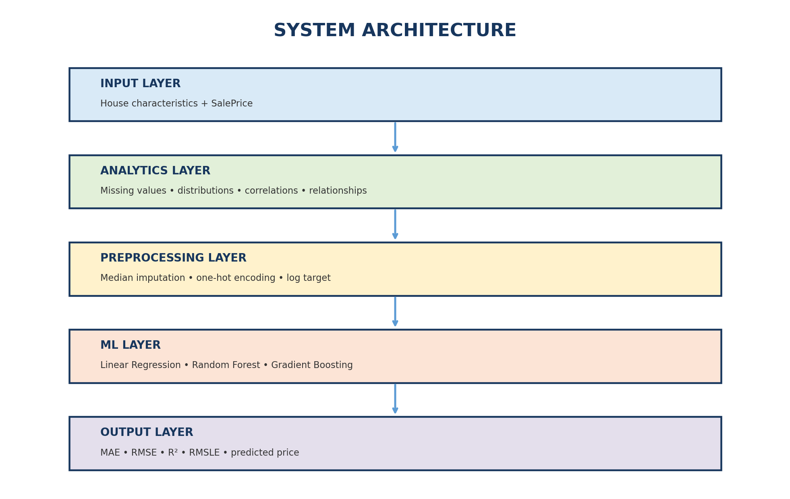
Figure 3. Layered system architecture.

8. Data Preprocessing
The notebook uses a Scikit-learn ColumnTransformer and Pipeline so that preprocessing is applied consistently to training and validation data.
- Numerical missing values → median imputation.
- Categorical missing values → most-frequent imputation.
- Categorical variables → One-Hot Encoding with unknown categories ignored.
- Identifier column Id → removed because it is an identifier rather than a meaningful predictive attribute.
- SalePrice → log1p transformation during training; predictions are converted back with expm1.

9. Exploratory Data Analysis
The executable notebook produces the actual dataset-based graphs during Run All. The main EDA views are SalePrice distribution, missing-value analysis, living-area versus price, and a correlation heatmap.
SalePrice Distribution  Shows target distribution and skewness. | Missing-Value Analysis  Highlights features requiring imputation.
GrLivArea vs SalePrice  Explores the relationship between living area and price. | Correlation Heatmap  Shows numerical relationships among important variables.

10. Machine Learning Models
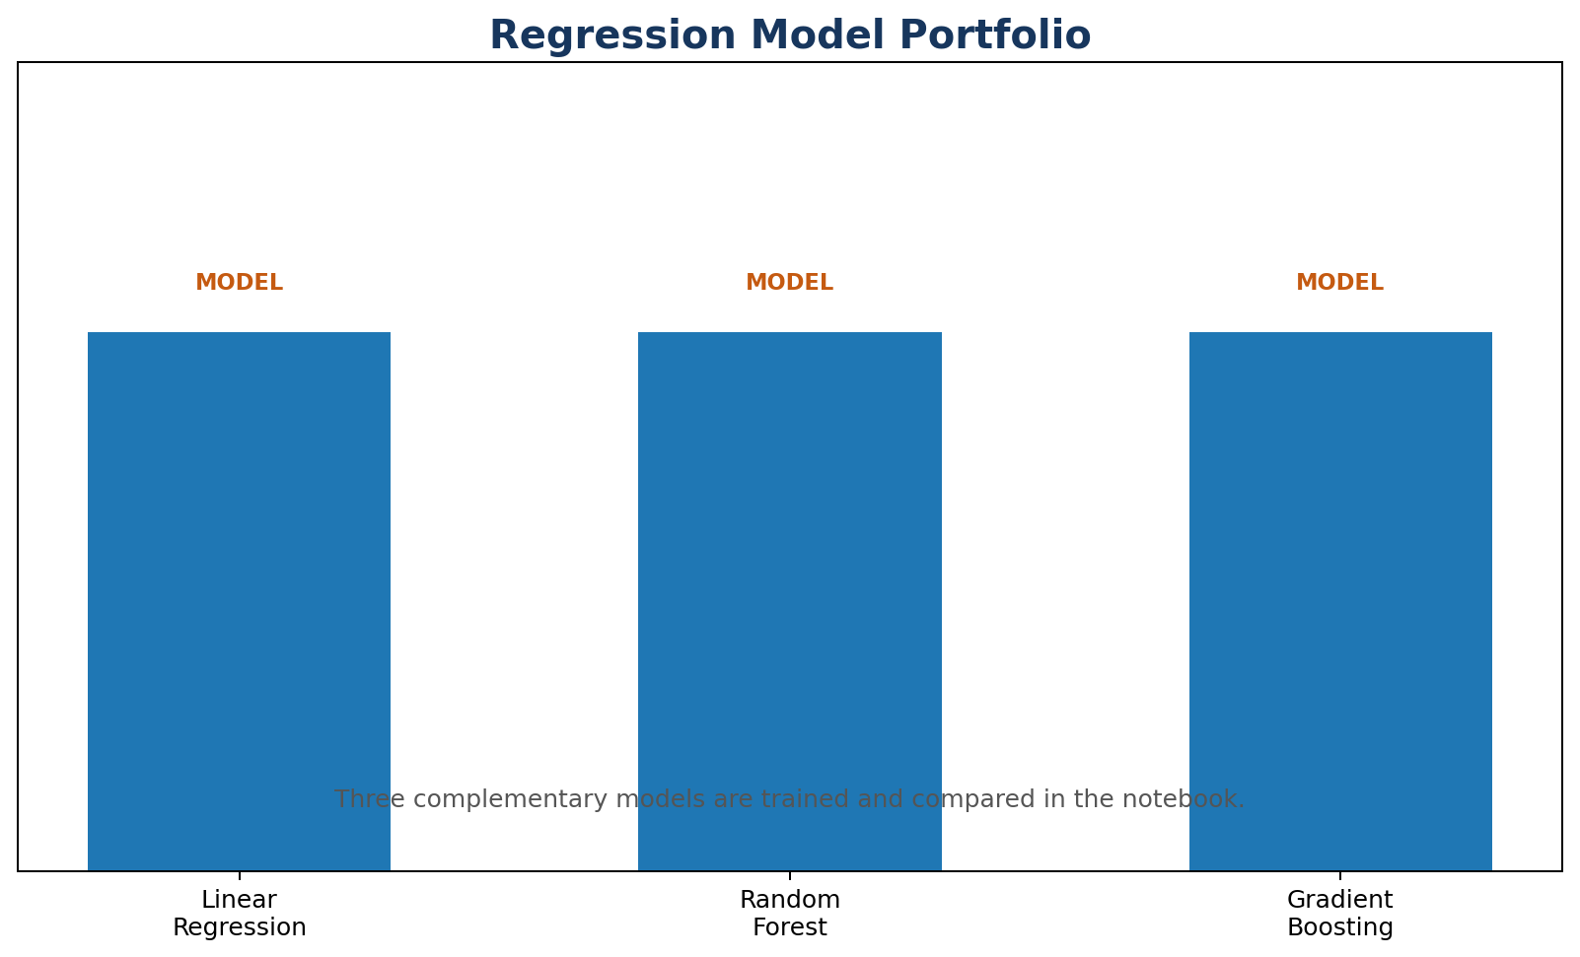
Figure 4. Three-model regression portfolio used for comparison.
- Linear Regression — interpretable baseline model.
- Random Forest Regressor — ensemble tree model for nonlinear relationships.
- Gradient Boosting Regressor — sequential tree ensemble designed to improve prediction error.

11. Evaluation Metrics
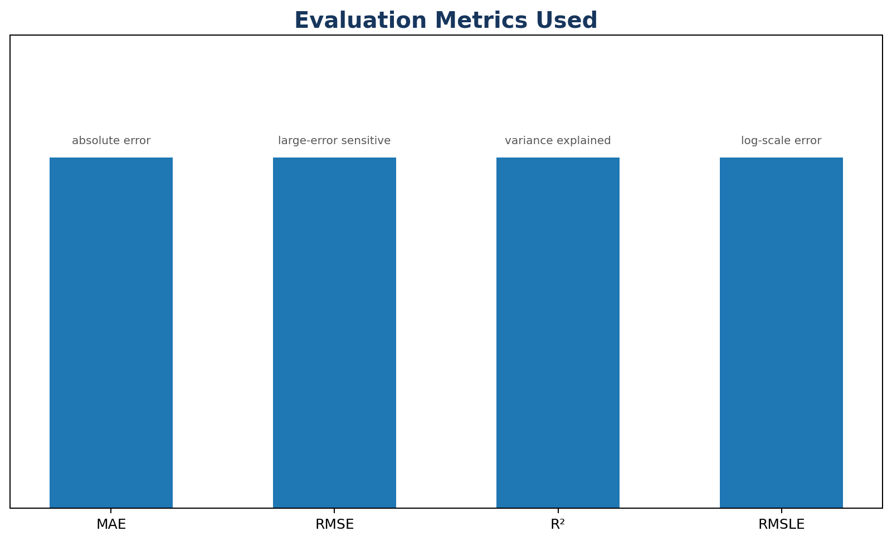
Figure 5. Evaluation metrics used by the notebook.
Metric | Meaning
MAE | Mean absolute prediction error.
RMSE | Penalizes larger errors more strongly.
R² | Measures variance explained by the model.
RMSLE | Measures logarithmic prediction error.

12. Results and Output
The notebook generates the model comparison table and charts at execution time. Performance values are intentionally not hard-coded into this report, so the submitted results remain reproducible and match the actual execution environment.
Model | MAE | RMSE | R² | RMSLE
Linear Regression | Generated on Run All | Generated on Run All | Generated on Run All | Generated on Run All
Random Forest | Generated on Run All | Generated on Run All | Generated on Run All | Generated on Run All
Gradient Boosting | Generated on Run All | Generated on Run All | Generated on Run All | Generated on Run All

13. Business Applications
- Preliminary property valuation and price estimation.
- Real-estate analytics and market research.
- Housing investment analysis.
- Property-feature and price relationship analysis.
- Data-driven decision support.

14. Limitations
- Historical data may not fully represent current market prices.
- Predictions depend on the quality and coverage of the training dataset.
- The model is an analytical estimate, not a professional property valuation.
- External market conditions are not explicitly modeled.

15. Future Enhancements
- Hyperparameter tuning with GridSearchCV or RandomizedSearchCV.
- Cross-validation for more robust evaluation.
- XGBoost, LightGBM and CatBoost comparison.
- SHAP-based explainability.
- Interactive Streamlit dashboard.
- Cloud deployment and model monitoring.

16. Conclusion
The House Price Prediction project demonstrates a complete analytics-to-machine-learning workflow. It combines data understanding, cleaning, visualization, feature preparation, model comparison and evaluation into a single reproducible notebook suitable for the IBM SkillsBuild Data Analytics with AI internship.

17. References
Kaggle — House Prices: Advanced Regression Techniques
https://www.kaggle.com/competitions/house-prices-advanced-regression-techniques/data
Scikit-learn documentation
https://scikit-learn.org/

