CSE435 : Comprehensive Seminar
Section : 222TR

1. Title
AI Based Crop Recommendation System
2. Student Name, Roll No, Registration Number, Phone Number
Name : Nithin Thokkala & Manoj Kadali & Sunny Singh
Rolls : 11 & 56 & 14
Reg no.s : 12206268 & 12207206 &12210355
Phone numbers : 9347712794 & 7702786281 & 8873725493
3. Brief Description of Project
The AI-Based Crop Recommendation System is a machine learning-based decision-support system designed to help farmers choose the most suitable crop based on soil and environmental parameters. The system analyze features such as Nitrogen (N), Phosphorus (P), Potassium (K), pH, temperature, humidity, and rainfall to predict the best crop for cultivation. A comparative framework using Random Forest, Logistic Regression, and LSTM models is developed to evaluate performance. The dataset contains around 2200 samples across 22 crop classes, enabling multi-class classification. Model performance is evaluated using metrics like Accuracy and F1-score.
The system is scalable and can be integrated with IoT sensors and weather APIs for real-time agricultural recommendations.

4. Problem Addressed by Project
Traditional crop selection mainly depends on farmer experience and past practices, which often leads to incorrect crop choices due to changing soil conditions and unpredictable weather patterns. Many existing systems fail to effectively integrate multiple parameters such as soil nutrients (N, P, K, pH) and environmental factors (temperature, humidity, rainfall), resulting in low productivity and financial losses.
There is a need for a reliable, data-driven, and automated system that can accurately recommend suitable crops based on scientific analysis of soil and climate data. This project addresses that gap by developing an AI-based crop recommendation system that improves decision-making and enhances agricultural productivity.

5. Literature
In recent years, Artificial Intelligence (AI), Machine Learning (ML), and Internet of Things (IoT) technologies have significantly transformed traditional agricultural practices into data-driven precision farming systems. Earlier farming methods largely depended on farmer experience and historical weather patterns, which often resulted in inefficient resource usage and inconsistent crop productivity. With the availability of structured agricultural datasets, AI-based models have been widely adopted for crop recommendation, yield prediction, and disease detection.
Senapaty et al. (2024) developed a decision support system using multiple machine learning classifiers and achieved high accuracy in crop prediction. Their work demonstrated that ensemble-based models such as Random Forest perform effectively in handling structured soil and climate data. Similarly, Apat et al. (2023) proposed an AI-based crop recommendation framework using Random Forest and Naïve Bayes algorithms, reporting accuracy above 99%. However, these systems relied heavily on region-specific datasets and lacked deep learning comparison.
Recent studies have also explored explainable AI approaches. Kumar et al. (2024) integrated LIME and SHAP techniques to enhance model interpretability while maintaining strong predictive performance. IoT-enabled precision farming solutions proposed by Reddy et al. (2023) incorporated real-time sensor data for dynamic crop recommendations, though hardware and deployment costs remained a limitation.
Deep learning applications in agriculture have gained attention as well. Nawaz et al. (2024) reviewed CNN-based systems for plant disease detection, reporting accuracy above 95%. While deep learning performs well for image-based tasks, its effectiveness for structured tabular agricultural data remains an active research area. LSTM networks have been explored for time-series agricultural prediction, but their suitability for static soil–weather datasets requires further evaluation.
Overall, the existing literature highlights the effectiveness of ensemble machine learning models for structured crop recommendation tasks and the growing importance of interpretability and real-time adaptability. However, many studies either focus solely on classical ML models or purely on deep learning techniques without comprehensive comparative analysis. Therefore, this project builds upon prior research by developing a comparative AI framework that evaluates both classical machine learning and deep learning models, while emphasizing scalability, interpretability, and practical deployment in precision agriculture.
6. Pipeline / Detailed Methodology of the Work
Phase 1 – Data Collection & Dataset Preparation:
- The Crop Recommendation Dataset containing approximately 2200 samples across 22 crop classes was collected in CSV format.
- Features include Nitrogen (N), Phosphorus (P), Potassium (K), pH, temperature, humidity, and rainfall.
- The dataset was imported using Python (Pandas) for further processing.

Phase 2 – Data Preprocessing & Exploratory Data Analysis (EDA):
- Label encoding was applied to convert crop names into numerical format.
- Feature scaling (MinMaxScaler) was performed to normalize input values.
- Data was split into 80% training and 20% testing sets.
- EDA techniques such as heatmaps, histograms, pairplots, and correlation analysis were used to understand feature relationships.
- understand feature relationships.

Phase 3 – Model Development & Training:
- Classical Machine Learning models such as Random Forest and Logistic Regression were implemented.
- A Deep Learning model (LSTM) was developed to evaluate performance on structured tabular data.
- Models were trained using normalized data and optimized using appropriate hyperparameters.
- Random Forest was configured with 100 decision trees.

Phase 4 – Model Evaluation & Comparison:
- Models were evaluated using Accuracy, Precision, Recall, F1-score, ROC–AUC, and Confusion Matrix.
- Comparative analysis was performed between ML and Deep Learning models.
- Random Forest achieved the highest predictive performance (~98% accuracy).

Phase 5 – Prediction & Model Deployment Preparation:
- Random test samples were used to validate prediction capability.
- Trained models were saved in .h5 format for deployment.
- The system is designed to be scalable and ready for integration with IoT sensors and weather APIs for real-time crop recommendation.

7. Expected Outcome from the Project
The expected outcome of this project is a functional AI-based Crop Recommendation System that provides accurate, data-driven crop suggestions based on soil and environmental parameters. Upon completion, the system will:
- Successfully analyze soil nutrients (N, P, K, pH) and environmental factors (temperature, humidity, rainfall).
- Accurately recommend the most suitable crop using trained Machine Learning and Deep Learning models.
- Achieve high prediction accuracy (approximately 98% using Random Forest).
- Provide performance evaluation using metrics such as Accuracy, Precision, Recall, F1-score, and Confusion Matrix.
- Store trained models for real-time deployment and future scalability.
The final system will serve as a proof-of-concept intelligent agricultural decision-support tool, demonstrating how AI can improve crop selection, enhance productivity, and support precision farming through scientific and data-driven recommendations.
8. Results and Evaluation Metrics / Screenshots of Project
The current implementation successfully performs data preprocessing, model training, and crop prediction using Machine Learning algorithms. The comparative framework between Random Forest, Logistic Regression, and LSTM models is functional, and performance evaluation metrics are generated successfully. The system accurately predicts suitable crops based on soil and environmental parameters. Screenshots of dataset visualization (EDA graphs), model training accuracy plots, confusion matrix, and prediction output interface can be included in this section to demonstrate implementation progress and system functionality.

Github Repo : https://github.com/Nithin10180/seminar-Project
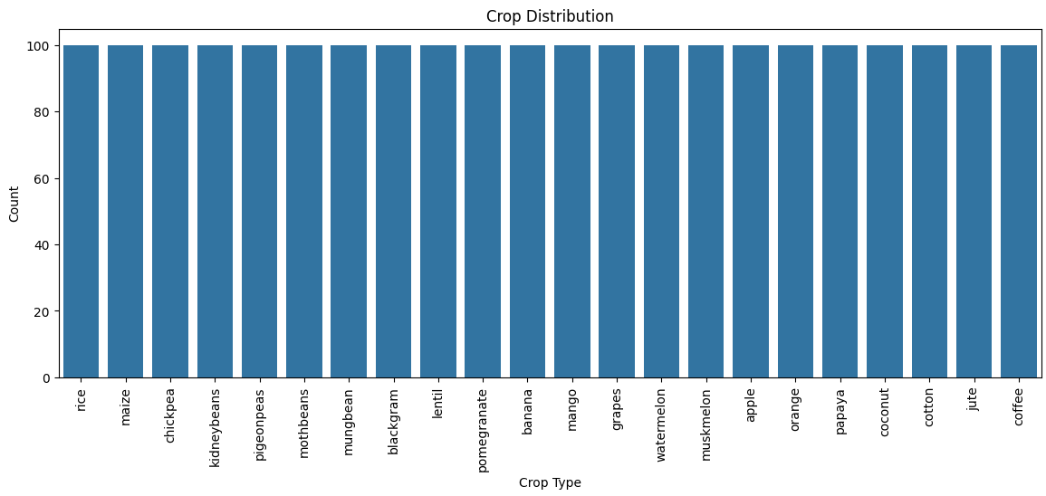

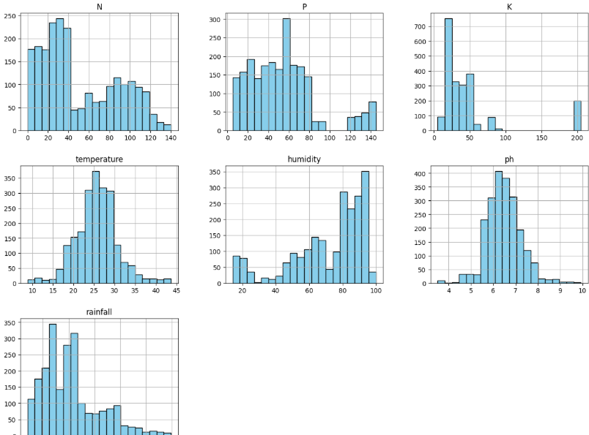
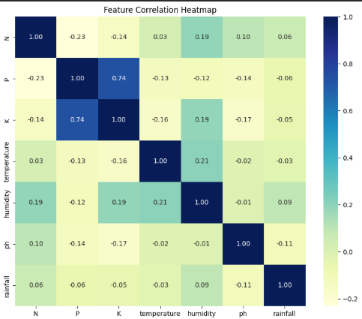

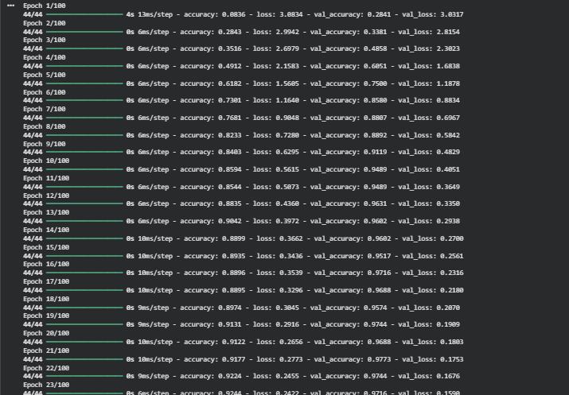
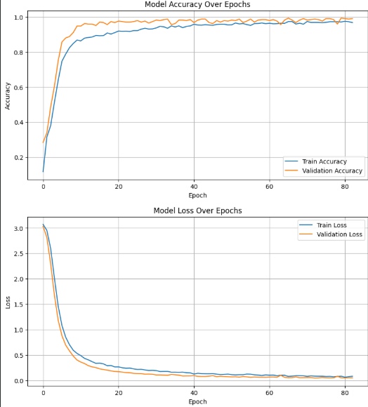
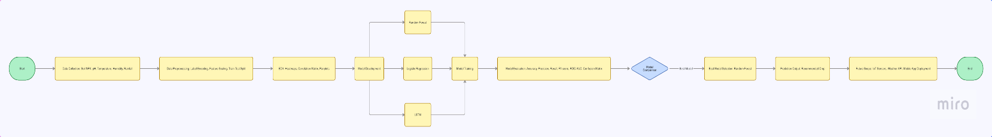
Data Flow :

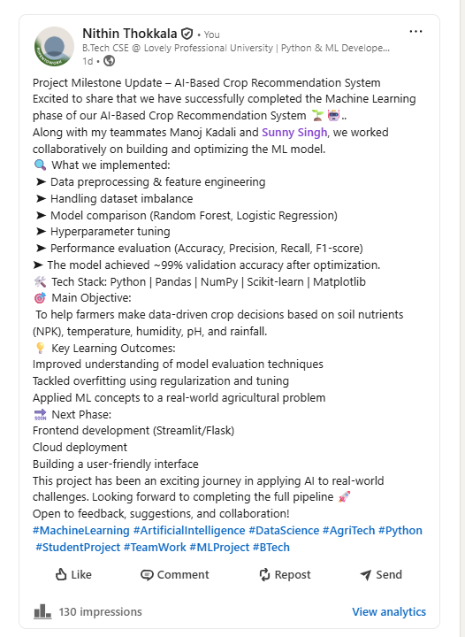
LinkedIn Post :

