Teacher-Student Appointment Management System
A comprehensive system designed to streamline academic appointments.

1. Project Title
Teacher-Student Appointment Management System

2. Introduction
The Teacher-Student Appointment Management System is a web-based application developed to automate the process of booking, approving, and tracking academic appointments between students and teachers. It features dedicated dashboards, real-time request handling, calendar views, and customizable availability.

3. Objective
To simplify and digitize the academic appointment booking process by providing an intuitive interface for both teachers and students.

4. Features
- Student and Teacher Login/Registration
- Separate Dashboards
- Real-time Appointment Requests
- Calendar Integration
- Availability Settings for Teachers
- Profile Management
- Password Change Functionality

5. Technologies Used
Frontend: HTML5, CSS3, JavaScript
UI/UX: Responsive Layout, Transitions, Animations
Storage: LocalStorage (for simulation)
Libraries: Google Fonts, FontAwesome Icons

6. System Architecture
HTML: Structure of forms, dashboard layouts, and calendar view.
CSS: Thematic styling, flex/grid layouts, animations.
JavaScript:
- Login/registration validation
- Form handling and event listeners
- Appointment state tracking and rendering
- Profile update and calendar navigation
- LocalStorage for session/data handling.

7. Pages Overview
- Landing Page
- Teacher/Student Login & Registration
- Teacher Dashboard (Requests, Calendar, Schedule, Profile)
- Student Dashboard (Book, View Appointments, Profile)
- Profile Sections with Update and Change Password Tabs

8. Functional Modules
- Authentication System
- Appointment Booking and Handling
- Calendar Display and Navigation
- Search and Filter for Requests
- Availability Configuration
- Profile and Password Management

9. UI/UX Highlights
- Consistent fonts (Poppins)
- Soft color palettes with hover interactions
- Smooth fade-in and scale transitions
- Mobile-friendly sidebar navigation

10. Sample Code Excerpts
JavaScript: Appointment Approval
```js
function approveRequest(id) {
// Update status
appointment.status = 'approved';
saveToStorage('appointments', appointments);
}
```

11. Testing & Validation
- Manual Testing across Browsers
- Verified responsiveness on mobile, tablet, and desktop
- Input validation for all major forms

12. Limitations
- No backend or database
- Local storage used only for simulation

13. Future Enhancements
- Firebase integration
- Notification System
- Persistent User Authentication
- Enhanced Scheduling Algorithm

System Architecture Diagram

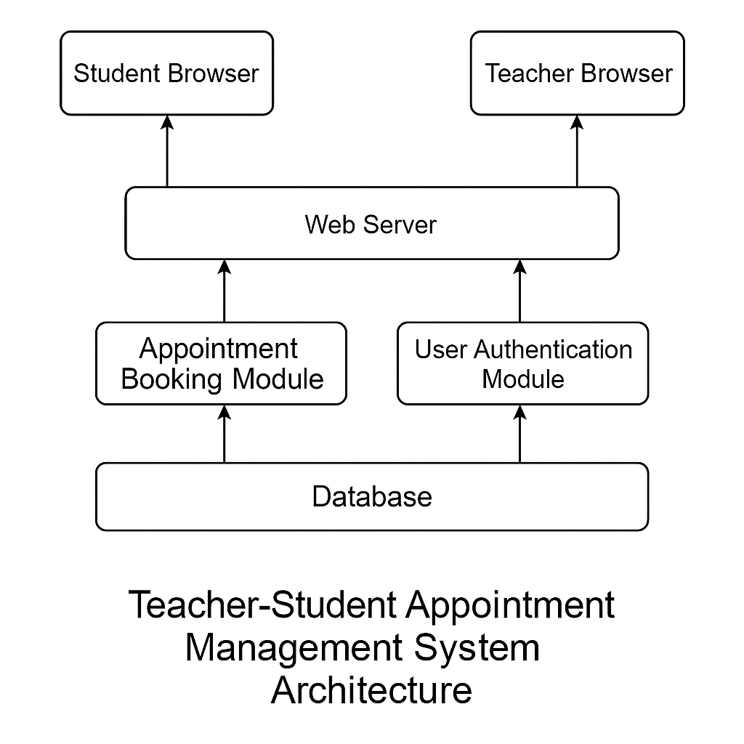

14. UI/ Webpage/ Screenshots

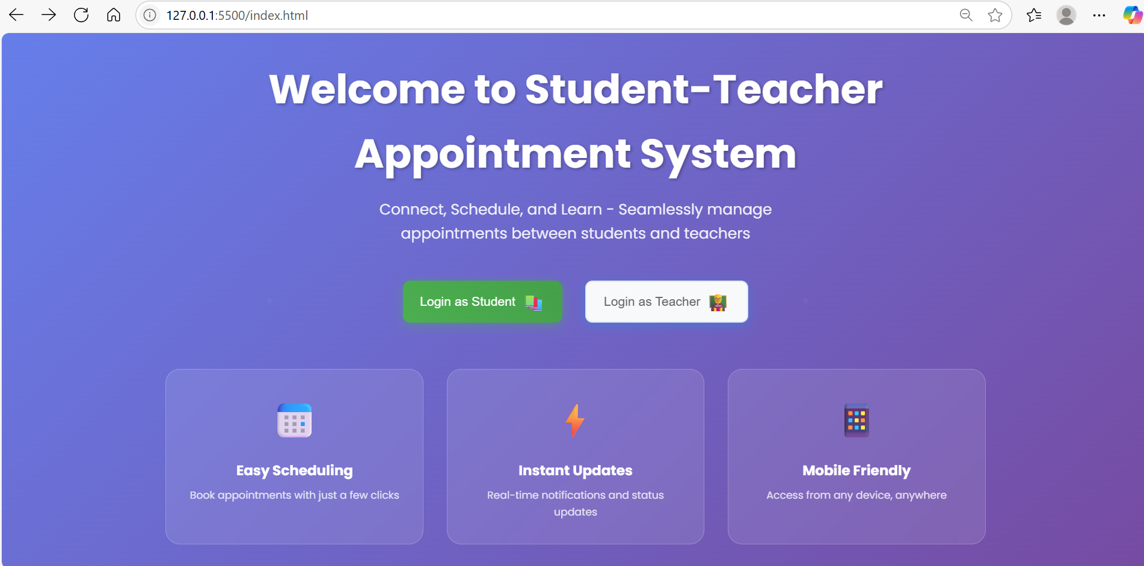
Teacher Login Page :
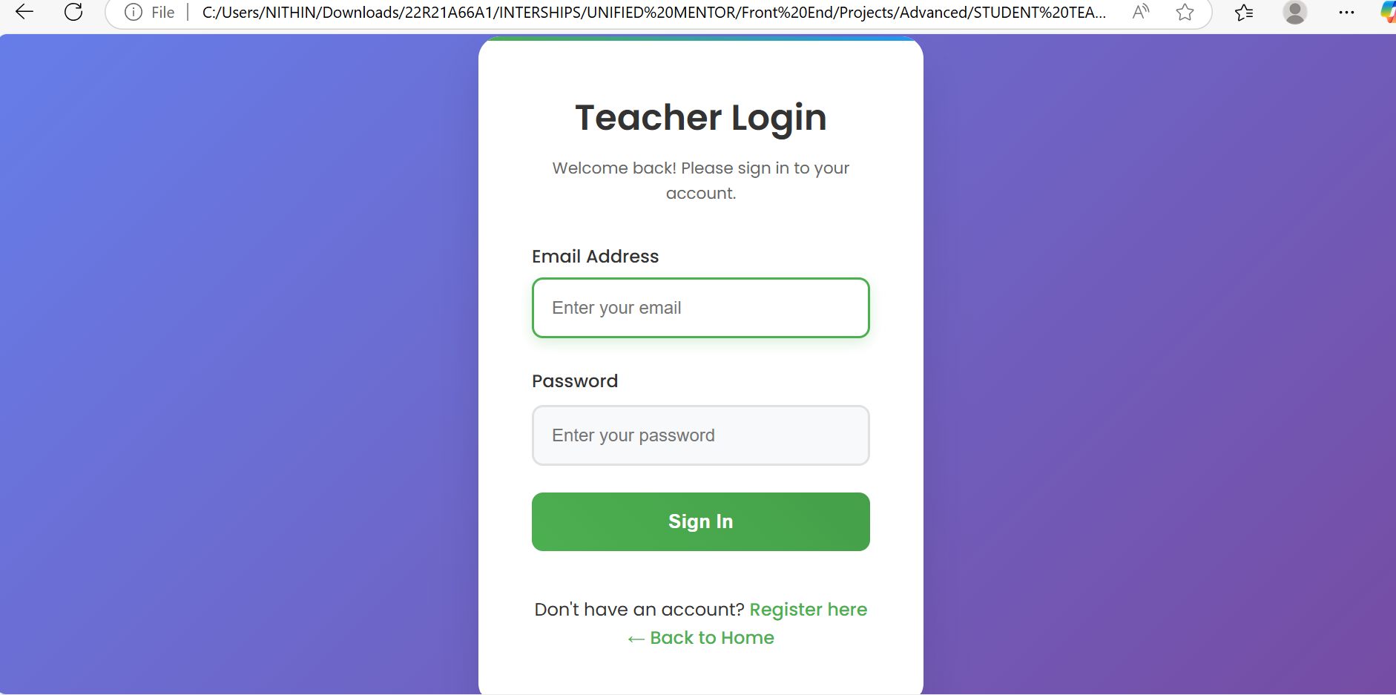
Teacher Portal :
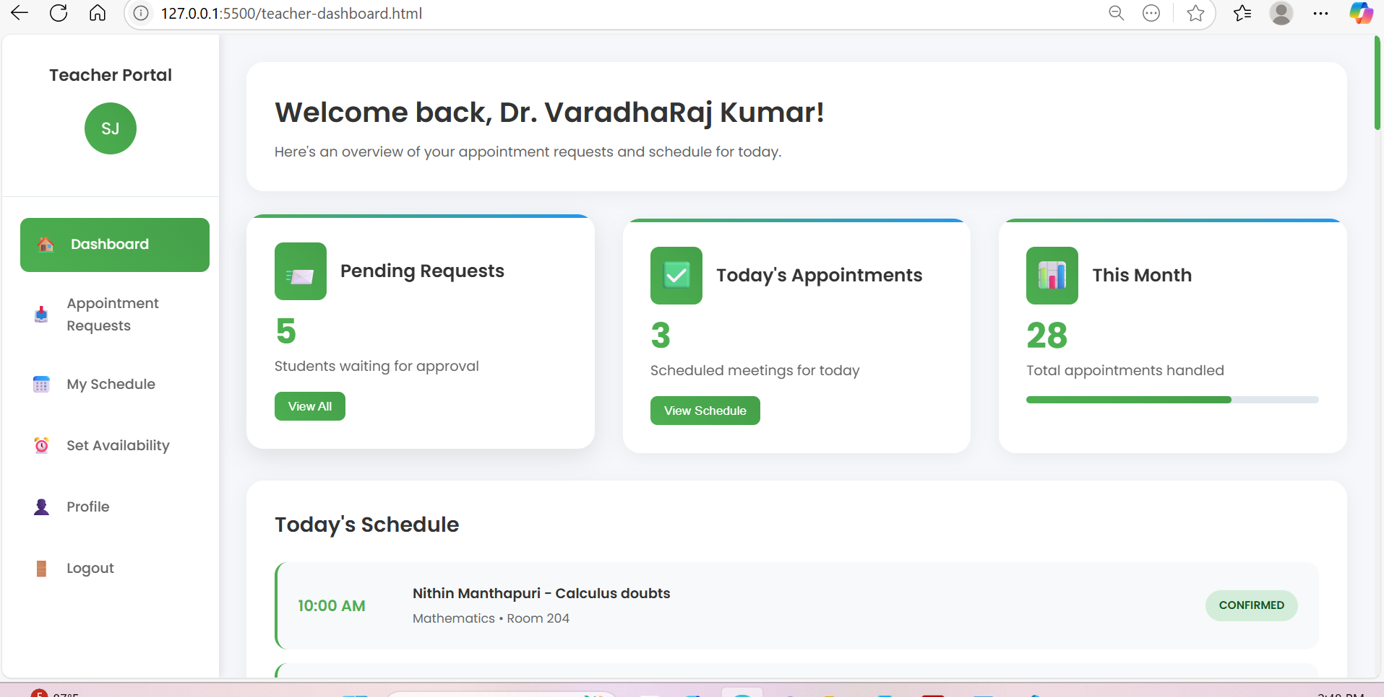

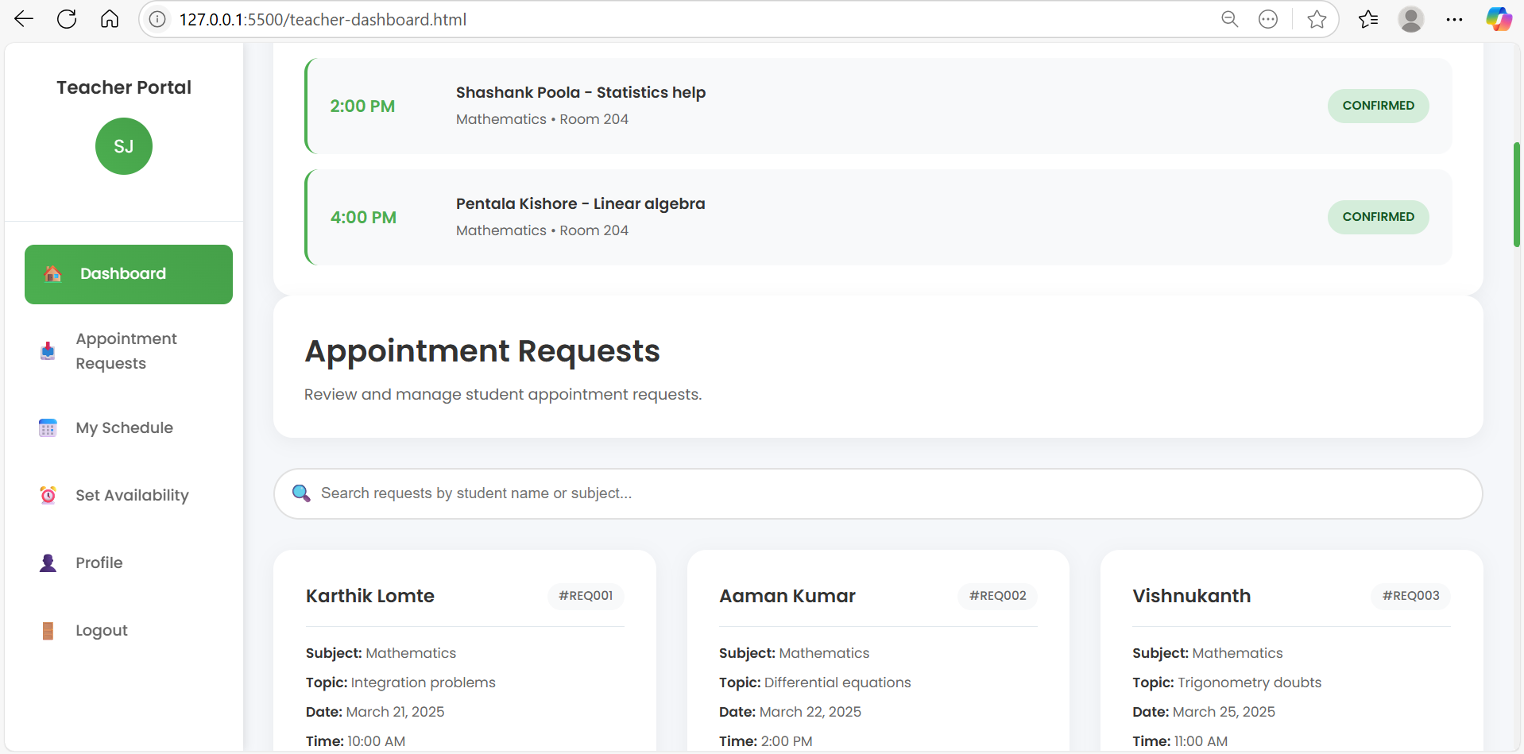

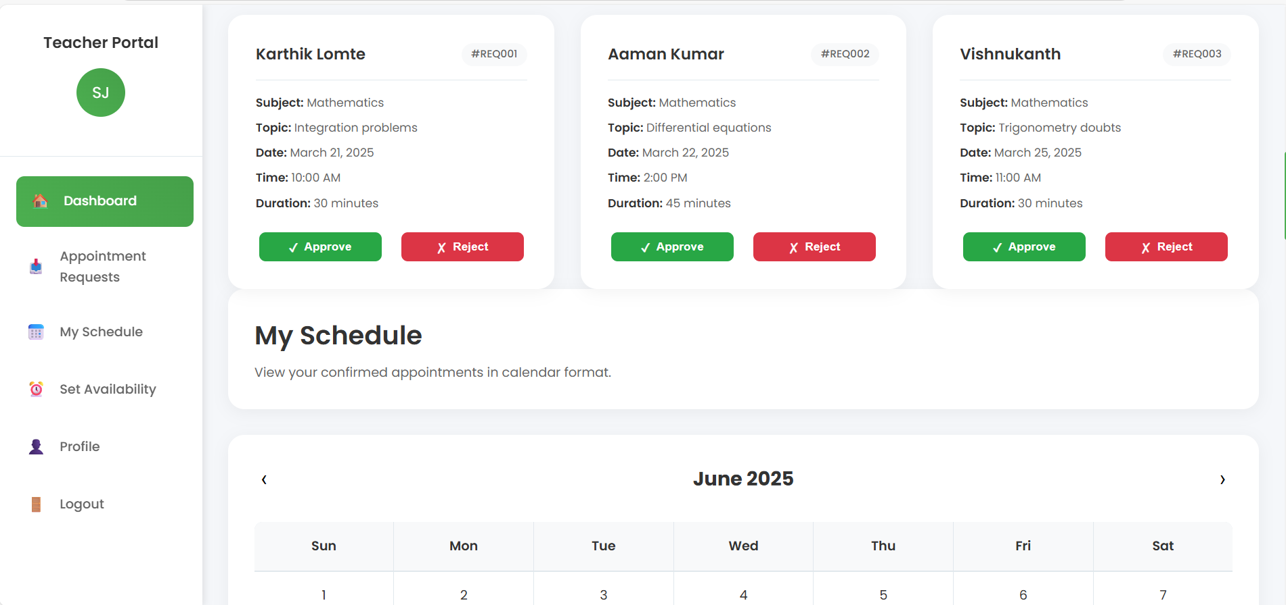

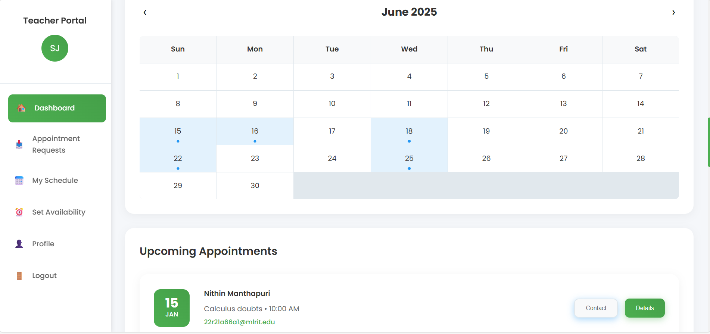

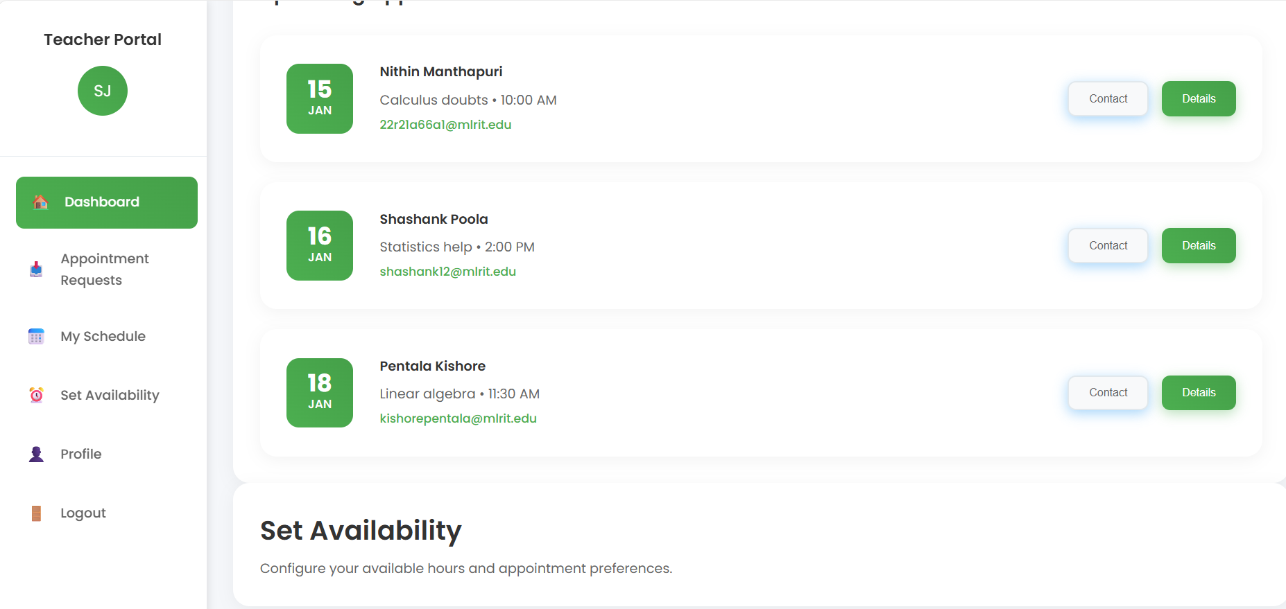

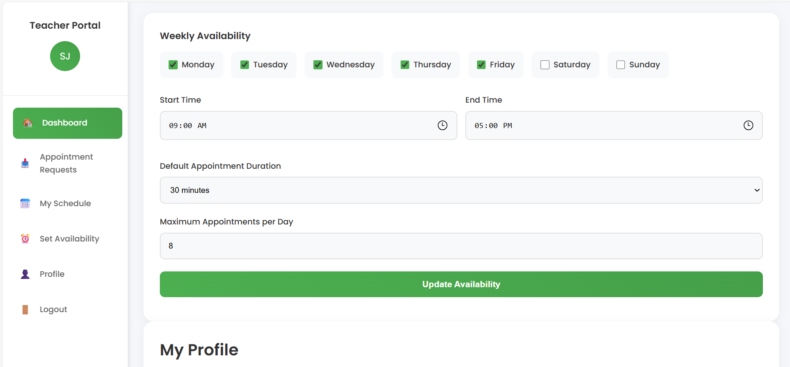

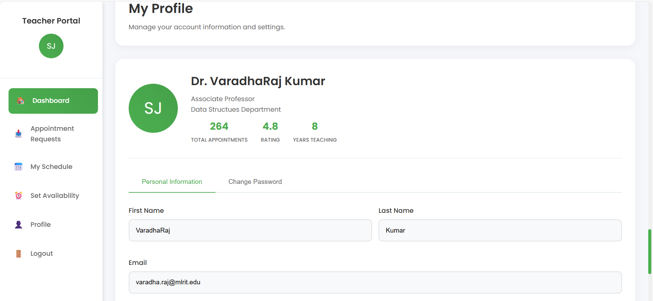

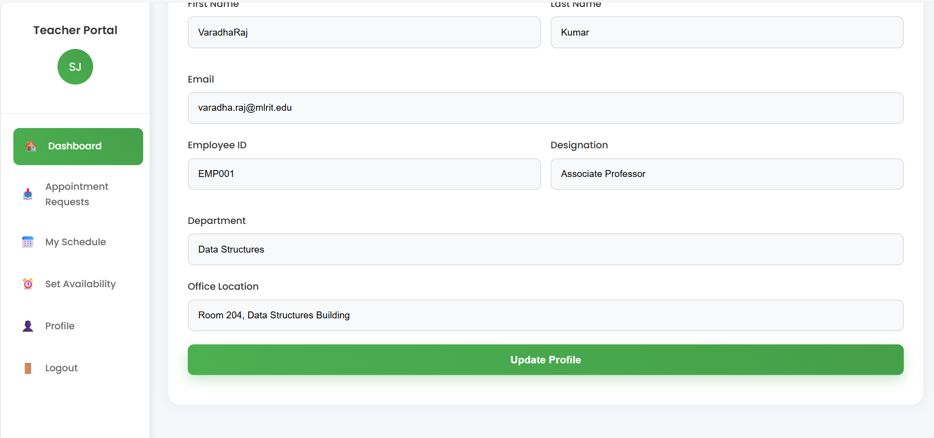
Student Login Page :
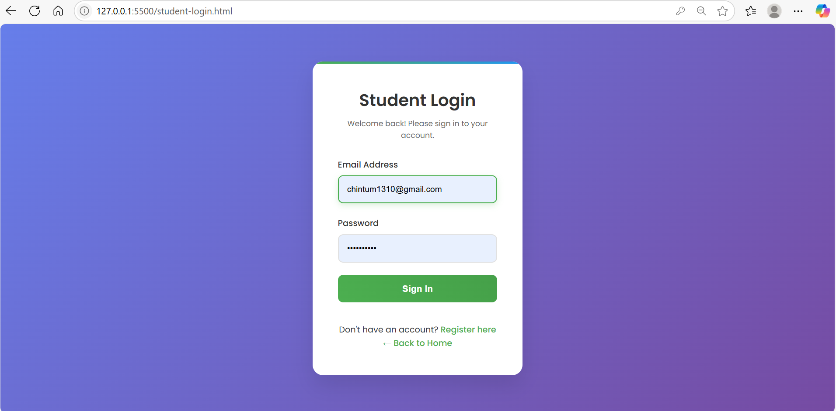
Student Portal :
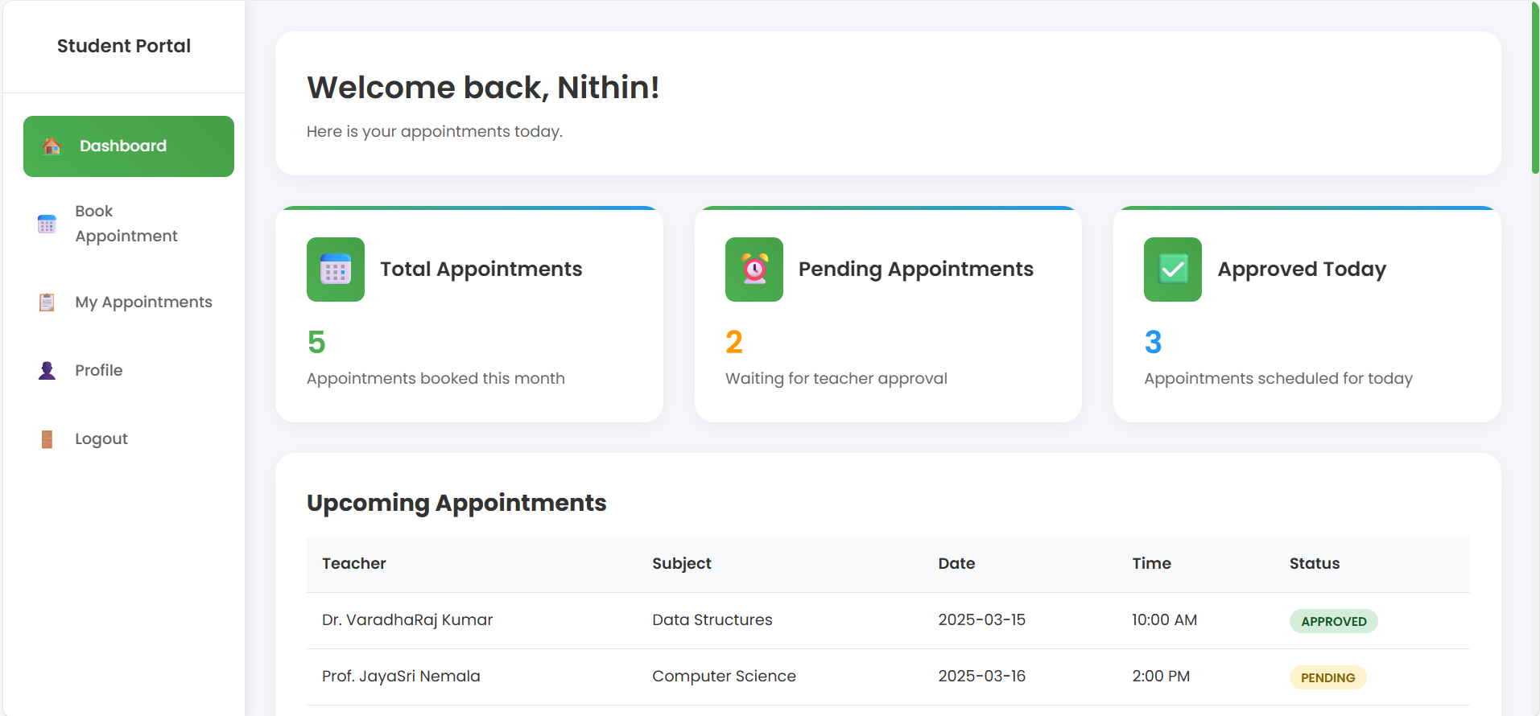

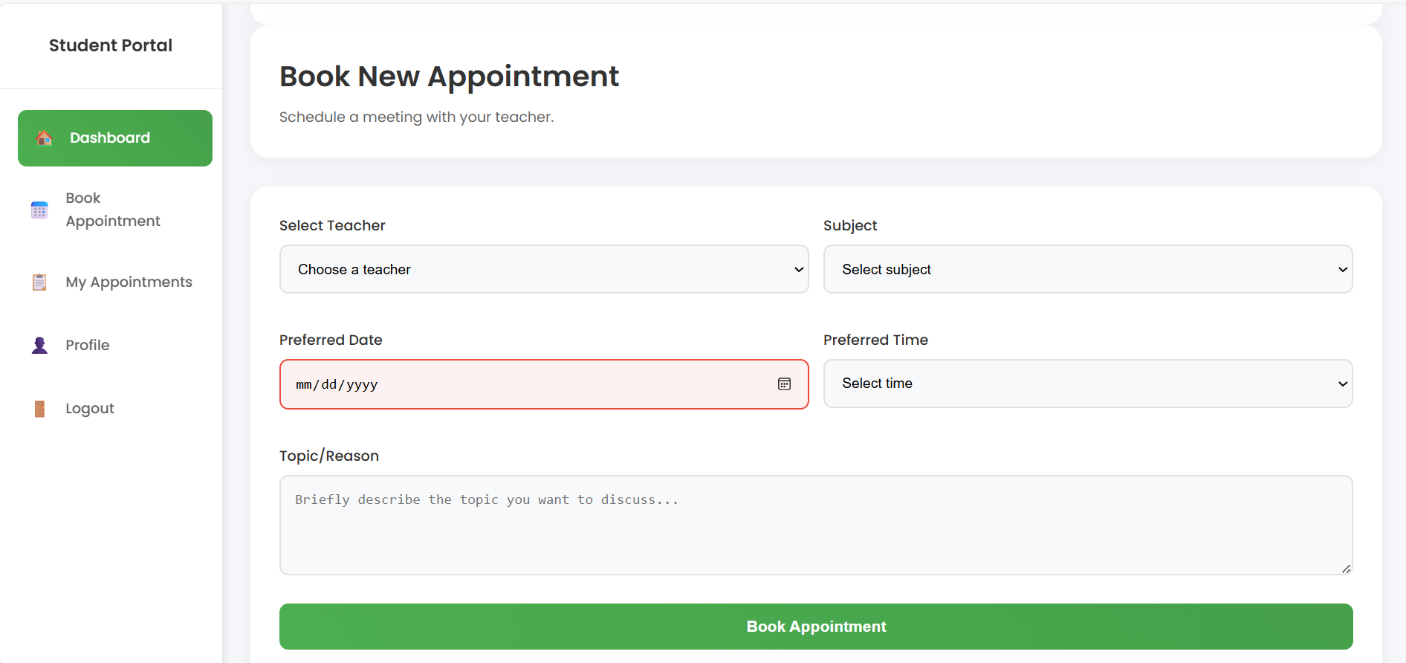

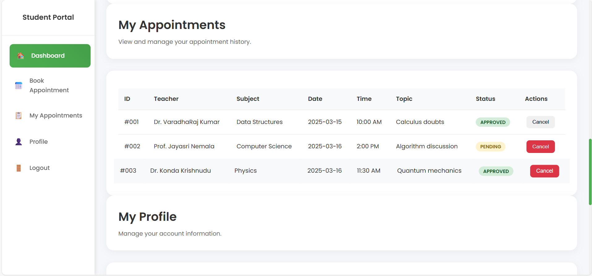

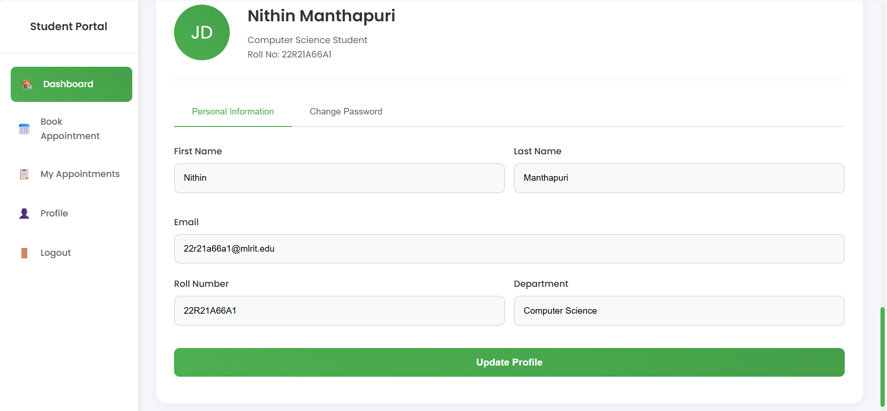

15. Conclusion
This project delivers a comprehensive and polished front-end system for academic appointment management. The modular and responsive approach ensures ease of use and can be extended into a full-stack deployment.

