Nithin S
221IT085

IT150 Lab Assignment

Q1.Write, save, compile and run the HelloWorld program in JAVA.

Code

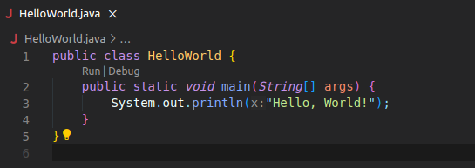
Output

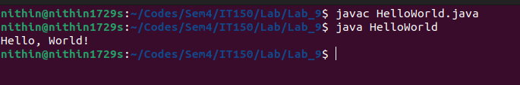

Q2.Write a JAVA program to display default value of all primitive data type of JAVA

Code
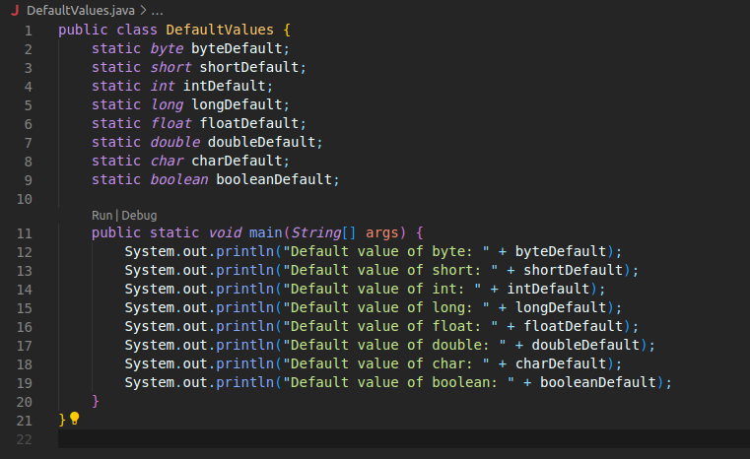

OUTPUT

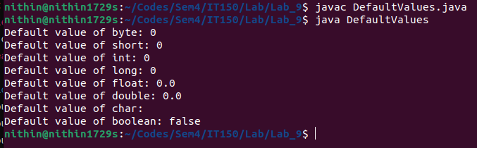

Q3.Write a JAVA program to Calculate Sum & Average of an Array

Code
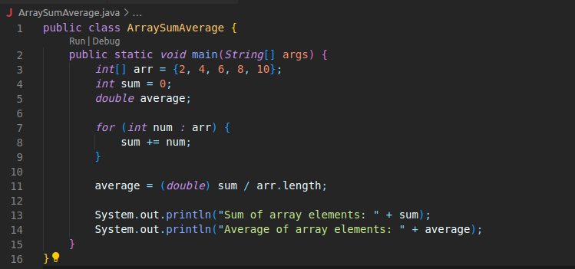

OUTPUT

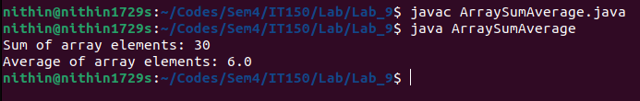

Q4.Write a program named ShoppingList:
a. that prints a shopping list, where each item to buy resides on its own line.
b. that prints a shopping list, where each item to buy is separated from another with a
comma.

Code

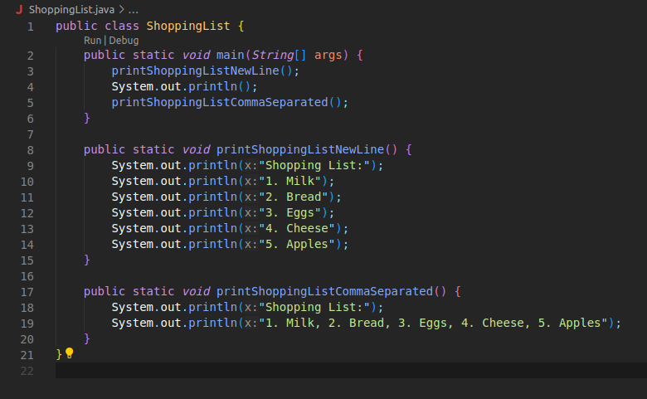

OUTPUT

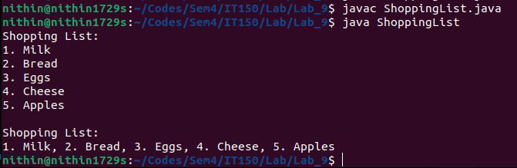

Q6.Write a JAVA program to create a three-dimensional array named cube with dimensions 4x5x6.
Initialize the elements using nested loops and finally access and print the elements using three
levels of nested loops.

CODE
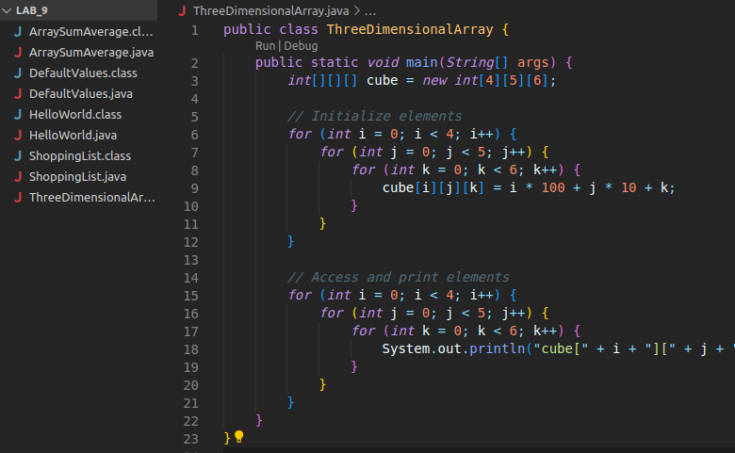

OUTPUT

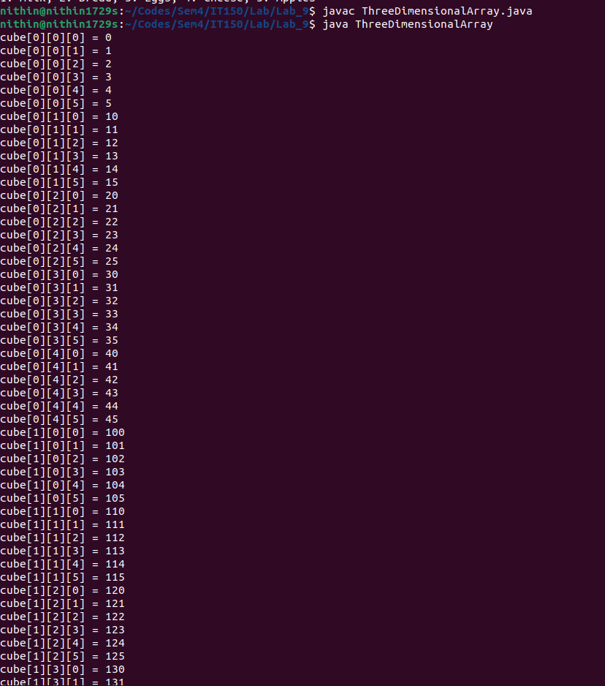

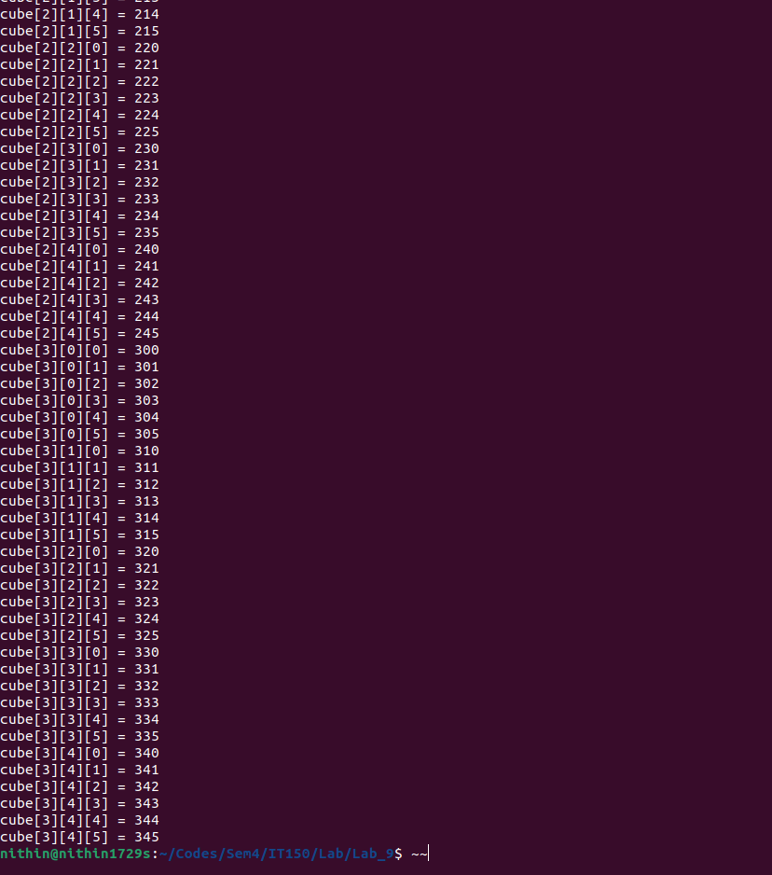

Q7.Write a Java application that prompts the user for side length of a square and uses a method
called SquareArea to calculate the area of the square and uses a method SquarePerimeter to
calculate the perimeter of the square.
a) In the above program declare the side length with ‘a’ and create multiple objects
to create the area and perimeter of the square.
b) Create a Rectangle class equivalent to the Square class created as above. Before
coding the class, decide which variables and methods this class must have.
c) Create a class called TestQuadrilaters that prints the details of a square and a
rectangle

CODE

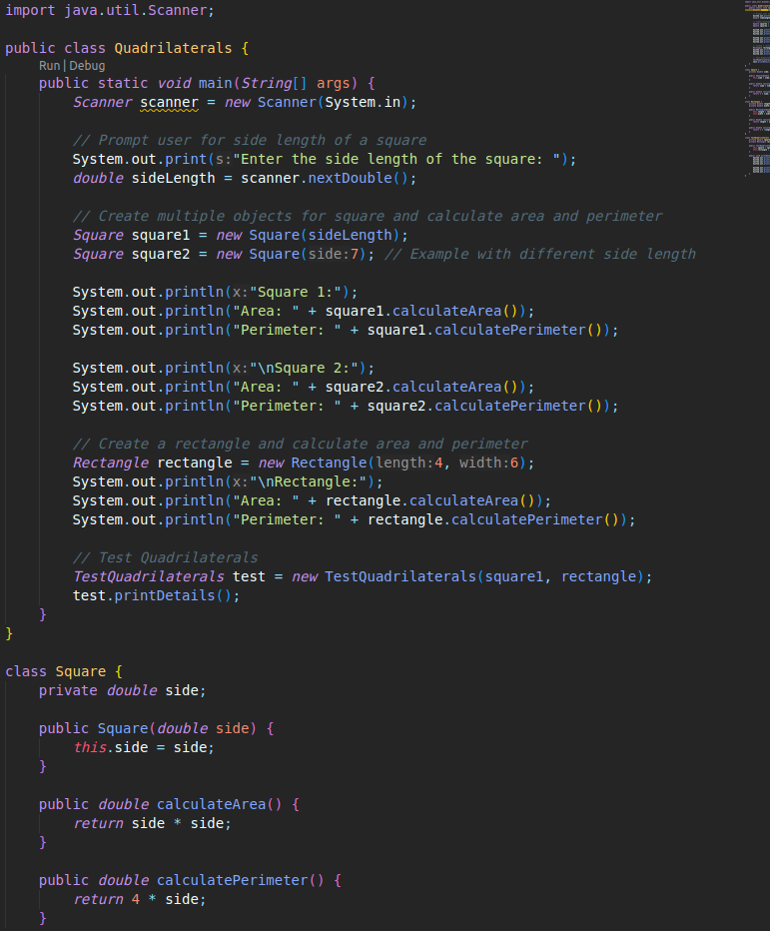

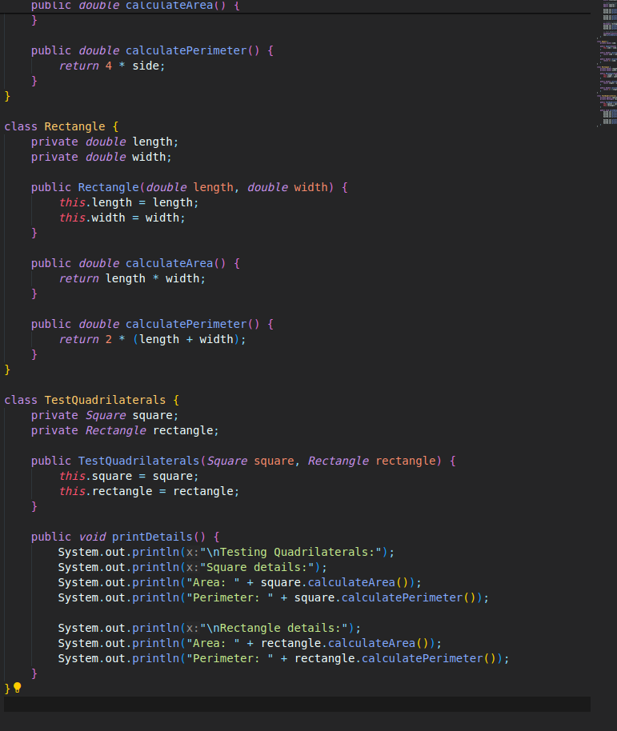

OUTPUT

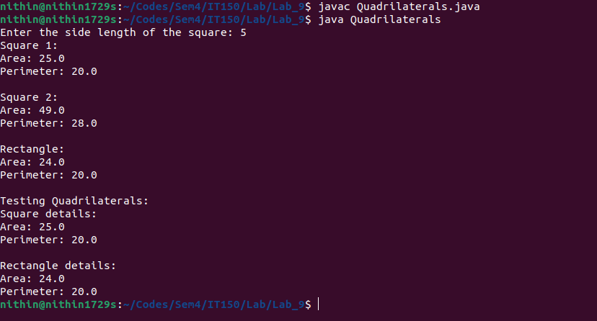

Q8.Write a JAVA program to create a Mydetails with data members Roll no, name and department.
The constructor Mydetails () should initialize the Roll no, name and the department. The member
function display() should display the values of Roll no, name and the department. In the main()
method, an object ‘m’ of class Mydetails to be created with values 1010,”xxx” and “xxdeptxx”.
Then the display() method should be called

CODE

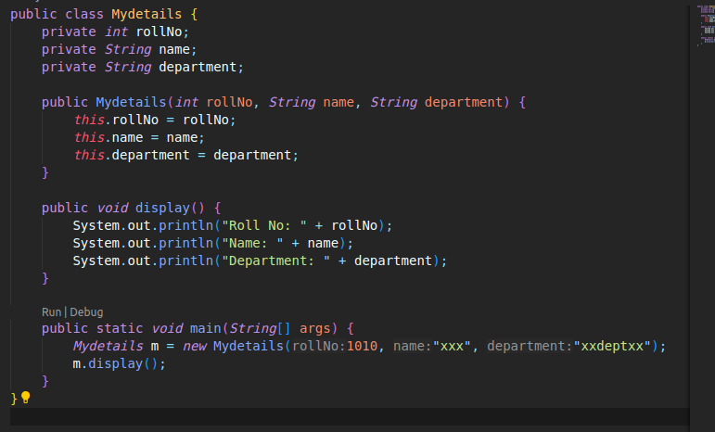

OUTPUT

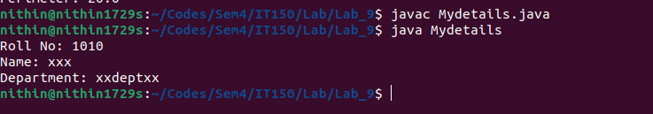

Q5. Create a new JAVA file named SayMyName that prints out your name as in the following
example:

Code

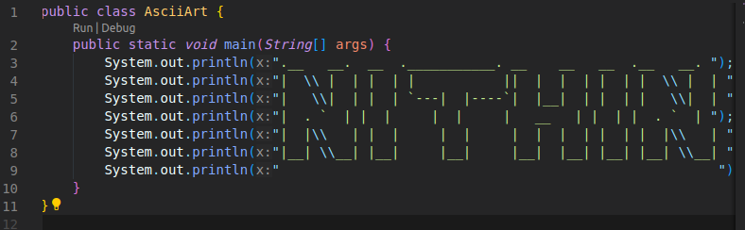
OUTPUT

