Nithin S
221IT085

IT301 Lab Assignment 1

Note: My System has 6 cores , so default no of threads is 12.

Q1. Write an Open MP program to print Hello World by setting the required number of threads using the Environment Variable in the program.

Code :

#include<stdio.h>
#include<omp.h>
int main()
{
#pragma omp parallel
printf("Hello World\n");
return 0;
}

Output :
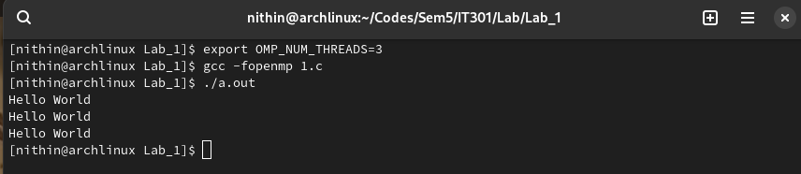
Analysis : This OpenMP code prints "Hello World" multiple times, once for each thread in a parallel region. The number of lines printed depends on the number of threads used, which defaults to the number of available CPU cores.

Q2. Write a simple OpenMP program to print Hello World by adding
appropriate clause to the parallel directive in order to set the number of
threads

Code :

#include<stdio.h>
#include<omp.h>
int main()
{
#pragma omp parallel num_threads(3)
printf("Hello World\n");
return 0;
}

Output :

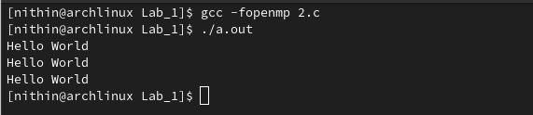

Analysis : This OpenMP code prints "Hello World" three times. The `#pragma omp parallel num_threads(3)` directive creates a parallel region with exactly 3 threads, so the `printf` statement is executed by each of the 3 threads.

Q3. Demonstrate the shared variable concept using a simple OpenMP
program.

Code :

#include <stdio.h>
#include <omp.h>

void main() {
int var =98;

#pragma omp parallel default(none) shared(var)
{
printf("Value of var: %d\n", var);
}
}

Output:
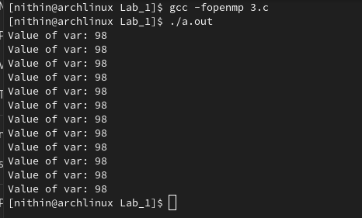

Analysis:

This OpenMP code prints the value of var in a parallel region:

#pragma omp parallel default(none) shared(var): Creates a parallel region with var shared among all threads. The default(none) clause ensures that all variables must be explicitly specified as shared or private.

The printf statement prints the value of var from each thread. Since var is shared, all threads see the same value, which is 98.
The output will show "Value of var: 98" multiple times, depending on the number of threads which is 12 in my case.

Q4. Demonstrate the fork-join parallel execution model in an OpenMP
program.

Code:

#include<stdio.h>
#include<omp.h>
int main()
{
printf("Before: Total no of threads: %d\n",omp_get_num_threads());
#pragma omp parallel
{
printf("Thread id is %d\n",omp_get_thread_num());
}
printf("After: Total no of threads: %d\n",omp_get_num_threads());
return 0;
}

Output:

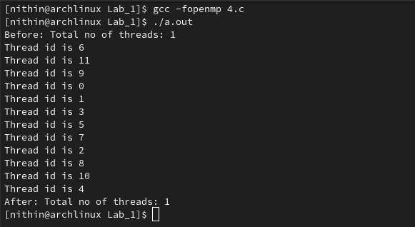

Analysis:

This OpenMP code prints thread information:

- `omp_get_num_threads()` before and after the parallel region will show `1` because it's called outside the parallel region.
- Inside the parallel region, `omp_get_thread_num()` prints each thread's ID, forking to generate threads.
- After parallel region all threads join together.
- The number of threads used defaults to the number of CPU cores unless set otherwise.

Q5. Write an OpenMP program to extract the thread identifiers from total number of threads using private clause.

Code :

#include<stdio.h>
#include<omp.h>
int main()
{
int tid;
#pragma omp parallel private(tid)
{
tid=omp_get_thread_num();
printf("Thread no %d from total %d threads\n",tid,omp_get_num_threads());
}
return 0;

}

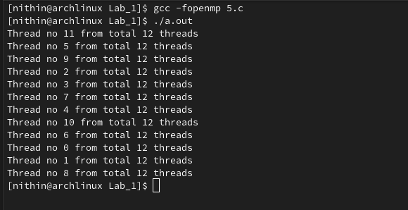
Output:

Analysis

This code uses OpenMP to create a parallel region where each thread prints its thread number (`tid`) and the total number of threads. The `private(tid)` directive ensures that each thread has its own private copy of the `tid` variable, avoiding conflicts. The `omp_get_thread_num()` function retrieves the thread number, while `omp_get_num_threads()` returns the total number of threads in the parallel region.

Q6. Write an OpenMP program to set the number of OpenMP threads and retrieve the thread ID number at runtime.

Code :

#include<stdio.h>
#include<omp.h>
int main()
{
#pragma omp parallel num_threads(3)
{
printf("Thread ID: %d\n",omp_get_thread_num());
}
return 0;
}

Output :

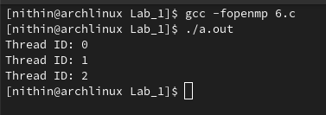

Analysis:

This code uses OpenMP to create a parallel region with exactly 3 threads (`num_threads(3)`). Each thread prints its thread ID using `omp_get_thread_num()`. The output shows the thread ID for each of the three threads executing concurrently.

Q7. Write a simple OpenMP program to demonstrate the parallel loop
construct.

Code:

#include <stdio.h>
#include <omp.h>

int main()
{
int num_procs = omp_get_num_procs();
printf("Number of processors available: %d\n", num_procs);

omp_set_num_threads(4);

#pragma omp parallel
{
#pragma omp for
for (int i = 0; i < 8; i++) {
int thread_id = omp_get_thread_num();
printf("Thread %d: Hello World\n", thread_id);
}
}

printf("Number of threads used: %d\n", omp_get_num_threads());

if (omp_in_parallel()) {
printf("Currently in a parallel region.\n");
} else {
printf("Not in a parallel region.\n");
}

int dynamic_enabled = omp_get_dynamic();
printf("Dynamic threads enabled: %d\n", dynamic_enabled);

int nested_enabled = omp_get_nested();
printf("Nested parallelism enabled: %d\n", nested_enabled);

return 0;
}

Output:

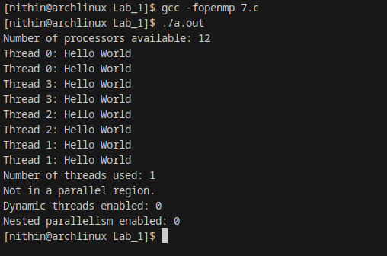

Analysis :

It first retrieves and prints the number of processors available using omp_get_num_procs().
It sets the number of threads to 4 with omp_set_num_threads(4).
Inside the parallel region, a loop is divided among the threads using #pragma omp for, with each thread printing its ID and "Hello World."
After the parallel region, it prints the number of threads used and checks if the code is currently in a parallel region using omp_in_parallel().
Finally, it checks and prints the status of dynamic thread adjustment and nested parallelism using omp_get_dynamic() and omp_get_nested().

Q8. Write a simple OpenMP program to illustrate the usage of shared clause.

Code:

#include <stdio.h>
#include <omp.h>

int main() {
int sharedVar=0;
#pragma omp parallel shared(sharedVar)
{
#pragma omp critical
{
printf("Thread no %d : sharedVar = %d\n",omp_get_thread_num(),sharedVar++);
}
}

return 0;
}

Output:

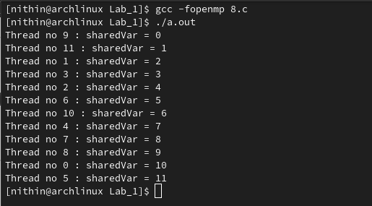

Analysis:

This code demonstrates the use of OpenMP's #pragma omp critical to safely update and print a shared variable (sharedVar) in a parallel region. The sharedVar is accessible by all threads, but the #pragma omp critical section ensures that only one thread at a time can increment and print the variable, preventing race conditions. Each thread prints its ID and the current value of sharedVar, then increments it.

Q9. Demonstrate the use of private clause in a simple OpenMP program.

Code:

#include<stdio.h>
#include<omp.h>
int main()
{
int tid;
int pVar;
#pragma omp parallel private(tid,pVar)
{
tid=omp_get_thread_num();
pVar=0;
if(tid==0){
pVar++;
}
printf("Thread no %d: pVar is %d\n",tid,pVar);
}
return 0;

}

Output:
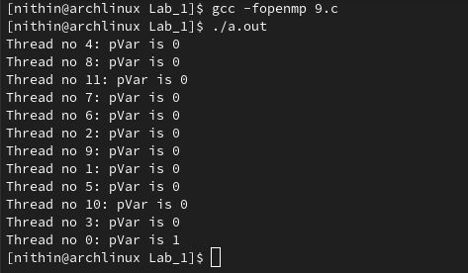

Analysis:

This code uses OpenMP to create a parallel region where each thread has its own private copies of tid and pVar due to the private(tid, pVar) directive. Each thread initializes pVar to 0 and retrieves its thread ID using omp_get_thread_num(). If the thread ID is 0, pVar is incremented by 1. Then, each thread prints its ID and the value of pVar. Since pVar is private, the value is 1 only for thread 0 and remains 0 for all other threads.

Q10. Write a simple OpenMP program that uses if clause to get the desired output.

Case 1 :

Code:

#include<stdio.h>
#include<omp.h>
int main()
{
int isParallel=0;
#pragma omp parallel if(isParallel==1) num_threads(4)
{
printf("Hello\n");
}
return 0;
}

Output:

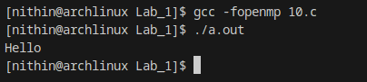

Case 2:

Code:

#include<stdio.h>
#include<omp.h>
int main()
{
int isParallel=1;
#pragma omp parallel if(isParallel==1) num_threads(4)
{
printf("Hello\n");
}
return 0;
}

Output:

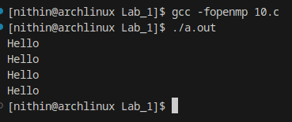

Analysis:

This code uses OpenMP to conditionally create a parallel region based on the value of `isParallel`. Here’s how the code behaves in two cases:

**Case 1: `isParallel = 0`**
- The `if(isParallel==1)` condition is false, so the `#pragma omp parallel` directive is ignored.
- The code runs sequentially in a single thread, printing "Hello" only once.

**Case 2: `isParallel = 1`**
- The `if(isParallel==1)` condition is true, so a parallel region is created with 4 threads (`num_threads(4)`).
- Each of the 4 threads prints "Hello," resulting in "Hello" being printed four times, each potentially by a different thread.

In summary:
- **Case 1**: The code runs sequentially and prints "Hello" once.
- **Case 2**: The code runs in parallel with 4 threads, each printing "Hello."

