Nithin S
221IT085

IT301 Lab Assignment 3

Q1.Write an OpenMP program to demonstrate default clause (default: shared) in parallel directive. Observe the results and analyze it.

Code

#include <omp.h>
#include <stdio.h>

int main() {
int x = 10;
#pragma omp parallel default(shared)
{
int tid = omp_get_thread_num();
printf("Thread %d: x = %d\n", tid, x);
}
#pragma omp parallel default(none) private(x)
{
int tid = omp_get_thread_num();
x = tid; // each thread has its own x
printf("Thread %d: x = %d\n", tid, x);
}

return 0;
}

Output
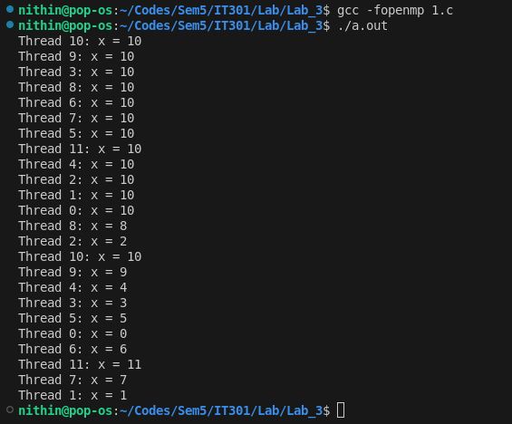

Analysis

In OpenMP, the default clause is used to specify the default data-sharing attributes of variables in parallel regions. When you create a parallel region using the #pragma omp parallel directive, each variable used within the parallel region can either be shared among all threads or private to each thread. The default clause allows you to control how OpenMP treats variables by default if you don't explicitly specify their data-sharing attributes.

In the first parallel region (default(shared)), x is shared among all threads, so each thread prints the same value of x.
In the second parallel region (default(none)), x is declared private, so each thread has its own instance of x, and the printed value is different for each thread.

Q2. Demonstrate the usage of lastprivate() clause in a parallel directive in an OpenMP program. Write your observation

Code

#include <omp.h>
#include <stdio.h>

int main() {
int i;
int sum = 0;

#pragma omp parallel for lastprivate(sum)
for (i = 0; i < 10; i++) {
sum = i;
printf("Thread %d: i = %d, sum = %d\n", omp_get_thread_num(), i, sum);
}

printf("After parallel region: sum = %d\n", sum);
return 0;
}

Output

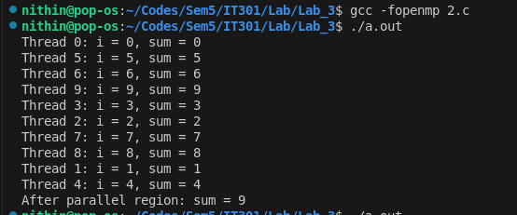

Analysis

The lastprivate clause in OpenMP is used to ensure that the value of a variable after the parallel region corresponds to the value of the variable from the last iteration of the loop executed by any thread. This can be useful in scenarios where you need to preserve the final value of a variable after parallel execution.

Within the Parallel Region: The value of sum varies based on which thread is executing which iteration. The threads execute different iterations in a non-deterministic order.

After the Parallel Region: The value of sum is 9, which is the value of the variable from the last iteration of the loop (i = 9). This demonstrates that the lastprivate clause successfully updated sum with the value from the last iteration of the loop executed by any thread.

Q3. Write an OpenMP program to demonstrate sharing of
section work by performing arithmetic operations on one
dimensional array by threads.

Code

#include <omp.h>
#include <stdio.h>

int main()
{
int n = 10;
int arr[] = {1, 2, 3, 4, 5};

#pragma omp parallel
{
#pragma omp single
{
#pragma omp critical
{
for (int i = 0; i < 5; i++)
{
arr[i] *= 2;
}
printf("\nThe first section was executed by thread no %d", omp_get_thread_num());
}
}

#pragma omp sections
{
#pragma omp section
{
#pragma omp critical
{
for (int i = 0; i < 5; i++)
{
arr[i] += 2;
}
printf("\nThe second section was executed by thread no %d", omp_get_thread_num());
}
}
}
}

printf("\nFinally the array looks like this: ");
for (int i = 0; i < 5; i++)
{
printf("%d ", arr[i]);
}
printf("\n");

return 0;
}

Output

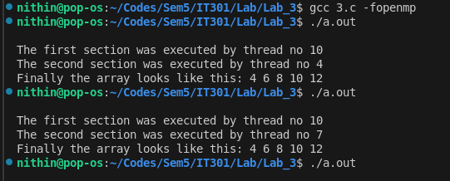
Analysis

There are two sections in this code. Each section will be executed by different threads. The first section will be executed first because the single clause is used. Later the second section will be executed by a different thread. You can see which thread is executing which section in the output screenshot. The critical clause is used to avoid race conditions.

Q4. Write an OpenMP program to demonstrate reduction
clause in a parallel directive. Write your observation.

Code

#include <omp.h>
#include <stdio.h>

int main() {
int arr[]={1,2,3,4,5,6,7,8,9,10};
int sum = 0;

#pragma omp parallel for reduction(+:sum)
for (int i = 0; i < 10; i++) {
sum += arr[i];
}

printf("Sum = %d\n", sum);
return 0;
}

Output
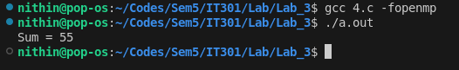
Analysis

The reduction clause in OpenMP is used to handle the situation where multiple threads need to update a shared variable without causing race conditions. It performs a reduction operation on variables in parallel, meaning it combines values from different threads into a single result

The reduction(+:sum) clause tells OpenMP to perform a summation reduction on the sum variable.
Each thread will calculate a partial sum using its own private copy of sum.
After the parallel region, these partial sums are combined into the final value of sum.

Q5. Write a parallel program to find the minimum number in a given array. Use ‘for’ directive for the same along with
reduction clause. Write the code, execution results and
your observation.

Code

#include <omp.h>
#include <stdio.h>

int main() {
int array[]={100,12,34,56,78,9,3,-12};
int min_val = 1e9;

#pragma omp parallel for reduction(min:min_val)
for (int i = 0; i < 8; i++) {
if (array[i] < min_val) {
min_val = array[i];
}
}

printf("Min value = %d\n", min_val);
return 0;
}

Output

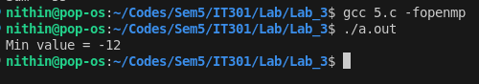

Analysis

The reduction(min:min_val) clause specifies that we want to find the minimum value of min_val across all threads.
Each thread updates its own private copy of min_val.
After the parallel region, OpenMP combines these private values to compute the final minimum value.

