Nithin S
221IT085

IT302 Lab Assignment 1

Q1. Consider a set of integers from 1 to 100. Write a R/Python code to find the probability that the selected number is :

(a) Even

Code

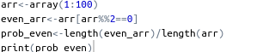

Output

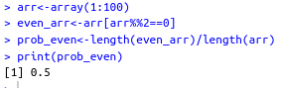

(b) Odd

Code

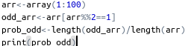

Output
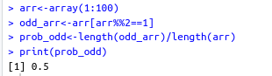

(c) Prime

Code
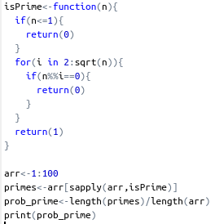

Output

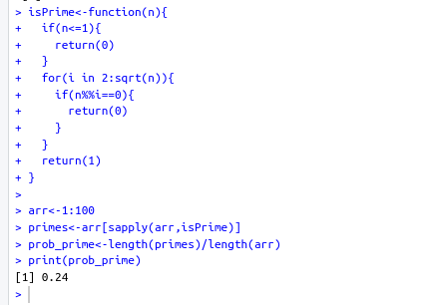

(d) Divisible by 4 and 6

Code
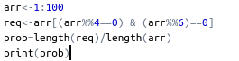

Output
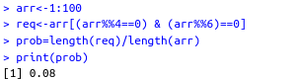

Q2. Suppose a fair dice is rolled 10 times. Using R/Python find the probability that

(a) sum of the numbers is less than 22

