Nithin S
221IT085

IT302 Lab Assignment 2

Q1. Suppose that a random variable X represents the daily percentage change in the stock price of a certain company. The probability distribution of X is given by
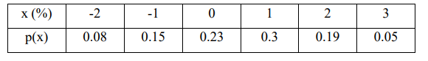
(a) The mean of the random variable X.

Code

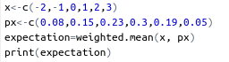

Output

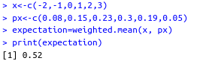

(b) The variance and standard deviation of the random variable X.

Code

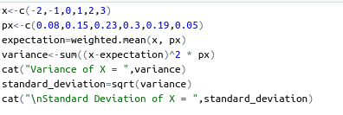

Output

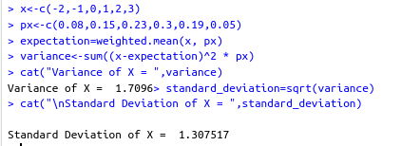

(c) The probability that the stock price increases by at least 1%

Code

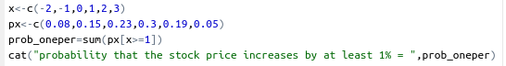
Output
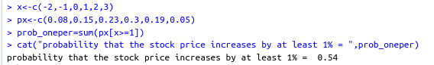

(d) The probability that the stock price changes (increases or decreases) by less than 2%

Code
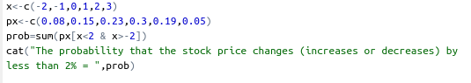
Output

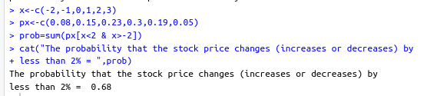

Q2. A car hire firm has two cars which it hires out every day. The number of demands for a car on each day is Poisson random variable with an average of 1.5. Find the percentages of days on which

(a) Neither car is hired?

Code
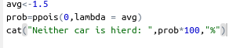

Output
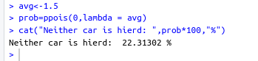

(b) Some demand is refused?

Code

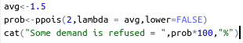

Output

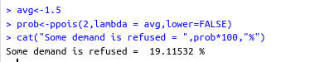

(c) Plot the histogram of the corresponding distribution.

Code
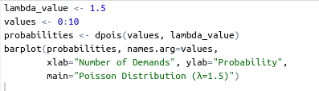

Output

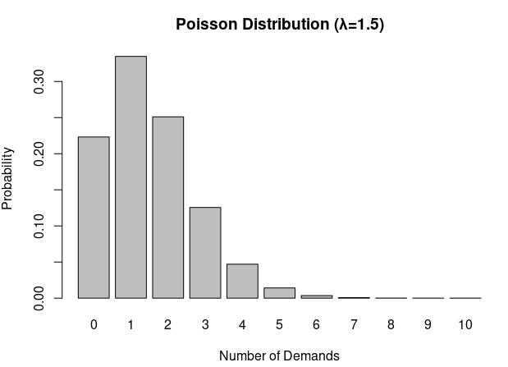

Q3. Let X be a continuous random variable having p.d.f

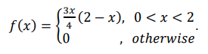

Using R/Python, find
(a) Cumulative distribution function (c.d.f.) of X.

Code

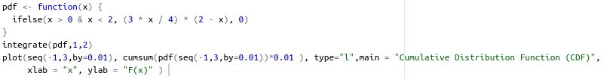
Output
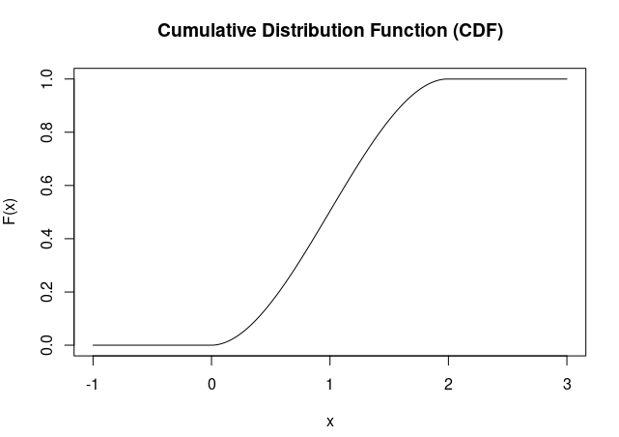

(b) Mean of X

Code

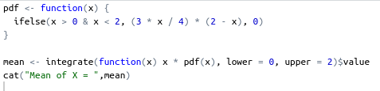

Output

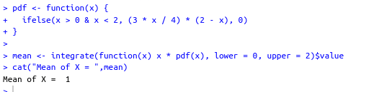
(c) Variance of X

Code

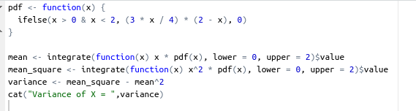
Output

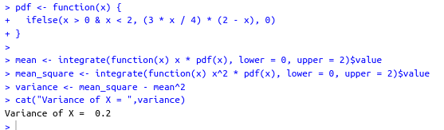

(d) Plot the p.d.f. function of the distribution.

Code

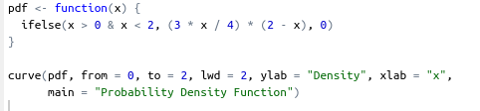

Output

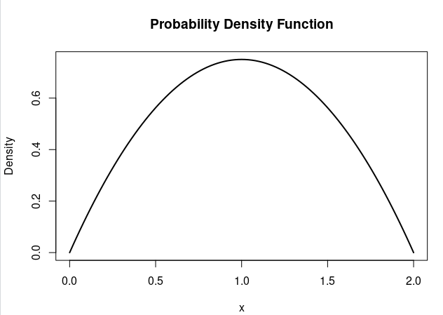

Q4. A new surgical procedure is said to be successful 80% of the time. Suppose the operation is performed five times and the results are to be independent of one another. Write a R/Python code to find the probability that

(a) All five operations are successful.

Code
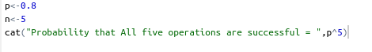

Output
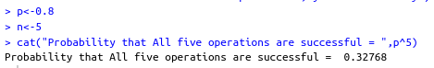

(b) Exactly four are successful.

Code
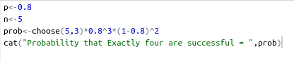

Output
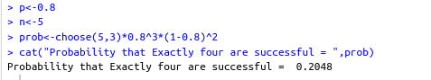

(c) Less than two are successful

Code
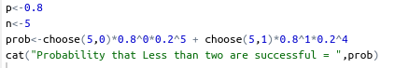

Output
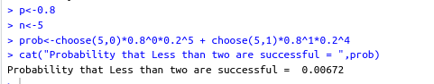

(d) Plot the histogram of the corresponding distribution.

Code
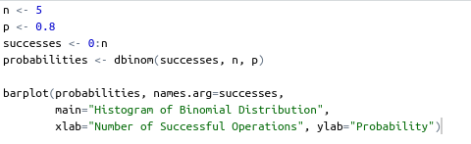

Output

