IT204 Mini Project

Visual Hand Gesture Recognition
with
Convolutional Neural Network
(CNN)

The Cited Paper:

M. Han, J. Chen, L. Li and Y. Chang, "Visual hand gesture
recognition with convolution neural network," 2016 17th
IEEE/ACIS International Conference on Software Engineering,
Artificial Intelligence, Networking and Parallel/Distributed
Computing (SNPD), Shanghai, China, 2016, pp. 287-291, doi:
10.1109/SNPD.2016.7515915.

Submitted By :
Nithin S [ 221IT085 ]

Abstract

In the era of human-computer interaction, gesture recognition has emerged as a pivotal technology with vast applications ranging from sign language interpretation to immersive gaming experiences.

This mini project, conducted using Python programming language, aims to explore the domain of Hand Gesture Recognition through the utilization of Convolutional Neural Networks (CNN) on the Linux operating system, employing key libraries such as OpenCV, TensorFlow,Keras,Numpy and with the assistance of Google Teachable Machine.

Technologies Used :

- Linux Environment
- Python Programming Language
- CNN Architecture
- Open CV
- Tensorflow
- Keras
- Numpy
- Google Teachable Machine

Convolutional Neural Network

A Convolutional Neural Network (CNN) for hand gesture recognition processes hand gesture images through layers that detect features like edges and shapes (convolutional layers), reduces spatial dimensions (pooling layers), and learns complex patterns (fully connected layers) to classify the gestures into predefined categories.

Introduction

The physical movement of the human hand produces gestures, and hand gesture recognition leads to the advancement in automated vehicle movement system. In this paper, the human hand gestures are detected and recognized using convolutional neural networks (CNN) classification approach. This process flow consists of hand region of interest segmentation using mask image, fingers segmentation, normalization of segmented finger image and finger recognition using CNN Classifier.

The hand region of the image is segmented from the whole image using mask images. The adaptive histogram equalization method is used as enhancement method for improving the contrast of each pixel in an image. In this paper, connected component analysis algorithm is used in order to segment the finger tips from hand image. The segmented finger regions from hand image are given to the CNN classification algorithm which classifies the image into various classes. The proposed hand gesture detection and recognition methodology using CNN classification approach with enhancement technique stated in this paper achieves high performance with state-of-the-art methods.

Keywords:
- Hand gesture Recognition
- Fingers Segmentation

The machines capture the gestures from the human and recognize it for operating the machines. The gestures are different types of modes as static and dynamic. The static gestures do not change their position, while the machine is operated, and the dynamic gestures change their positions during the machine is operated

(Elmezain et al. 2010; Mitra and Acharya 2007). Hence, the identification or recognition of dynamic gestures is very important
than the static gestures (Yrk et al. 2006; Tauseef et al. 2009).

Initially, the camera, which is connected with machine, captures the
gestures which are generated by humans. The background of the detected gestures is removed, and the foreground of the gesture is captured. The noises in the foreground gesture are detected and removed by filtering techniques (Manresa-Yee et al. 2005). These noise removed gestures are compared with pre-stored and trained gestures for verifying the sign of the gestures. Figure 1 shows the diferent types of gestures which are generated by humans.
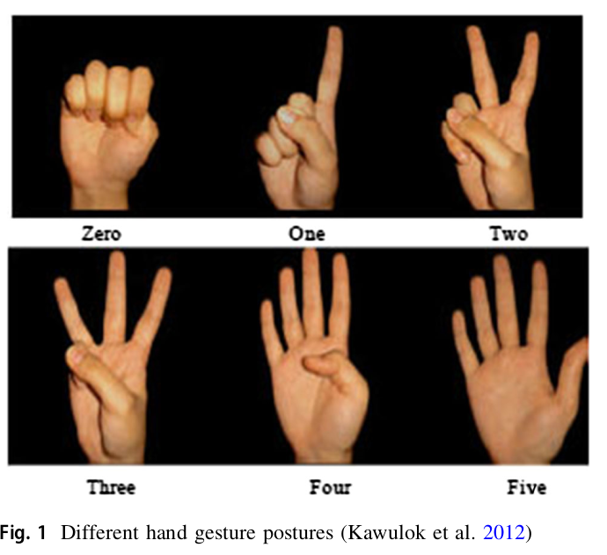

Fig 1: Different hand gesture postures (Kawulok et al. 2012)

It does not require high number of samples in training mode, and the complexity level of this algorithm is low. The novelty of
this proposed work is to implement deep learning algorithm in hand gesture recognition system with novel segmentation technique.

Literature Survey

Mengmeng Han (2018) proposed hand gesture recognition system using particle filtering approach. The authors applied this filtering approach on hand gesture images with same background.

The authors obtained 92.1% of sensitivity, 84.7% of specificity and 90.6% of accuracy. Chen and Lang (2017) extracted shape features from hand gesture image for the classification of hand gesture images into various classes. Then, these extracted features were trained and classified using k-means clustering algorithm. Marium et al. (2017) proposed hand gesture recognition system using convexity algorithm approach.

The authors applied this filtering approach on hand gesture images with same background. The authors obtained 90.7% of sensitivity, 82.1% of specificity and 87.5% of accuracy. The main limitation of this approach is that the proposed algorithm produced optimum results if the background of the hand gesture image is static. Ashfaq and Khurshid (2016) used Gabor filtering approach for converting the spatial domain format hand gesture image into multi-class domain format image.

Then, the authors applied both Bayesian and Naı̈ve Bayes classifier on Gabor transformed hand gesture image in order to classify the test hand gesture image into different classes. The authors obtained high level of classification accuracy on Naı̈ve Bayes classifier than the Bayesian classification methodology due to its simple architecture pattern.

Rahman and Afrin (2013) used support vector machine (SVM) classification approach for classifying the hand gesture images into various classes. The authors achieve 89.6% of sensitivity, 79.9% of specificity and 85.7% of accuracy.

The error rate was high in this method, and this is not suitable for fast moving background and foreground object images. Rao et al. (2009) developed hand gesture recognition system using hidden Markov model. The authors constructed Markov model for foreground fingers in hand gesture image.

This Markov model was used in both training and testing modes of binary classification approach. The authors produced 90.1% of sensitivity, 82.6% of specificity and 90.6% of accuracy. The classification time is high in this methodology as the mail limitation.

The following points are limitations of the conventional
methods for gesture recognition.
• Conventional gesture recognition method used SVM
and Naı̈ve Bayes classifier, which required high number
of training samples for gesture pattern recognition.
• The complexities of these algorithms are quite high in
nature.

Proposed Methodology

In this paper, the human hand gestures are detected and
recognized using CNN classification approach. This process flow consists of hand ROI segmentation using mask image, fingers segmentation, normalization of segmented finger image and finger recognition using CNN classifier.

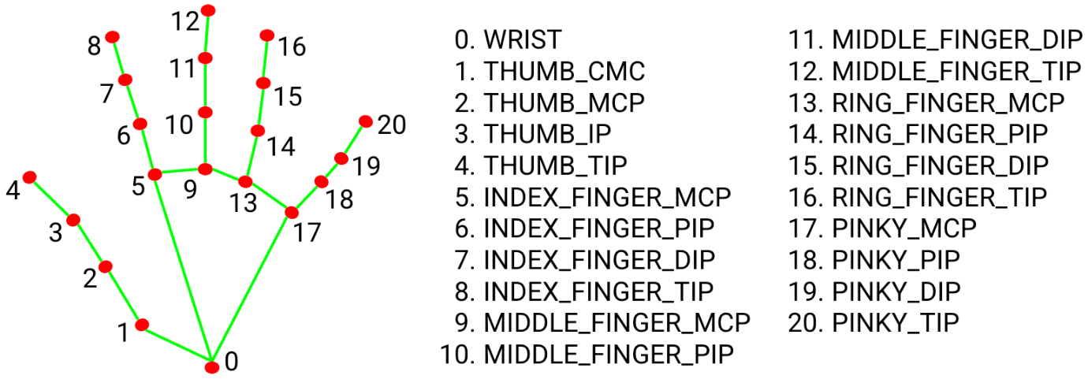

The proposed algorithm for hand gesture recognition
system is given in the following.

Start:

Step 1: Segment hand region ROI using hand mask images;

Step 2: Segment fingers using Connected Component Analysis algorithm;

Step 3: Classify the segmented fingers using CNN classification algorithm;

End;

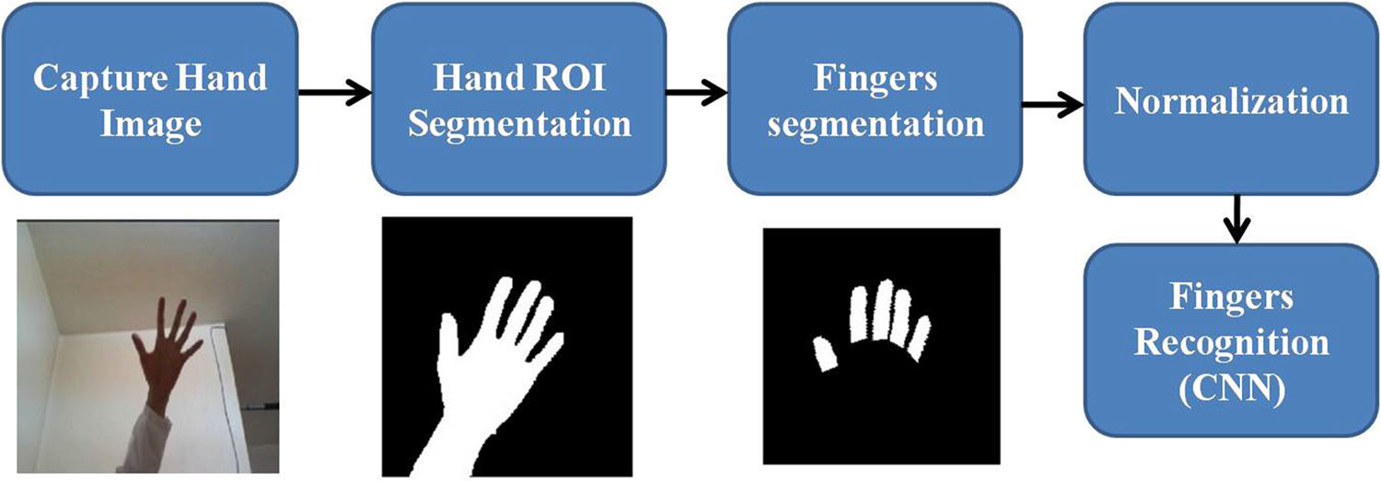

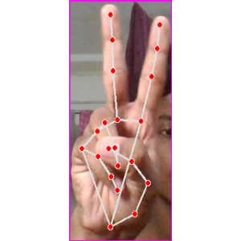

Fig 2 The proposed flow of hand gesture recognition system.

Hand ROI Segmentation

The hand region of the image is segmented from the whole image using mask images available in open access dataset (Rautaray and Agrawal 2015). The mask image is inverted, and it is convolved with the hand image which produces convolved image. The gray-level threshold is applied on the convolved image which produced hand region segmented image.


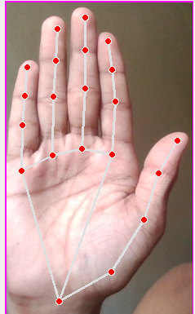

a) Source hand gesture image b) Segmented hand gesture image

Deep learning CNN Classifier

The segmented finger regions from hand image are given to the CNN classification algorithm which classifies the image into various classes (Hong et al. 2012). This classification algorithm is explained in the following sections.

Over fitting and back propagation are the present problems of neural networks, and hence, it is not able to produce high classification accuracy for pattern recognition.

In order to overcome such limitations in neural networks, CNN is used for obtaining high classification accuracy for hand gesture recognition. CNN has only forward path which does not have any feedback path for classifications. CNN is a kind of deep learning classification methodology which has many successful records in image analysis and classifications tasks. In this paper, CNN classification methodology is proposed to classify each input hand sign gesture image into various classes with high classification accuracy.

Figure 6 shows the developed CNN architecture which is used in this paper for hand gesture image classifications. It consists of convolutional filters which perform multiplication of kernel with input image (7 * 7 size), pooling and fully connected layers as shown in Fig. 6.

Figure 7 shows the detailed internal architecture of proposed CNN classifier for hand gesture recognition which depicts convolution layers and fully connected layers. The fully connected layers produce N number of output classes. The proposed CNN architecture consists of five convolutional layers and one fully connected layer with 1024 units.

The first convolutional layer is designed with Gaussian filter of size 3 * 3 for 32 filters, second convolutional layer is designed with Gaussian filter of size 3 * 3 for 64 filters, third convolutional layer is designed with Gaussian filter of size 3 * 3 for 128 filters, fourth convolutional layer is designed with Gaussian filter of size 3 * 3 for 256 filters, and fifth convolutional layer is designed with Gaussian filter of size 3 * 3 for 512 filters.

The final fully connected layer is a standard feed forward neural network. This fully connected layer produces final classification responses.

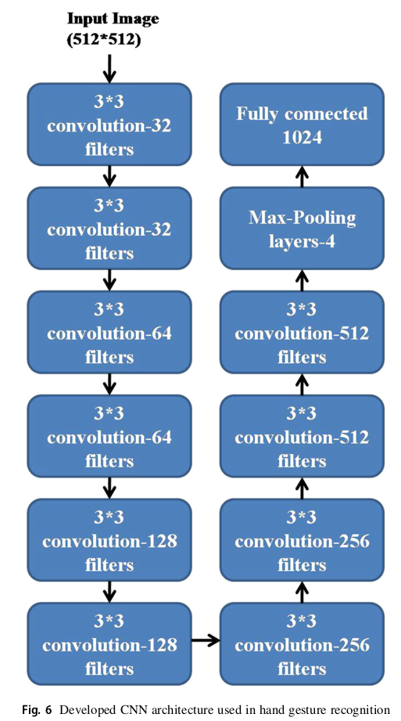

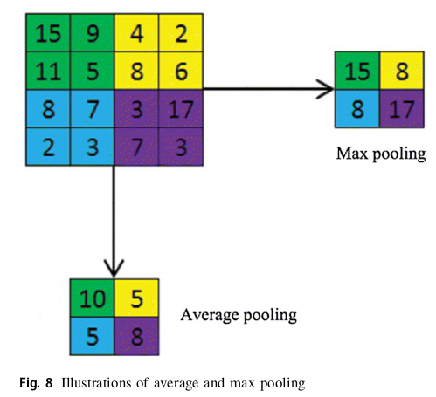

Convolution Layers

Each convolutional layers act as feature extractors, and they extract individual feature set from the input source image for classification process. The feature map is constructed by integrating the neuron factors which are obtained from convolutional layers. All neurons within a feature map have weights that are constrained to be equal;
however, different feature maps within the same convolutional layer have different weights so that several features can be extracted at each location.

The feature map at ith level can be determined using the
following equation,

where W is internal weight and I is the input source image.

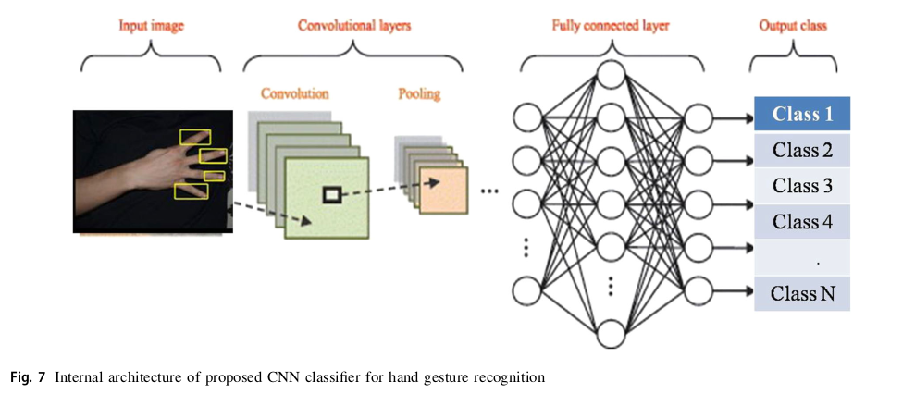

Pooling Layers

The purpose of the pooling layers is to reduce the spatial resolution of the feature maps which are obtained from convolutional layers. There are two pooling techniques used in pattern recognition as average pooling and max pooling, as depicted in Fig. 8. The average pooling demolishes the originality of the source image pixel, and
the max pooling retains the original pixel value in source hand gesture image. Hence, in this paper, max pooling aggregation methodology is used which determines the maximum value from each feature set map and passes these maximum feature set values to the next layer. This can be illustrated in the following equation.

In this paper, max pooling with a filter of size 2 * 2 with a stride of 2 is commonly used in practice. This paper uses 4 numbers of max pooling layers in order to obtain the optimum classification accuracy.

Fully Connected Layers

The fully connected layers that follow the convolutional and pooling layers interpret these feature representations and perform the function of high-level reasoning.

The first convolutional layer receives training samples along with test samples. The training set along with test sample forms the test vector which can be further convolved with 3 * 3 mask Gaussian filter for producing its corresponding hypotheses. Each hypothesis is considered as new test samples. The output from CNN classification algorithm produces eight different classes, and each class represents the individual hand gesture.

Inputs: Hand gesture image and m*n window;
Output: Fingers detected image;

Start
Step 1: Move Width (m)* Height (n) window on hand gesture image from the position (i,j) as set
to (0,0);
Step 2: Check its center pixel p(i,j) on m*n window as either 1 or 0;
Step 3: If (p (i,j)==1)
{
Check its neighboring pixel as 1
Set new label ‘a’ if condition is not satisfied;
Else
Set parent label of previous pixel;
}
Else
Step 4: Move m*n window by one pixel towards right;
End

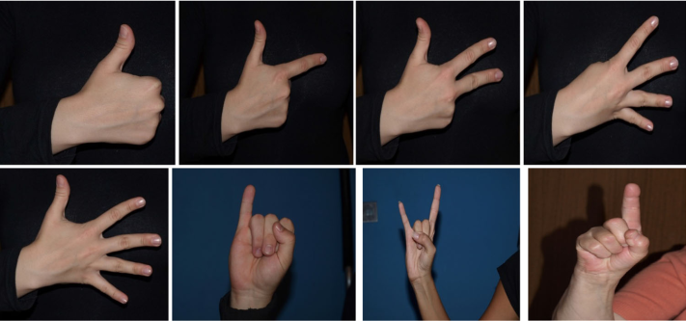
Fig: The training hand gesture images with different postures and backgrounds.

Result

The proposed hand gesture detection and recognition methodology is simulated using Python version 2.7 open source simulation software. This open-source software is authorized by Python scientific distributions. The Python software package includes spyder, Anaconda, keras, panda and theano modules. These modules are license free and available as open tools. Each module is integrated in Python kernel, and Python programming language is used to simulate the proposed work. The Python software is installed in Ubuntu Focal Fossa with 4 GB internal memory and executed in Ryzen 5 processor.

The proposed hand gesture detection and recognition methodology is applied on the images which are openly available in Kawulok et al. (2012) dataset. This dataset consists of large number of gesture patterns which were taken at different angles of orientation. The gesture images in this dataset were obtained or captured with different background environment under different lighting conditions. In this paper, eight different gestures and 200 images for each gesture posture are used. These 1600 gesture images from this open-source dataset are used as training set in this paper. The testing set contains 800 images which represent eight different gestures. The hand gesture images in both training and testing dataset are independent with each other. This dataset also contains 700 non-hand gesture images. The following parameters are used to evaluate the out performance of the proposed work which is stated in
this paper.

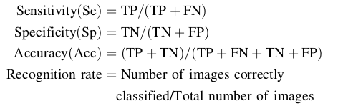

TP - is the true positive which represents the total number of correctly recognized hand gesture images (154 images)
TN - is the true negative which represents the total number of correctly recognized non-hand gesture images (50 images).
FP - is the false positive which represents the total number of wrongly recognized hand gesture images (six images)
FN - is the false negative which represents the total number of wrongly recognized non-hand gesture images (five images). The value of sensitivity,specificity and accuracy lies between 0 and 100, and they are determined in %.

Higher values of these parameters show that the efficiency of the proposed hand gesture detection and recognition methodology is high.

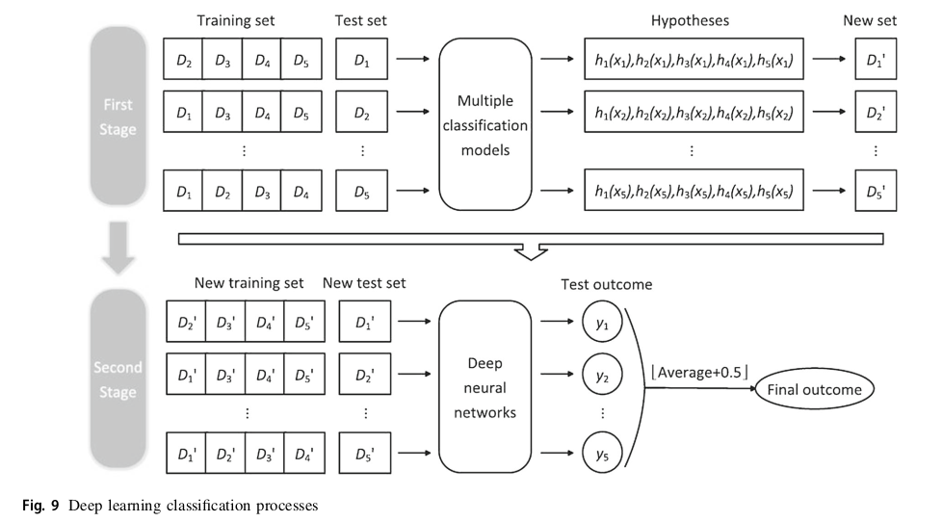

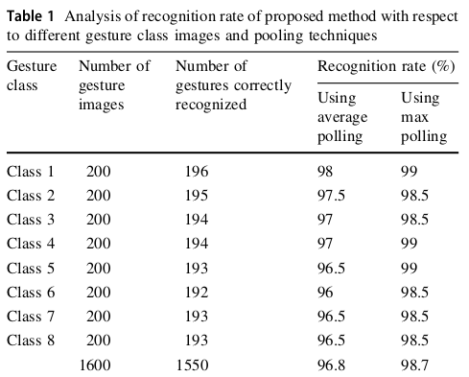

Conclusion

In this paper, deep learning convolutional neural network based hand gesture detection and recognition methodology is proposed.

This proposed method segments the finger tips from the hand gesture image, and then, this finger tips are given as input to the CNN classifier. The CNN classification approach trains and classifies the test hand gesture image which is obtained from open access image dataset. The performance of the proposed hand gesture detection and recognition methodology is analyzed in terms of sensitivity, specificity, accuracy and recognition rate. The proposed hand gesture detection and recognition methodology using CNN classification approach stated in this paper achieves 98.1% of sensitivity, 93.4% of specificity, 96.2% of accuracy and 96.2% of recognition rate.

References

- Ashfaq T, Khurshid K (2016) Classification of hand gestures using gabor filter with bayesian and naı̈ve bayes classifier. Int J Adv
Comput Sci Appl 7(3):276–279

- Chaikhumpha T, Chomphuwiset P (2018) Real—time two hand
gesture recognition with condensation and hidden Markov
models. In: 2018 international workshop on advanced image
technology (IWAIT), Chiang Mai, 2018, pp 1–4

- Elmezain M, Al-Hamadi A, Michaelis B (2010) A robust method for hand gesture segmentation and recognition using forward spotting scheme in conditional random fields. In: Proceedings of the 20th international conference on pattern recognition (ICPR’10), August 2010, pp 3850–3853

- Hong J, Kim ES, Lee H-J (2012) Rotation-invariant hand posture
classification with a convexity defect histogram. In: IEEE
international symposium on circuits and systems (ISCAS)
20–23 May 2012, pp 774–777

- Kapil Y, Bhattacharya J (2016) Real-time hand gesture detection andrecognition for human computer interaction. In: Berretti S,
Thampi S, Srivastava P (eds) Intelligent systems technologies
and applications. Springer, Cham, pp 559–567

- Kawulok M, Grzejszczak T, Nelapa J, Knyc M (2012) Database for
hand gesture recognition. http://sun.aei.polsl.pl/*mkawulok/
gestures/. Accessed 12 May 2018

- Liu K, Chen C, Jafari R, Kehtarnavaz N (2014) Fusion of inertial and depth sensor data for robust hand gesture recognition. Sens J
IEEE 14(6):1898–1903

- Manresa-Yee C, Varona J, Mas R, Perales FJ (2005) Hand tracking
and gesture recognition for human–computer interaction. Elec-
tronic letters on computer vision and image analysis 5(3):96–104

- Marium A, Rao D, Crasta DR, Acharya K, D’Souza R (2017) Hand
gesture recognition using webcam. Am J Intell Syst 7(3):90–94
Mitra S, Acharya T (2007) Gesture recognition: a survey. IEEE Trans
Syst Man Cybern Part C Appl Rev 37(3):311–324

- Park S, Yu S, Kim J, Kim S, Lee S (2012) 3D hand tracking using
Kalman filter in depth space. EURASIP J Adv Signal Process
2012(1), 36

- Rahman MH, Afrin J (2013) Article: hand gesture recognition using
multiclass support vector machine. Int J Comput Appl
74(1):39–43

- Rao J, Gao T, Gong Z, Jiang Z (2009) Low cost hand gesture learning and recognition system based on hidden markov model. In:
Proceedings of the 2009 2nd international symposium on
information science and engineering (ISISE ‘09), IEEE, Shanghai, China, December 2009, pp 433–438

- Rautaray SS, Agrawal A (2015) Vision based hand gesture recogni-
tion for human computer interaction: a survey. Artif Intell Rev
43(1):1–54

- Ren Z, Yuan J, Meng J, Zhang Z (2013) Robust part-based hand
gesture recognition using kinect sensor. IEEE Trans Multimed
15(5):1110–1120

- Sharma S, Jain S, Khushboo (2019) A static hand gesture and face
recognition system for blind people. In: 2019 6th international
conference on signal processing and integrated networks (SPIN),
Noida, India, 2019, pp 534–539

- Suguna R, Neethu PS (2017) Hand gesture recognition using shape
features. Int J Pure Appl Math 117(8):51–54

- Tauseef H, Fahiem MA, Farhan S (2009) Recognition and translation of hand gestures to Urdu alphabets using a geometrical
classification. In: Proceedings of IEEE international conference
on visualisation (VIZ), Barcelona, Spain, pp 213–217

- Wang Z, Chen B, Wu J (2018) Effective inertial hand gesture
recognition using particle filtering based trajectory matching.
J Electric Comput Eng 2018, 6296013

- Wang Y, Jung C, Yun I, Kim J (2019) SPFEMD: super-pixel based
finger earth mover’s distance for hand gesture recognition. In:
ICASSP 2019–2019 IEEE international conference on acoustics,
speech and signal processing (ICASSP), Brighton, United
Kingdom, 2019, pp 4085–4089

- Yao Y, Fu Y (2014) Contour model-based hand-gesture recognition
using the Kinect sensor. IEEE Trans Circ Syst Video Technol
24(11):1935–1944

- Yasukochi N, Mitome A, Ishii R (2008) A recognition method of
restricted hand shapes in still image and moving image as a
man–machine interface. In: IEEE conference on human system
interactions, pp 306–310

- Yrk E, Konukoglu E, Sankur B, Darbon J (2006) Shape-based hand
recognition. IEEE Trans Image Process 15(7):1803–1815

