SPAM GUARD AI

TEAM DETAILS:
VEMULA VISHNU VARDHAN 2403A54076
ANUMULA NITHIN 2403A54077
NARIGE ROHITH 2403A54L01

EDUCATION:
SR UNIVERSITY

COURSE:
CSE(DS)

GUIDE:
Dr. Venkataramana Sir

Abstract:
In today’s world mobile users get a lot of messages every day. Many of them are spam or fake. These messages often have delivery notifications urgent payment requests or suspicious links that can lead to scams. It's hard for users to identify messages manually especially when they look genuine. This project aims to solve this problem by developing a system that can automatically detect spam messages and unsafe URLs.
The proposed system, "Spam Guard AI" is a web-based application that uses machine learning techniques to classify messages as spam or not spam. It also checks URLs using security APIs (Google Safe Browsing API Key) to determine whether they are safe or not. In addition to machine learning rule-based detection is used to identify scam patterns such as delivery fraud and urgent payment requests.
The application is developed using Flask. Provides features like user login, trial usage limits and an easy-to-use interface. Users can enter a message or URL. Get instant results with a confidence score. This project shows how machine learning and real-time threat detection can be combined to improve user safety and awareness. Nowadays this application can help the public from scams.
Introduction and Discussion on existing methods:
The huge growth of internet usage and smartphones has made communication through text messages common. However this convenience has also increased the number of spam and phishing attacks. Many users receive messages related to parcel deliveries, bank alerts or urgent payments which're often fake. These messages are designed to trick users into clicking links or sharing sensitive information. During mobile usage it's easy to notice how frequently such messages appear making it difficult for users to distinguish genuine or fake messages. This creates a need for a system that can automatically detect spam messages and protect users from potential threats.
Traditional spam detection methods mainly rely on techniques such as keyword filtering and blacklist-based URL detection. In keyword filtering certain words like "free," "urgent," or "win" are used to identify spam messages. However attackers can easily bypass these filters by changing the wording. Blacklist-based systems also have limitations because they depend on known malicious URLs. If a new harmful link is created its not detected immediately. Due to these disadvantages traditional methods are not enough to handle spam attacks effectively.
Machine learning has improved spam detection by allowing systems to learn patterns from data of relying only on predefined rules. Algorithms such as Bayes and Logistic Regression are commonly used to classify messages. These models analyze the text content. Predict whether it's spam or not based on the training data. Machine learning models can adapt better to types of spam compared to traditional methods. However they mainly focus on text. May not detect always a link in a message its harmful or not.
To improve detection accuracy modern systems combine machine learning with real-time threat intelligence APIs. APIs like Google Safe Browsing and URL Haus provide updated information about URLs. By checking links against the databases the system can identify threats that're not visible through text analysis alone. This combination of machine learning and API-based check system creates a reliable solution for spam detection.
In this project a hybrid approach is used by combining machine learning rule-based logic and API integration. The system not checks the message content but also extracts and verifies any URLs present in the message. Additional rules are applied to detect scam patterns such as delivery-related fraud and urgent payment requests. This approach improves accuracy. Provides more protection for users. The system is implemented as a web application making it accessible and easy to use for both desktop users.. The application has some animations for a better interface for users.
Methodology:
Dataset:
- Spam message collection dataset.
- Contains Spam or Not messages.
Model:
- Text Vectorization: TF-IDF.
- Algorithm used: Bayes or Logistic Regression.
- Output contains spam probability score.
Metrics:
- Accuracy.
- Precision.
- Recall.
- F1 Score.
Application:
- User enters message or URL.
- Message is processed using ML model.
- URL is extracted from message.
- URL is checked using security APIs.
- Rule-based detection is applied.
- Final result is displayed in percentage.
- This application can be accessible by any user because of render(deployed).

Results and Discussion:
This system was tested by types of messages including spam and normal messages. It was observed that the model was able to classify most spam messages especially those containing suspicious keywords and payment-related content. The integration of URL checking APIs helped in identifying links effectively. Messages containing delivery information and shortened URLs were detected with high accuracy and percentage.
However the system depends on APIs for URL checking, which may sometimes cause delays. Except this disadvantage the overall performance of the system is reliable, useful for users and useful for real-world applications.
Metric Value (%):
- Accuracy 94–96%
- Precision 93%
- Recall 92%
- F1-Score 92.5%
Screen Shorts:
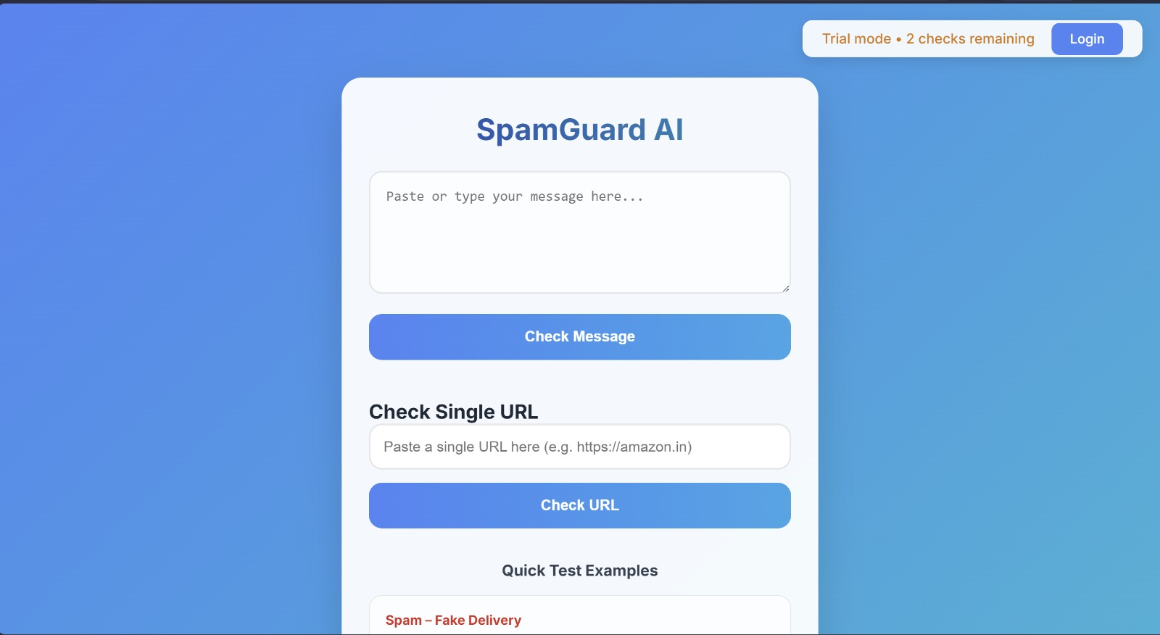
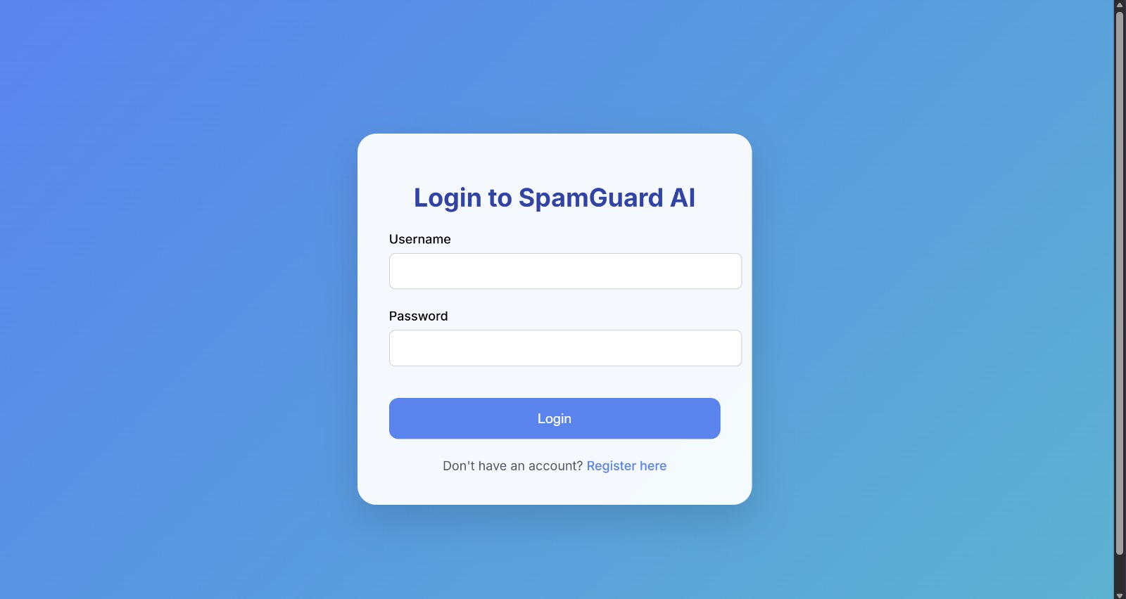
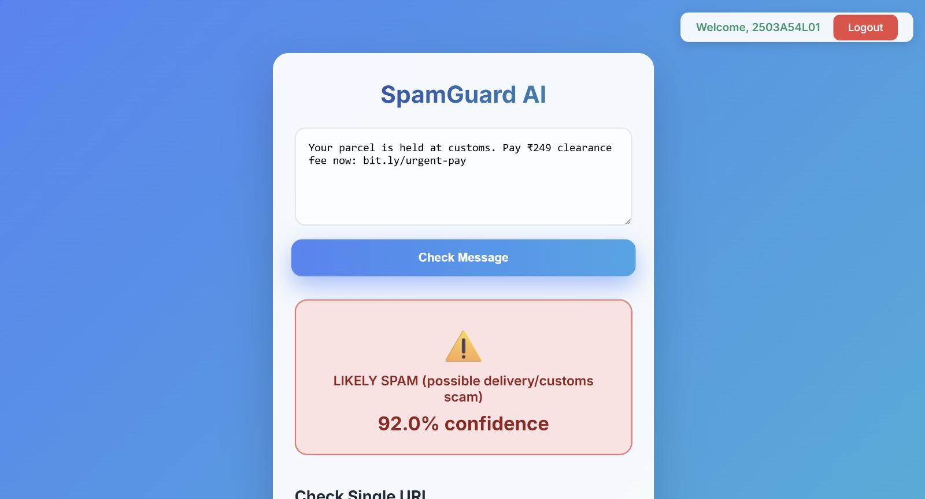
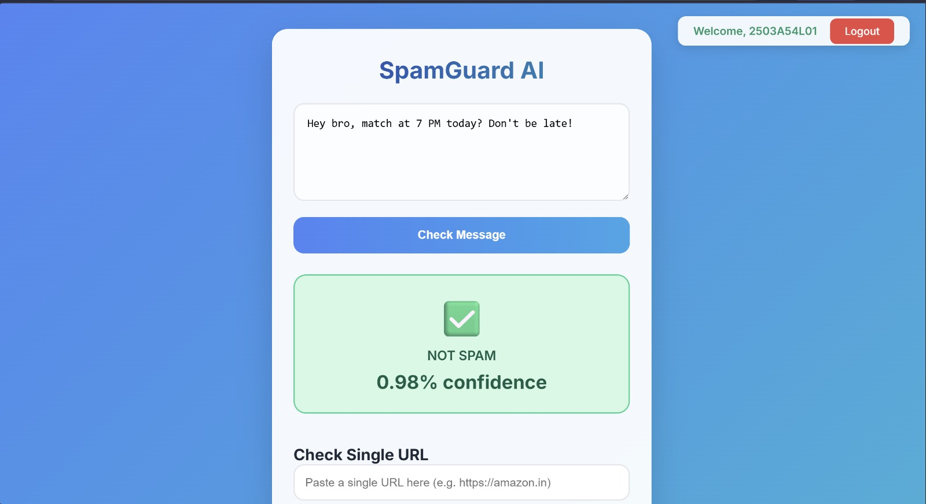
Conclusion:
This project successfully demonstrates how machine learning and API-based solutions can be used to detect spam messages and malicious URLs. The system provides results and helps users to avoid scams. It's simple, to use. Can be further improved by adding advanced models and mobile application support.

References:
- Spam message collection dataset (Kaggle).
- Google Safe Browsing API Documentation.
- URL Haus API Documentation.
- Flask Documentation.
- Machine Learning
- Text Classification Resources.

