**Prompt Engineering**

Prompt engineering is the craft of designing and refining inputs (prompts) to elicit the desired output from AI language models. It requires a blend of creativity, understanding of the model’s capabilities, and strategic structuring of the question or statement to guide the AI towards providing accurate, relevant, and useful responses. Prompt engineering improves communication between humans and machines, ensuring the resulting interaction is efficient and effective.

**Importance of Prompt Engineering**

* **Improves accuracy:** Well-crafted prompts lead to more precise answers, reducing the likelihood of misinterpretation or irrelevant responses from the AI.
* **Saves time:** Prompt engineering streamlines interactions with the AI by getting the desired information in fewer attempts, saving valuable time for users.
* **Facilitates complex tasks:** Complex tasks require complex understanding; good prompts translate intricate questions into a form that AI can process effectively.
* **Improves user experience:** A user’s experience with an AI system can greatly improve when the prompts lead to clear, concise, and contextually appropriate answers.
* **Enables better outcomes:** In areas such as coding, content creation, and data analysis, well-engineered prompts can lead to higher-quality outcomes by leveraging AI’s capabilities to the fullest.
* **Drives innovation:** As we better understand how to communicate with AI, we can push the boundaries of what’s possible, leading to innovative applications and solutions.

**Formula for better prompting**

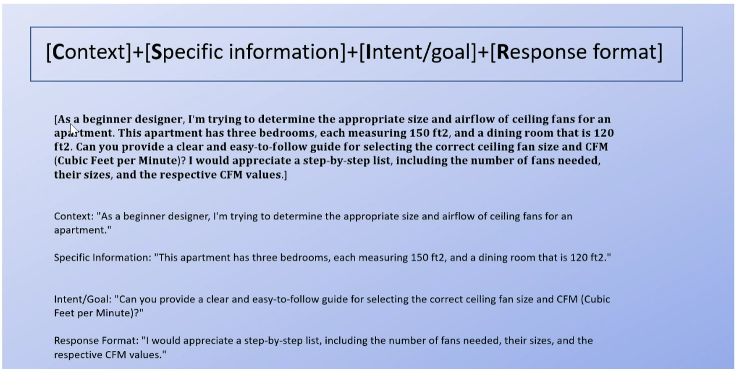

**Types of Prompting**

1. **Zero-shot prompting**

Zero-shot prompting is one of the most **straightforward** yet versatile techniques in prompt engineering. Zero-shot prompting is exceptionally useful for generating fast, on-the-fly responses to a broad range of queries.

Classify the text into neutral, negative or positive.

Text: I think the weather today is great!

Sentiment:

Output:

Positive

1. **One-shot prompting**

One-shot prompting is a technique where a single **example** guides the AI model's output. This example can be a question-answer pair, a simple instruction, or a specific template. The aim is to align the model's response more closely with the user's specific intentions or desired format.

"I give you the keyword 'sustainable travel,' and you write me blog post elements in this format: Blog post H1 title: Meta title: Meta description:"

Output:

Blog post H1 title: Exploring the World Sustainably Meta title: The New Age of Sustainable Travel Meta description: A detailed look at how to make your travels more eco-friendly without sacrificing comfort or experience.

Create a comparison table for two project management tools, Tool A and Tool B.

Include the following categories: Price, Key Features, User Reviews, and Support Options. For instance, under Key Features, list things like ‘Task Assignment’, ‘Time Tracking’, and ‘File Sharing’.

The format should mirror something like this:

| Feature | Tool A | Tool B |

|--------|-------|-------|

| Price | $X per user/month | $Y per user/month |

| Key Features | Task Assignment | File Sharing |

| User Reviews | X stars | Y stars |

| Support Options | 24/7 Live Chat, Email | Business Hours Phone, Email **|**

1. **Few-shot prompting**

Few-shot prompting is an extension of one-shot prompting where **multiple examples** are provided to guide the AI model's output. The concept is similar, but including several examples offers more contextual cues to the model. This enables the model to understand the user's requirements better, generating output that closely adheres to the given examples.

Prompt: "I give you the topic 'revenue management in hospitality,' and you provide me with the list of strategies in this format:

Strategy 1: Dynamic Pricing

Strategy 2: Yield Management

Strategy 3: Overbooking

Please continue the list (without explaining)"

Output:

Strategy 4: Seasonal Pricing

Strategy 5: Package deals

Strategy 6: Channel Management

Strategy 7: Customer Segmentation

Strategy 8: Stay discounts

1. **Role-play technique**

The role-playing technique employs a unique approach to crafting prompts: instead of using examples or templates to guide the model's output, you assign a specific "**role**" or "**persona**" to the AI model. This often includes explicitly explaining the intended audience, the AI's role, and the goals of the interaction. The roles and goals offer contextual information that helps the model understand the purpose of the prompt and the tone or level of detail it should aim for in its response.

Example Prompt:

“Act as a Business Executive: Analyze the current trends in the global financial market.”

"You are a prompt engineer, and you need to explain to a 6-year-old kid what your job is."

1. **Positive and negative prompting**

Positive and negative prompting are techniques used to guide the model's output in specific directions. As the names suggest, positive prompting encourages the model to include certain types of content or responses, while negative prompting discourages it from including other specific types. This framing can be vital in controlling the direction and quality of the model’s output.

"You are a sustainability expert. Generate a list of five feasible strategies for a small business to reduce its carbon footprint."

Building on the above scenario, you should ensure the model doesn't suggest too expensive or complicated strategies for a small business. So you extend your initial prompt as follows:

"You are a sustainability expert. Generate a list of five feasible strategies for a small business to reduce its carbon footprint. Do not include suggestions that require an initial investment of more than $10,000 or specialized technical expertise."

Adding the negative prompting here filters out too expensive or technical strategies, tailoring the model's output to your specific requirements.

1. **Model-guided prompting**

Another useful approach is model-guided prompting, which flips the script by **instructing the model** to ask you for the details it needs to complete a given task. This approach minimizes guesswork and discourages the model from making things up.

"I need you to generate a FAQ section for a new travel booking feature we're launching. Can you ask me for the information you need to complete this?"

ChatGPT might then ask you, "What is the name of the new travel booking feature?" and "What is the primary purpose or functionality of this new feature?" among other things.

1. **Iterative prompting**

Iterative prompting is a strategy that involves building on the model's **previous outputs to refine**, expand, or dig deeper into the initial answer. This approach enables you to break down complex questions or topics into smaller, more manageable parts, which can lead to more accurate and comprehensive results.

The key to this technique is paying close attention to the model's initial output. You can then create follow-up prompts to explore specific elements, inquire about subtopics, or ask for clarification. This approach is useful for projects that require in-depth research, planning, or layered responses.

Example. Your initial prompt might be:

"I am working on a project about fraud prevention in the travel industry. Please provide me with a general outline covering key aspects that should be addressed.”

Assume the model's output includes points like identity verification, secure payment gateways, and transaction monitoring.

Follow-up prompt 1: "Great, could you go into more detail about identity verification methods suitable for the travel industry?"

At this point, the model might elaborate on multifactor authentication, biometric scanning, and secure documentation checks.

Follow-up prompt 2: "Now, could you explain how transaction monitoring can be effectively implemented in the travel industry?"

The model could then discuss real-time monitoring, anomaly detection algorithms, and the role of machine learning in identifying suspicious activities.

**Best practices for prompt engineering**

1. **Put instructions at the beginning of the prompt and use ### or """ to separate the instruction and context.**

Less effective ❌:

Summarize the text below as a bullet point list of the most important points.  
  
{text input here}

Better ✅:

Summarize the text below as a bullet point list of the most important points.  
  
Text: """  
{text input here}  
"""

1. **Be specific, descriptive and as detailed as possible about the desired context, outcome, length, format, style, etc**

Be specific about the context, outcome, length, format, style, etc

Less effective ❌:

Write a poem about OpenAI.

Better ✅:

Write a short inspiring poem about OpenAI, focusing on the recent DALL-E product launch (DALL-E is a text to image ML model) in the style of a {famous poet}

1. **Articulate the desired output format through examples**

Less effective ❌:

Extract the entities mentioned in the text below. Extract the following 4 entity types: company names, people names, specific topics and themes.  
  
Text: {text}

Better ✅:

Extract the important entities mentioned in the text below. First extract all company names, then extract all people names, then extract specific topics which fit the content and finally extract general overarching themes  
  
Desired format:  
Company names: <comma_separated_list_of_company_names>  
People names: -||-  
Specific topics: -||-  
General themes: -||-  
  
Text: {text}

1. **Give the model a persona or frame of reference**

Imagine you are a seasoned marketing consultant. Please draft an email to a new startup client outlining three digital marketing strategies tailored for their upcoming product launch (see attached PDF for details).

Include key performance indicators (KPIs) for each strategy that will help track their campaign’s success. Ensure the tone is encouraging and professional, imparting confidence in your expertise.

1. **Reduce “fluffy” and imprecise descriptions**

Less effective ❌:

The description for this product should be fairly short, a few sentences only, and not too much more.

Better ✅:

Use a 3 to 5 sentence paragraph to describe this product.

1. **Instead of just saying what not to do, say what to do instead**

Less effective ❌:

The following is a conversation between an Agent and a Customer. DO NOT ASK USERNAME OR PASSWORD. DO NOT REPEAT.  
  
Customer: I can’t log in to my account.  
Agent:

Better ✅:

The following is a conversation between an Agent and a Customer. The agent will attempt to diagnose the problem and suggest a solution, whilst refraining from asking any questions related to PII. Instead of asking for PII, such as username or password, refer the user to the help article www.samplewebsite.com/help/faq  
  
Customer: I can’t log in to my account.  
Agent:

1. **Code Generation Specific - Use “leading words” to nudge the model toward a particular pattern**

Less effective ❌:

# Write a simple python function that  
# 1. Ask me for a number in mile  
# 2. It converts miles to kilometers

In this code example below, adding “*import*” hints to the model that it should start writing in Python. (Similarly “SELECT” is a good hint for the start of a SQL statement.)

Better ✅:

# Write a simple python function that  
# 1. Ask me for a number in mile  
# 2. It converts miles to kilometers  
   
import

**Common Mistakes in Prompt Engineering**

## Over-Complication

**Mistake**: Making the prompt overly complex.

This prompt is too broad and complex:

Write a detailed, comprehensive guide on growth marketing strategies, including SEO, social media, content marketing, email campaigns, PPC, and affiliate marketing, with a focus on B2B tech startups.

This can confuse the model, leading to convoluted or irrelevant responses.

**Avoidance**: Keep the prompt as simple as possible while maintaining clarity and specificity. It's about finding the balance between detail and conciseness.

This improved prompt is focused and manageable:

Outline key growth marketing strategies for B2B tech startups focusing on SEO and content marketing.

## Under-Specification

**Mistake**: Providing too little information or context.

A suboptimal prompt lacks detail and context:

Give me some tips on copywriting.

The AI might generate generic or off-target responses due to a lack of guidance.

**Avoidance**: Ensure that the prompt includes enough context to guide the AI, especially when dealing with nuanced or complex topics.

A good prompt will clearly and specifically include what you want to accomplish:

Provide five actionable copywriting tips for creating engaging product descriptions on e-commerce websites.

## 3. Misalignment with AI Capabilities

**Mistake**: Expecting the AI to understand and respond to prompts beyond its training or capabilities.

This is a bad prompt because it is beyond AI’s predictive capabilities:

Predict the most profitable growth marketing channel for 2025.

**Impact**: This leads to responses that are either incorrect or outside the scope of what the AI can reliably generate.

**Improvement**: Familiarize yourself with the strengths and limitations of the AI model. Avoid prompts that require real-time data, subjective opinions, or highly specialized knowledge outside the AI’s training.

An improved prompt would be within AI's knowledge base and even provide extra information:

Summarize current trends in growth marketing channels based on recent data and the information of 2 articles I will provide you with.

## 4. Ignoring Audience and Purpose

**Mistake**: Not tailoring the prompt to the specific audience or purpose.

This prompt doesn’t consider audience knowledge level:

Explain market segmentation

The response may not align with the intended use or audience, reducing its effectiveness.

**Improvement**: Consider the end-user and the purpose of the response. Craft the prompt to align with these elements, adjusting the complexity and style as needed.

With this prompt tailored to a beginner audience you will improve the effectiveness of the answer because now the audience can better understand it.

Explain market segmentation in simple terms for someone new to customer research.

## 5. Ambiguity and Vagueness

**Mistake**: Using ambiguous or vague terms in the prompt.

This is a vague and unclear prompt:

Write a go-to-market strategy for the fitness industry.

Leads to responses that might not address the intended query or topic accurately.

**Improvement**: Use clear and precise language. If necessary, rephrase the prompt to eliminate any potential ambiguity.

This again is about prompting specifically and clearly:

Write a brief overview of a go-to-market strategy for a new fitness app targeting millennials in NYC.

## 6. Neglecting Prompt Structure

**Mistake**: Overlooking the importance of prompt structure.

This prompt, for example is unstructured and too broad:

Tell me how to do audience research and create personas.

Poorly structured prompts can lead to disorganized or disjointed responses.

**Improvement**: Structure the prompt logically, especially for complex tasks. Consider using bullet points, numbered lists, or clear step-by-step instructions where appropriate.

Structured and sequenced prompts lead to better results:

List the steps for conducting audience research, followed by a guide on creating detailed customer personas.

## 7. Failure to Iterate

**Mistake**: Not refining or iterating the prompt based on initial responses.

While an initial prompt What are growth strategies in marketing? is suboptimal, it serves for iterated improvement.

The answer will be too broad and unspecific to be of any value to you. These answers then lead people to unsubstantiated statements like “ChatGPT is not working for me” missing the opportunity to have a personal Assistant or intern readily available.

The key here is to improve the quality and accuracy of the AI’s response.

Use the initial responses as feedback. Refine the prompt iteratively to hone in on the desired outcome.

A refined prompt based on AI's initial response could be

Based on point 3 of your answer: Describe three effective growth strategies for SaaS companies in the digital marketing s