**Retrieval Augmented Generation**

RAG is the process of retrieving information from the data source and sending it to large language model alongside with the user's prompt.

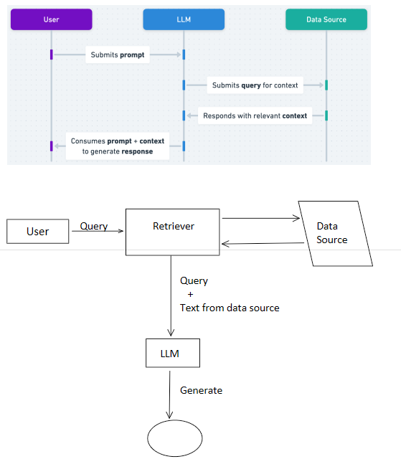

<https://help.openai.com/en/articles/8868588-retrieval-augmented-generation-rag-and-semantic-search-for-gpts>

Python requirements:

langchain 0.0.148

langchain-community 0.0.28

langchain-core 0.1.36

langchain-openai 0.0.8

langchain-text-splitters 0.0.1

openai 0.27.4

chromadb 0.3.21

hnswlib 0.8.0

Download this if error in chromadb insatll

1. Go to this page: https://visualstudio.microsoft.com/visual-cpp-build-tools/

2. Click on "Download Build Tools" and run what you downloaded

3. Click on "Install" (a window with different options to click should show up)

4. Click only on "Desktop Development with C++" and click on install (image for reference)

5. Reboot your system

6. try "pip install chromadb" again, it should work

Requirements:

• Retriever

• Database

• Embedding

• API key

• Langchian