**Snyk Integration with Jenkins for Python cartridge**

**Steps**1. Sign in for Snyk account   
 https://app.snyk.io/ 

2. Configure snyk security with Jenkins Server

Navigate to the Jenkins tool click on **Manage Jenkins > Manage Plugins**  area of Jenkins to install the **Snyk Security** plugin for Jenkins  
 **a. Snyk Security** plugin is installed but we need to add configuration after that we will start using that in our pipeline

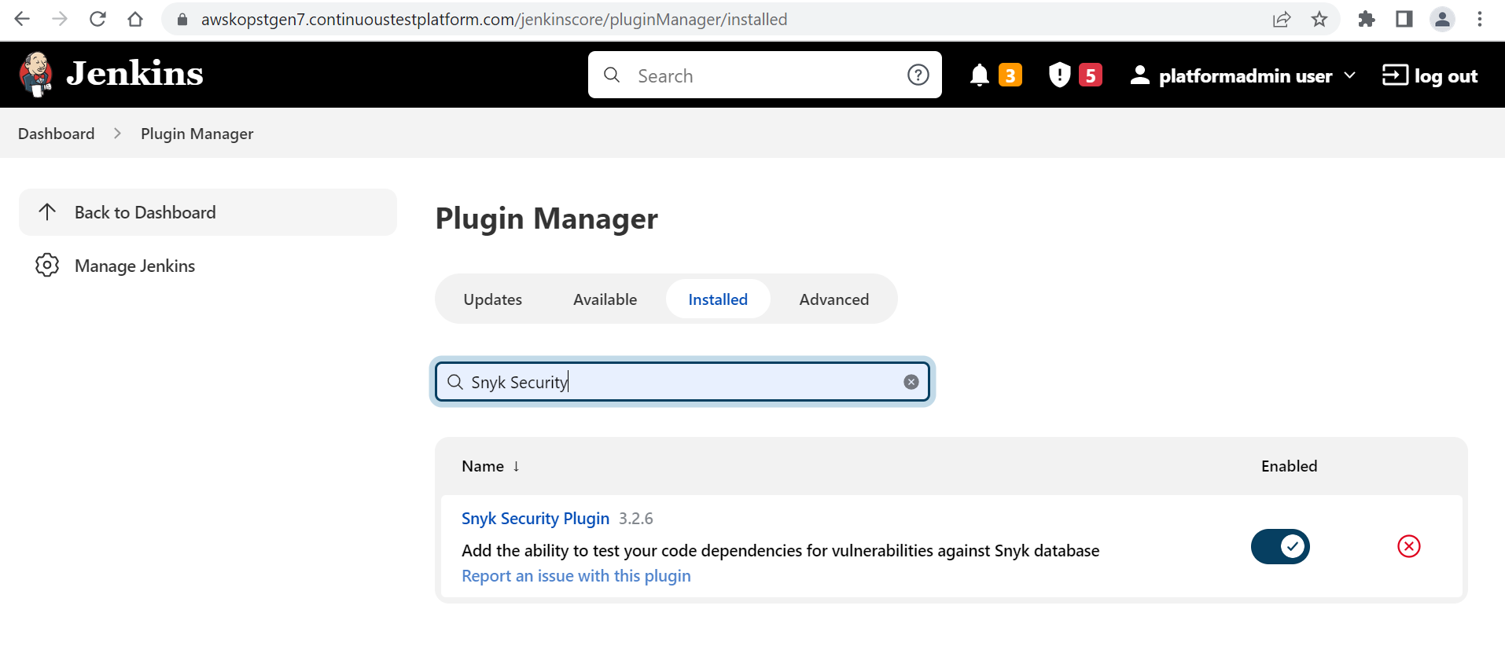

b.Navigate to Manage Jenkins>> Global tool configuration and click on snyk installation  
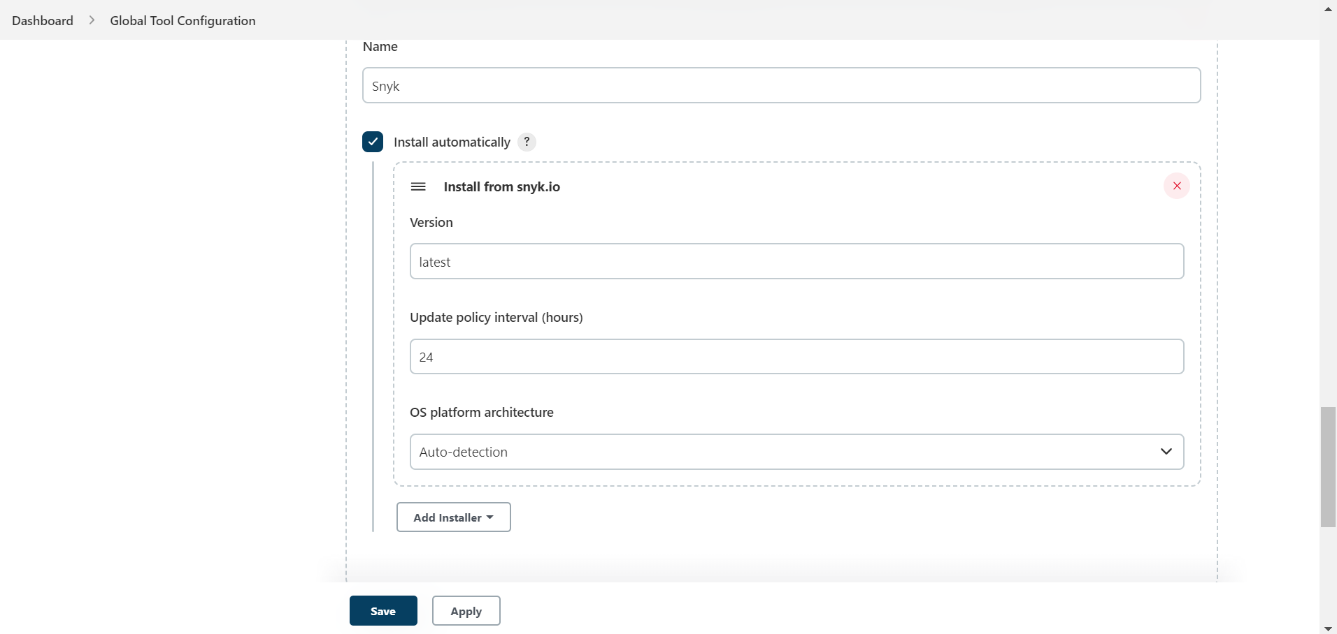

i. Enter the unique name  
 ii. **Install automatically: default is selected.** Ensure Install automatically is selected.  
 This ensures your plugin automatically upgrades when there are newer versions available.  
 iii. Click on **Add Installer >**Select**Install with snyk.io.   
 version: latest** Update policy interval (hours): 24  
 OS platform architecture: Auto-detection  
 iv. Save the changes

**Now Snyk Security** plugin is configured on our Jenkins server

3.Now get API Token from Snyk account  
 a. Login to the Snyk account  
 Navigate Snyk account>>click on profile>>Account setting>>General>>click to show  
 b. Copy the API token

4. Add Snyk API Token credential to Jenkins  
 Navigate to Manage Jenkins>>Manage Credential>>Add credential  
 Kind: Select**Snyk API token.  
 Scope:**Select **Global.  
 Token:**Enter the Snyk API token that we coped from the Snyk account.  
 **ID:**Enter a name for the token.

5. Copy the below script inside Jenkins file above deploy build to Kubernetes stage for python cartridge   
 stage(' Snyk scan')

{

container('maven')

{

snykSecurity failOnError: false, failOnIssues: false,organisation: 'biswajitamohanty10', snykInstallation: 'Snyk', snykTokenId: 'Snyk'

}

}

Save the changes click on build now in Jenkins

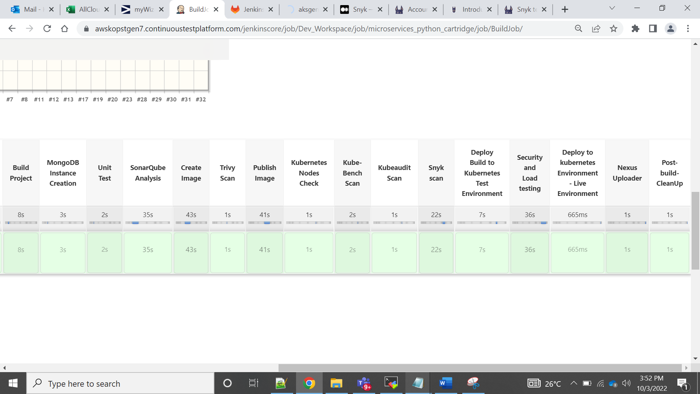

7. Click on last successful artifact>>click on all files in zip

8. Open the snyk report in the downloaded artifact(file)  
