AI Assisted Coding

ASSIGNMENT 4

Name: N.Nithin Varma
HT No: 2303A52011
Batch: 31

Lab Objectives:
To explore and apply different levels of prompt examples in
AI-assisted code generation.
To understand how zero-shot, one-shot, and few-shot
prompting affect AI output quality.
To evaluate the impact of context richness and example
quantity on AI performance.

Question 1: Zero-Shot Prompting (Basic Lab Task)
Task 1:
Write a Python function that classifies a given text as Spam or Not Spam using zero-shot prompting.
Steps:
1. Construct a prompt without any examples.
2. Clearly specify the output labels.
3. Display only the predicted label.
Input: "Congratulations! You have won a free lottery ticket." Expected Output: Spam

Prompt:
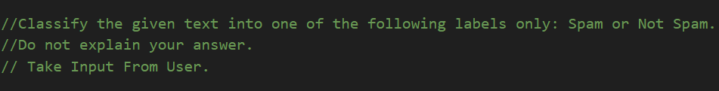
Code:

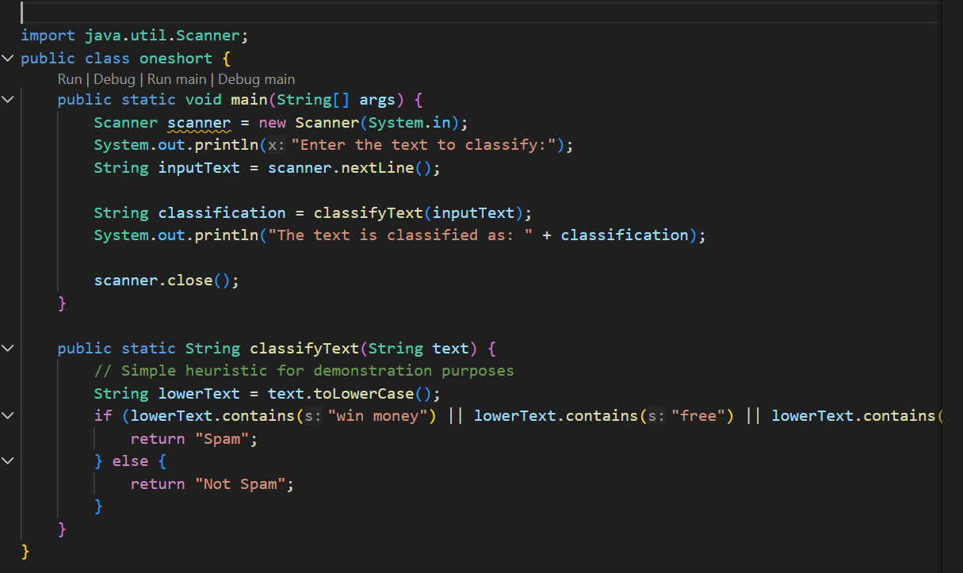

Output(O/P)

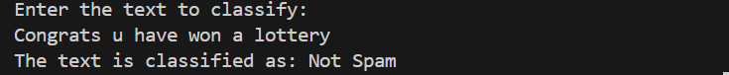

Explanation:
This function checks if any of the predefined spam keywords are present in the input text.
If any keyword is found, it classifies the text as "Spam"; otherwise, it classifies it as "Not Spam".

Question 2: One-Shot Prompting (Emotion detection)
Task 2:
Write a Python program that detects the emotion of a sentence using one-shot prompting.
Emotions: [‘happy', 'sad', 'angry', 'excited', 'nervous', ’neutral’] Steps:
1. Provide one labeled example inside the prompt.
2. Take a sentence as input.
3. Print the predicted emotion

Prompt:
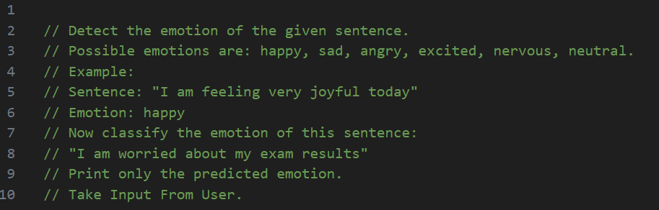Code:
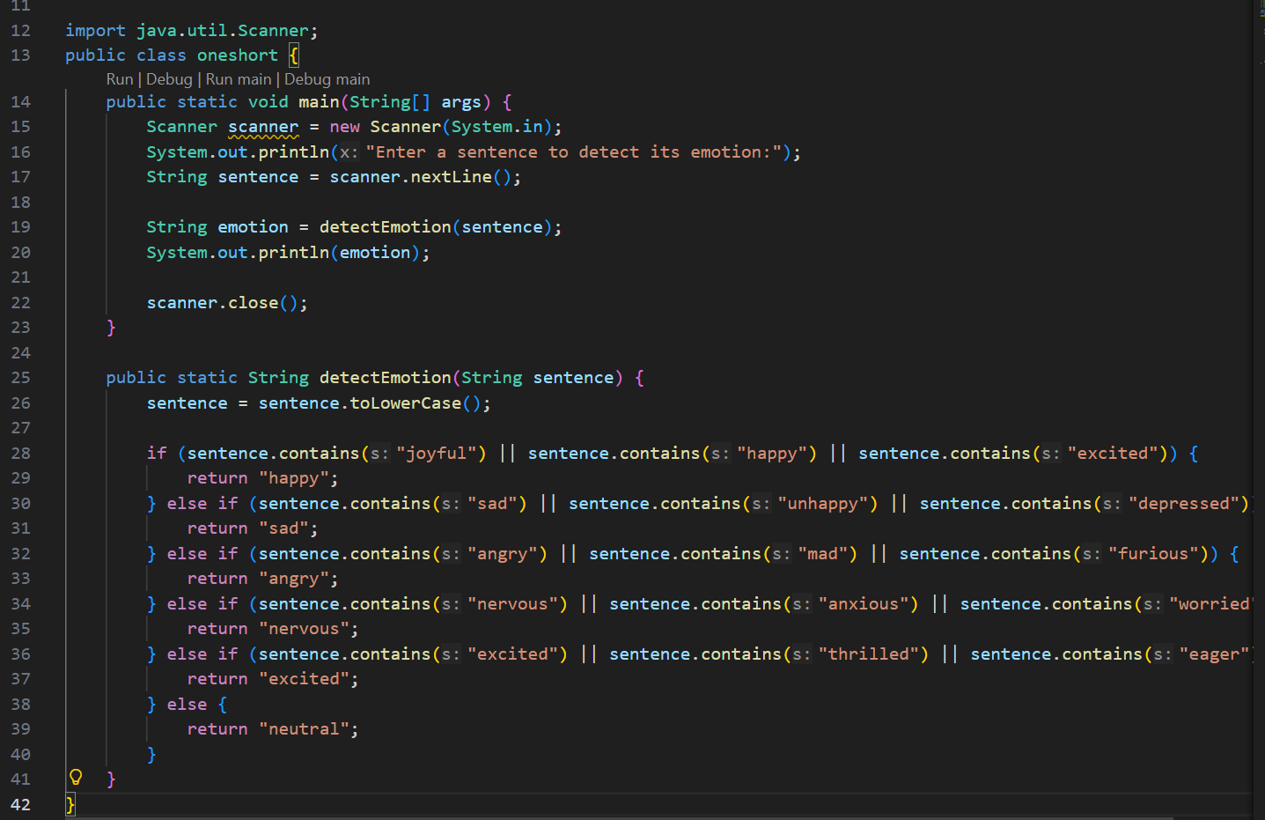
Output:
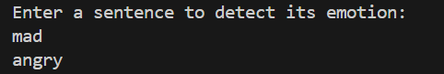
Explanation:
The code defines a function detect_emotion that takes a sentence as input and returns the detected emotion based on specific keywords. It converts the sentence to lowercase and checks for the presence of keywords associated with different emotions such as happy, sad, angry, excited, and nervous. If none of these keywords are found, it returns "neutral". The user is prompted to enter a sentence, and the detected emotion is printed.

Question 3: Few-Shot Prompting (Student Grading Based on Marks)
Task 3:
Write a Python program that predicts a student’s grade based on marks using few-shot prompting.
Grades: ['A', 'B', 'C', 'D', 'F']
Grading Criteria (to be inferred from examples):
• 90–100 → A
• 80–89 → B
• 70–79 → C
• 60–69 → D
• Below 60 → F
Prompt:
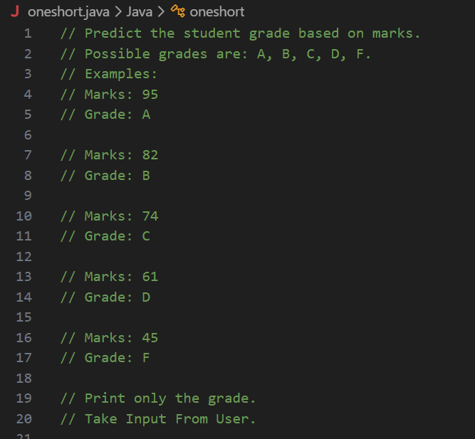Code:
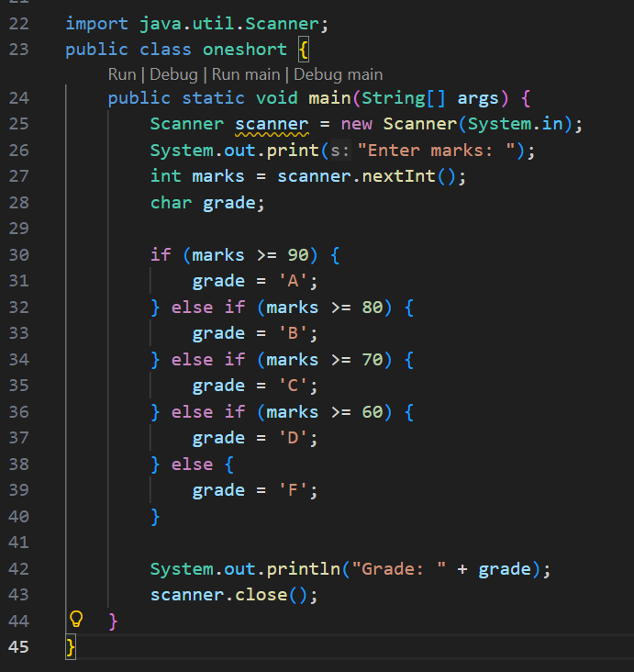

Output:
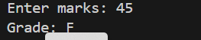

Explanation:
This code defines a function get_grade that takes an integer input marks and returns a corresponding grade based on predefined thresholds.

Question 4:Multi-Shot Prompting (Indian Zodiac Sign Prediction using Month Name)
Task 4:
Write a Python program that predicts a person’s Indian Zodiac sign (Rashi) based on the month of birth (month name) using multi-shot prompting.
Indian Zodiac Order (Simplified Month-Based Model):
The Indian Zodiac cycle starts in March with Mesha and follows this order:
March → Mesha
April → Vrishabha
May → Mithuna
June → Karka
July → Simha
August → Kanya
September → Tula
October → Vrischika
November → Dhanu
December → Makara
January → Kumbha
February → Meena

Prompt:
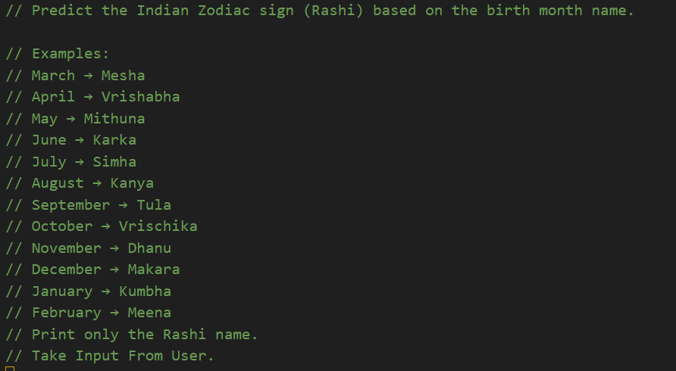
Code:
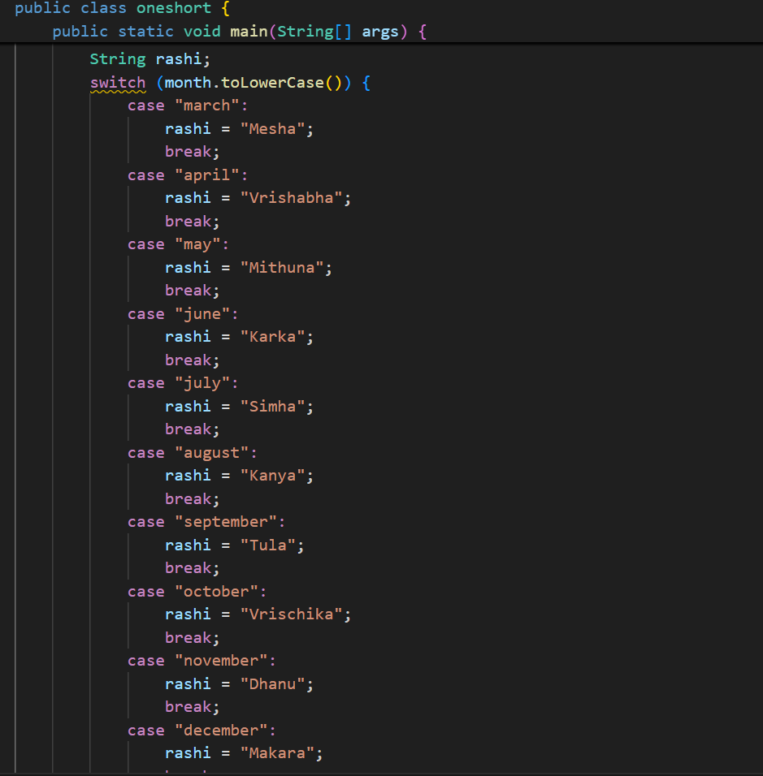

Output:

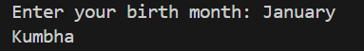

Explanation:

This code defines a dictionary that maps each month of the year to its corresponding Indian Zodiac sign (Rashi). It then prompts the user to input their birth month, retrieves the associated Rashi from the dictionary, and prints it. If the user enters an invalid month, it returns "Invalid month".

Question 5: Result Analysis Based on Marks
Task 5:
Write a Python program that determines whether a student Passes or Fails based on marks using Chain-of-Thought (CoT) prompting.
Result Categories: ['Pass', 'Fail']
Prompt:
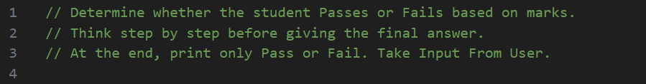Code:
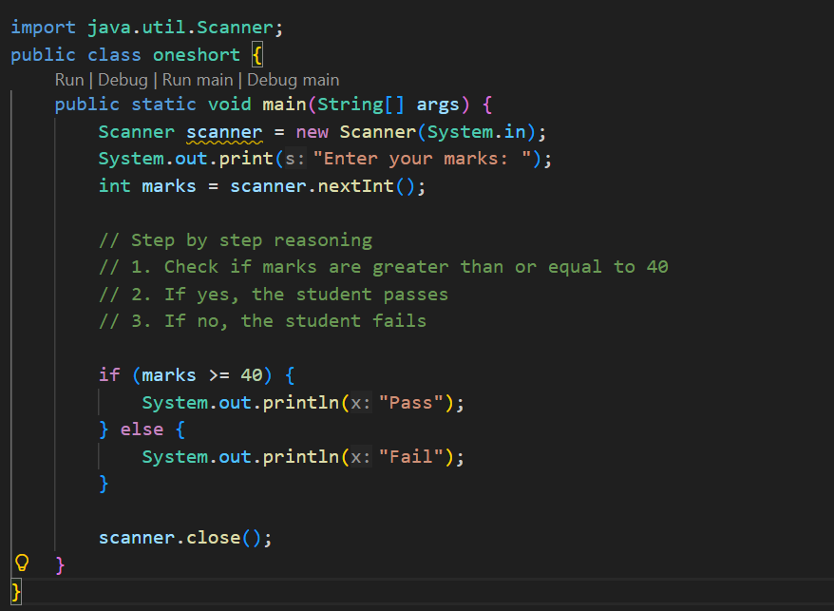
Output:
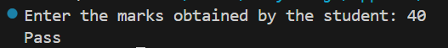

Explanation:
This code takes the marks obtained by a student as input and checks if the student has passed or failed based on a predefined passing criteria (40 marks). If the marks are greater than or equal to 40, it prints "Pass"; otherwise, it prints "Fail".

Question 6: Voting Eligibility Check (Chain-of-Thought Prompting)
Task 6:
Write a Python program that determines whether a person is
eligible to vote using Chain-of-Thought (CoT) prompting.
Prompt:
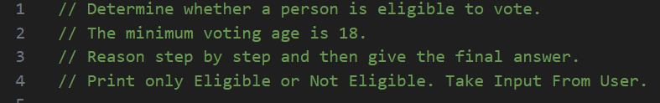Code:
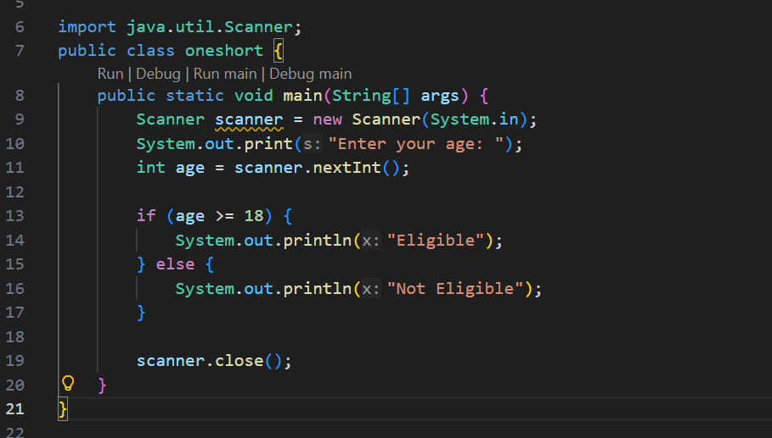

Output:
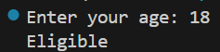

Explanation:
This code snippet checks if a user is eligible to vote based on their age. It prompts the user to enter their age and then evaluates whether the age is 18 or older. If the condition is met, it prints "Eligible"; otherwise, it prints "Not Eligible".

Question 7: Prompt Chaining (String Processing – Palindrome Names)
Task 7:
Write a Python program that uses the prompt chaining technique to identify palindrome names from a list of student names.
Prompt:
Code:
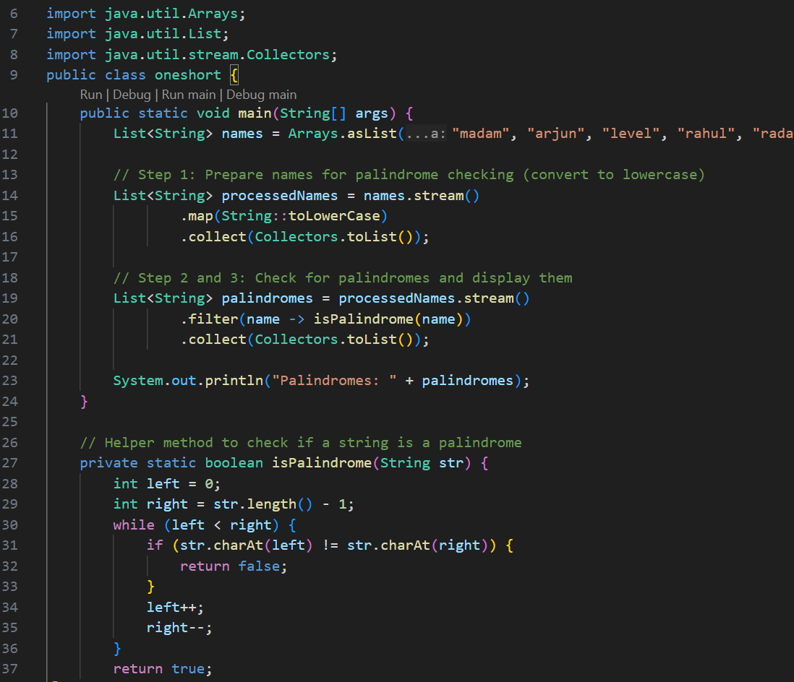
Output:

Explanation:
This code defines a list of student names and includes a function to check if a name is a palindrome (a word that reads the same backward as forward). It then filters the list to find all names that are palindromes and prints them. The use of list comprehension makes the filtering process concise and efficient. Used prompt chaining technique.

Question 8: Prompt Chaining (String Processing – Word Length Analysis)
Task 8:
Write a Python program that uses prompt chaining to analyze a list of words. In the first prompt, generate a list of words. In the second prompt, traverse the list and calculate the length of each word. In the third prompt, use the output of the previous step to determine whether each word is Short (length less than 5) or Long (length greater than or equal to 5), and display the result for each word

Prompt:
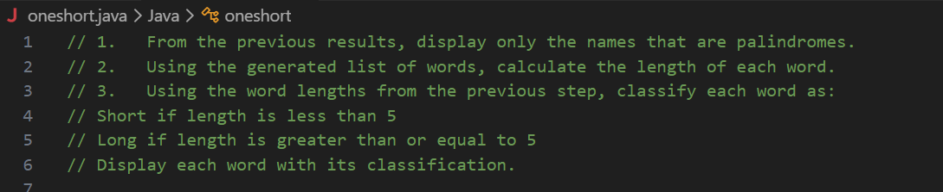

Code:
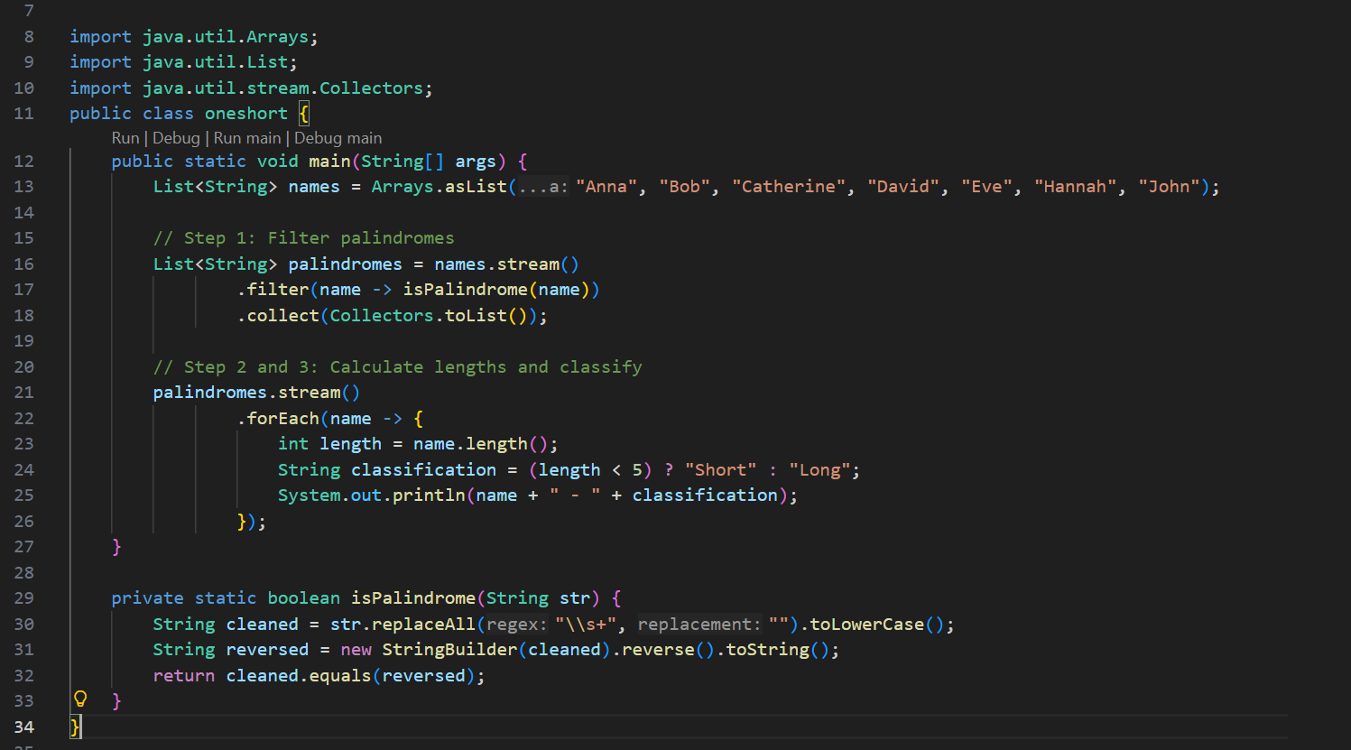
Output:

Explanation:
This code defines a list of student names and checks which of those names are palindromes (words that read the same forwards and backwards). It uses a helper function is_palindrome to perform this check. The palindromic names are then filtered into a new list called palindromes. Used prompt chaining technique.

