AI Assisted Coding

ASSIGNMENT 3.1

Name: N.Nithin Varma
HT No: 2303A52011
Batch: 31

Experiment - Prompt Engineering Techniques

Task Description: Design and refine prompts using different prompting strategies to generate Python programs for basic computational problems.

Question 1:

Zero-Shot Prompting (Palindrome Number Program)

Write a zero-shot prompt (without providing any examples) to generate a Python function that checks whether a given number is a palindrome.

Task:

• Record the AI-generated code.

• Test the code with multiple inputs.

• Identify any logical errors or missing edge-case handling.

Prompt:

Write a Python function that takes a number as input and checks whether it is a palindrome or not.
If the number reads the same from left to right and right to left, the function should return True; otherwise, it should return False.

Code:
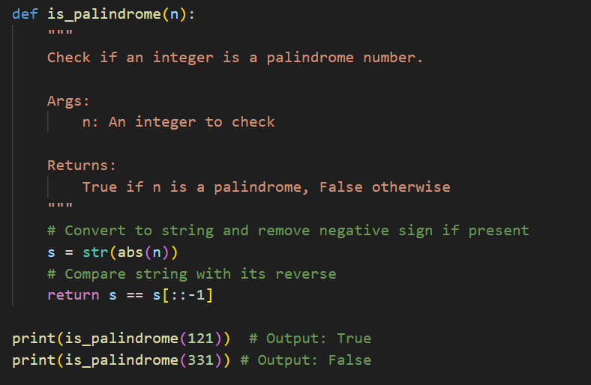

Output(O/P)
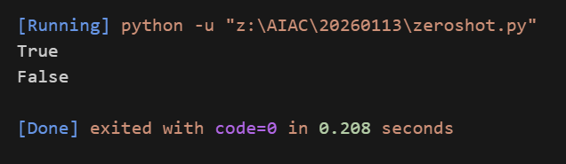

Explanation:
In this task, zero-shot prompting was used where no examples were provided. The prompt only explained what a palindrome number is and what the function should return. Based on this, the program checks whether the number remains the same when reversed. If the original and reversed numbers match, it returns true; otherwise, it returns false. The logic works correctly for positive integers.

Question 2:
One-Shot Prompting (Factorial Calculation)
Write a one-shot prompt by providing one input-output example and ask the AI to generate a Python function to compute the factorial of a given number.
Example:
Input: 5 → Output: 120
Task:
• Compare the generated code with a zero-shot solution.
• Examine improvements in clarity and correctness.

Prompt:
Write a Python function to calculate the factorial of a given non-negative number.
Write a Python function to calculate the factorial of a given non-negative number.
Example:
Input: 5
Output: 120
The function should return the factorial value of the number.
Code:
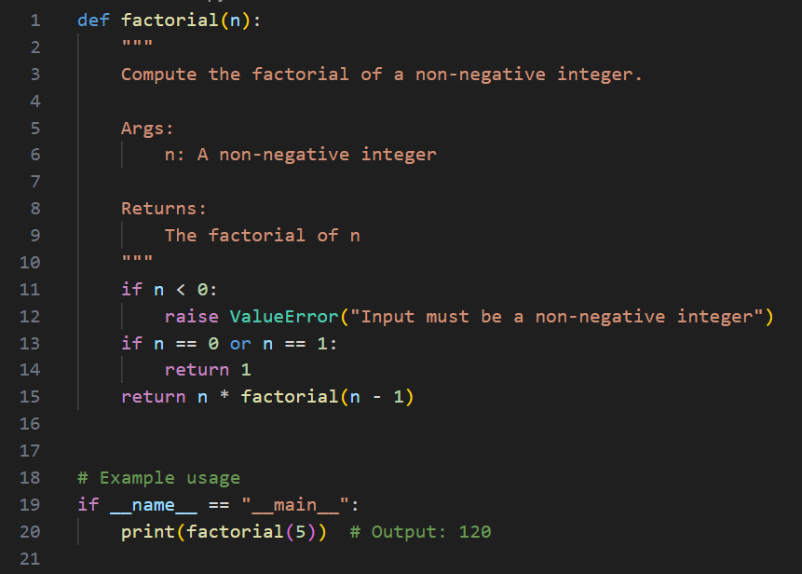
Output:
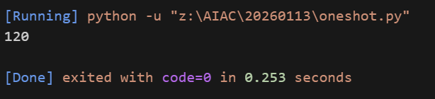

Explanation:

One-shot prompting was used by providing a single example along with the instruction. The example input and output clearly showed how factorial calculation should work. Because of this, the generated function was more structured and easy to understand. The program correctly handles edge cases such as factorial of zero. Compared to zero-shot prompting, this approach gives better clarity and accuracy. The example helps reduce ambiguity in the logic.

Question 3:
Few-Shot Prompting (Armstrong Number Check)
Write a few-shot prompt by providing multiple input-output examples to guide the AI in generating a Python function to check whether a given number is an Armstrong number.
Examples:
• Input: 153 → Output: Armstrong Number
• Input: 370 → Output: Armstrong Number
• Input: 123 → Output: Not an Armstrong Number Task:
• Analyze how multiple examples influence code structure and accuracy. • Test the function with boundary values and invalid inputs.

Prompt:
Write a Python function that checks whether a given number is an Armstrong number or not.
Examples:
a= 153 Output: Armstrong Number
b= 370 Output: Armstrong Number
c= 123 Output: Not an Armstrong Number
The function should return the result in the same format shown above

Code:
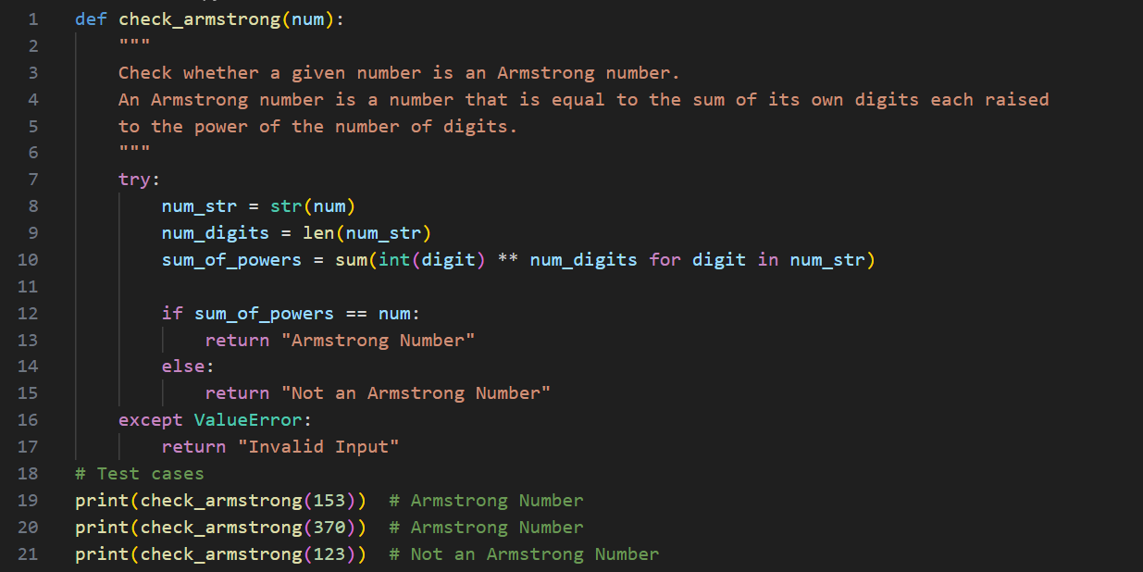
Output:
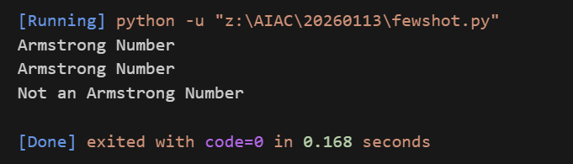

Explanation:
Few-shot prompting was applied by giving multiple examples of Armstrong and non-Armstrong numbers. These examples helped the program understand how to calculate the sum of digits raised to the power of the number of digits. The output format also followed the examples exactly. The function worked correctly for boundary values such as 0 and 1. Invalid inputs were handled more carefully due to clear expectations. Overall, multiple examples improved accuracy and reduced errors.

Question 4:
Context-Managed Prompting (Optimized Number Classification)
Design a context-managed prompt with clear instructions and constraints to generate an optimized Python program that classifies a number as prime, composite, or neither.
Task:
• Ensure proper input validation.
• Optimize the logic for efficiency.
• Compare the output with earlier prompting strategies.

Prompt:
Write a Python function that takes a number as input and tells whether the number is Prime, Composite, or Neither.
The function should work only with integers and handle invalid inputs properly.
If the number is less than or equal to 1, it should return Neither.
Use an efficient approach by checking divisibility only up to the square root of the number.
The function should return only one of these values: Prime, Composite or Neither

Code:
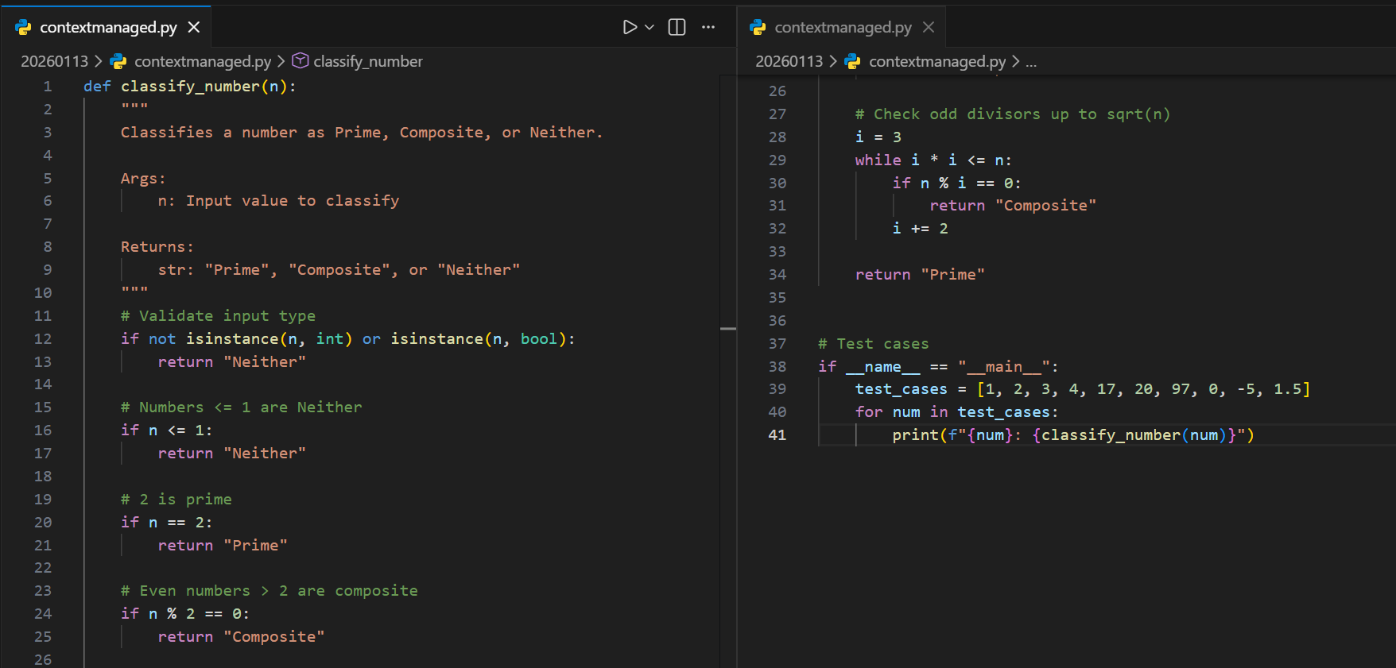

Output:
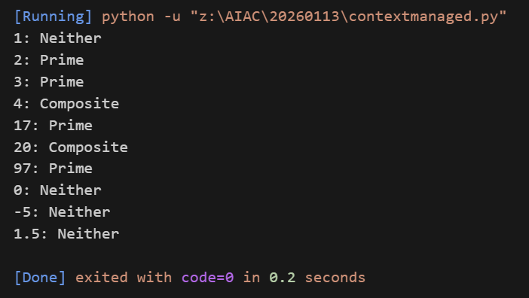

Explanation:

This question used context-managed prompting with clear rules and constraints. The prompt specified input validation, efficiency, and the exact output format. As a result, the program used an optimized approach by checking divisibility only up to the square root of the number. It correctly classified numbers as prime, composite, or neither. Edge cases like numbers less than or equal to one were handled properly. This method produced more reliable and efficient code than earlier prompting techniques.
Question 5:
Zero-Shot Prompting (Perfect Number Check)
Write a zero-shot prompt (without providing any examples) to generate a Python function that checks whether a given number is a perfect number.
Task:
• Record the AI-generated code.
• Test the program with multiple inputs.
• Identify any missing conditions or inefficiencies in the logic.
Prompt:
Write a Python function that checks whether a given number is a perfect number.
A perfect number is a number that is equal to the sum of its positive divisors, excluding itself.
The function should return True if the number is perfect; otherwise, it should return False.

Code:
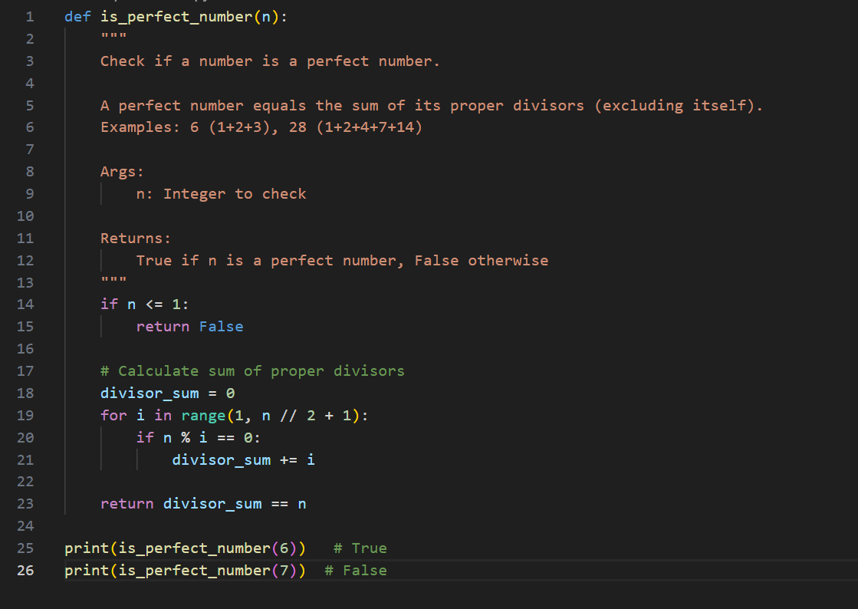

Output:
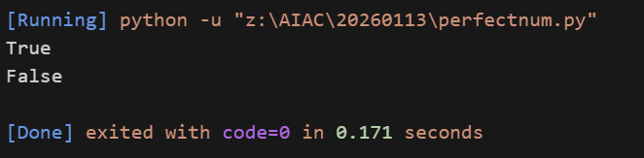

Explanation:

In this task, zero-shot prompting was used without any examples. The program checks whether the sum of proper divisors of a number is equal to the number itself. It correctly identifies perfect numbers such as 6 and 28. However, the approach is not optimized for large values. The program also lacks proper input validation for non-integer inputs. This highlights the limitations of zero-shot prompting when handling complex conitions.
Question 6:
Few-Shot Prompting (Even or Odd Classification with Validation)
Write a few-shot prompt by providing multiple input-output examples to guide the AI in generating a Python program that determines whether a given number is even or odd, including proper input validation. Examples:
• Input: 8 → Output: Even
• Input: 15 → Output: Odd
• Input: 0 → Output: Even Task:
• Analyze how examples improve input handling and output clarity.
• Test the program with negative numbers and non-integer inputs.

Prompt:
Write a Python program that checks whether a given input number is Even or Odd.
Examples:
Input: 8 Output: Even
Input: 15 Output: Odd
Input: 0 Output: Even
The program should validate the input and display a proper message if the input is not a valid integer.

Code:
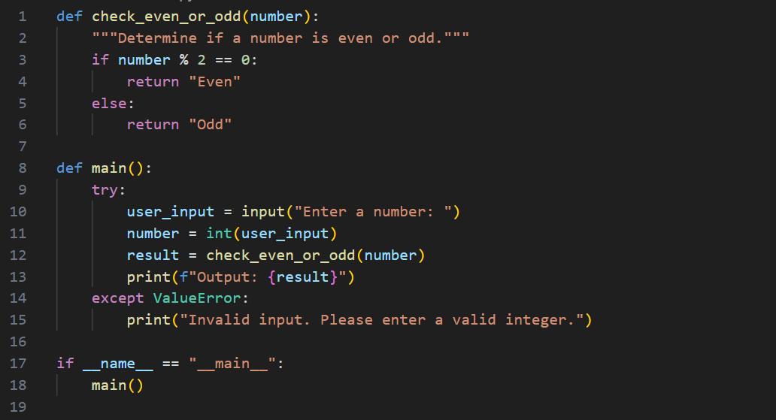
Output:
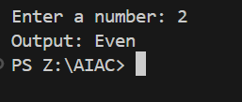

EXPLANATION:
Few-shot prompting was used by providing examples for even, odd, and zero values. These examples clearly defined the expected output format. They also encouraged proper input validation in the program. The function correctly identifies even and odd numbers, including negative values. Invalid inputs such as strings or decimal numbers are handled gracefully. This shows that few-shot prompting improves clarity, reliability, and input handling.

