AIAC

Lab Assignment 9.5

Name: N.Nithin Varma
HT No: 2303A52011
Batch: 31

Problem 1: String Utilities Function
Consider the following Python function:
def reverse_string(text):
return text[::-1]
Task:
1. Write documentation in:
o (a) Docstring
o (b) Inline comments
o (c) Google-style documentation
2. Compare the three documentation styles.
3. Recommend the most suitable style for a utility-based string
library.

Code:
(a) Docstring
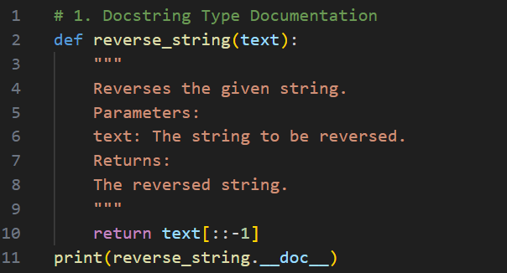
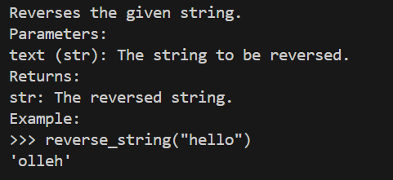
(b) Inline comments
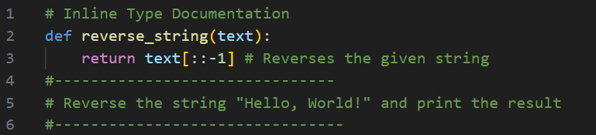
(c) Google-style documentation
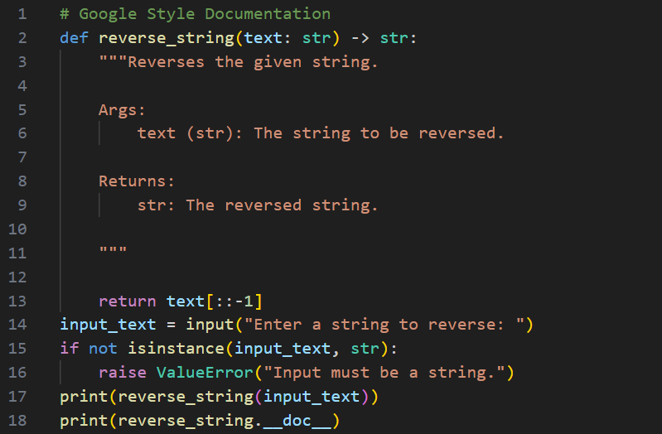

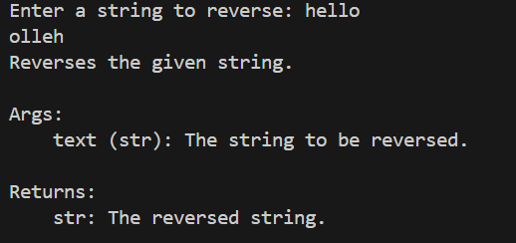

2. Compare the three documentation styles.

Aspect | Docstring | Inline Comments | Google-Style
Scope | Function | Line | Function
Structure | Basic | None | Structured
Readability | Good | Simple | Clear
Detail Level | Medium | Low | High
Tool Support | Yes | No | Yes
Professional Use | Moderate | Low | High
Best For | Scripts | Logic | Libraries

3. Recommend the most suitable style for a utility-based string
library.
Google-style documentation is most suitable for a utility-based string library because it reflects professional coding standards and industry practices.
Problem 2: Password Strength Checker
Consider the function:
def check_strength(password):
return len(password) >= 8
Task:
1. Document the function using docstring, inline comments, and
Google style.
2. Compare documentation styles for security-related code.
3. Recommend the most appropriate style.

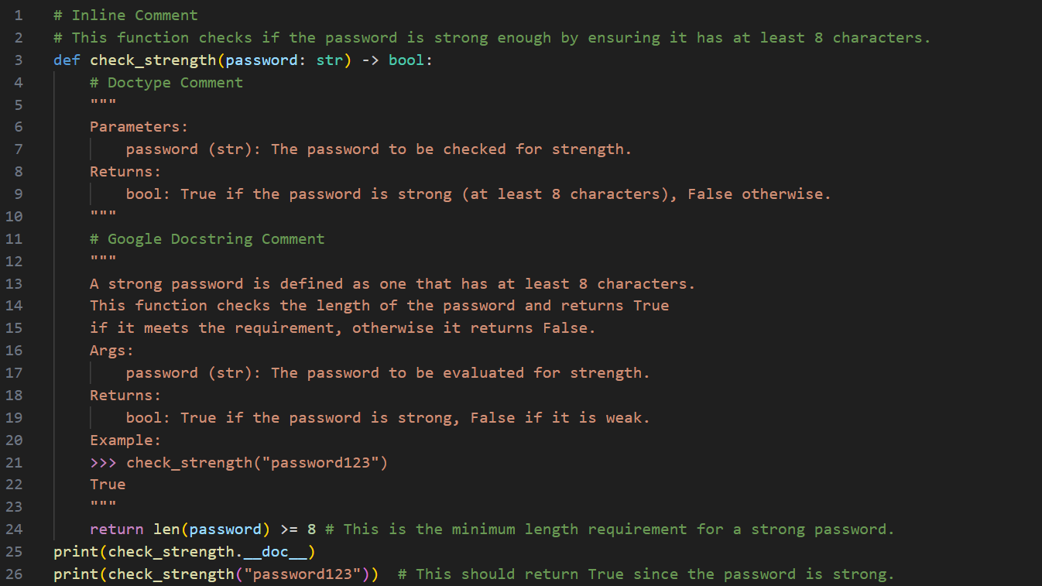
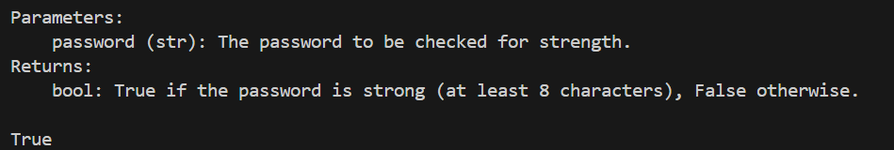
2. Compare documentation styles for security-related code.
Aspect | Docstring | Inline Comments | Google-Style
Clarity | Good | Basic | Very Clear
Structure | Simple | None | Structured
Security Explanation | Limited | Minimal | Detailed
Professional Use | Moderate | Low | High
Maintainability | Medium | Low | High
Industry Preference | Acceptable | Rare | Strong

3. Recommend the most appropriate style.
For security-related code like password validation, Google-style documentation is most appropriate because it ensures clarity, professionalism, and maintainability.

Problem 3: Math Utilities Module
Task:
1. Create a module math_utils.py with functions:
o square(n)
o cube(n)
o factorial(n)
2. Generate docstrings automatically using AI tools.
3. Export documentation as an HTML file.

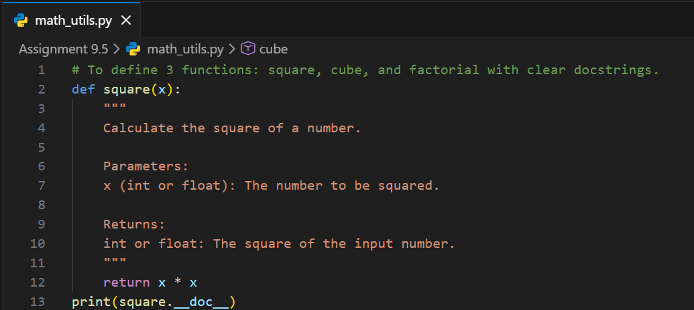
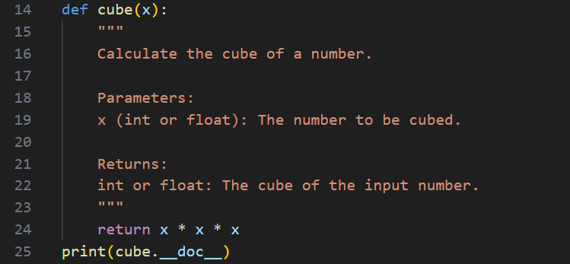
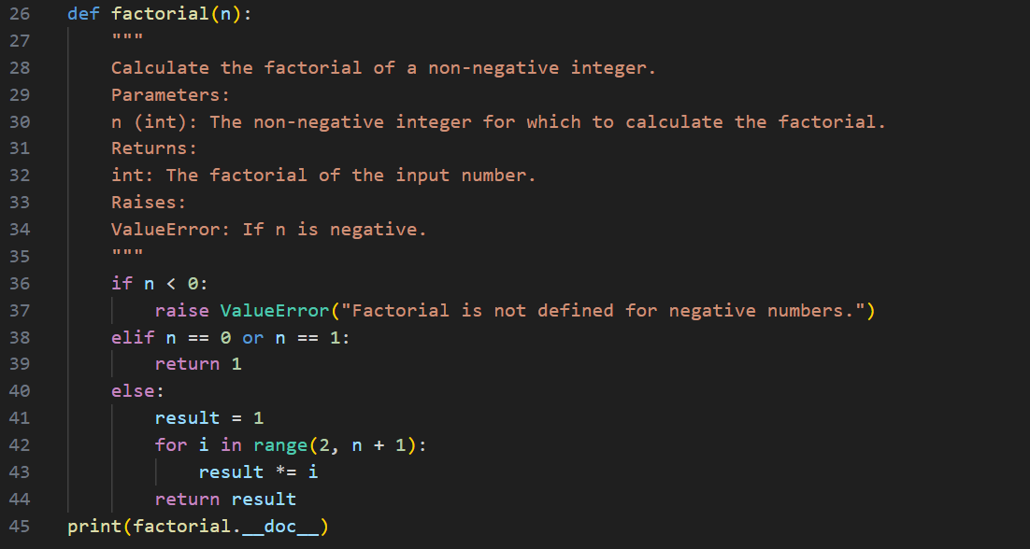

3. Export documentation as an HTML file.
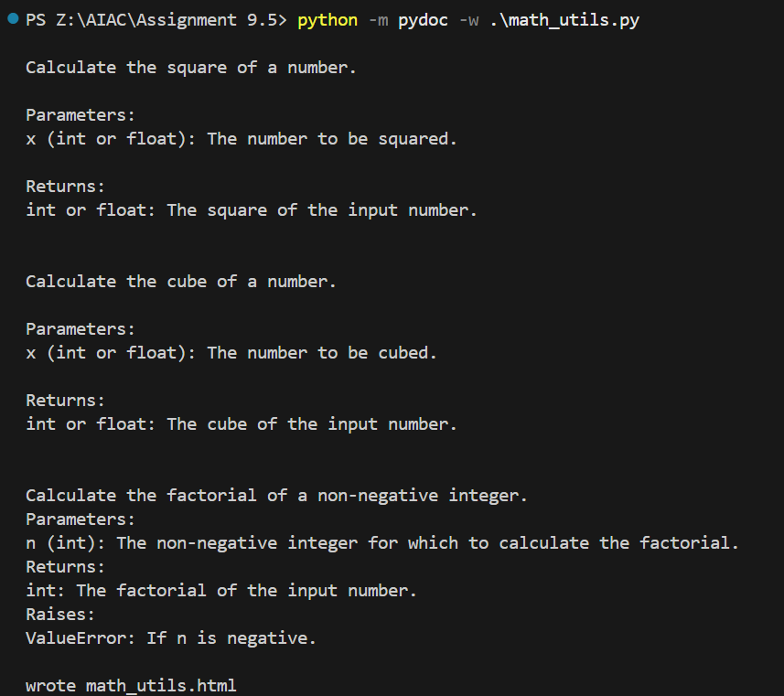
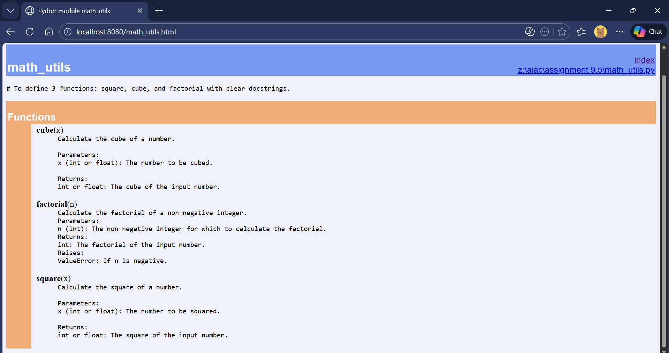

Problem 4: Attendance Management Module
Task:
1. Create a module attendance.py with functions:
o mark_present(student)
o mark_absent(student)
o get_attendance(student)
2. Add proper docstrings.
3. Generate and view documentation in terminal and browse

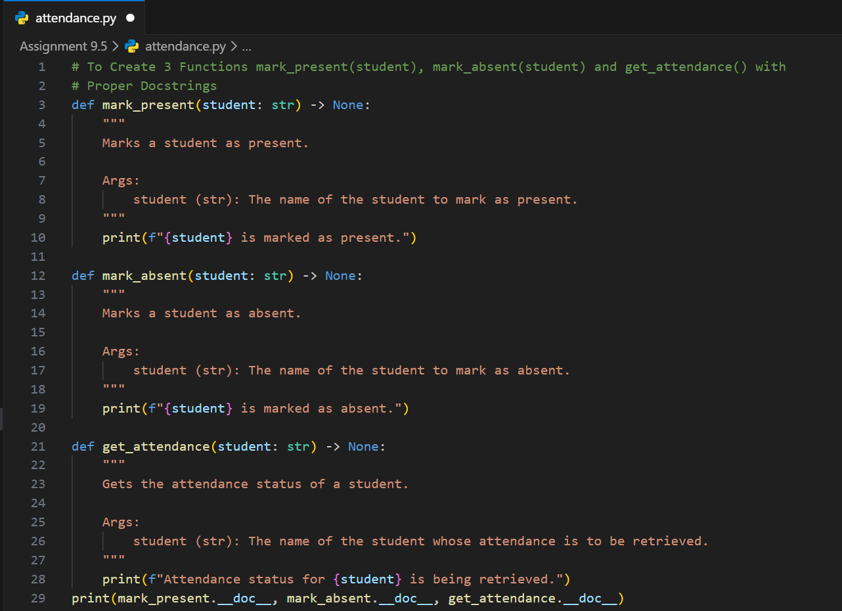
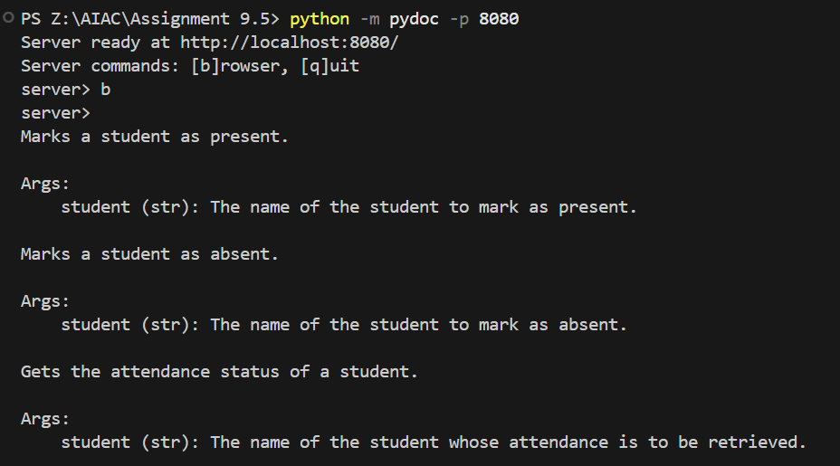
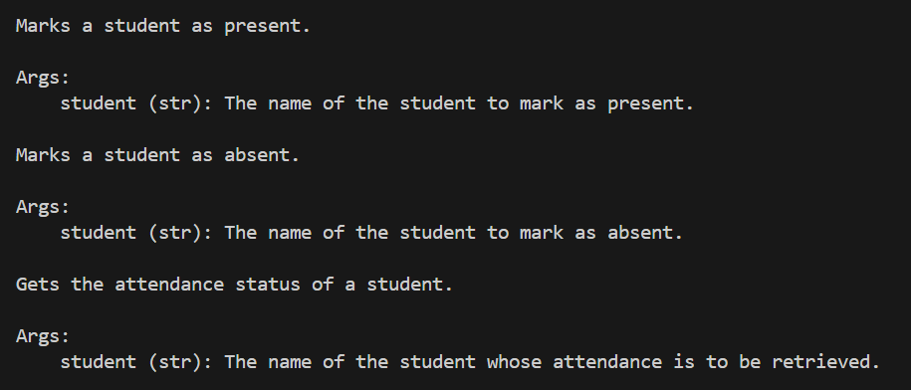
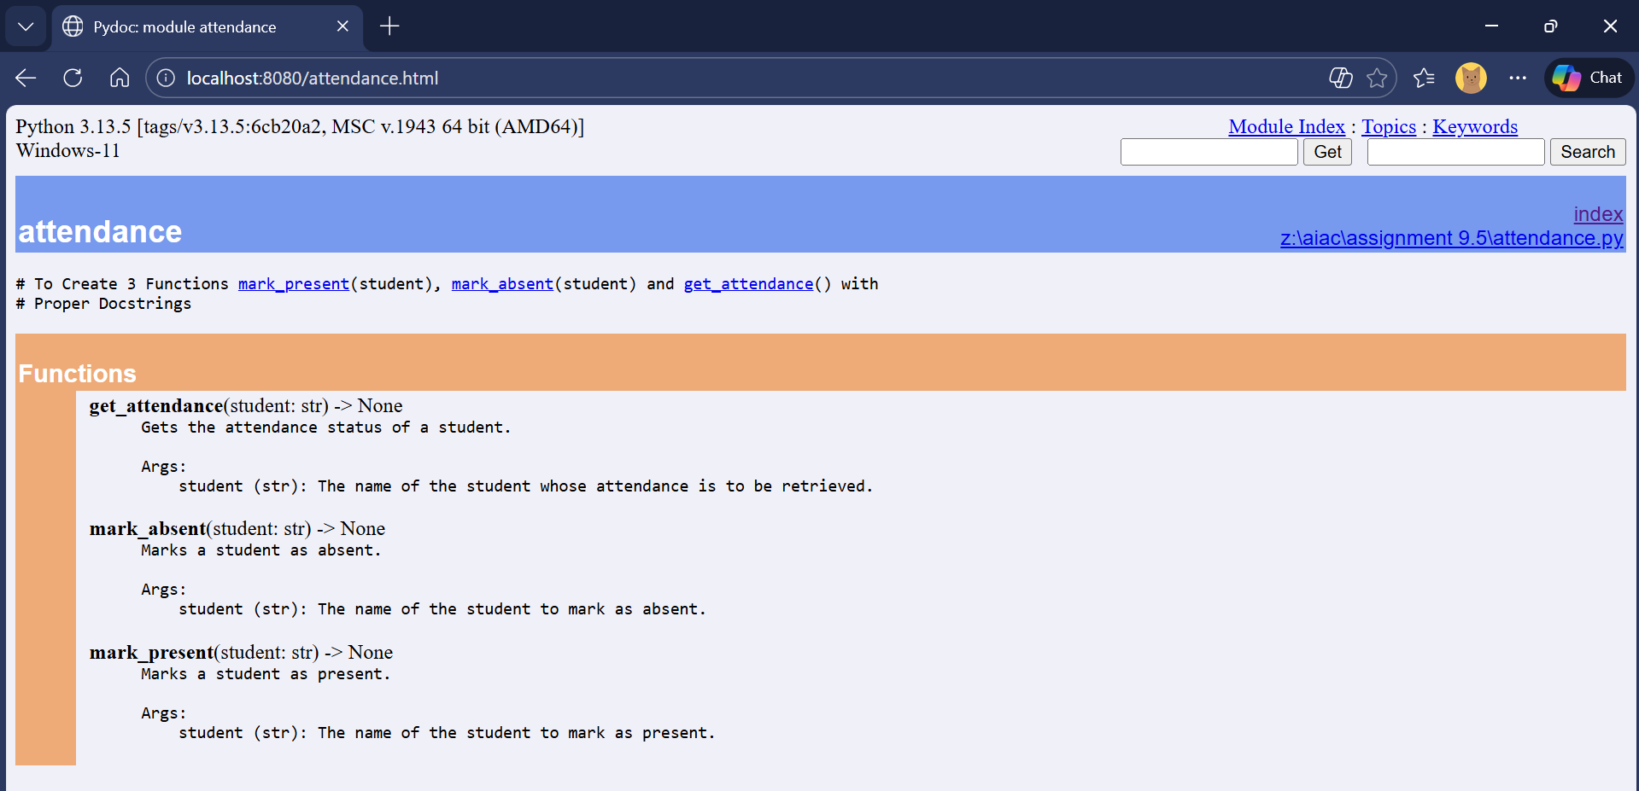

Problem 5: File Handling Function
Consider the function:
def read_file(filename):
with open(filename, 'r') as f:
return f.read()
Task:
1. Write documentation using all three formats.
2. Identify which style best explains exception handling.
3. Justify your recommendation.
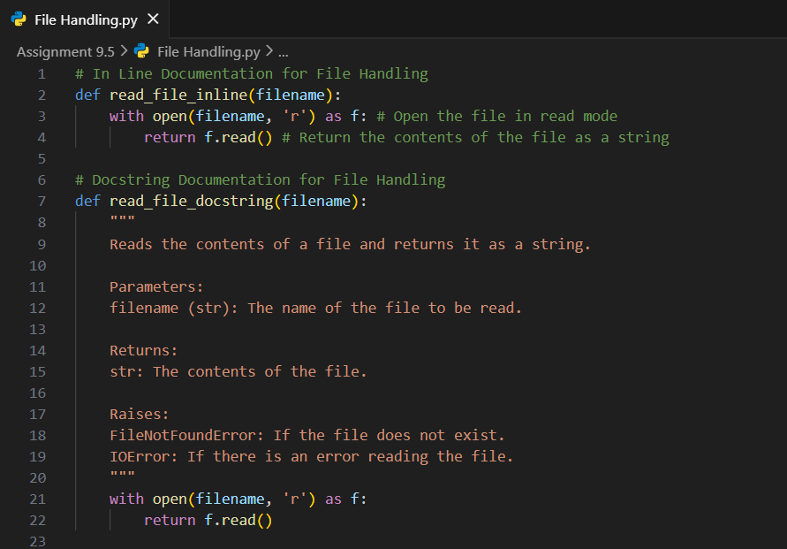
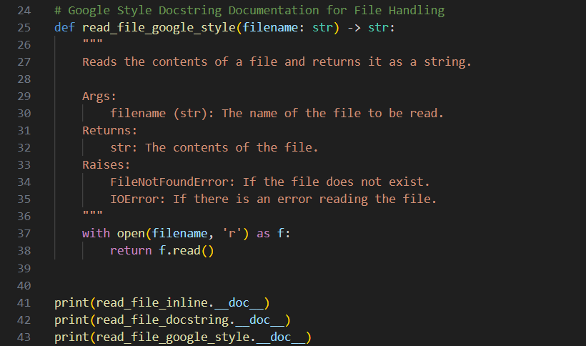
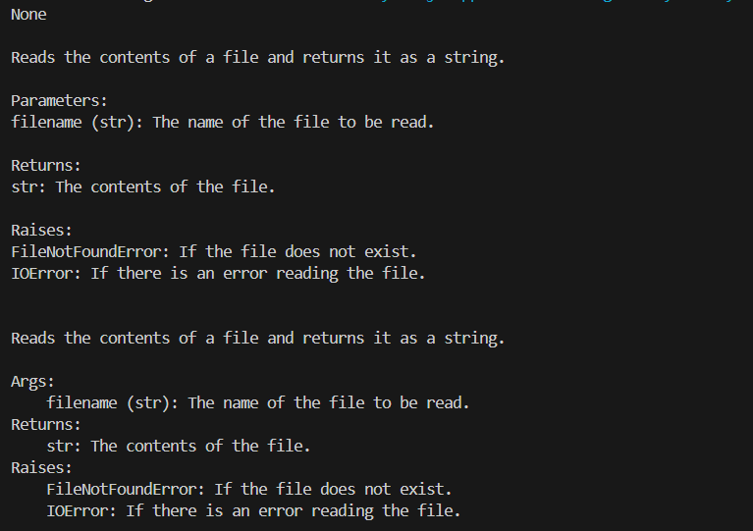

Identify which style best explains exception handling, Justify your recommendation.
Google Style Docstring
It clearly separates exceptions under a dedicated "Raises" section, making error handling easy to understand and professionally structured.

