AI Assisted Coding

ASSIGNMENT 3.3

Name: N.Nithin Varma
HT No: 2303A52011
Batch: 31

Lab 3: Application for TGNPDCL - Electricity Bill Generation Using Python & AI Tools

Lab Objectives
• To design a real-world electricity billing application using Python
• To use AI-assisted coding tools for logic generation and optimization
• To understand conditional logic and arithmetic operations
• To generate structured billing output similar to utility bills

Question 1:
Task 1: AI-Generated Logic for Reading Consumer Details
Scenario:
An electricity billing system must collect accurate consumer data.
Task Description:
Use an AI tool (GitHub Copilot / Gemini) to generate a Python program that:
• Reads:
Previous Units (PU)
Current Units (CU)
Type of Customer
• Calculates units consumed
• Implements logic directly in the main program (no functions)

Expected Output:

• Correct input reading

• Units consumed calculation

• Screenshot showing AI-generated code

• Sample input and output

Prompt:
Write a Python program for an electricity billing system that asks the user to enter Previous Units, Current Units, and Customer Type.
The program should calculate the units consumed by subtracting previous units from current units.
All calculations and logic should be written directly in the main program without using functions.
Finally, display the entered values and the calculated units consumed.

Code:
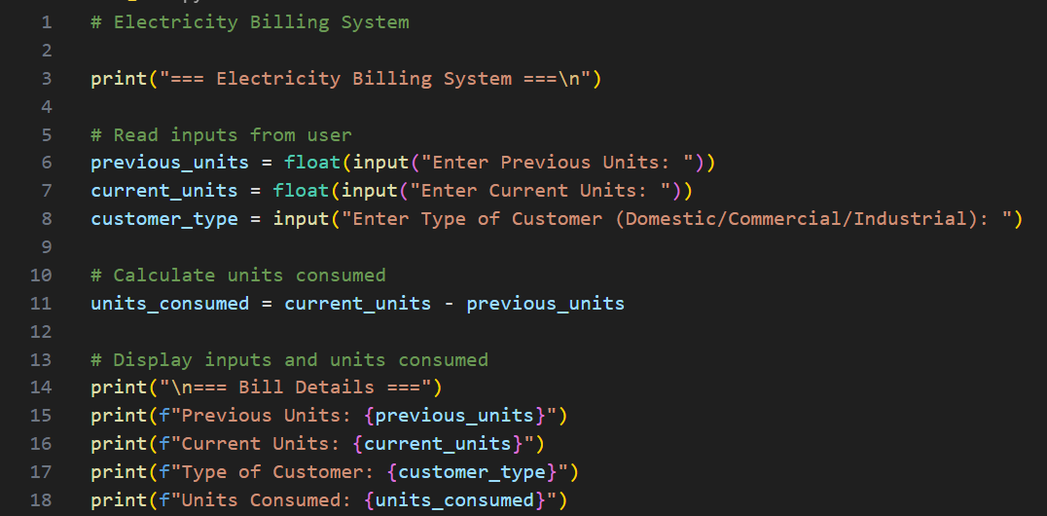
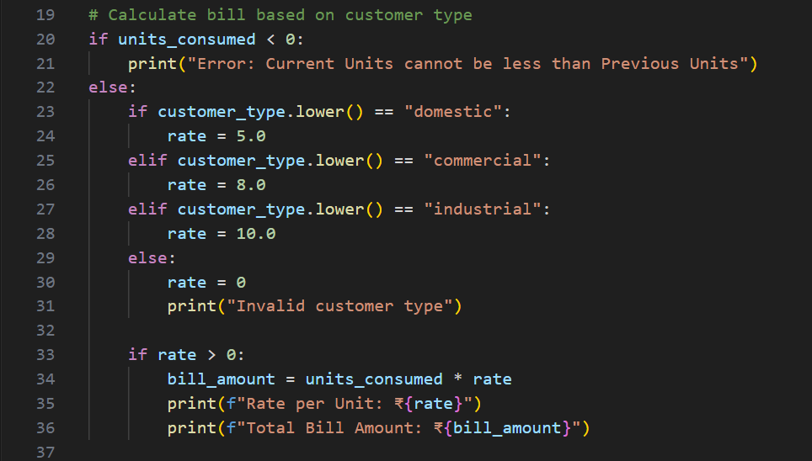

Output(O/P)
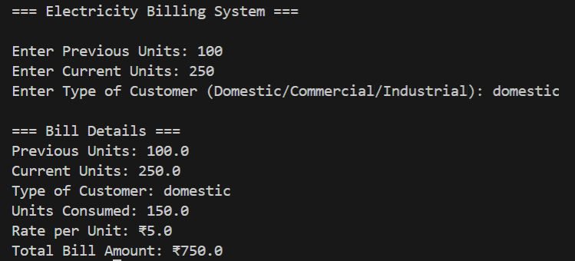
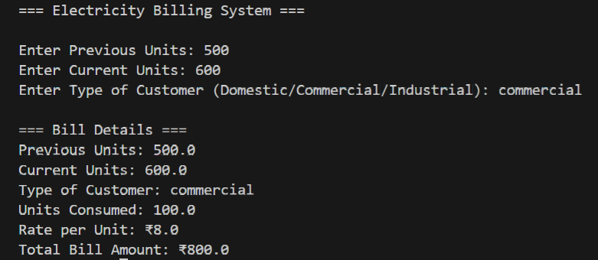
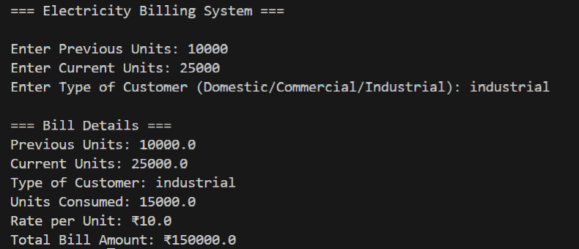

Explanation:

In this task, an AI tool was used to generate a basic Python program that reads consumer details such as previous units, current units, and customer type. The program calculates the units consumed by finding the difference between current and previous readings. All logic is written directly in the main program to keep it simple and easy to understand. The output clearly displays the input values and the calculated units consumed. This task helps in understanding user input handling and basic arithmetic operations.

Question 2:
Task 2: Energy Charges Calculation Based on Units Consumed Scenario:
Energy charges depend on the number of units consumed and customer type.
Task Description:
Review the AI-generated code from Task 1 and extend it to:
• Calculate Energy Charges (EC)
• Use conditional statements based on:
Domestic
Commercial
Industrial consumers
• Improve readability using AI prompts such as:
“Simplify energy charge calculation logic”
“Optimize conditional statements”
Expected Output
• Correct EC calculation
• Clear conditional logic
• Original and improved versions (optional)
• Sample execution results

Prompt:
Review the existing electricity billing program and extend it to calculate Energy Charges based on the number of units consumed and the type of customer.
Use conditional statements to apply different charge rates for Domestic, Commercial, and Industrial customers.
Improve the readability of the code by simplifying the charge calculation logic and optimizing conditions.
Display the units consumed, customer type, and calculated Energy Charges.
Code:
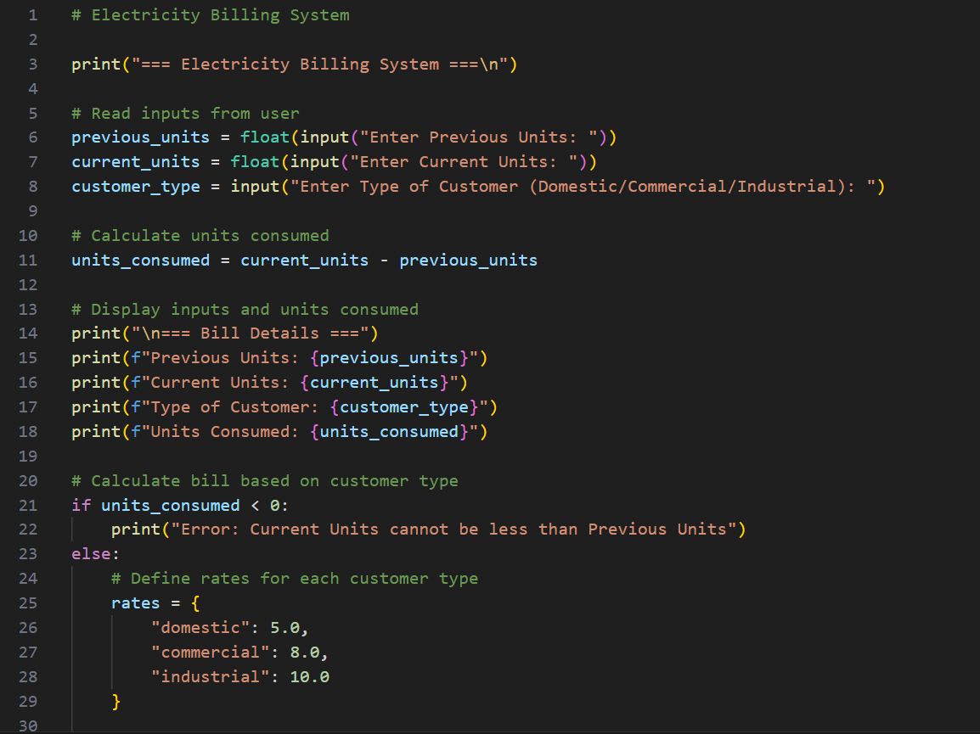
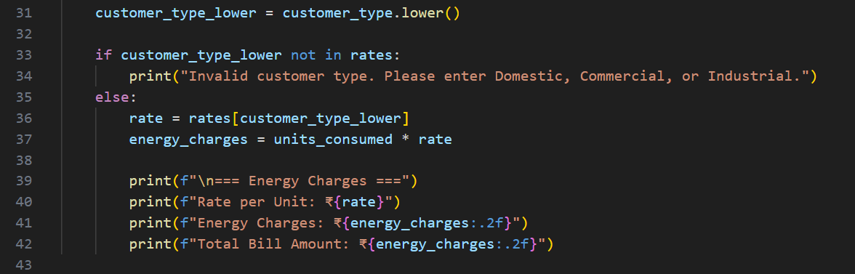
Output:
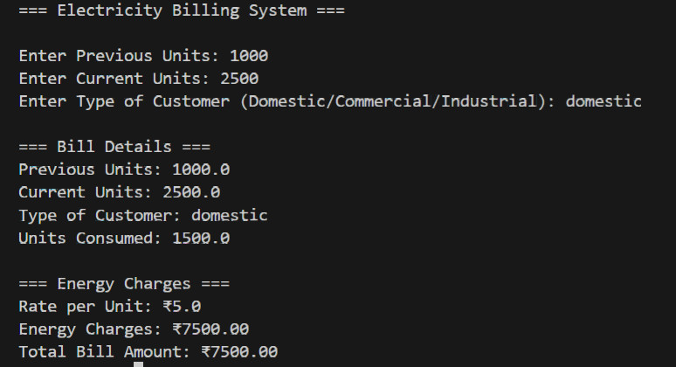

Explanation:

In this task, the earlier program is extended to calculate Energy Charges based on customer type and units consumed. Conditional statements are used to apply different tariff rates for Domestic, Commercial, and Industrial consumers. AI assistance helps simplify the logic and make the conditions more readable. The program correctly calculates and displays the energy charges along with customer details. This task improves understanding of decision-making statements in Python.

Question 3:
Task 3: Modular Design Using AI Assistance (Using Functions) Scenario:
Billing logic must be reusable for multiple consumers.
Task Description:
Use AI assistance to generate a Python program that:
• Uses user-defined functions to:
Calculate Energy Charges
Calculate Fixed Charges
• Returns calculated values
• Includes meaningful comments
Expected Output:
• Function-based Python program
• Correct EC and FC values
• Screenshots of AI-assisted function generation
• Test cases with outputs
Prompt:
Create a Python electricity billing program using a modular approach.
Define separate user-defined functions to calculate Energy Charges and Fixed Charges based on units consumed and customer type.
Each function should return the calculated value and include meaningful comments.
In the main program, read inputs, call the functions, and display the results clearly.
Code:
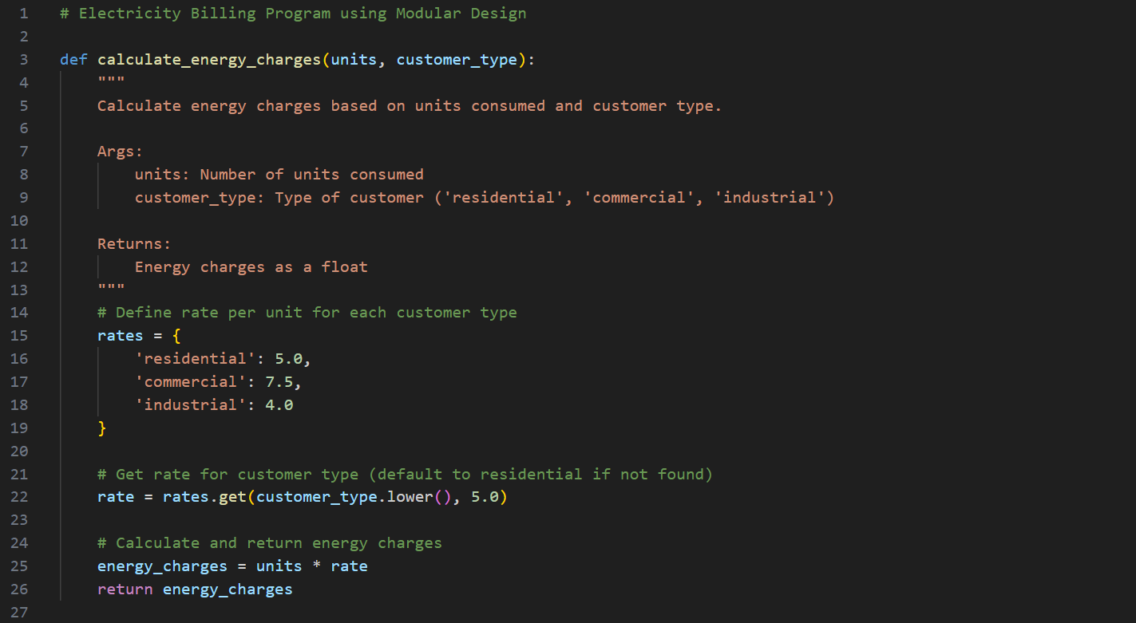
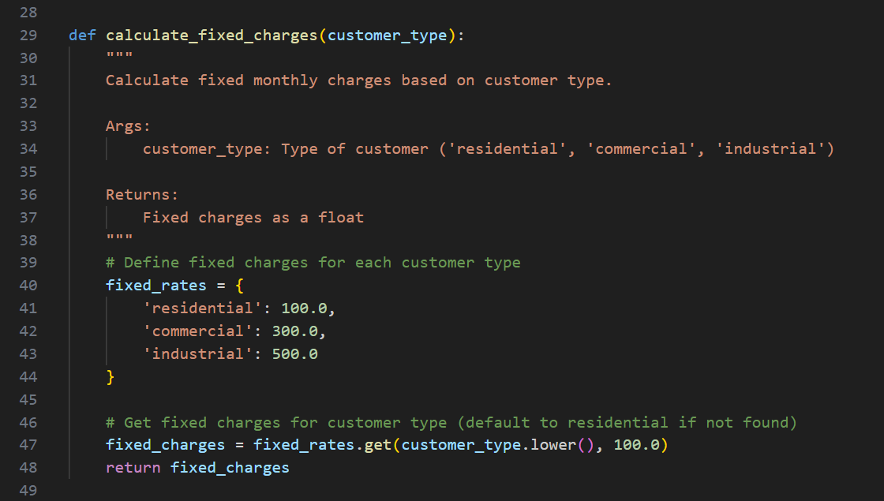
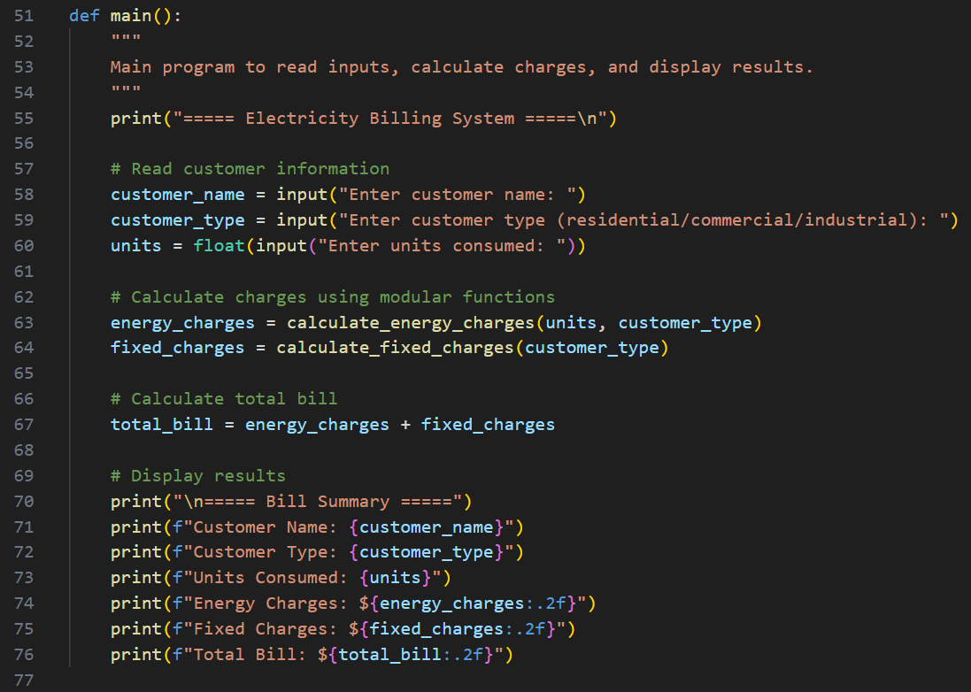
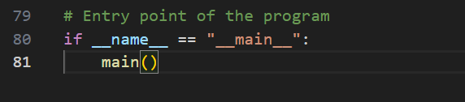
Output:
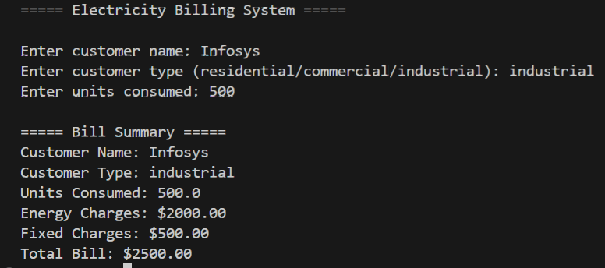

Explanation:

This task focuses on using functions to make the electricity billing program modular and reusable. Separate functions are created to calculate Energy Charges and Fixed Charges, which improves code organization. Each function returns its calculated value, making the program easy to modify and reuse for multiple consumers. Meaningful comments help in understanding the logic. The main program collects input, calls the functions, and displays correct billing values.

Question 4:
Task 4: Calculation of Additional Charges
Scenario:
Electricity bills include multiple additional charges.
Task Description:
Extend the program to calculate:
• FC – Fixed Charges
• CC – Customer Charges
• ED – Electricity Duty (percentage of EC)
Use AI prompts like:
• “Add electricity duty calculation”
• “Improve billing accuracy”
Expected Output
• Individual charge values printed
• Correct duty calculation
• Well-structured output
• Verified intermediate results

Prompt:
Extend the electricity billing program to calculate additional charges such as Fixed Charges, Customer Charges, and Electricity Duty.
Electricity Duty should be calculated as a percentage of Energy Charges.
Display each charge separately and show intermediate calculation results.
Ensure accurate calculations and present the output in a clear and structured format.
Code:
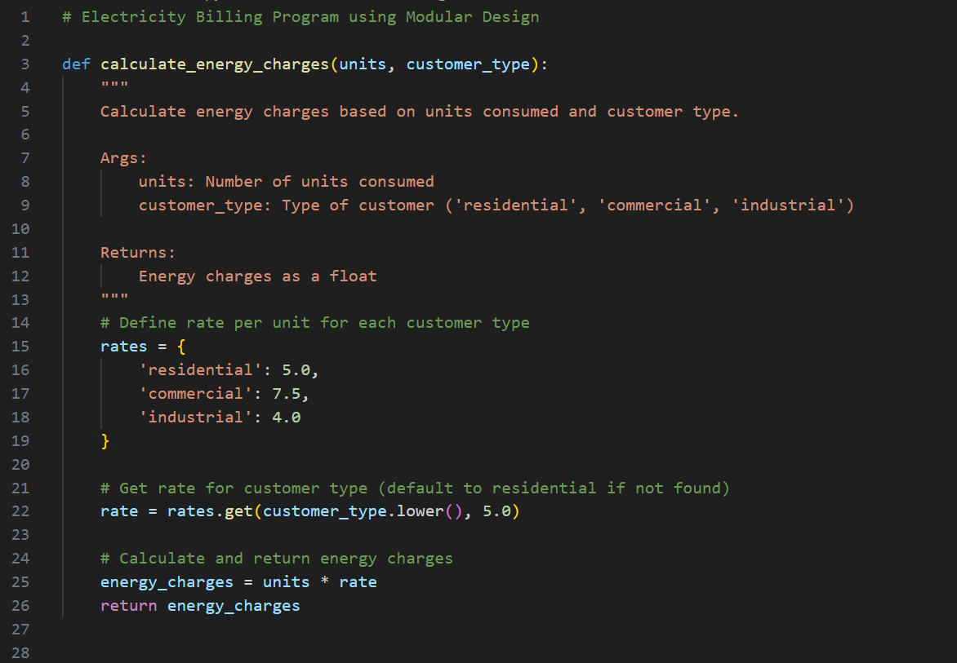

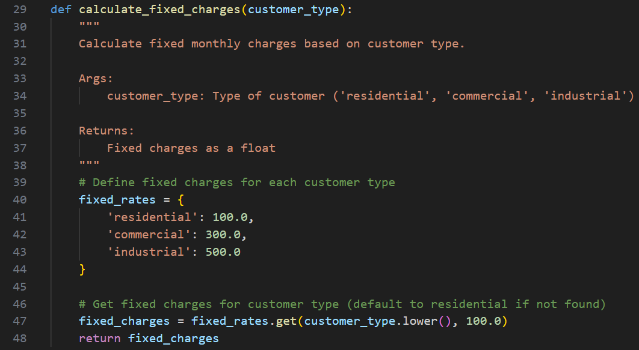
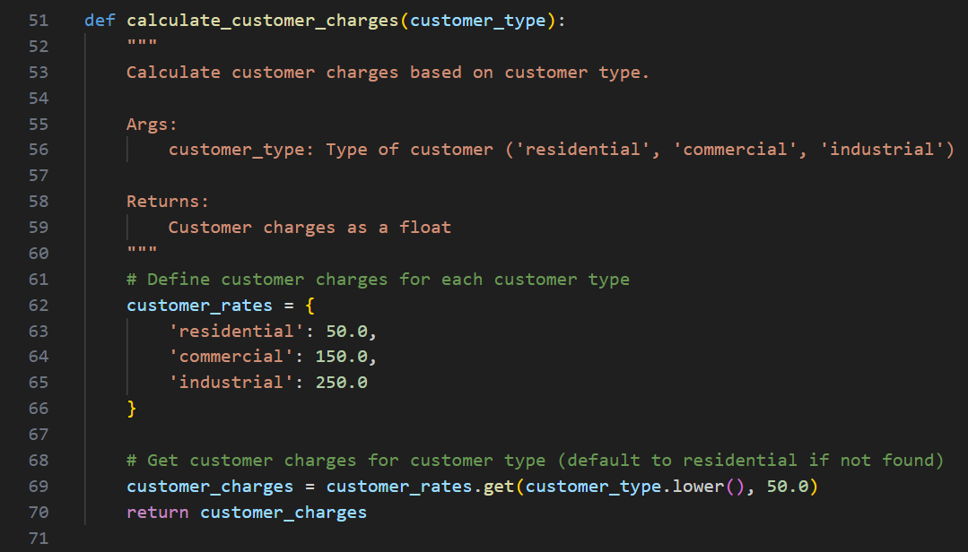
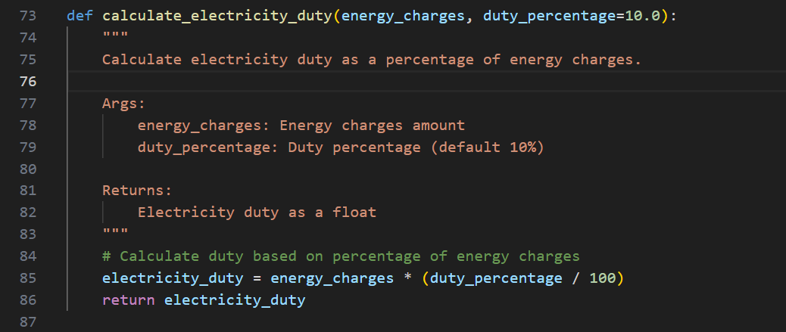
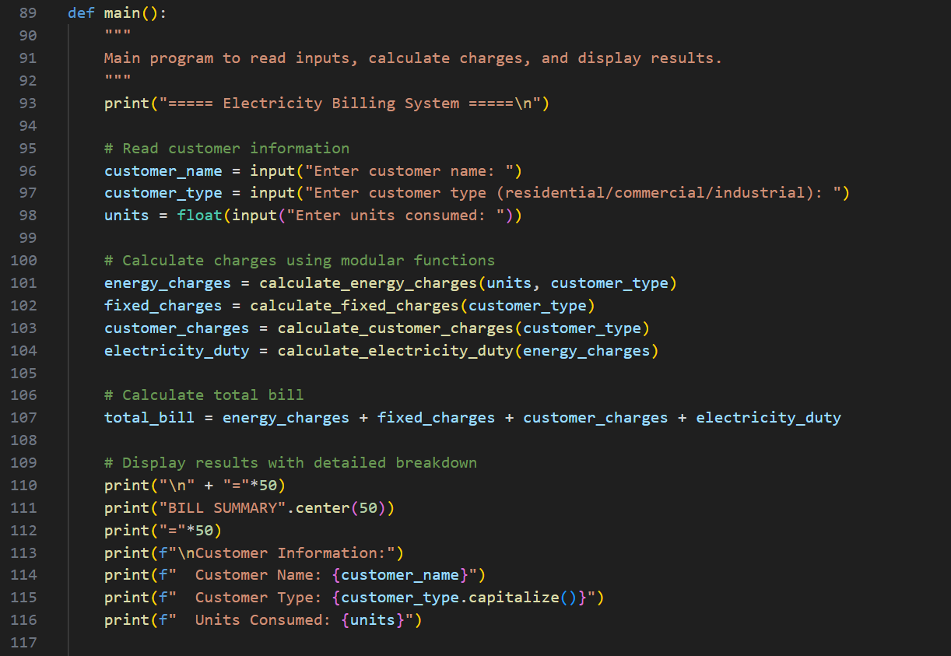
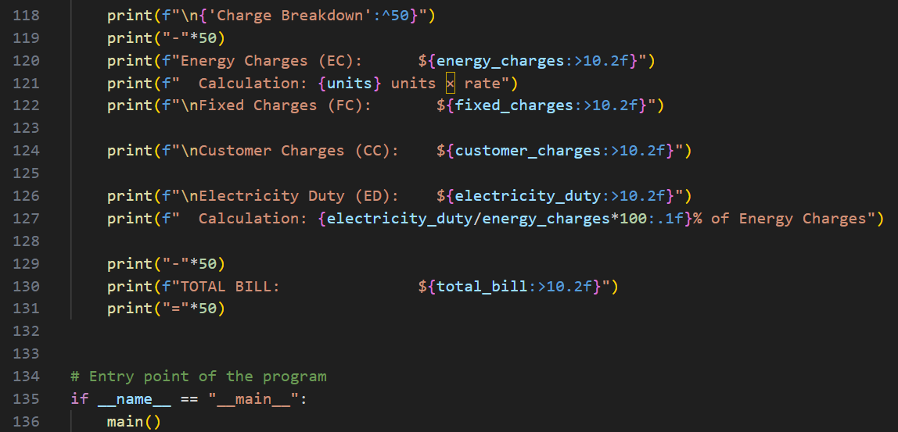
Output:
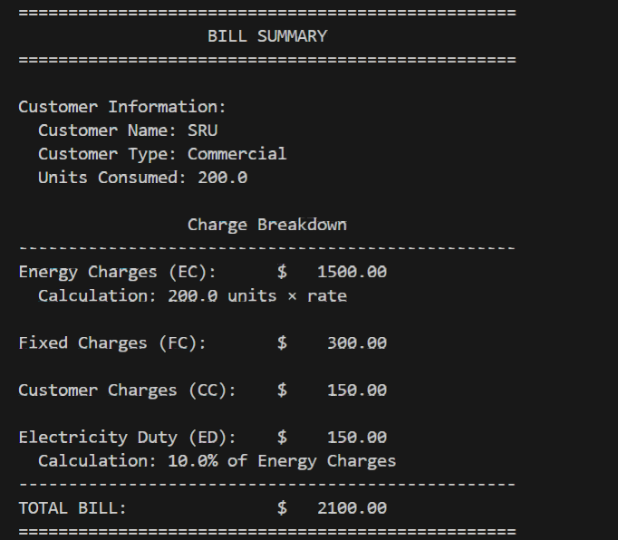

Explanation:

In this task, additional billing components like Fixed Charges, Customer Charges, and Electricity Duty are added to the program. Electricity Duty is calculated as a percentage of Energy Charges to reflect real billing practices. AI assistance helps improve accuracy and structure in the calculations. Each charge is displayed separately, making the bill easy to understand. This task helps simulate a real-world electricity billing system more closely.

Question 5:
Task 5: Final Bill Generation and Output Analysis
Scenario:
The final electricity bill must present all values clearly.
Task Description:
Develop the final Python application to:
• Calculate total bill:
• Total Bill = EC + FC + CC + ED
• Display:
Energy Charges (EC)
Fixed Charges (FC)
Customer Charges (CC)
Electricity Duty (ED)
Total Bill Amount
• Analyze the program based on:
Accuracy
Readability
Real-world applicability
Expected Output
• Complete electricity bill output
• Neatly formatted display
• Sample input/output
• Short analysis paragraph

Prompt:
Develop the final Python electricity billing application that calculates Energy Charges, Fixed Charges, Customer Charges, and Electricity Duty.
Compute the Total Bill as the sum of all charges.
Display each charge clearly along with the total bill amount in a neatly formatted output suitable for an electricity bill.
Code:
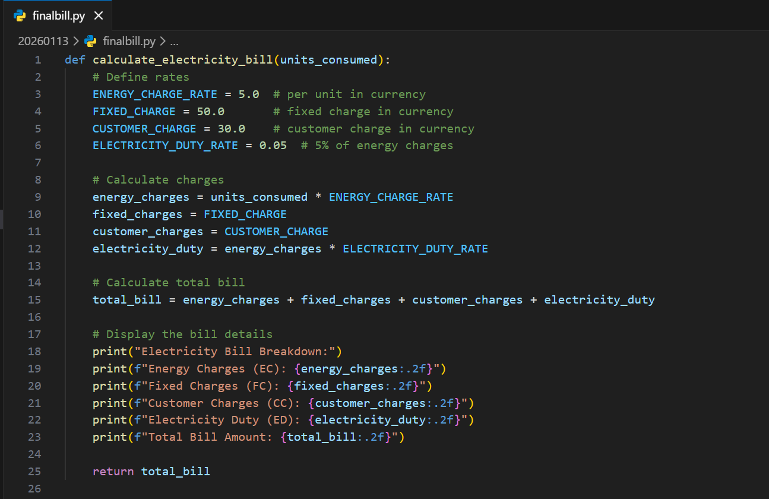
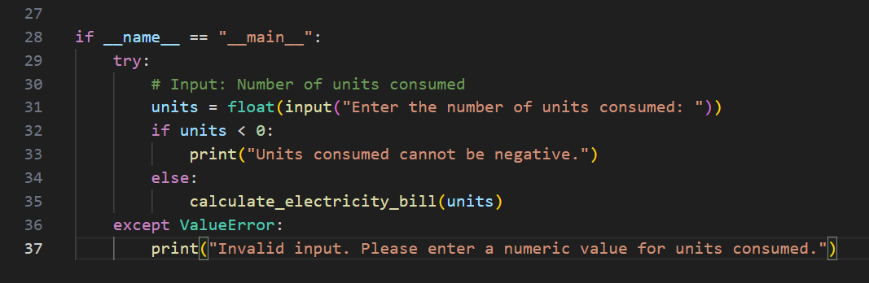

Output:
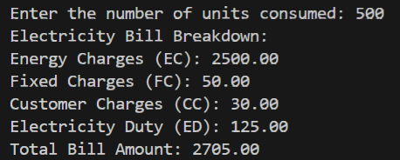

Explanation:
In the final task, all calculated charges are combined to generate the total electricity bill. The program adds Energy Charges, Fixed Charges, Customer Charges, and Electricity Duty to compute the final amount. The output is neatly formatted to clearly display each charge and the total bill value. The program is accurate, readable, and closely matches real-world electricity billing systems. This makes the application practical and easy to extend in the future.

