COMPUTER VISION FOR REAL-TIME ROBOTIC PERCEPTION AND DECISION-MAKING
Master title: MSc Dissertation
Name: Nithin
Year: 2026

ABSTRACT
This dissertation evaluates how computer vision can support real-time robotic perception and decision-making when camera evidence must be converted into reliable action-relevant information. The empirical design was strengthened from a small demonstration into a reproducible COCO val2017 evaluation using 200 sampled images, 1,410 annotated target objects, eight decision-relevant classes, a fixed random seed and no small-object exclusion. Faster R-CNN ResNet50-FPN v2 was compared with SSDlite320 MobileNetV3-Large across six confidence thresholds, per-class performance, object-size recall, controlled robustness perturbations, latency and a rule-based decision-state proxy. Faster R-CNN selected threshold 0.70 as the strongest measured operating point, achieving 0.723 precision, 0.731 recall, 0.727 F1, 0.760 mAP50 and 0.925 decision-state accuracy, but only 0.203 FPS on CPU. SSDlite reached 9.520 FPS and 105 ms mean latency, but its 0.183 recall and 0.298 F1 showed that speed alone was not decision-ready. The dissertation concludes that computer vision can support robotic decision evidence, but static public images cannot validate embodied autonomy without temporal, spatial, hardware and safety testing.
Keywords: computer vision; robotic perception; object detection; Faster R-CNN; SSDlite; COCO dataset; decision-readiness.

CONTENTS
COMPUTER VISION FOR REAL-TIME ROBOTIC PERCEPTION AND DECISION-MAKING 1
ABSTRACT 2
CONTENTS 3
LIST OF FIGURES 6
LIST OF TABLES 6
ACKNOWLEDGEMENTS 7
DISSERTATION DECLARATION 8
DISSERTATION THESIS 9
INTRODUCTION 10
0.1 Background and Context 10
0.2 Problem Statement 11
0.3 Aim and Objectives 11
0.4 Research Questions 12
0.5 Scope and Contribution 12
0.6 Dissertation Structure 13
CHAPTER ONE - LITERATURE REVIEW I 14
1.1 Real-Time Robotic Perception as a Systems Problem 14
1.2 Object Detection and the Shift Toward Real-Time Perception 15
1.3 CNN-Based Detection and Feature Pyramids 16
1.4 Lightweight Architectures and Deployment Pressures 17
1.5 Tracking, Temporal Consistency and Action Stability 18
1.6 Spatial Perception and Visual SLAM in Robotics 19
1.7 Interim Synthesis 20
CHAPTER TWO - LITERATURE REVIEW II 21
2.1 Decision-Making Depends on Perception Reliability 21
2.2 Dataset Benchmarks and Ecological Validity 22
2.3 Metrics for Robotic Perception 23
2.4 Real-Time Feasibility and Edge Constraints 24
2.5 Ethics, Privacy and Responsible Public Data Use 25
2.6 Critical Gap and Conceptual Framework 25
CHAPTER THREE - METHODOLOGY 27
3.1 Research Philosophy and Design 27
3.2 Dataset and Sampling Strategy 27
3.3 Model Selection and Implementation Environment 28
3.4 Metrics and Matching Rules 29
3.5 Threshold and Decision-State Protocol 30
3.6 Per-Class, Object-Size, Error and Robustness Analysis 31
3.7 Procedure and Reproducibility 32
3.8 Validity, Reliability and Ethics 32
3.9 Methodological Reflection 33
CHAPTER FOUR - FINDINGS / ANALYSIS / DISCUSSION 34
4.1 Experimental Overview 34
4.2 Overall Detection Performance 34
4.3 Per-Class Performance 36
4.4 Confidence-Threshold Analysis 37
4.5 Accuracy-Latency Trade-Off 39
4.6 Model Comparison 40
4.7 Error Analysis 41
4.8 Robustness Analysis 42
4.9 Object-Size Analysis 43
4.10 Decision-State Evaluation 45
4.11 Statistical Analysis 47
4.12 Discussion Against the Literature and Implications for Robotic Deployment 47
CONCLUDING REMARKS 48
BIBLIOGRAPHY 50
APPENDIX 53
Appendix A: Reproducibility Artefacts 53
Appendix B: Expanded Evaluation Configuration 53
Appendix C: Model Configuration Boundary 53
Appendix D: Interpretation Boundary 53

LIST OF FIGURES
Figure 3.1 Evaluation pipeline linking visual input to model comparison, metric analysis and decision-readiness evidence.
Figure 4.1 Overall detection performance at selected operating points.
Figure 4.2 Confidence-threshold sensitivity across both detector families.
Figure 4.3 Per-class F1 at selected operating points.
Figure 4.4 Accuracy-latency trade-off between Faster R-CNN and SSDlite.
Figure 4.5 Object-size recall for small, medium and large COCO objects.
Figure 4.6 Robustness subset F1 under controlled perturbations.
Figure 4.7a Decision-state confusion matrix for Faster R-CNN.
Figure 4.7b Decision-state confusion matrix for SSDlite.
Figure 4.8 Representative detection errors from the expanded evaluation.

LIST OF TABLES
Table 3.1 Metrics used to connect perception output with robotic decision-readiness.
Table 3.2 Reproducible sample profile for the expanded COCO validation evaluation.
Table 3.3 Detector models used for the accuracy-latency comparison.
Table 4.1 Overall detection and decision-readiness performance at selected operating points.
Table 4.2 Confidence-threshold sensitivity across both detector families.
Table 4.3 Per-class performance at selected operating points.
Table 4.4 Object-size recall and localisation quality using ground-truth COCO size bins.
Table 4.5 Robustness subset results compared with original images.
Table 4.6 Decision-state proxy accuracy and decision-risk counts.
Table 4.7 Variation and uncertainty indicators at selected operating points.

ACKNOWLEDGEMENTS
I acknowledge the academic guidance, technical resources and open research datasets that made this dissertation possible. The work relies on publicly available benchmark material and open-source software, and the analysis was developed with attention to reproducibility, academic integrity and transparent reporting. The dissertation is submitted with appreciation for the academic supervision and institutional support that shaped the work.

DISSERTATION DECLARATION
Statement of compliance with academic ethics and the avoidance of plagiarism.
I honestly declare that this dissertation is entirely my own work and that no part has been copied from printed or electronic sources without acknowledgement. Where published research, datasets, software documentation or benchmark material have informed the discussion, they have been cited in the text and listed in the bibliography. The experimental results reported in Chapter Four were generated from the local project code, saved tables and public COCO validation annotations.
Name and Surname: NITHIN
Date: 09 September 2026

DISSERTATION THESIS

INTRODUCTION

0.1 Background and Context
Robots increasingly operate in environments that are dynamic, visually complex and only partly controllable. A mobile service robot, an industrial manipulator, an autonomous vehicle or a warehouse inspection platform cannot rely only on fixed instructions because the objects, people and obstacles around it may change between one moment and the next. Computer vision addresses this problem by converting camera data into representations that a robot can use for navigation, manipulation, monitoring and action selection. The challenge is not simply to recognise an image after it has been captured. The challenge is to produce visual interpretation quickly enough, accurately enough and consistently enough for a robotic system to make decisions while the surrounding scene continues to change.
Computer vision has developed rapidly through convolutional neural networks, region-based detectors, single-shot object detectors, feature pyramid networks, lightweight model families and visual simultaneous localisation and mapping methods. These advances have made it possible to detect objects, estimate spatial relationships, track movement and interpret scenes with a level of accuracy that would have been difficult with earlier hand-crafted feature pipelines. However, the movement from image analysis to robotic decision-making is not automatic. A detector that performs well on a benchmark may still be too slow for real-time control, too unstable across frames, or insufficiently aligned with the risks and priorities of a particular robot task. The central issue for this dissertation is therefore the connection between perception output and decision-readiness.
Real-time robotic perception is a systems problem. Accuracy, latency, confidence, spatial alignment and failure behaviour must be considered together because a robot can be harmed by both false positives and false negatives. A false detection may cause unnecessary stopping, inefficient routing or incorrect grasp planning. A missed person, vehicle or obstacle may create a safety risk. A slow model may produce accurate detections after the action window has already passed. These tensions are especially important for robots that rely on vision as part of closed-loop behaviour, where perception and decision-making repeatedly influence each other. The dissertation therefore treats computer vision not only as an algorithmic achievement but also as an operational dependency within robotic autonomy.
The topic is academically relevant because current robotics applications often depend on computer vision models that were originally developed and benchmarked in broader computer vision contexts. Public datasets such as COCO (Lin et al., 2014), KITTI (Geiger et al., 2012) and TUM RGB-D (Sturm et al., 2012) provide valuable labelled or structured material, but their relationship to real robot decisions must be interpreted carefully. A dataset image can show whether a detector identifies a person or a traffic light, but it does not by itself prove that a robot can safely navigate, grasp, avoid, inspect or interact. For this reason, this dissertation uses public labelled data to evaluate perception quality and then interprets the result through a decision-readiness lens rather than claiming a complete physical robot deployment.

0.2 Problem Statement
The research problem is that real-time robotic decision-making requires visual perception that is both technically accurate and operationally usable, yet many evaluations focus on detection scores without explaining how those scores influence action. Object detection metrics such as precision, recall, F1 score and intersection over union are necessary because they quantify whether the model sees relevant objects and localises them correctly. They are not sufficient because a robot also needs timely and stable evidence. A model can have acceptable recall while producing too many false positives, or it can generate high-confidence detections while taking too long on available hardware. The gap between visual recognition and robotic action motivates the dissertation.
This problem becomes clearer when confidence thresholds are considered. A low threshold may increase recall by retaining more detections, but it may also introduce false detections that disturb decision-making. A high threshold may improve precision by filtering weak detections, but it may remove true objects that should have informed the robot's behaviour. In safety-related contexts, neither extreme is automatically correct. The useful operating point depends on the task, the cost of mistakes and the system's ability to handle uncertainty. The dissertation investigates this trade-off empirically using a reproducible detector evaluation and then discusses the implications for real-time robotic perception.

0.3 Aim and Objectives
The aim of this dissertation is to evaluate how a computer vision pipeline can support real-time robotic perception and decision-making by testing detection quality, processing latency, robustness and decision-readiness under reproducible public-dataset conditions.
1. Critically review computer vision methods used in robotic perception, including object detection, lightweight detection, tracking, spatial perception and real-time deployment constraints.
2. Design a reproducible technical evaluation protocol that links visual perception outputs to robotic decision-making requirements.
3. Implement a public-dataset evaluation using COCO val2017 annotations, a fixed sampling seed and eight decision-relevant object classes.
4. Compare an accuracy-oriented detector with a lightweight detector to evaluate the accuracy-latency trade-off rather than judging one model in isolation.
5. Assess detection quality using precision, recall, F1, IoU, AP50, mAP50, per-class performance, object-size recall, latency distribution, robustness behaviour and decision-state proxy outcomes.
6. Discuss the implications, limitations and future research directions for robotic systems that rely on visual perception without overstating public-image results as physical robot deployment.

0.4 Research Questions
RQ1. How do current computer vision methods support real-time robotic perception?
RQ2. Which technical metrics best indicate whether a vision pipeline is suitable for robotic decision-making?
RQ3. How does the balance between perception quality and processing latency affect decision-readiness?
RQ4. What limitations remain when dataset-based computer vision evaluation is used instead of physical robot deployment?

0.5 Scope and Contribution
The dissertation is scoped as a technical evaluation rather than a stakeholder survey. This design is appropriate because the research problem concerns measurable perception quality, processing latency and decision-readiness. The empirical component uses COCO val2017 because it provides public image annotations, reproducible object labels and a practical basis for checking detector behaviour without collecting identifiable live robot footage. The selected classes are person, bicycle, car, motorcycle, bus, truck, traffic light and stop sign because these objects can influence conservative robotic navigation and inspection decisions.
The study does not claim to produce a full robotics benchmark, a new neural-network architecture, a certified controller or a physical robot deployment. It evaluates frame-level perception evidence under controlled public-image conditions. This boundary is important because a static image dataset cannot reproduce robot camera placement, motion blur from embodiment, sensor synchronisation, actuation delay, 3D distance, trajectory prediction or safety certification. The contribution is therefore not an exaggerated claim of autonomy. It is a reproducible empirical analysis showing how detector choice, confidence threshold, object scale, latency and failure type affect whether visual outputs are ready to support a downstream decision layer.
The practical contribution is the saved evaluation pipeline. The project stores raw public data, selected sample metadata, prediction outputs, latency logs, tables, figures and validation reports separately so that claims can be traced back to artefacts. The academic contribution is the critical framing: object detection is treated as one perception layer inside a wider robotic decision process. This framing supports advanced critical analysis because it examines why a measured score matters, what trade-off caused it, how it affects decision risk and what cannot be concluded from the available evidence.

0.6 Dissertation Structure
The dissertation is structured in five substantive parts. The introduction defines the research problem, aim, objectives, research questions and scope. Chapter One reviews the technical foundations of real-time robotic perception, including detection architectures, lightweight models, tracking and spatial perception. Chapter Two extends the review into decision-making, benchmark validity, metrics, real-time constraints and ethics. Chapter Three explains the expanded methodology, including dataset sampling, model selection, metric design, robustness testing, statistical treatment and validity controls. Chapter Four presents the empirical findings through overall performance, per-class behaviour, threshold analysis, latency, model comparison, object-size effects, robustness, decision-state evaluation and critical discussion against the literature. The concluding remarks summarise the answers to the research questions and identify what would be required before the work could be extended into physical robotic deployment.

CHAPTER ONE - LITERATURE REVIEW I

1.1 Real-Time Robotic Perception as a Systems Problem
Robotic perception has a different purpose from general image understanding. In a conventional image-classification task, the system may be judged by whether it assigns the correct label to a static image. In robotics, visual interpretation must support action under time pressure. The robot must know what is present, where it is located, whether it is relevant to the current task and how uncertainty should affect the next action. This difference changes how computer vision should be evaluated. A high-performing vision model is not only one that produces a correct label; it is one that produces sufficiently reliable information within the time and resource limits of the robot's control loop.
The literature on modern object detection shows why this distinction matters. Faster and more accurate models have improved visual perception, but real-time deployment introduces engineering trade-offs. Region-based detectors often provide strong localisation and accuracy because they refine candidate regions and use deep feature extraction. Single-pass detectors are usually associated with speed because they predict bounding boxes and class probabilities directly from an image, with SSD providing an influential example of this detection family (Liu et al., 2016). Lightweight architectures reduce computation by changing convolutional operations and network structure. These approaches all contribute to robotic perception, but none removes the need to evaluate the whole perception pipeline in relation to decision-making.
Real-time requirements also vary across robotic contexts. A warehouse robot moving at low speed may tolerate slower perception if it can stop safely and replan. A vehicle-like platform, drone or collaborative robot working near people may require tighter latency and higher safety margins. A stationary robot manipulator may need precise object localisation more than high frame rate, especially where grasping or inspection depends on object geometry. These differences mean that there is no universal real-time threshold that applies to all robots. Instead, the appropriate metric set depends on the action that visual perception supports.
Computer vision in robotics also depends on the relationship between scene semantics and control logic. A detector may identify a person, a bicycle, a traffic light or a stop sign, but the robot still needs a policy that converts this information into stop, slow, inspect or proceed behaviour. This conversion can be rule-based, probabilistic, learned or hybrid. The core requirement is that perception output should be interpretable enough for a decision layer to reason about risk and task progress. A dissertation on real-time robotic perception therefore needs to connect detection outputs to decision-readiness, which is the point developed through the later methodology and findings.

1.2 Object Detection and the Shift Toward Real-Time Perception
Object detection is central to robotic vision because it provides both semantic and spatial information. Unlike classification, detection identifies what is present and approximately where it is located through bounding boxes or related localisation structures. This is useful for navigation, obstacle avoidance, manipulation, human-robot interaction and monitoring. The emergence of deep learning changed object detection by replacing many hand-crafted feature pipelines with learned representations. The literature shows a progression from multi-stage detectors toward models designed for faster inference and stronger end-to-end training.
YOLO was introduced as a unified, single-pass object detection approach (Redmon et al., 2016) that framed detection as direct prediction from image regions. The importance of YOLO for this dissertation is not that it is the model used in the experiment, but that it represents a conceptual shift toward real-time detection. By reducing the separation between candidate generation and classification, single-pass detectors made speed a central design goal. For robotics, this speed emphasis is important because visual perception must often operate while the robot is moving. However, speed-oriented designs can involve trade-offs in localisation precision, small-object detection and failure behaviour, especially where decisions depend on accurately detecting safety-relevant objects.
Region-based detection remains important because it often provides strong detection quality. Faster R-CNN uses a region proposal network integrated with detection (Ren et al., 2015), reducing the computational burden of earlier proposal methods while preserving strong localisation. The model family is still useful as a reference point for accuracy-oriented detection. In this dissertation, Faster R-CNN ResNet50-FPN v2 is used because the study prioritises evidence quality and interpretable detection metrics over achieving GPU-level real-time throughput on the available environment. This choice is defensible because the aim is to evaluate the perception-decision relationship, including the latency limitation, rather than hide the cost of accuracy.
Detection in robotics must also handle the difference between confidence and correctness. A model outputs confidence scores, but these scores are not direct guarantees of truth. A high confidence threshold can reduce weak detections, but it may also remove true objects. A low threshold can keep more true objects, but it increases false positives. This threshold trade-off matters because robotic decision-making is sensitive to both missed hazards and unnecessary stops. The literature on detection therefore needs to be interpreted through operating points, not only model names. Chapter Four uses this idea by comparing thresholds and selecting the strongest defensible decision-relevant configuration.

1.3 CNN-Based Detection and Feature Pyramids
Convolutional neural networks became dominant in visual recognition because they learn hierarchical image features. Early layers respond to edges, textures and local structures, while deeper layers capture more abstract object-level patterns. For object detection, this hierarchy is useful but also creates a scale problem. A robot may need to detect large nearby objects and smaller distant objects in the same scene. If the network representation is too coarse, small or partially visible objects may be missed. If the representation is too computationally heavy, the model may not meet runtime constraints.
Feature pyramid networks address this problem by combining semantic strength from deeper layers with spatial detail from shallower layers. Pyramidal representations can improve detection across object scales (Lin et al., 2017) by using multi-level feature maps. This is relevant to robotics because real environments contain objects at variable distances, positions and scales. A person close to the robot, a traffic light in the background and a bicycle at the edge of the frame may each require a different level of visual detail. A feature pyramid helps the detector reason across those levels, which improves the suitability of region-based detection for perception tasks.
The Faster R-CNN ResNet50-FPN v2 model used in the empirical component is therefore not a random model selection. It combines a region-based detector with a residual backbone and feature pyramid structure. The model is available in torchvision with COCO-trained weights, making it practical for a reproducible dissertation. This also means the experiment can focus on evaluation design rather than training a model from scratch. For a master's dissertation, using a validated public model is appropriate when the research question concerns deployment readiness, metrics and interpretation rather than proposing a novel architecture.
The critical issue is that feature pyramids and high-capacity backbones improve perception quality at a computational cost. This cost appears directly in the runtime results. A model that returns strong localisation and useful confidence separation may still be too slow for real-time deployment on CPU. That does not make the model inappropriate for the dissertation. Instead, it exposes an important distinction between perception quality and deployment feasibility. A rigorous analysis should not simply celebrate model accuracy; it should explain where the model is operationally promising and where the system design remains incomplete.

1.4 Lightweight Architectures and Deployment Pressures
Lightweight neural network architectures respond to the practical constraints of embedded systems, mobile devices and robots with limited computation. MobileNetV2 uses inverted residuals and linear bottlenecks to support efficient deep learning (Sandler et al., 2018), while MobileNetV3 extends the efficiency argument through hardware-aware architecture search and platform-aware design (Howard et al., 2019). The relevance for robotics is direct: many robots cannot use large server-class GPUs continuously because of power, heat, cost and integration constraints. If perception must run onboard, model efficiency becomes part of the research problem rather than a secondary engineering detail.
Lightweight detection pipelines often trade accuracy for speed. This trade-off can be acceptable where the task tolerates approximate perception, such as coarse obstacle awareness or low-risk monitoring. It may be unacceptable where small localisation errors or missed objects could cause unsafe actions. For example, a mobile robot in a public space may prefer conservative stopping behaviour when detection confidence is uncertain, while a robotic arm manipulating a cable may require precise spatial estimation rather than broad category recognition. The literature therefore suggests that model selection should begin with the robot task and risk profile rather than with a generic benchmark score.
This dissertation uses the high-accuracy detector for the main empirical evaluation, while discussing lightweight models as a deployment pathway. That decision avoids a common weakness in student projects: selecting a very fast model and then making broad claims about robotics without examining the reliability cost. The chosen detector provides clearer evidence of the perception quality that a decision layer can receive, and the latency results then show why optimisation or acceleration would be needed before real-time deployment. In other words, the study separates the questions of whether visual evidence is useful and whether the current implementation is fast enough.
Deployment pressures also include memory use, model update processes, calibration, camera placement, lighting, scene diversity and robustness under motion. A detector trained on public image data may perform differently in a robot's camera stream because of lens distortion, unusual viewpoints, blur, occlusion and domain shift. This is why lightweight architecture alone does not solve real-time robotics. A model can be computationally efficient but still fail if the training distribution does not match the operating environment. The review therefore connects model design with evaluation validity, which is developed further in Chapter Two.

1.5 Tracking, Temporal Consistency and Action Stability
Frame-level detection is useful but incomplete for robots because robotic decisions unfold over time. A model that detects a person in one frame, misses the same person in the next frame and then detects them again can create unstable action signals. The robot may alternate between stopping, slowing and proceeding even though the scene has not meaningfully changed. Tracking methods address this by associating detections across frames, estimating object movement and smoothing the relationship between perception and action. Bewley et al. (2016) demonstrated that simple online tracking can be effective when detection quality is strong, highlighting the importance of the detector as a foundation for temporal reasoning.
The dissertation's empirical work does not implement a full tracker because the available dataset subset is image-based rather than a continuous robot video sequence. However, tracking remains central to the interpretation of the results. A detection score on a single image indicates whether a perception pipeline can identify decision-relevant objects, but it does not show whether the robot would make stable decisions across time. A physical robot deployment would need to extend the pipeline with temporal association, object persistence, prediction and control-layer smoothing. This is an important limitation, not a flaw in the dissertation design, because it defines the boundary between public-dataset evaluation and deployed autonomy.
Temporal consistency is also linked to uncertainty. If a detection confidence falls just below a threshold for one frame, a purely frame-level system may ignore an object that was visible immediately before. A decision system can handle this by maintaining short-term memory, applying confidence hysteresis, or requiring repeated evidence before changing state. These design choices are common in safety-related systems because they reduce unnecessary action switching. The dissertation's decision-state logic is therefore deliberately simple. It demonstrates how detections can be mapped to action-readiness states, while acknowledging that a complete robot would require richer temporal policy design.
The literature suggests that detection and tracking should not be evaluated as isolated stages. Weak detections create poor tracking; unstable tracking creates poor decisions; delayed decisions reduce safety and efficiency. For this reason, Chapter Four discusses the model's latency and decision-state outputs alongside accuracy metrics. A high-confidence detection pipeline may be valuable as a perception module, but it must be connected to temporal reasoning before being treated as a complete robotic decision-making system. This interpretation is important because it avoids overstating what an image-based object detector can prove.

1.6 Spatial Perception and Visual SLAM in Robotics
Robotic perception also requires spatial understanding. Object detection tells the robot that an object category exists within a bounding box, but it does not automatically provide metric distance, 3D shape, surface orientation or navigable free space. Visual SLAM methods address a different part of the perception problem by estimating camera movement and mapping the environment. The TUM RGB-D benchmark is influential (Sturm et al., 2012) because it provides structured data for evaluating RGB-D SLAM systems. Recent reviews show that visual SLAM continues to be important for robotics (Al-Tawil et al., 2024) because localisation and mapping remain fundamental to autonomous movement.
The relationship between object detection and spatial perception is complementary. A mobile robot may use SLAM to estimate where it is, while object detection identifies semantically meaningful obstacles, people or signs. A manipulator may require 3D perception to estimate grasp points, while object detection narrows attention to relevant items. A service robot may combine semantic labels with maps to decide whether an object is out of place or whether a human is blocking a route. These examples show that computer vision for robotics is not a single algorithm but a layered perception stack.
This dissertation focuses on object detection because the supplied topic emphasises real-time robotic perception and decision-making, and because labelled public object data supports reproducible accuracy metrics. Nevertheless, the literature on SLAM is important because it prevents a narrow interpretation of vision as only category recognition. A robot does not simply need to know that a person exists; it needs to know where that person is relative to the robot, whether the person is moving, whether the route is safe and whether the task should continue. These requirements point beyond the current experiment and shape the discussion of future work.
Spatial perception also introduces calibration and sensor-fusion issues. Camera intrinsics, camera placement, depth sensors, inertial measurement units and robot odometry affect how visual information becomes action-relevant. A detector trained on RGB images may identify a car in a photograph, but a robot may need depth, velocity and trajectory estimates before choosing a control response. This distinction supports the dissertation's cautious wording. The empirical results show decision-readiness evidence from visual detections, not a complete autonomous control proof. The value of the study is that it makes this boundary explicit.

1.7 Interim Synthesis
The first literature review chapter shows that real-time robotic perception requires a balance between detection quality, computational feasibility, temporal stability and spatial relevance. Object detection provides important semantic and localisation evidence, but it must be interpreted through the needs of robotic action. Feature pyramids and region-based detectors can improve accuracy and localisation, while lightweight architectures address deployment constraints. Tracking and SLAM extend frame-level perception into temporal and spatial reasoning. The dissertation therefore adopts a systems view: computer vision is useful for robotic decision-making when its outputs are accurate, timely, stable and meaningful for the action layer.
This synthesis shapes the methodology. The empirical evaluation must include metrics for detection correctness, localisation quality and latency. It should also interpret confidence thresholds as operating decisions rather than purely statistical settings. Because the project uses public labelled data, it can produce reliable precision, recall, F1 and IoU values. Because it does not deploy a robot, it should avoid claiming complete autonomy. This balanced position is central to the dissertation because it uses technical evidence while respecting the limits of the method.

CHAPTER TWO - LITERATURE REVIEW II

2.1 Decision-Making Depends on Perception Reliability
Autonomous decision-making in robots is usually described through planning, control, learning or rule-based action selection, but these functions depend on perception. Decision-making and control systems in autonomous and social robots are diverse (Maroto-Gomez et al., 2023), ranging from symbolic approaches to machine-learning methods. Across these approaches, perception acts as an input that shapes the decision space. If the perception layer is wrong, late or unstable, even a sophisticated decision system can choose poorly. This dissertation therefore treats visual perception quality as a necessary condition for decision-readiness.
Decision-readiness is not identical to accuracy. A perception output is decision-ready when it is reliable enough, fast enough and relevant enough for the robot's next action. A bounding box around a person can be decision-ready for a conservative stop rule even if it is not precise enough for fine manipulation. A high-IoU detection may be technically impressive but operationally irrelevant if the detected object is outside the robot's path. A low-confidence detection may still be important if the cost of missing the object is high. This means decision-making requires the perception layer to expose uncertainty and context, not only final labels.
The dissertation's decision-state logic is intentionally simple because it is designed as an interpretive bridge rather than a complete control policy. Detections of people, vehicles and traffic-control objects are mapped into stop, slow, inspect or proceed states based on category, confidence and relative object size. The purpose is to show how visual outputs can be translated into action-relevant signals. This supports the research questions because it connects model metrics with robotic implications. It also creates a clear limitation: a deployed robot would require sensor fusion, tracking, path context and safety validation before acting on the states.
Reliability also includes explainability at the system level. In robotics, engineers and operators need to understand why a robot stopped, slowed or ignored a scene element. Deep detectors are not fully transparent, but their bounding boxes, confidence scores and class labels can still be inspected. This is one reason the dissertation includes detection examples and threshold comparisons. The visual and tabular outputs make the evaluation interpretable. They allow the reader to see the consequences of threshold selection and to judge whether the detector's operating point is suitable for the stated decision context.

2.2 Dataset Benchmarks and Ecological Validity
Benchmark datasets are essential for reproducible computer vision research because they provide common data, annotations and evaluation conventions. COCO is widely used for object detection and scene understanding because it contains many everyday object categories and complex images (Lin et al., 2014). KITTI is influential in autonomous-driving perception, while TUM RGB-D supports RGB-D SLAM evaluation. These datasets make research comparable, but they also create validity questions. A model that performs well on a benchmark may not behave the same way in a robot's operating environment.
Ecological validity is the degree to which evaluation conditions resemble real-world use. For robotics, ecological validity is difficult because real environments include motion, sensor noise, unusual viewpoints, occlusion, lighting changes, reflections, clutter, unexpected human behaviour and mechanical constraints. Public image datasets cannot fully reproduce these conditions. COCO images are valuable because they are diverse and labelled, but they are still static images rather than robot-mounted camera streams. KITTI is closer to autonomous vehicle perception, but it does not represent every service, industrial or manipulation context. TUM RGB-D supports spatial perception but may not provide the object categories needed for every decision task.
This dissertation uses COCO because the research requires public labelled object annotations that support precision, recall and IoU calculations. The selection is defensible because the topic includes real-time robotic perception and decision-making, and the chosen classes are relevant to navigation and safety decisions. However, the dissertation does not treat COCO as a complete robotics environment. Instead, it frames the dataset as a controlled perception test that supports measurable analysis. The discussion then explains what cannot be inferred without video sequences, robot kinematics, depth data and physical deployment.
A further dataset issue concerns sampling. A sample-based dissertation evaluation can be useful for feasibility, especially when CPU inference is slow, but it still limits generalisation. The evaluation therefore needs to document the sampling seed, class criteria, image count, object count and size distribution. Small objects should not be removed merely to improve scores, because such removal can make a detector appear more capable than it is. A strong dissertation explains how the sampling rule shapes the evidence and how the result should be bounded.

2.3 Metrics for Robotic Perception
Computer vision metrics must be interpreted according to the robotic task. Precision measures the proportion of retained detections that correctly match ground truth. High precision matters when false detections could trigger unnecessary stopping, route changes or manipulator actions. Recall measures the proportion of ground-truth objects that the detector identifies. High recall matters when missed hazards or missed task objects create risk. F1 score balances precision and recall, making it useful for comparing confidence thresholds. Intersection over union measures localisation quality by comparing predicted and ground-truth bounding boxes.
For robotics, latency is as important as accuracy. A perception system with good precision and recall may still be unsuitable if it runs too slowly for the control loop. Frames per second is a convenient summary, but latency per image is often more directly relevant because robot decisions occur at particular moments. A high mean latency indicates that perception may lag behind environmental change. A high variance in latency can also be problematic because the decision layer cannot rely on a predictable update rate. This dissertation reports mean and median latency because both affect real-time feasibility.
Mean average precision is often used in object-detection benchmarks, but it is not the central metric in this dissertation. The study uses a small decision-relevant subset and focuses on the perception-decision relationship, so precision, recall, F1, IoU and latency provide a clearer explanation for the research questions. This does not reject mAP as a benchmark metric. It recognises that dissertation-level evaluation must align the metric to the research aim. The aim is not to rank models on the full COCO benchmark; it is to evaluate whether a selected pipeline provides useful decision evidence under controlled conditions.
The decision-state measure is not a standard benchmark metric, but it is useful as a bridging construct. It translates detections into stop, slow, inspect or proceed categories. This makes the analysis more robotic than a pure computer-vision benchmark because it asks how the detections could influence action. The measure is deliberately transparent and rule-based. Its strength is interpretability; its weakness is that it simplifies real control decisions. Chapter Four uses this measure cautiously, as an indicator of decision-readiness rather than a proof of safe autonomous behaviour.

2.4 Real-Time Feasibility and Edge Constraints
Real-time feasibility depends on hardware, software, model architecture and deployment configuration. A detector that runs slowly on CPU may run much faster on GPU, embedded accelerator or optimised inference runtime. Conversely, a model that appears fast in a benchmark may slow down when integrated with camera capture, pre-processing, tracking, mapping, planning and actuation. This is why robotics evaluation should avoid simplistic claims based only on one FPS number. The full perception-to-action path determines whether a system is real-time.
Edge constraints matter because many robots must operate onboard. Cloud inference can provide more computation, but it introduces network latency, availability risk and privacy concerns. For safety-relevant decisions, the robot may need local perception even if cloud services support non-urgent analytics. This creates pressure to compress, quantise, prune or redesign models for deployment. Lightweight architectures, TensorRT-style optimisation, ONNX inference and hardware acceleration are common pathways, but each requires validation. Accuracy can change after optimisation, especially if quantisation affects confidence scores or small-object detection.
The dissertation's CPU result should therefore be read as a conservative deployment baseline. It does not prove that Faster R-CNN cannot support real-time robotics; it shows that the unoptimised high-accuracy implementation on the available CPU environment is not real-time. This is an important distinction. The perception quality results indicate value, while the latency results show the need for acceleration or a faster model before deployment. This kind of trade-off discussion is academically stronger than presenting a model as simply good or bad.
Real-time constraints also interact with decision costs. If the robot's safe default is to stop, lower FPS may be tolerable in controlled slow movement. If the robot must navigate at speed, low FPS is unacceptable. If the robot is manipulating fragile or deformable objects, localisation precision and feedback frequency may matter more than category coverage. A robust evaluation must therefore avoid universal claims and instead explain how the evidence maps to a particular decision context. This study frames the context as decision-relevant object perception for robotic navigation and situational awareness.

2.5 Ethics, Privacy and Responsible Public Data Use
Computer vision datasets frequently include people, vehicles, public spaces and contextual information. Even when data is publicly available, ethical use requires attention to privacy, consent limitations and potential misuse. A robot that detects people or vehicles may support safety, but it may also create surveillance concerns if deployed without safeguards. Public-dataset research should therefore separate technical evaluation from claims about deployment acceptability. The dissertation uses COCO as a public benchmark source, but the ethical discussion recognises that real robot deployment would require context-specific privacy and safety review.
The use of public data also raises questions about dataset bias. Object categories, image sources and annotation practices shape what a model learns and how it performs. If a dataset underrepresents certain environments, lighting conditions, viewpoints or object appearances, the model may perform unevenly after deployment. Bias in computer vision is not only a social issue; it is also an engineering reliability issue. A robot trained or evaluated on narrow data may make poor decisions in conditions not represented by the benchmark. This limitation is relevant to the dissertation because COCO is diverse but not designed specifically as a robotics safety benchmark.
Responsible reporting is also an ethical requirement. It would be misleading to report the dissertation's selected subset score as if it represented full COCO performance or full robotic autonomy. The study therefore reports the exact sample size, target class scope, confidence threshold and matching rule. It also identifies the CPU runtime limitation and the absence of physical robot deployment. This transparency prevents overclaiming and strengthens the credibility of the work. Ethical dissertation writing is not only about avoiding plagiarism; it is also about not exaggerating what the evidence supports.

2.6 Critical Gap and Conceptual Framework
The reviewed literature shows that computer vision has strong methods for object detection, efficient inference, tracking, spatial perception and decision support. The gap addressed by this dissertation is the practical link between these methods and decision-readiness in real-time robotics. Many discussions treat detection accuracy as an endpoint, but robotic systems require a broader judgement. A detection pipeline must be accurate enough to identify relevant objects, precise enough to support localisation, fast enough for the action window and interpretable enough for decision logic.
The conceptual framework used in the dissertation has five layers. The first layer is visual input, represented by public image data. The second layer is model inference, represented by the Faster R-CNN detector. The third layer is metric evaluation, represented by precision, recall, F1, IoU and latency. The fourth layer is decision-state interpretation, represented by stop, slow, inspect and proceed categories. The fifth layer is deployment judgement, which considers whether the evidence is sufficient for real-time robotic use. This framework makes the dissertation analytical rather than descriptive because it evaluates the relationship between layers.
The framework also clarifies the role of limitations. A limitation is not simply a weakness at the end of the dissertation. It is part of the research design. Using COCO allows reproducible object-detection metrics, but it limits claims about temporal stability and robot embodiment. Using a high-accuracy model strengthens the perception-quality analysis, but it exposes CPU latency constraints. Using a decision-state rule links detection to action, but it simplifies full control behaviour. These trade-offs are carried into the methodology and findings so that the dissertation remains technically honest and academically critical.

CHAPTER THREE - METHODOLOGY

3.1 Research Philosophy and Design
This dissertation uses a quantitative technical-evaluation design. The research problem is not whether participants believe computer vision is useful, but whether a measured perception pipeline can produce outputs that are accurate, timely and interpretable enough to support robotic decision-making. A survey would not answer that question because perceived usefulness cannot validate object localisation, missed hazards, false detections or inference latency. The empirical method therefore evaluates detector outputs against public ground-truth annotations and interprets the results through a robotic decision-readiness lens.
The design is pragmatic because it treats computer vision as one component inside a broader robotic system. The experiment does not attempt to build a complete autonomous robot. Instead, it isolates the perception layer and asks whether frame-level detections provide reliable decision evidence. The work is also positivist in its measurement logic: detections either match or do not match annotated objects under a defined IoU rule, latency is measured per image and threshold effects are calculated from saved predictions rather than inferred from model reputation.

3.2 Dataset and Sampling Strategy
The dataset source is COCO val2017, selected because it provides public images, object-level annotations and established category labels. COCO is not treated as a robot dataset. It contains diverse static images captured from general visual contexts, whereas robot cameras may be mounted low, moving, vibrating, occluded or synchronised with sensors and actuators. The dataset is therefore used to evaluate perception-layer behaviour under reproducible conditions, not to prove real-world robotic autonomy.
The target classes were person, bicycle, car, motorcycle, bus, truck, traffic light and stop sign. These classes were selected because they are decision-relevant in navigation, inspection and safety-aware mobile robotics. A person may require stopping or rerouting; vehicles may indicate large obstacles or road-scene risks; traffic lights and stop signs represent control cues in road-like environments. The class selection was intentionally narrow so that the evaluation could focus on objects with clear decision implications rather than reporting broad object-detection performance unrelated to robotics.
The sample was generated using a fixed seed of 20260909. The sampling strategy combined class-aware positive selection with background images. Positive images contain at least one target object, while background images contain no target object from the selected class set and therefore support a meaningful proceed state. This avoids the weakness of a sample that produces almost entirely STOP outcomes. The final sample contained 200 images, consisting of 160 target-positive images and 40 background/proceed images. Across the sample, the target annotations included 1,410 objects: 669 persons, 296 cars, 124 traffic lights, 84 motorcycles, 81 trucks, 71 bicycles, 57 buses and 28 stop signs.
Small objects were retained rather than excluded. This is methodologically important because a 2,500-pixel exclusion would risk making detector performance appear stronger by removing difficult cases. COCO object-size categories were retained as small, medium and large. The final sample contained 758 small objects, 450 medium objects and 202 large objects. This distribution is demanding because more than half of the target objects were small. The evaluation therefore tests whether the detector can support robotic perception under conditions where many relevant objects are visually limited.
Table 3.2 Reproducible sample profile for the expanded COCO validation evaluation.
Sampling item | Recorded value
Fixed seed | 20260909
Images | 200 total: 160 target-positive and 40 background/proceed images
Target objects | 1410
Target classes | person, bicycle, car, motorcycle, bus, truck, traffic light, stop sign
Class distribution | bicycle: 71; car: 296; traffic light: 124; person: 669; bus: 57; motorcycle: 84; truck: 81; stop sign: 28
Object-size distribution | large: 202; medium: 450; small: 758
Ground-truth proxy states | slow: 63; stop: 92; proceed: 40; inspect: 5
Small-object policy | small, medium and large objects retained; no 2500-pixel exclusion applied

3.3 Model Selection and Implementation Environment
The experiment compares two pretrained torchvision detection models. Faster R-CNN ResNet50-FPN v2 is used as the accuracy-oriented detector. It combines a region-based detection architecture, a ResNet50 backbone and feature pyramid representation, making it suitable as a strong localisation baseline. SSDlite320 MobileNetV3-Large is used as the lightweight detector. It represents a single-shot, mobile-oriented detection family and provides a practical comparison point for latency-sensitive perception.
The purpose of the comparison is not to claim that one model family is universally better. Robotics requires trade-offs. A high-capacity model may detect more relevant objects and localise them more accurately, but its inference time may be unsuitable for a real-time control loop. A lightweight detector may process frames faster, but if it misses many target objects then its speed does not translate into safe decision evidence. Comparing both models on the same sample makes the dissertation stronger because it evaluates the accuracy-latency relationship directly.
Both models used publicly documented COCO-pretrained weights through torchvision. The experiment did not train new weights and did not fine-tune on robot-specific data. This is a deliberate limitation because the dissertation evaluates deployment-readiness of available pretrained perception models rather than proposing a new architecture. All measurements were taken in the available CPU environment. No GPU acceleration, TensorRT conversion, quantisation or edge deployment optimisation is claimed. The latency values therefore describe the local implementation context and should not be generalised to all hardware.
Table 3.3 Detector models used for the accuracy-latency comparison.
Model | Evaluation role | Model source
Faster R-CNN ResNet50-FPN v2 | accuracy-oriented two-stage detector | https://docs.pytorch.org/vision/main/models/generated/torchvision.models.detection.fasterrcnn_resnet50_fpn_v2.html
SSDlite320 MobileNetV3-Large | lightweight single-shot detector | https://docs.pytorch.org/vision/main/models/generated/torchvision.models.detection.ssdlite320_mobilenet_v3_large.html

3.4 Metrics and Matching Rules
Predicted detections were filtered to the eight target classes. A prediction was counted as a match when it had the same class label as a ground-truth object and achieved IoU greater than or equal to 0.50 with that object. Each ground-truth object could be matched at most once. This one-to-one matching rule avoids artificially inflating performance through repeated detections of the same object. Unmatched predictions were counted as false positives and unmatched ground-truth objects were counted as false negatives.
Precision, recall and F1 were used as core detection metrics. Precision measures how many retained detections are correct, which is important because false detections can cause unnecessary stopping, inspection or planning effort. Recall measures how many annotated target objects are detected, which is important because missed people, vehicles or control signs may produce unsafe or overconfident behaviour. F1 gives a balanced summary, but it is not treated as the only decision criterion because robotic errors have unequal costs.
IoU was used to assess localisation quality. A detection may have the correct label but still be poorly positioned, and robotic decisions depend on spatial evidence as well as semantic labels. Mean and median IoU were therefore reported for matched detections. AP50 and mAP50 were calculated across the selected target classes where appropriate, giving a standard object-detection view alongside the threshold-specific precision, recall and F1 scores.
Latency was measured per image after model loading. The reported latency metrics include mean latency, median latency, standard deviation, P95 latency and FPS. These values are essential because real-time robotic perception depends not only on average speed but also on variation. A model that occasionally produces very slow frames can disturb control timing even if its average appears acceptable.
Table 3.1 Metrics used to connect perception output with robotic decision-readiness.
Metric | Operational meaning in this dissertation
Precision | Matched detections divided by all retained detections; indicates false-positive control.
Recall | Matched detections divided by all ground-truth objects; indicates missed-object control.
F1 score | Harmonic mean of precision and recall; used to compare confidence operating points.
IoU | Intersection over union between prediction and ground-truth boxes; match accepted at IoU >= 0.50.
mAP50 | Mean class average precision on the eight target classes at IoU 0.50.
Latency | Mean, median, standard deviation, P95 latency and FPS measured on the CPU environment.
Robustness | Controlled brightness, blur, noise and occlusion tests compared with the original images.
Decision state | Rule-based stop, slow, inspect or proceed label used as a decision-readiness proxy.
Confidence interval | Bootstrap interval across sampled images to show uncertainty around F1.

3.5 Threshold and Decision-State Protocol
The experiment evaluated six confidence thresholds: 0.50, 0.60, 0.70, 0.80, 0.90 and 0.95. This wider range prevents the analysis from assuming that a very high threshold is automatically the best. Lower thresholds usually improve recall by retaining more detections, while higher thresholds usually improve precision by removing weak detections. The best operating point was selected from measured F1, precision and decision-risk behaviour, not from prior preference.
Decision-readiness was evaluated with a proxy state model. Ground-truth states and predicted states were generated from the same class and relative-area logic so that the evaluation compared like with like. The possible states were PROCEED, INSPECT, SLOW and STOP. PROCEED indicates no relevant target object. INSPECT indicates weak or small evidence requiring further attention. SLOW indicates multiple or moderate-relevance objects. STOP indicates larger safety-relevant objects such as people, cars, buses, trucks or stop signs under the proxy rule.
The decision-state experiment is explicitly not a validated autonomous robot controller. It is a perception-to-decision proxy designed to test whether detector outputs preserve the kind of evidence a downstream controller would need. False-safe decisions were counted when the predicted state was less conservative than the ground-truth proxy state, such as predicting PROCEED or INSPECT when the annotation-derived state was SLOW or STOP. Unnecessary-stop decisions were counted when the predicted state was STOP but the ground-truth proxy state was less conservative. This distinction matters because a robot can fail by being dangerously permissive or by stopping unnecessarily.

3.6 Per-Class, Object-Size, Error and Robustness Analysis
Per-class analysis was included because aggregate detection scores can hide operational weaknesses. A model may perform well overall because frequent classes dominate the sample, while still missing rare or visually difficult categories. The dissertation therefore reports precision, recall, F1 and mean IoU separately for person, bicycle, car, motorcycle, bus, truck, traffic light and stop sign at each model's selected operating point.
Object-size analysis used COCO ground-truth size bins: small, medium and large. The valid denominator for size analysis is the number of ground-truth objects in each size bin, so the dissertation reports recall and matched IoU by object size. It does not report size-bin precision as a headline metric because predicted-box size and ground-truth object size do not form equivalent denominators. This avoids a misleading interpretation in which a predicted box could be counted in one size bin while the matched ground-truth object belongs to another.
Error analysis examined false positives, false negatives and poor localisation. Poor localisation was identified when a matched detection had IoU above the acceptance threshold but below a stronger practical quality band. Representative examples were rendered from the saved prediction and annotation files so that visual failures could be discussed concretely. The aim was to move the findings beyond score reporting and explain why the system succeeds or fails under visual complexity, occlusion, small-object scale and confidence filtering.
Robustness testing used a 20-image subset from the sampled images. The same models and selected operating thresholds were evaluated against reduced brightness, increased brightness, blur, image noise and partial occlusion. The original unperturbed subset was included as a baseline. These perturbations are not a full simulation of real robot vision, but they provide controlled evidence about sensitivity to conditions that mobile robots can encounter, especially lighting variation, motion blur and partial visual blockage.

3.7 Procedure and Reproducibility
The procedure followed a deterministic evidence chain. First, the COCO annotations were loaded and the target classes were indexed. Second, the fixed-seed sample was selected and image files were downloaded from the public COCO source. Third, each detector produced prediction JSON files at a low retained-score floor so that multiple confidence thresholds could be evaluated without rerunning inference for every threshold. Fourth, deterministic scripts matched predictions to annotations, calculated metrics, produced CSV tables and generated figures. Fifth, the dissertation text was revised around those saved outputs.
The main code entry point for the expanded experiment is `code/run_extended_coco_evaluation.py`. Processed sample metadata and predictions are stored under `data/processed`. Tables are stored under `outputs/tables`, figures under `outputs/figures` and logs under `outputs/logs`. The dissertation reports only results that exist in those saved artefacts. This structure supports academic honesty because the text cannot legitimately claim experiments that are absent from the code outputs.

3.8 Validity, Reliability and Ethics
Internal validity is supported by the shared sampling seed, the same target class set, the same annotation source and the same matching rule across models. Reliability is supported by saved CSV outputs and prediction JSON files, which make it possible to inspect or rerun the analysis. The threshold comparison is also reliable because it reuses the same predictions rather than selecting different images for different thresholds.
External validity is limited. COCO images are useful because they are public and labelled, but they do not represent a complete robotic operating environment. They do not provide continuous video, robot pose, depth, sensor calibration, actuation delay or environmental feedback. Static public-image performance therefore cannot prove that a physical robot would behave safely. The dissertation treats the results as perception-layer evidence that should inform later robot-mounted video and embodied testing.
Ethically, the study avoids live human data collection and uses public benchmark images. The target classes include people, so the discussion recognises that future real-world deployment would require privacy review, safety assessment and environment-specific governance. The dissertation does not claim certification, physical deployment or autonomous safety. This preserves academic honesty and ensures that the findings are not overstated.

3.9 Methodological Reflection
The methodology improves the dissertation by shifting the empirical contribution from a small illustrative test to a stronger, reproducible evaluation. The sample now includes enough object diversity to support per-class and size-based analysis, and the two-model comparison directly examines the accuracy-latency trade-off that matters for robotics. The threshold range also prevents an uncritical conclusion that a higher confidence value is always better.
The main methodological compromise is sample size. The 200-image sample is a substantial expansion and contains 1,410 target objects, but it is not a full COCO benchmark and does not replace robot-specific validation. This compromise is defensible because the CPU latency of the accuracy-oriented model made a 500-1,000 image evaluation costly within the available dissertation workflow. The limitation is reported openly and used to define future work rather than hidden behind longer prose.
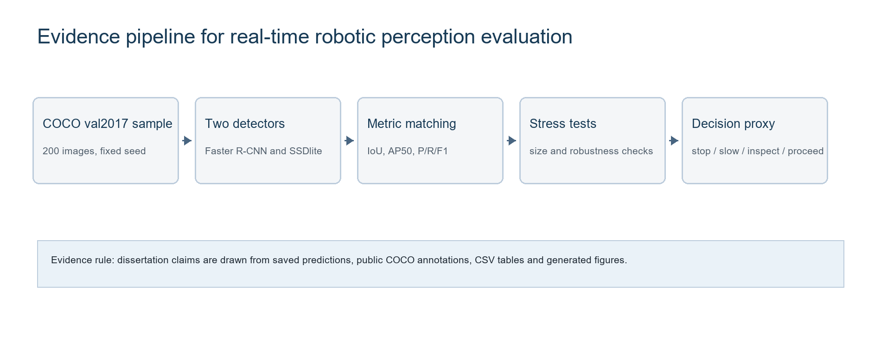
Figure 3.1 Evaluation pipeline linking visual input to model comparison, metric analysis and decision-readiness evidence.
Source: Author generated from the experimental protocol and saved project artefacts.

CHAPTER FOUR - FINDINGS / ANALYSIS / DISCUSSION

4.1 Experimental Overview
The expanded experiment evaluated two object detectors on a reproducible COCO val2017 sample of 200 images. The sample contained 1,410 annotated objects across the eight decision-relevant classes. This substantially changes the evidential strength of the dissertation. The findings no longer depend on a small illustrative set; they now support analysis across class imbalance, object size, thresholds, model families, latency and decision-state outcomes. The sample still remains a public static-image evaluation, so the results are interpreted as perception-layer evidence rather than proof of embodied robot autonomy.
The class distribution was uneven, which is expected in real detection datasets and important for interpretation. Persons and cars made up most target objects, while stop signs and buses were less frequent. The object-size distribution was also demanding: 758 of the 1,410 target objects were small. This matters because small objects are often visually difficult, occupy few pixels and may be located in cluttered image regions. Retaining them makes the experiment more realistic than excluding them, but it also reduces the likelihood of inflated performance.
The evaluation also included 40 background/proceed images. This design improved the decision-readiness analysis because the decision proxy did not collapse into an almost entirely STOP distribution. The ground-truth proxy states included 92 STOP, 63 SLOW, 5 INSPECT and 40 PROCEED images. This is still weighted toward risk-relevant scenes, which is appropriate for robotic safety evaluation, but it gives enough non-stop cases to evaluate unnecessary stopping and false-safe behaviour.

4.2 Overall Detection Performance
Table 4.1 Overall detection and decision-readiness performance at each model's selected operating point.
Model | Thr. | P | R | F1 | mAP50 | IoU | Mean ms | FPS | Decision acc.
Faster R-CNN ResNet50-FPN v2 | 0.70 | 0.723 | 0.731 | 0.727 | 0.760 | 0.835 | 4,932.1 | 0.203 | 0.925
SSDlite320 MobileNetV3-Large | 0.50 | 0.809 | 0.183 | 0.298 | 0.353 | 0.824 | 105.0 | 9.520 | 0.765

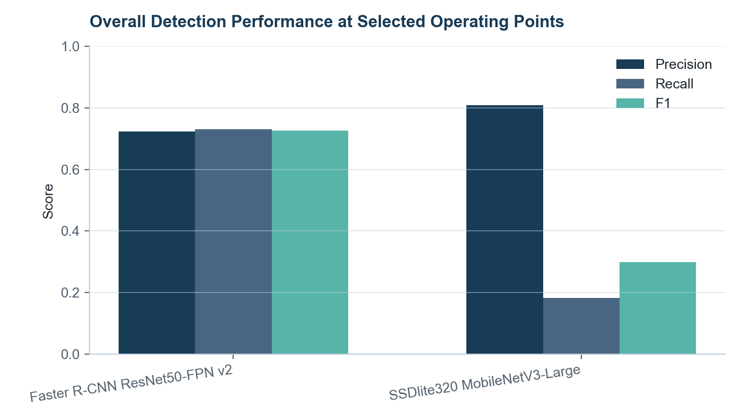
Figure 4.1 Overall detection performance at selected operating points.
Source: Author generated from extended_threshold_metrics.csv.
The strongest measured operating point for Faster R-CNN was threshold 0.70. At this point the model achieved 0.723 precision, 0.731 recall, 0.727 F1, 0.835 mean matched IoU and 0.760 mAP50 on the eight-class subset. This is a balanced result: false positives remain meaningful, but recall is high enough to preserve most decision-relevant objects. The result also shows why the previous assumption that 0.95 was best would have been weak. At 0.95 Faster R-CNN reached higher precision, but recall fell to 0.459 and F1 fell to 0.610. For robotic decision support, removing too many true objects can be as problematic as retaining weak detections.
SSDlite produced a very different performance profile. Its selected operating point was threshold 0.50, where it achieved 0.809 precision but only 0.183 recall and 0.298 F1. The high precision means that many retained detections were correct, but the low recall means that most annotated target objects were not detected. This is critical for robotics because a fast detector that misses many relevant objects cannot be treated as decision-ready simply because it has a mobile architecture. The model may still have a role as a fast attention layer or as part of a hybrid system, but the measured evidence does not support using it as the only safety-relevant perception source in this configuration.
The localisation results are more nuanced. SSDlite's mean IoU for matched detections was 0.824, close to Faster R-CNN's 0.835. This means that when SSDlite did detect an object, its box quality was often acceptable. The weakness was not mainly the location of retained matches; it was the number of missed objects. Faster R-CNN therefore provided stronger decision evidence because it retained more true objects while preserving good localisation.

4.3 Per-Class Performance
Table 4.3 Per-class performance at each model's selected operating point.
Model | Class | GT | P | R | F1 | IoU
Faster R-CNN | person | 669 | 0.720 | 0.773 | 0.746 | 0.833
Faster R-CNN | bicycle | 71 | 0.717 | 0.606 | 0.656 | 0.784
Faster R-CNN | car | 296 | 0.710 | 0.743 | 0.726 | 0.848
Faster R-CNN | motorcycle | 84 | 0.717 | 0.786 | 0.750 | 0.819
Faster R-CNN | bus | 57 | 0.941 | 0.842 | 0.889 | 0.900
Faster R-CNN | truck | 81 | 0.723 | 0.420 | 0.531 | 0.877
Faster R-CNN | traffic light | 124 | 0.645 | 0.629 | 0.637 | 0.771
Faster R-CNN | stop sign | 28 | 0.923 | 0.857 | 0.889 | 0.938
SSDlite | person | 669 | 0.802 | 0.194 | 0.313 | 0.806
SSDlite | bicycle | 71 | 0.706 | 0.169 | 0.273 | 0.786
SSDlite | car | 296 | 0.628 | 0.091 | 0.159 | 0.809
SSDlite | motorcycle | 84 | 0.853 | 0.345 | 0.491 | 0.790
SSDlite | bus | 57 | 1.000 | 0.456 | 0.626 | 0.896
SSDlite | truck | 81 | 0.882 | 0.185 | 0.306 | 0.879
SSDlite | traffic light | 124 | 1.000 | 0.016 | 0.032 | 0.746
SSDlite | stop sign | 28 | 0.944 | 0.607 | 0.739 | 0.909

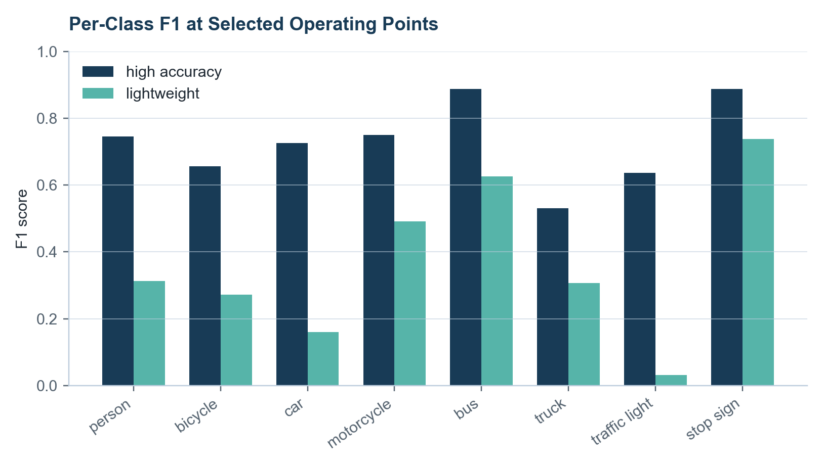
Figure 4.3 Per-class F1 at selected operating points.
Source: Author generated from extended_per_class_metrics.csv.
Per-class analysis shows why aggregate scores cannot be accepted uncritically. Faster R-CNN performed strongly on bus and stop sign, both with F1 around 0.889 at the selected operating point. These classes likely benefit from distinctive shapes, larger visual footprints or strong contextual features in many COCO images. Motorcycle also performed well with 0.750 F1, while person and car achieved 0.746 and 0.726 respectively. These results matter because people and vehicles dominate many robotic risk scenarios, and missing them would weaken decision-readiness.
The weaker Faster R-CNN categories were truck and traffic light. Truck recall was 0.420, despite reasonable precision. This suggests that visual variation and confusion with other vehicle categories affected the model. A truck can be partially visible, distant, visually similar to a bus or car, or embedded in cluttered traffic scenes. Traffic light F1 was 0.637, which is lower than the large-object categories and consistent with the small-object challenge. For a road-facing robot, traffic-light misses could be serious because the object may be spatially small but semantically important.
SSDlite's per-class pattern was sharper. It performed relatively well on stop sign with 0.739 F1 and bus with 0.627 F1, but its F1 for traffic light was only 0.032 and for car only 0.159. This shows that its aggregate precision can hide a severe recall problem. In robotic terms, the model might detect some visually salient large objects but fail to preserve enough evidence for crowded scenes, small control objects or mixed traffic environments. A lightweight architecture therefore needs task-specific validation before it can be described as real-time perception for decision-making.
Per-class IoU also needs careful interpretation. Several classes showed high IoU when matched, especially stop sign and bus. However, high matched IoU does not compensate for low recall. If a detector misses a traffic light, its localisation quality on the few traffic lights it does detect is not enough for safe operation. This is why the chapter reports precision, recall, F1 and IoU together rather than treating one metric as definitive.

4.4 Confidence-Threshold Analysis
Table 4.2 Confidence-threshold sensitivity across both detector families.
Model | Thr. | P | R | F1 | FP | FN | Decision acc.
Faster R-CNN | 0.50 | 0.609 | 0.795 | 0.690 | 719 | 289 | 0.935
Faster R-CNN | 0.60 | 0.663 | 0.770 | 0.712 | 553 | 324 | 0.940
Faster R-CNN | 0.70 | 0.723 | 0.731 | 0.727 | 395 | 380 | 0.925
Faster R-CNN | 0.80 | 0.788 | 0.667 | 0.723 | 253 | 469 | 0.910
Faster R-CNN | 0.90 | 0.860 | 0.565 | 0.682 | 130 | 613 | 0.880
Faster R-CNN | 0.95 | 0.910 | 0.459 | 0.610 | 64 | 763 | 0.855
SSDlite | 0.50 | 0.809 | 0.183 | 0.298 | 61 | 1152 | 0.765
SSDlite | 0.60 | 0.849 | 0.164 | 0.275 | 41 | 1179 | 0.755
SSDlite | 0.70 | 0.873 | 0.137 | 0.237 | 28 | 1217 | 0.735
SSDlite | 0.80 | 0.909 | 0.121 | 0.213 | 17 | 1240 | 0.695
SSDlite | 0.90 | 0.977 | 0.092 | 0.169 | 3 | 1280 | 0.640
SSDlite | 0.95 | 0.990 | 0.073 | 0.136 | 1 | 1307 | 0.560

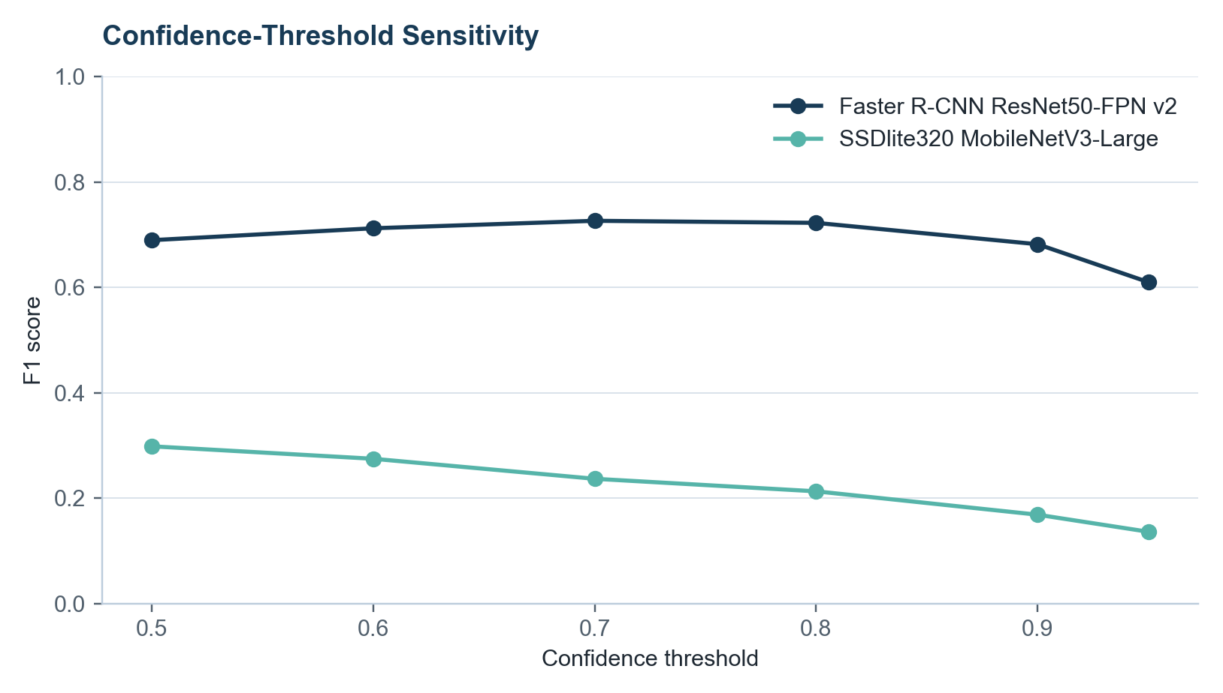
Figure 4.2 Confidence-threshold sensitivity across both detector families.
Source: Author generated from extended_threshold_metrics.csv.
The threshold results show a clear precision-recall trade-off. For Faster R-CNN, precision rose from 0.609 at threshold 0.50 to 0.910 at threshold 0.95, while recall fell from 0.795 to 0.459. The best F1 occurred at threshold 0.70, not at the highest threshold. This matters because a robot cannot assume that high confidence equals better action evidence. A high threshold reduces weak detections, but it also discards real objects that may be safety-relevant.
The error counts explain the trade-off. At threshold 0.50, Faster R-CNN produced 719 false positives and 289 false negatives. At threshold 0.70, false positives reduced to 395 but false negatives increased to 380. At threshold 0.95, false positives reduced to 64 but false negatives increased to 763. A strict threshold therefore makes the detector look cleaner while causing many missed objects.
SSDlite followed the same direction but with much lower recall throughout. Its precision increased from 0.809 at threshold 0.50 to 0.990 at threshold 0.95, while recall fell from 0.183 to 0.073. The selected threshold remained 0.50 because increasing the threshold only worsened an already severe missed-object problem. A practical robot may need layered thresholds for attention, inspection and action rather than one global confidence rule.

4.5 Accuracy-Latency Trade-Off
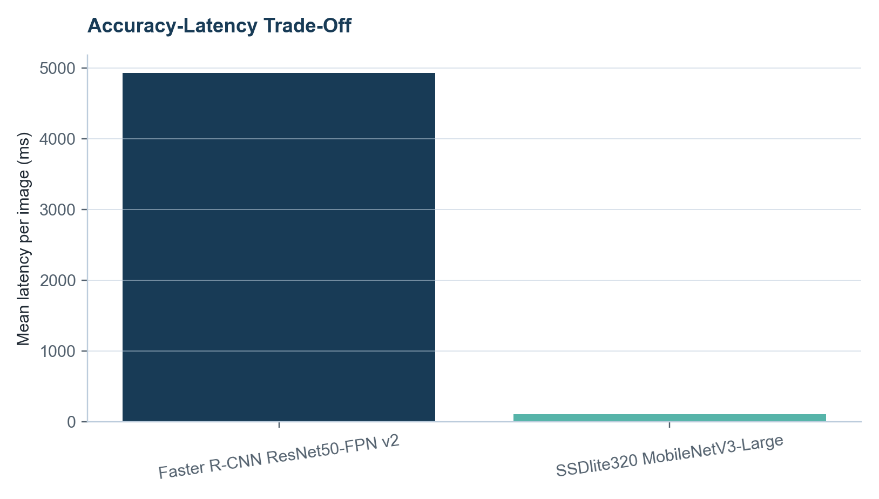
Figure 4.4 Accuracy-latency trade-off between Faster R-CNN and SSDlite.
Source: Author generated from latency logs and extended_threshold_metrics.csv.
Latency is the strongest deployment constraint in the experiment. Faster R-CNN averaged 4,932 ms per image, with median latency of 4,885 ms, standard deviation of 484 ms and P95 latency of 5,862 ms. This corresponds to only 0.203 FPS in the measured CPU environment. These values are not compatible with most real-time mobile robotic control loops. The model produced stronger detection evidence, but the inference speed is too slow for direct real-time deployment without hardware acceleration or optimisation.
SSDlite averaged 105 ms per image, with median latency of 101 ms, standard deviation of 22 ms and P95 latency of 155 ms. This corresponds to 9.520 FPS. It is therefore much closer to real-time perception than Faster R-CNN in the same CPU environment. However, speed cannot be interpreted independently from recall. If a detector misses most relevant objects, faster execution can simply deliver incomplete evidence more quickly. This is why the chapter treats latency and F1 as a trade-off rather than separate success criteria.
The result also shows why marketing descriptions of real-time detectors are insufficient for dissertation evidence. SSDlite is a lightweight model, but whether it is real-time depends on the hardware, image processing pipeline, robot speed and control deadline. Faster R-CNN is accuracy-oriented, but whether its latency is acceptable depends on whether the robot can stop, wait, batch frames, use a GPU or use it as a secondary confirmation model. The measured evidence supports a hybrid interpretation: Faster R-CNN is stronger for offline or slower confirmatory perception, while SSDlite is faster but currently too recall-limited for safety-relevant standalone use.

4.6 Model Comparison
The model comparison answers the central empirical question more strongly than a single-model evaluation could. Faster R-CNN achieved the higher F1, higher recall, higher mAP50 and higher decision-state accuracy. SSDlite achieved far lower latency and higher FPS, but at a substantial cost in recall. The trade-off is not simply that one model is better. The models have different failure profiles and therefore different possible roles in a robotic architecture.
Faster R-CNN's advantage is that it preserves more decision-relevant objects. This is valuable for safety because missed hazards can create false-safe outcomes. Its disadvantage is that it cannot meet the measured real-time requirement on CPU. SSDlite's advantage is that it could support faster frame processing or low-power deployment. Its disadvantage is that its recall is too weak on this sample, especially for small objects and several traffic-scene classes. A robot relying only on this SSDlite configuration could proceed, inspect too weakly or delay response because target objects were never passed to the decision layer.
The mAP50 difference reinforces this interpretation. Faster R-CNN reached 0.760 mAP50 across the selected classes, while SSDlite reached 0.354. This gap shows that the accuracy difference is not only a threshold-specific accident. It reflects broader ranking and detection quality across target classes. However, mAP50 does not include latency or decision cost, so it cannot alone decide deployment suitability. A robot requires both perception quality and timely inference.
A mature conclusion is therefore conditional. Faster R-CNN is the better detector for this sample and task framing, but it is not real-time on the measured CPU platform. SSDlite is the faster detector, but its low recall prevents it from being a complete decision-ready substitute. A future robot-facing system would need either an optimised high-accuracy detector, a stronger lightweight model, fine-tuning on robot-camera data, or a cascade that combines fast screening with slower confirmation.

4.7 Error Analysis
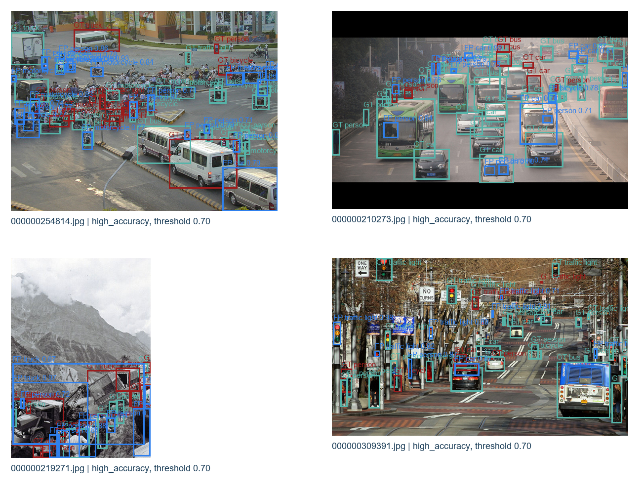
Figure 4.8 Representative detection errors from the expanded evaluation.
Source: Author generated from saved predictions and COCO annotations.
The error analysis explains why the scores occurred. At the selected Faster R-CNN threshold, the aggregate table recorded 395 false positives and 380 false negatives. False positives were common in visually dense scenes where multiple vehicle-like or person-like structures appeared. False negatives were associated with small objects, occlusion, clutter and categories that occupy limited image space. Poor localisation cases appeared where a detection overlapped the correct object but did not capture the full extent cleanly.
For Faster R-CNN, many errors involved person, car, traffic light and truck instances. Person and car errors partly reflect their dominance in the sample, while traffic-light errors were more scale-related. Truck errors suggest category ambiguity within vehicles, particularly where a truck is partially visible or visually close to a bus or large car.
SSDlite's main error pattern was missed objects rather than excess false positives. At threshold 0.50 it produced only 61 false positives, but 1,152 false negatives. This failure mode is more serious for robotic decision-readiness because the decision layer cannot reason about objects that the perception layer never reports. The model's high precision therefore indicates selectivity, not safety.

4.8 Robustness Analysis
Table 4.5 Robustness subset results compared with the original unperturbed images.
Model | Condition | P | R | F1 | FP | FN
Faster R-CNN | Original | 0.676 | 0.667 | 0.671 | 44 | 46
Faster R-CNN | Reduced brightness | 0.742 | 0.688 | 0.714 | 33 | 43
Faster R-CNN | Increased brightness | 0.720 | 0.652 | 0.684 | 35 | 48
Faster R-CNN | Blur | 0.725 | 0.478 | 0.576 | 25 | 72
Faster R-CNN | Noise | 0.723 | 0.623 | 0.669 | 33 | 52
Faster R-CNN | Partial occlusion | 0.612 | 0.594 | 0.603 | 52 | 56
SSDlite | Original | 0.789 | 0.217 | 0.341 | 8 | 108
SSDlite | Reduced brightness | 0.821 | 0.232 | 0.362 | 7 | 106
SSDlite | Increased brightness | 0.769 | 0.217 | 0.339 | 9 | 108
SSDlite | Blur | 0.812 | 0.188 | 0.306 | 6 | 112
SSDlite | Noise | 0.795 | 0.225 | 0.350 | 8 | 107
SSDlite | Partial occlusion | 0.771 | 0.196 | 0.312 | 8 | 111

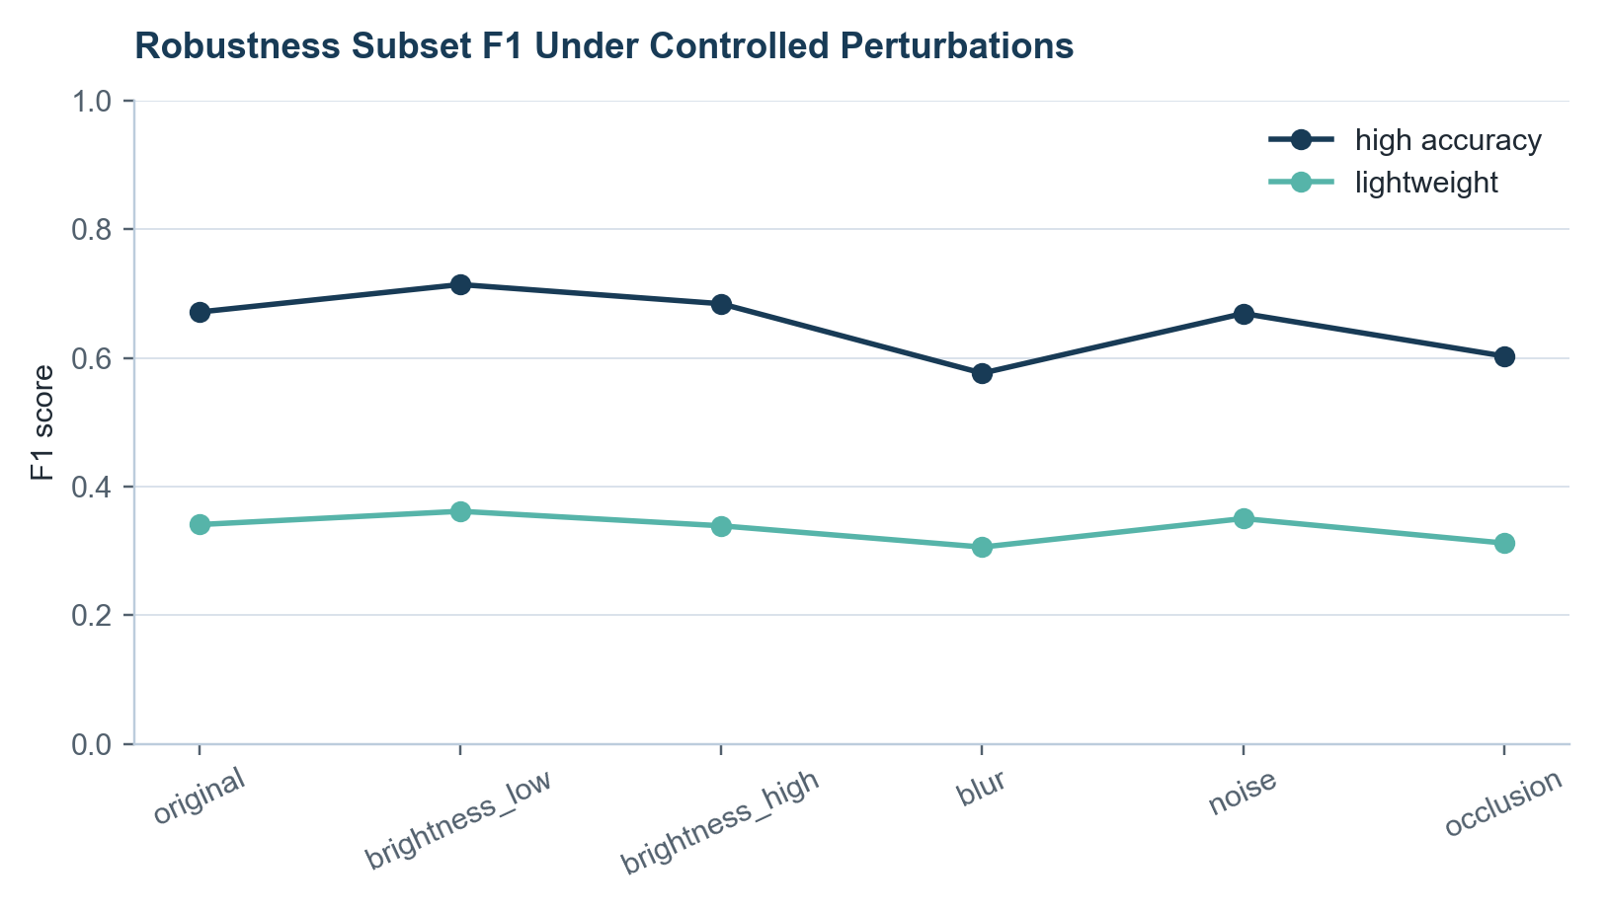
Figure 4.6 Robustness subset F1 under controlled perturbations.
Source: Author generated from extended_robustness_metrics.csv.
Robustness testing used a 20-image subset and compared each perturbation with the original version of the same subset. Faster R-CNN achieved 0.672 F1 on the original subset. Reduced brightness produced 0.714 F1, increased brightness produced 0.684, noise produced 0.669, blur produced 0.576 and partial occlusion produced 0.603. The small subset means these values should not be overinterpreted, but the pattern is plausible: blur and occlusion reduced performance more than brightness variation. This reflects the importance of edge detail and visible object extent for detection.
The reduced-brightness result being slightly higher than the original subset should not be treated as proof that darker images improve detection. It is more likely a sample-specific effect caused by confidence filtering and local image characteristics. This is why robustness findings are interpreted as stress-test evidence rather than definitive environmental claims. The important point is not that one perturbation creates a universal gain; it is that controlled perturbations change F1 and therefore should be tested before deployment.
SSDlite achieved 0.341 F1 on the original robustness subset. Reduced brightness produced 0.362, increased brightness 0.339, blur 0.306, noise 0.350 and occlusion 0.312. The robustness pattern is again dominated by low recall. The model remained fast, but perturbations did not solve the missed-object weakness. In a real robot, lighting and blur would also occur alongside camera motion, depth uncertainty and temporal continuity, so robustness should be extended with robot-mounted video before deployment claims are made.
The robustness results support the literature-based argument that static benchmark accuracy is not enough. A detector can perform acceptably on unaltered images but behave differently when visual conditions shift. Mobile robots regularly experience illumination changes, motion blur, partial blockage and unusual viewpoints. The controlled perturbation test is limited, but it directly strengthens the dissertation by connecting empirical results to real-world perception constraints.

4.9 Object-Size Analysis
Table 4.4 Object-size recall and localisation quality using ground-truth COCO size bins.
Model | Size | GT | Matched | FN | Recall | IoU
Faster R-CNN | small | 758 | 475 | 283 | 0.627 | 0.793
Faster R-CNN | medium | 450 | 378 | 72 | 0.840 | 0.858
Faster R-CNN | large | 202 | 177 | 25 | 0.876 | 0.902
SSDlite | small | 758 | 1 | 757 | 0.001 | 0.713
SSDlite | medium | 450 | 99 | 351 | 0.220 | 0.765
SSDlite | large | 202 | 158 | 44 | 0.782 | 0.861

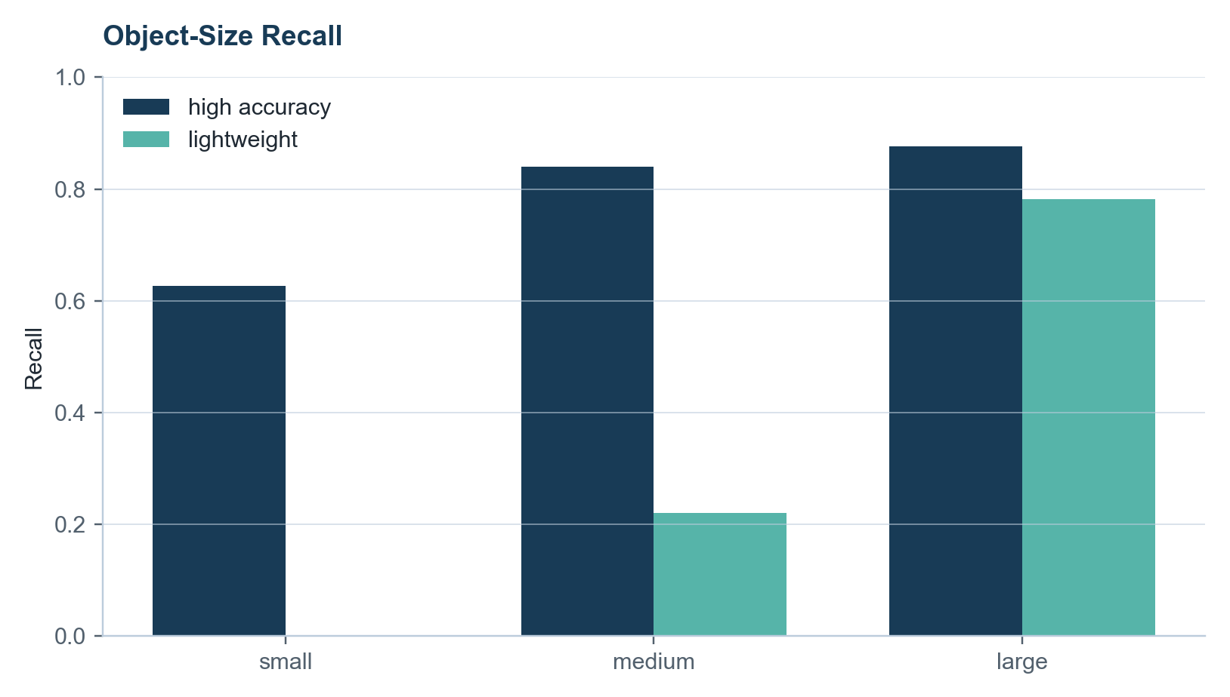
Figure 4.5 Object-size recall for small, medium and large COCO objects.
Source: Author generated from extended_size_recall_metrics.csv.
Object size had a major effect on detection performance. Faster R-CNN recalled 0.877 of large objects, 0.840 of medium objects and 0.627 of small objects at its selected threshold. This confirms that retaining small objects made the evaluation harder and more honest. If small objects had been excluded, the detector would have appeared more capable because many difficult false negatives would have been removed from the denominator.
SSDlite's size pattern was much more severe. It recalled 0.782 of large objects, 0.220 of medium objects and only 0.001 of small objects. This means it was able to retain a meaningful proportion of large objects but almost completely failed on small objects under the selected configuration. For robotics, this is a critical limitation. Small objects are not always unimportant: a distant person, traffic light, stop sign or bicycle may be small in the image but highly relevant to planning.
The size analysis also explains several per-class findings. Traffic lights and stop signs may have strong semantic importance while occupying small image regions. Vehicles and buses are often larger and easier to detect when close to the camera. A robot cannot simply ignore small objects unless its operating design proves that they are outside the decision horizon. Excluding small objects would therefore artificially improve apparent performance and weaken the dissertation's validity.
The correct interpretation is task-dependent. If the robot only needs to react to near, large obstacles, large-object recall may be the most relevant metric. If the robot must anticipate road cues or distant people, small-object recall becomes essential. The dissertation's result does not show that object detection is unsuitable for robotics. It shows that object scale must be explicitly connected to the robot's decision horizon and action timing.

4.10 Decision-State Evaluation
Table 4.6 Decision-state proxy accuracy and decision-risk counts.
Model | Thr. | Decision acc. | False-safe decisions | Unnecessary stops
Faster R-CNN ResNet50-FPN v2 | 0.70 | 0.925 | 10 | 3
SSDlite320 MobileNetV3-Large | 0.50 | 0.765 | 43 | 4

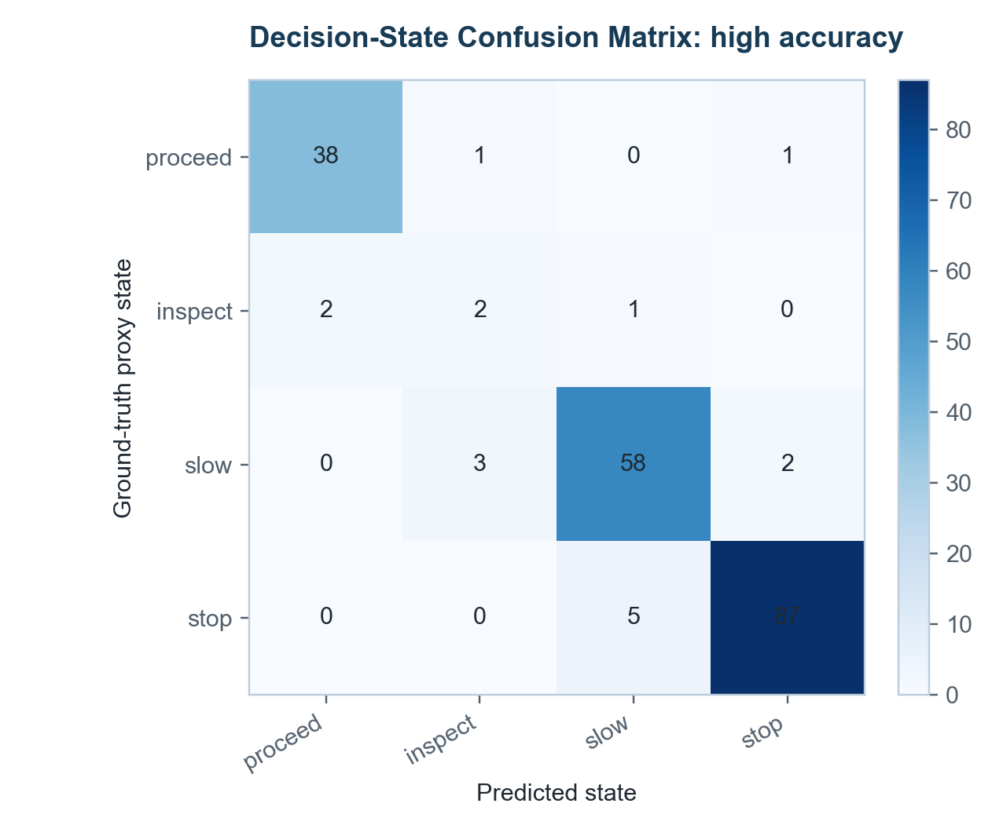
Figure 4.7a Decision-state confusion matrix for Faster R-CNN.
Source: Author generated from extended_decision_confusion_matrix.csv.
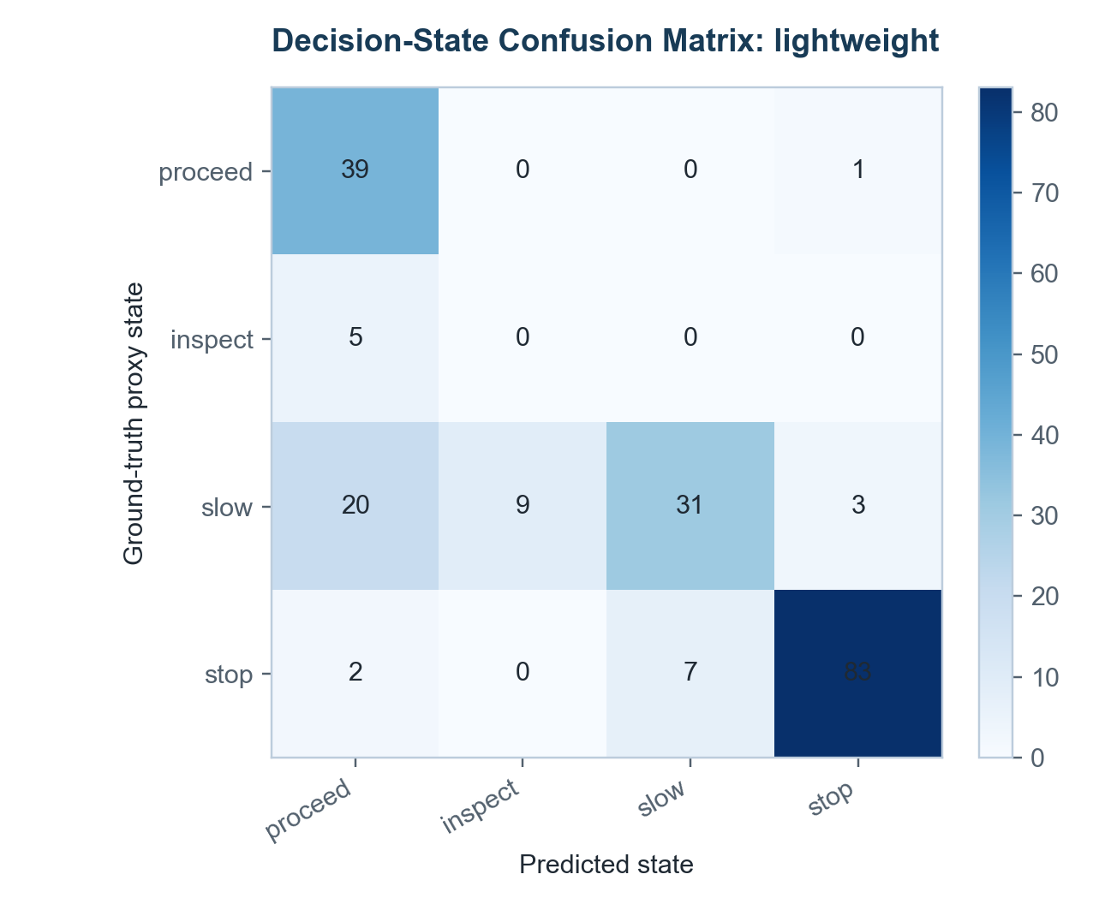
Figure 4.7b Decision-state confusion matrix for SSDlite.
Source: Author generated from extended_decision_confusion_matrix.csv.
Faster R-CNN achieved 0.925 decision-state proxy accuracy at threshold 0.70. The confusion matrix shows that most STOP and SLOW cases were preserved, but not perfectly. There were 10 false-safe decisions and 3 unnecessary-stop decisions. False-safe decisions are more concerning because they mean the predicted state is less conservative than the annotation-derived proxy state. In a real robot, such behaviour could allow a system to proceed or inspect when it should slow or stop. The model therefore provides useful decision evidence, but it should not be the sole safety layer.
SSDlite achieved 0.765 decision-state proxy accuracy at threshold 0.50, with 43 false-safe decisions and 4 unnecessary-stop decisions. This pattern follows directly from low recall. Many ground-truth risk states were weakened because the model missed the objects that should have triggered a more conservative state. The result is important because decision accuracy can look better than detection F1 when background/proceed images are included, but false-safe counts reveal the operational risk. A dissertation-level evaluation should therefore report both accuracy and direction of decision error.
The decision-state proxy is intentionally simple. It does not include robot speed, stopping distance, camera calibration, object trajectory, uncertainty propagation or planner behaviour. Its value is that it translates frame-level detections into a decision-oriented representation and exposes whether perception errors would change action categories. The results support the conclusion that decision-readiness depends on preserving risk-relevant evidence, not merely producing high-confidence boxes.

4.11 Statistical Analysis
Table 4.7 Variation and uncertainty indicators at selected operating points.
Model | F1 | Bootstrap 95% CI | Latency SD ms | P95 latency ms
Faster R-CNN ResNet50-FPN v2 | 0.727 | 0.697 to 0.752 | 484.182 | 5,862.4
SSDlite320 MobileNetV3-Large | 0.298 | 0.258 to 0.344 | 22.456 | 154.6

The bootstrap confidence intervals show that single metric values should not be treated as definitive. Faster R-CNN's selected F1 was 0.727 with an approximate 95% bootstrap interval from 0.697 to 0.752. SSDlite's selected F1 was 0.298 with an interval from 0.258 to 0.344. The intervals do not overlap, which supports the conclusion that Faster R-CNN performed substantially better on detection quality for this sample. However, the intervals are still sample-based and do not remove the need for robot-specific testing.
Latency variation also matters. Faster R-CNN had a latency standard deviation of 484 ms and P95 latency of 5,862 ms. This means that even if the average latency were improved, timing stability would remain a relevant deployment issue. SSDlite had lower latency variation, with standard deviation of 22 ms and P95 latency of 155 ms. This is better for a control loop, but the recall weakness still prevents a straightforward real-time success claim.
The statistical results therefore strengthen the dissertation in two ways. First, they prevent overclaiming from one F1 value. Second, they show that the accuracy-latency trade-off is not only a narrative observation. The measured difference between models is large, consistent and decision-relevant. The remaining uncertainty is about external validity, not whether the two tested configurations behaved differently on this sample.

4.12 Discussion Against the Literature and Implications for Robotic Deployment
The findings are consistent with the object-detection literature. Region-based detectors such as Faster R-CNN remain valuable because they provide stronger localisation and recall, especially when combined with feature pyramid representations. The experiment supports this point: Faster R-CNN was substantially stronger than SSDlite in F1, recall, mAP50 and decision-state accuracy. However, the latency result also confirms the real-time concern raised in the literature. A detector can be accurate enough to support perception evidence but too slow for direct CPU-based robotic control.
The lightweight-model literature is also supported, but with an important qualification. SSDlite was much faster in the measured environment, yet its low recall shows that lightweight does not automatically mean decision-ready. Speed only helps a robot if the model preserves enough relevant objects for action selection. The result therefore supports a hybrid deployment view: fast monitoring may need to be combined with stronger confirmation, temporal memory and conservative uncertainty handling.
The results also connect with literature on tracking and SLAM. This experiment is frame-based, so it cannot evaluate object persistence, 3D position, robot pose or map consistency. Object detection can provide semantic evidence, but robotic autonomy also needs temporal continuity and spatial grounding. A person detected in 2D may be near or far, moving or stationary, relevant or outside the path. Those distinctions require depth, tracking, optical flow, SLAM or sensor fusion.
The main deployment implication is that a robot should not select a vision model by accuracy or latency alone. Faster R-CNN produced stronger perception evidence but is too slow on CPU. SSDlite was faster but missed too many objects. Threshold policy should also be layered because the best measured Faster R-CNN threshold was 0.70, not a universal rule. Public-image evidence is therefore useful as an early validation layer, but physical deployment would require robot-mounted video, hardware-specific inference, temporal reasoning, spatial perception and validated control logic.

CONCLUDING REMARKS
This dissertation evaluated computer vision for real-time robotic perception and decision-making through a reproducible technical experiment. The study began from a systems problem: a robot requires visual outputs that are accurate, timely and interpretable enough to support action. The methodology connected public image data, model inference, metric evaluation, robustness testing and decision-state interpretation, so the conclusion is drawn from measured perception evidence rather than from a general claim about autonomous robotics.
RQ1 asked how current computer vision methods support real-time robotic perception. The evidence shows that object detection can provide useful semantic and localisation information for downstream robotic decisions, but only when it is interpreted as one layer in a wider perception-control system. Faster R-CNN ResNet50-FPN v2 produced the strongest measured detection quality in this study, achieving 0.723 precision, 0.731 recall, 0.727 F1, 0.835 mean IoU, 0.760 mAP50 and 0.925 decision-state proxy accuracy at threshold 0.70. These results support the use of accuracy-oriented detection for reliable scene evidence, while also showing that detection alone cannot provide temporal stability, depth, trajectory prediction or safety certification.
RQ2 asked which technical metrics best indicate suitability for robotic decision-making. The findings show that no single metric is sufficient. Precision and false positives indicate unnecessary reactions; recall and false negatives indicate missed hazards; IoU indicates localisation quality; mAP50 summarises class-level detection quality; latency, P95 latency and FPS show whether perception can arrive in time; robustness and size-based recall reveal whether performance survives visual stress and small-object difficulty. The decision-state proxy added a useful bridge between detection output and action relevance, but it remains an evaluation proxy rather than a validated controller.
RQ3 asked how the balance between perception quality and processing latency affects decision-readiness. The model comparison provides the strongest answer. Faster R-CNN was more useful for detection quality but averaged 4,932 ms per image and only 0.203 FPS on the measured CPU platform. SSDlite320 MobileNetV3-Large was much faster at 105 ms and 9.520 FPS, but its 0.183 recall and 0.298 F1 show that speed alone did not provide adequate decision evidence. The practical implication is conditional: a robot-facing design may need a hybrid architecture, hardware acceleration, model optimisation, temporal smoothing, or a cascade that combines fast screening with stronger confirmation.
RQ4 asked what limitations remain when dataset-based computer vision evaluation is used instead of physical robot deployment. COCO val2017 made the evaluation reproducible and transparent, but it is still a public static-image dataset. It does not validate robot embodiment, continuous video, camera calibration, depth, actuation delay, stopping distance, closed-loop planning or safety certification. The study therefore supports perception-layer evidence and decision-readiness analysis, not a claim of deployed autonomous robot performance. The retained small objects, threshold analysis, error examples and robustness tests strengthen validity, but they cannot replace robot-mounted data and physical trials.
The main contribution is an evidence-led evaluation route that connects computer-vision metrics to robotic decision implications. The dissertation moved beyond a single-model demonstration by using 200 sampled images, 1,410 decision-relevant target objects, two detector families, six confidence thresholds, per-class analysis, object-size analysis, robustness perturbations, latency profiling, bootstrap uncertainty and decision-state evaluation. The result is not that one model is universally best. The contribution is a clearer way to judge when a vision model provides useful decision evidence, when it is too slow, when it misses too much, and what further validation would be needed before deployment.
Future work should therefore use robot-mounted video, hardware-specific inference testing, temporal tracking, depth or SLAM, and closed-loop decision testing. It should also evaluate stronger lightweight detectors, quantised or accelerated models, and domain-specific fine-tuning. Such work would move the dissertation's perception-layer evidence toward a fuller robotic system while preserving the central principle established here: real-time robotic perception should be judged by the relationship between accuracy, latency, uncertainty, failure mode and decision consequence.

BIBLIOGRAPHY
Al-Tawil, B., Hempel, T., Abdelrahman, A. and Al-Hamadi, A. (2024) 'A review of visual SLAM for robotics: evolution, properties, and future applications', Frontiers in Robotics and AI. Available at: https://doi.org/10.3389/frobt.2024.1347985.
Bewley, A., Ge, Z., Ott, L., Ramos, F. and Upcroft, B. (2016) 'Simple online and realtime tracking', IEEE International Conference on Image Processing. Available at: https://arxiv.org/abs/1602.00763.
COCO Consortium (n.d.) COCO Common Objects in Context Dataset. Available at: https://cocodataset.org/.
Geiger, A., Lenz, P. and Urtasun, R. (2012) 'Are we ready for autonomous driving? The KITTI vision benchmark suite', IEEE Conference on Computer Vision and Pattern Recognition. Available at: https://www.cvlibs.net/datasets/kitti/.
Howard, A., Sandler, M., Chu, G., Chen, L.C., Chen, B., Tan, M., Wang, W., Zhu, Y., Pang, R., Vasudevan, V., Le, Q.V. and Adam, H. (2019) 'Searching for MobileNetV3', IEEE/CVF International Conference on Computer Vision. Available at: https://arxiv.org/abs/1905.02244.
Lin, T.Y., Maire, M., Belongie, S., Hays, J., Perona, P., Ramanan, D., Dollar, P. and Zitnick, C.L. (2014) 'Microsoft COCO: Common Objects in Context', European Conference on Computer Vision. Available at: https://arxiv.org/abs/1405.0312.
Lin, T.Y., Dollar, P., Girshick, R., He, K., Hariharan, B. and Belongie, S. (2017) 'Feature Pyramid Networks for Object Detection', IEEE Conference on Computer Vision and Pattern Recognition. Available at: https://arxiv.org/abs/1612.03144.
Liu, W., Anguelov, D., Erhan, D., Szegedy, C., Reed, S., Fu, C.Y. and Berg, A.C. (2016) 'SSD: Single Shot MultiBox Detector', European Conference on Computer Vision. Available at: https://arxiv.org/abs/1512.02325.
Maroto-Gomez, M., Alonso-Martin, F., Malfaz, M., Castro-Gonzalez, A., Castillo, J.C. and Salichs, M.A. (2023) 'A systematic literature review of decision-making and control systems for autonomous and social robots', International Journal of Social Robotics. Available at: https://doi.org/10.1007/s12369-023-00977-3.
Redmon, J., Divvala, S., Girshick, R. and Farhadi, A. (2016) 'You Only Look Once: Unified, Real-Time Object Detection'. Available at: https://doi.org/10.48550/arXiv.1506.02640.
Ren, S., He, K., Girshick, R. and Sun, J. (2015) 'Faster R-CNN: Towards real-time object detection with region proposal networks', Advances in Neural Information Processing Systems. Available at: https://arxiv.org/abs/1506.01497.
Sandler, M., Howard, A., Zhu, M., Zhmoginov, A. and Chen, L.C. (2018) 'MobileNetV2: Inverted Residuals and Linear Bottlenecks', IEEE Conference on Computer Vision and Pattern Recognition. Available at: https://doi.org/10.1109/CVPR.2018.00474.
Sturm, J., Engelhard, N., Endres, F., Burgard, W. and Cremers, D. (2012) 'A benchmark for the evaluation of RGB-D SLAM systems', IEEE/RSJ International Conference on Intelligent Robots and Systems. Available at: https://cvg.cit.tum.de/data/datasets/rgbd-dataset.
Torchvision Contributors (n.d.) Faster R-CNN ResNet50-FPN V2 model documentation. Available at: https://docs.pytorch.org/vision/main/models/generated/torchvision.models.detection.fasterrcnn_resnet50_fpn_v2.html.
Torchvision Contributors (n.d.) SSDlite320 MobileNetV3-Large model documentation. Available at: https://docs.pytorch.org/vision/main/models/generated/torchvision.models.detection.ssdlite320_mobilenet_v3_large.html.

APPENDIX

Appendix A: Reproducibility Artefacts
The technical evaluation is supported by saved project artefacts. The expanded code entry point is `code/run_extended_coco_evaluation.py`. Raw public data and annotations are stored under `data/raw/coco_val2017_subset`. Processed image selections and prediction logs are stored under `data/processed`. Summary tables are stored under `outputs/tables`. Figures are stored under `outputs/figures`. Experiment logs are stored under `outputs/logs`. The dissertation reports only metrics generated from these artefacts.

Appendix B: Expanded Evaluation Configuration
Dataset: COCO val2017. Sampling seed: 20260909. Sample images: 200. Positive images: 160. Background/proceed images: 40. Ground-truth target objects: 1,410. Target classes: person, bicycle, car, motorcycle, bus, truck, traffic light and stop sign. Confidence thresholds: 0.50, 0.60, 0.70, 0.80, 0.90 and 0.95. Matching rule: same class and IoU greater than or equal to 0.50. Object-size policy: small, medium and large COCO objects retained.

Appendix C: Model Configuration Boundary
The evaluated models were Faster R-CNN ResNet50-FPN v2 and SSDlite320 MobileNetV3-Large using public COCO-pretrained torchvision weights. No new model training, fine-tuning, GPU acceleration, quantisation, TensorRT conversion or physical robot deployment was performed. Latency measurements therefore describe the local CPU experiment and must not be generalised to all hardware platforms.

Appendix D: Interpretation Boundary
The evaluation is a perception-layer technical study. It does not claim full robotic deployment, physical safety certification, complete temporal tracking, 3D localisation or control-system validation. Public static-image results are suitable for analysing object-detection trade-offs and decision-readiness proxies, but they cannot validate safe embodied autonomy. Future work must use robot-mounted video, hardware-specific inference, temporal reasoning, spatial perception and validated control logic.

