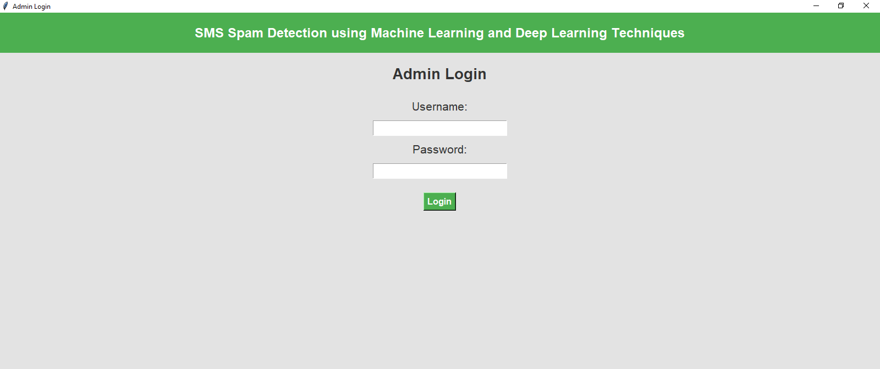

First, double-click on the run.bat file. After that, the system should display the template as shown above.

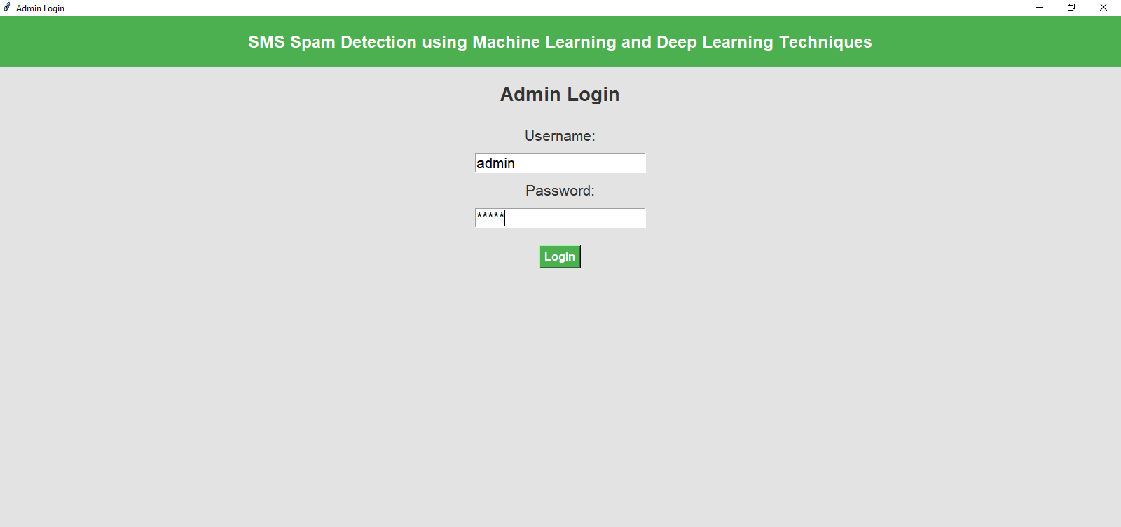

The username and password combination is as follows:

* **Username:** admin
* **Password:** admin

This is the official login credential for the system. Please ensure to keep your credentials secure and avoid sharing them unnecessarily.

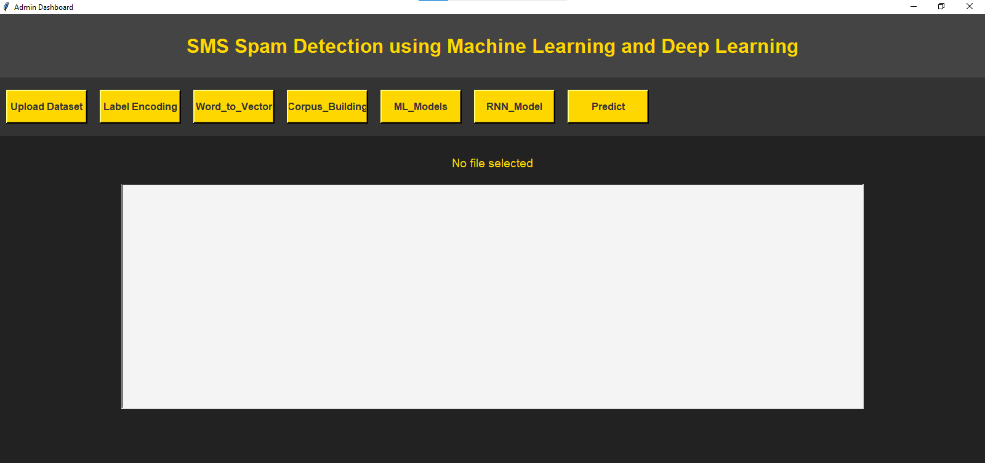

Once the user completes the action, they will be redirected to the **Admin Dashboard** page, where they can manage and view administrative functionalities.

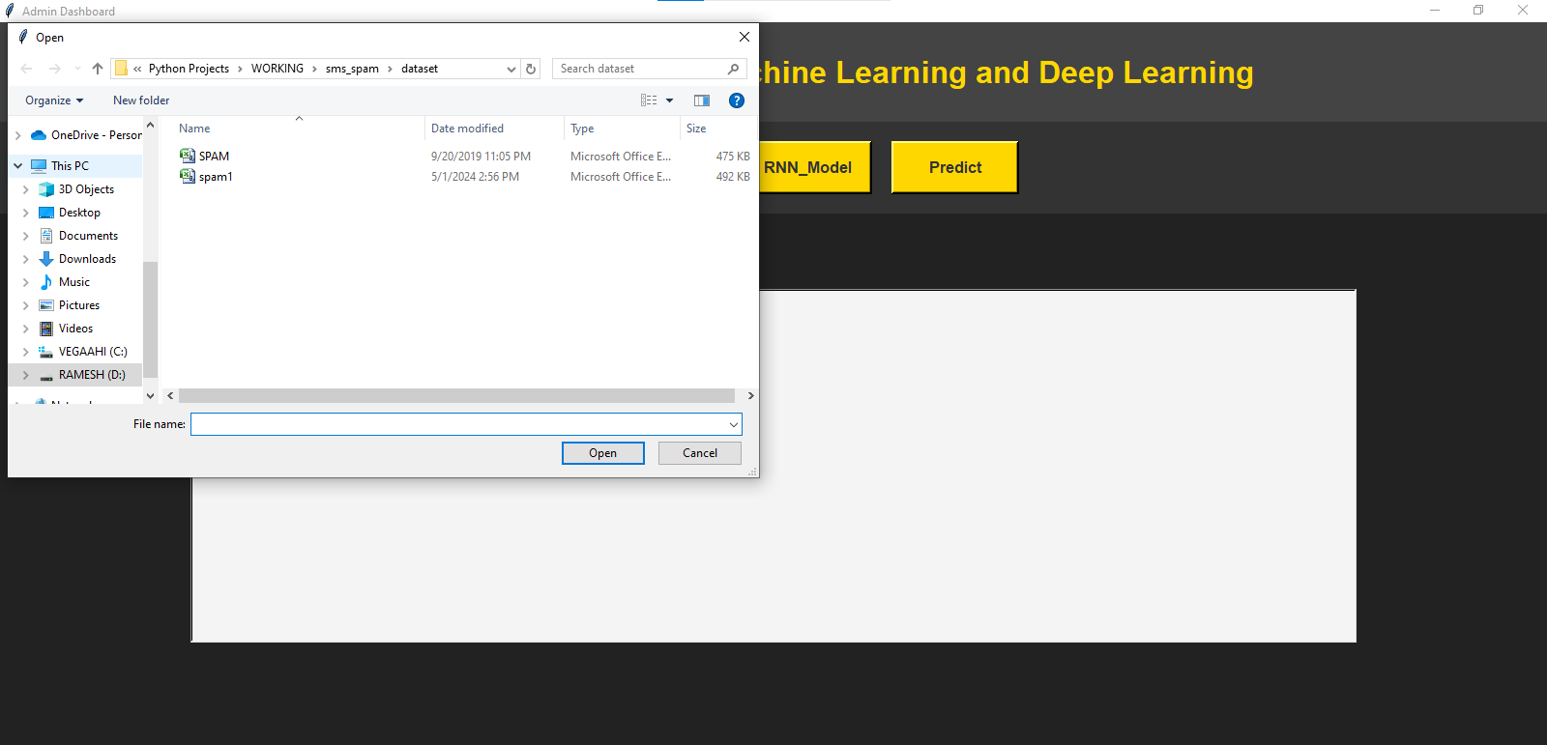

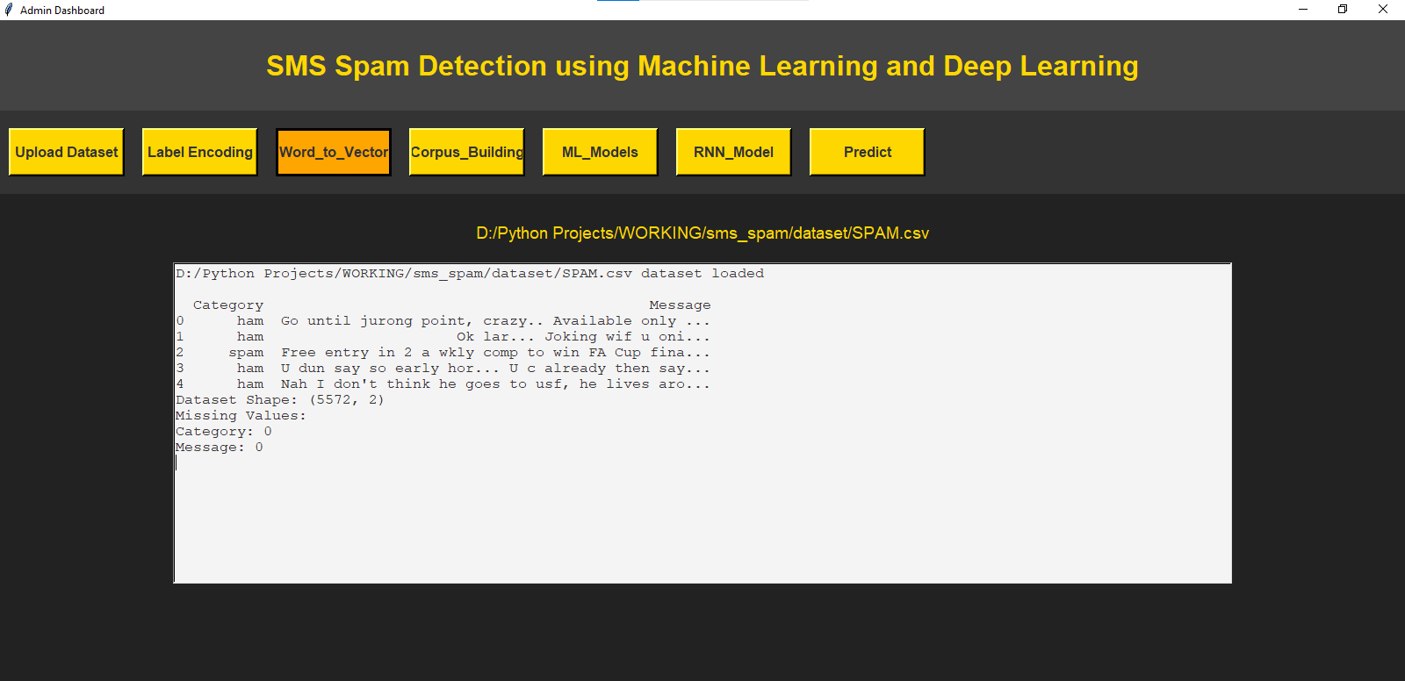

• **Go to the Dataset Upload Section:** Navigate to the platform or application where you want to upload the dataset. Look for a section labeled "Upload Dataset" or a similar option.

• **Click on "Upload Dataset":** Once you are in the dataset upload area, click on the "Upload Dataset" button. This will open a file selection window.

• **Select the Dataset:** Browse through your computer or storage location and select the dataset you wish to upload. Make sure the file format is compatible (commonly CSV, Excel, JSON, etc.).

• **Confirm the Upload:** After selecting the dataset, you may be asked to confirm your selection. Click on the "Confirm" or "Upload" button to start the upload process.

• **Wait for the Upload to Complete:** Depending on the size of the dataset and the platform, the upload may take some time. Ensure you wait for the process to finish, and once done, the dataset will be available for use in your project or analysis.

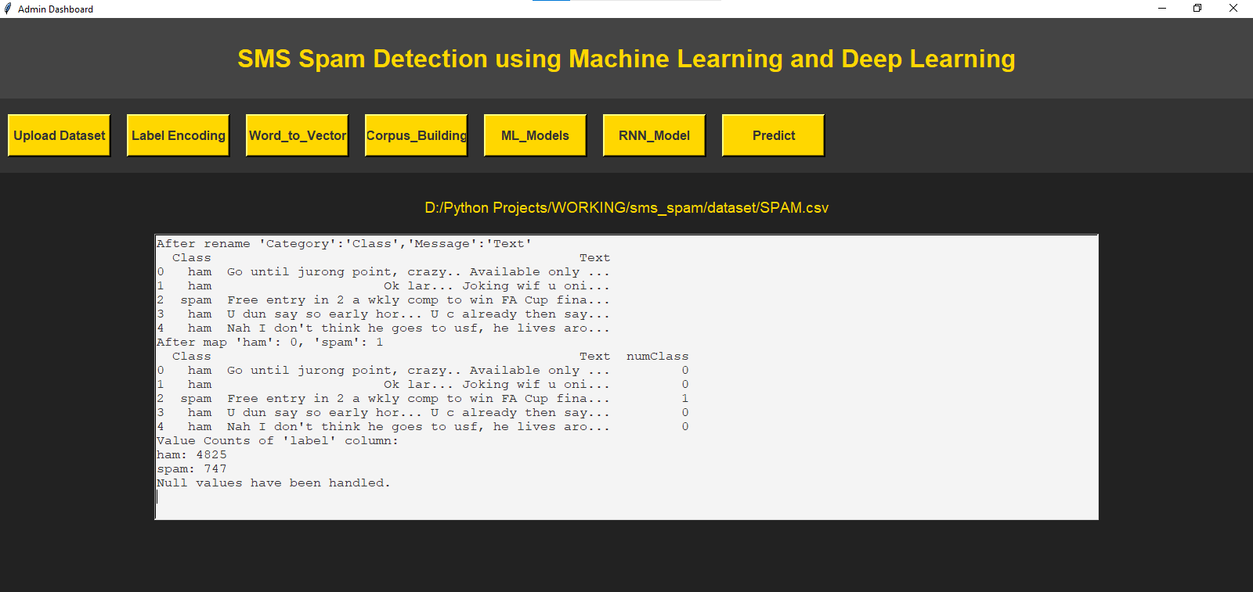

Click on the "Label Encoding" button to modify the label names. This action will assign numerical values to the categorical labels and count the occurrences of each target value.

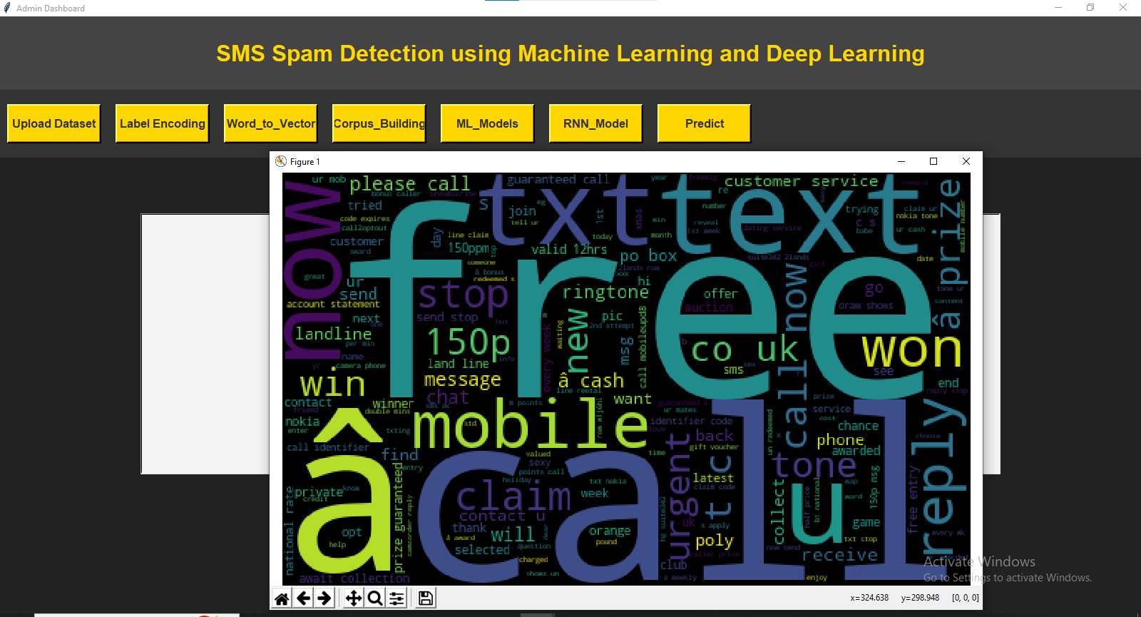

To view the image of frequent words, click on the "Word to Vector" button. This action will generate and display an image representing the most frequent words.

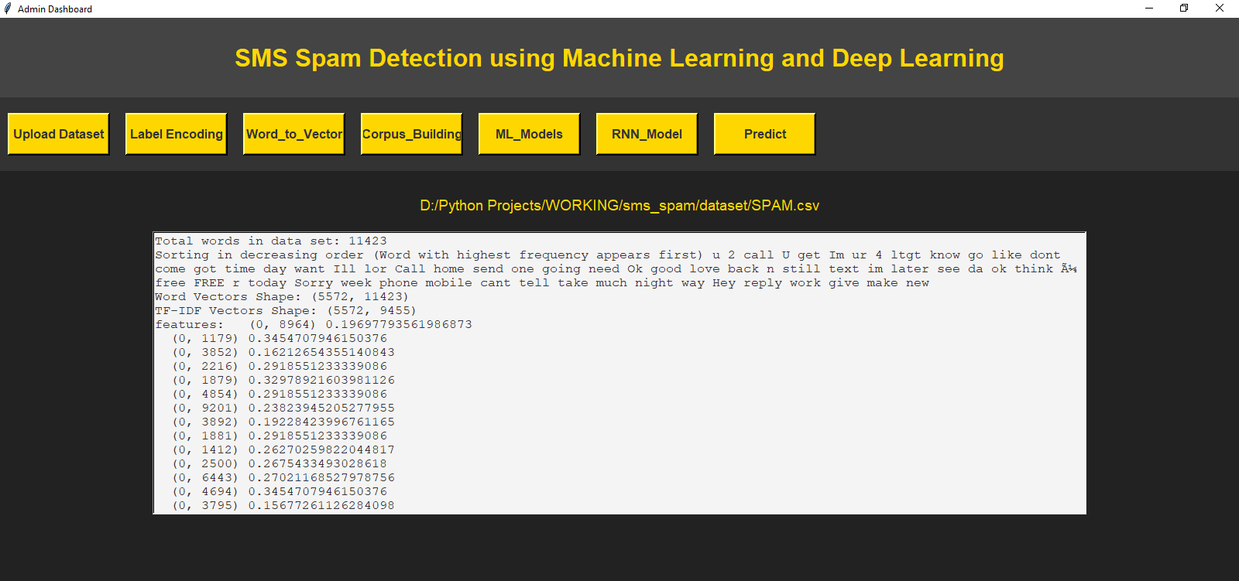

To view the image of frequent words, click on the "Word to Vector" button. This action will generate and display an image representing the most frequent words.

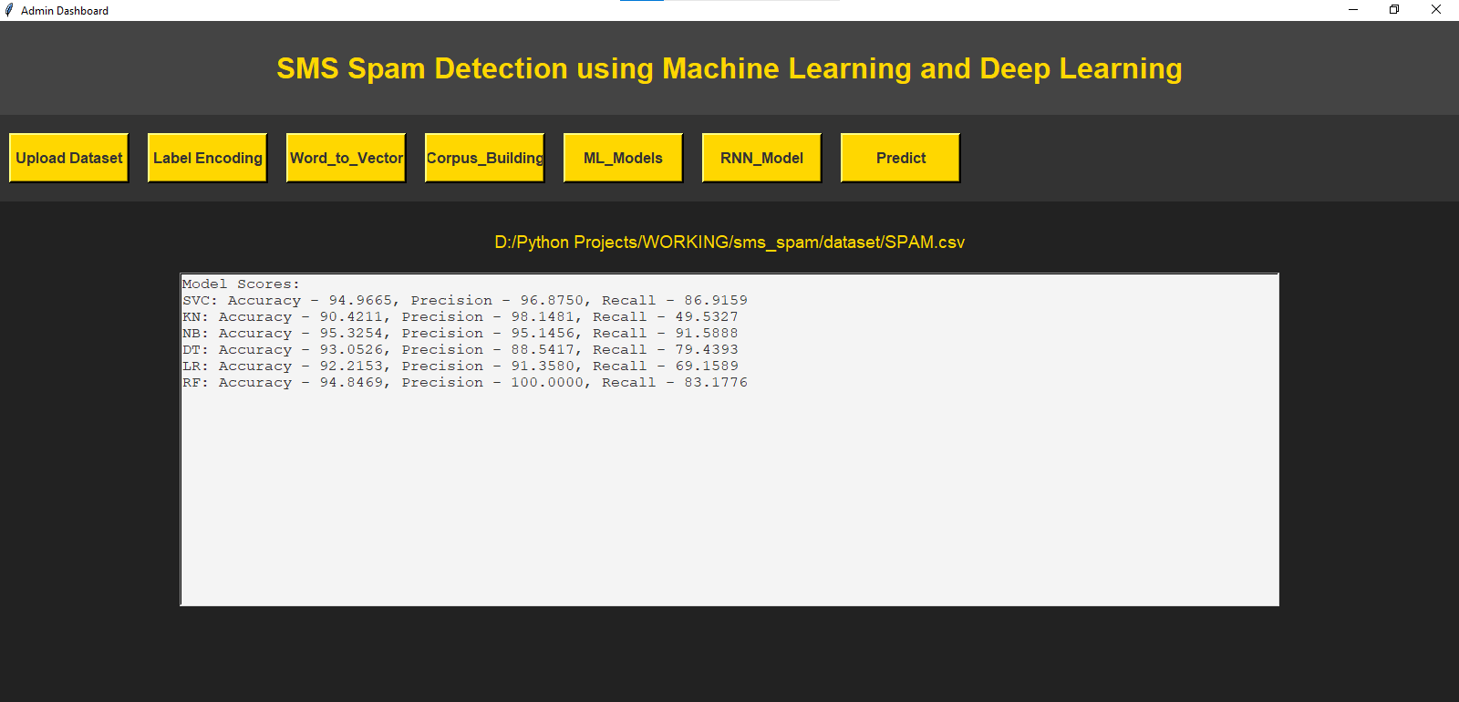

Please click on the "ML Models" button to view the accuracy, precision, and recall scores of the machine learning algorithms.

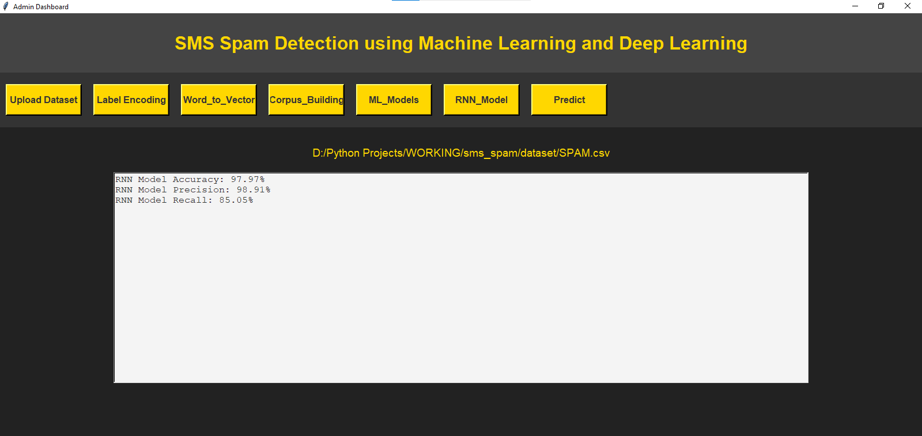

To view the accuracy, precision, and recall scores of the LSTM RNN algorithms, please click on the "RNN Models" button. This will display the relevant performance metrics for the LSTM RNN algorithm.

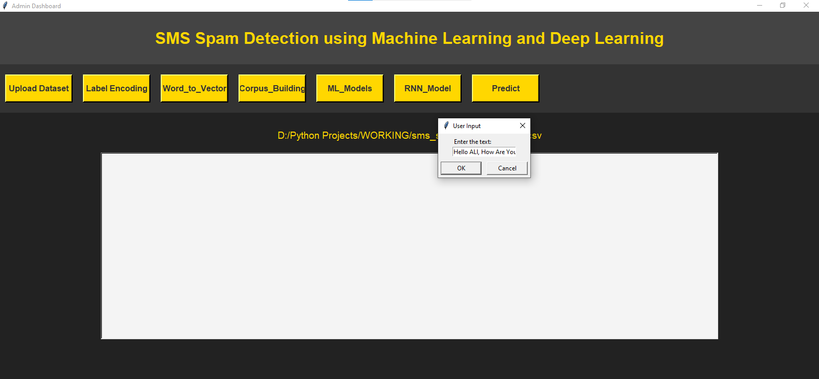

Upon clicking the "Predict" button, the system will navigate to another page where an input box and a submit button will be displayed. Please enter the required user input in the provided input box and click the submit button to proceed.

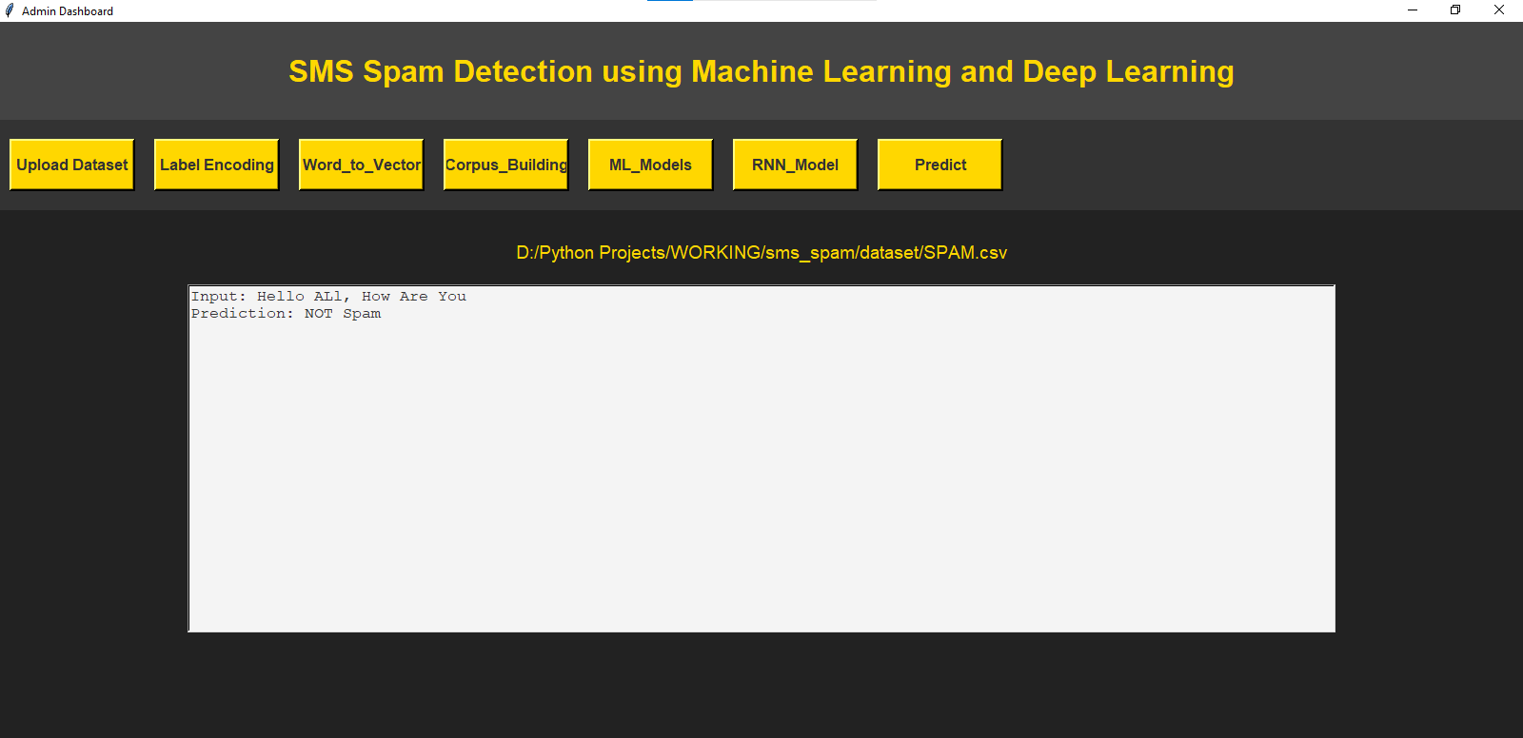

and finally display the resultlike this

Input: Hello ALl, How Are You

Prediction: NOT Spam