Setting up telegram bot:-

1. Go and search for BotFather in Telegram and click on start.
2. Select create a newbot and give a name to your bot.
3. Then your bot is ready and keep the HTTP API token with you.

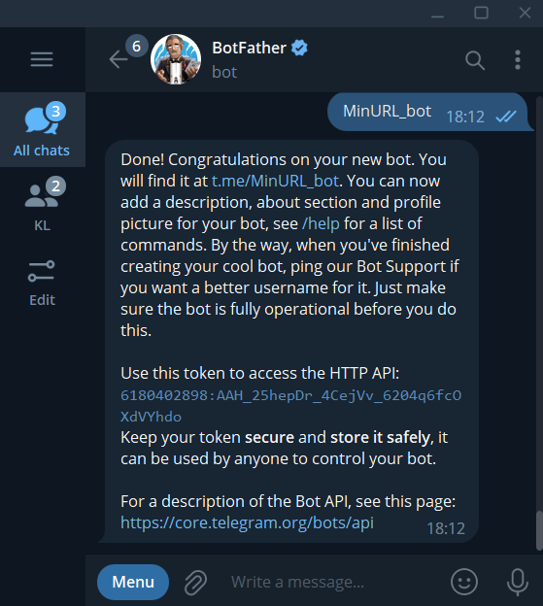



Creating a Lambda Function:-

1. Name the lambda function and select python 3.7 as runtime.
2. Click on create a sample function.

Integration with API Gateway:-

1. Go to API Gateway and Select build on HTTP API.
2. Select the Lambda function that you have created.
3. Click on Next.

4.) In configure route events select POST method.

5.) Click on next and create an API Gateway.

6.) Copy the API endpoint and resource path.



7.) Now setup the webhook by using the http api token.



8.) So our webhook is set.

Lambda Function:-

1. Now in lambda function you can see that API gateway is triggered.

1. Now paste the HTTPS token in the url of the lambda function code.
2. Now deploy the Lambda code.



Testing our bot:-

1. Now give a long url to our bot telegram bot.
2. Then it will gives the shorten url.

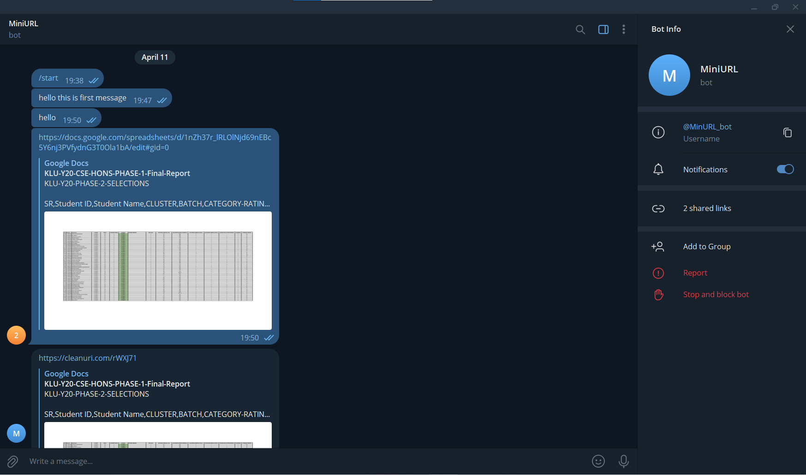

CloudWatch:-

You can monitor all the action in the cloud watch.

