CREATING A NEW VPC

1. SEARCH VPC, THEN GO TO YOUR VPC

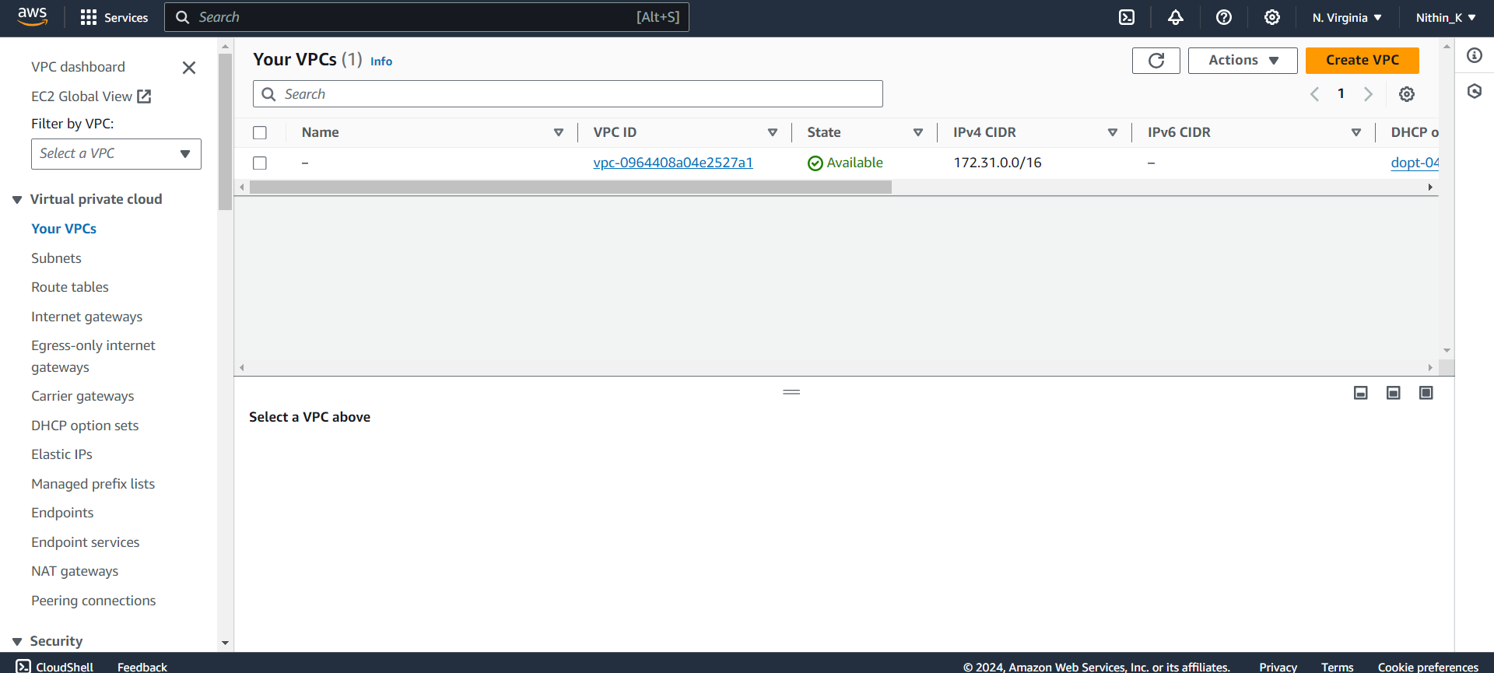

1. CREATE VPC  
   GIVE YOUR VPC A NAME.

GIVE IPV4 CIDR AS 10.180.0.0/16

CREATE VPC

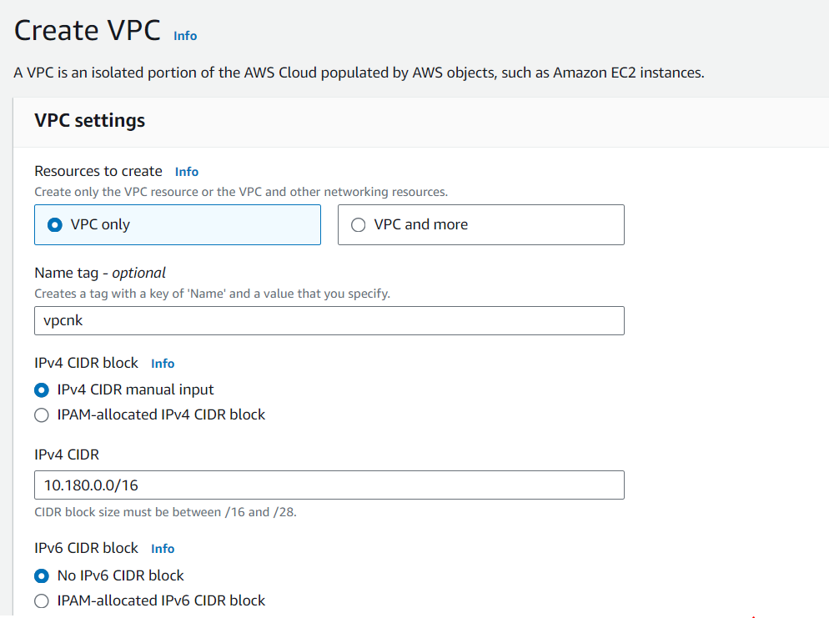

ONCE CREATED, IT WILL BE SHOWN

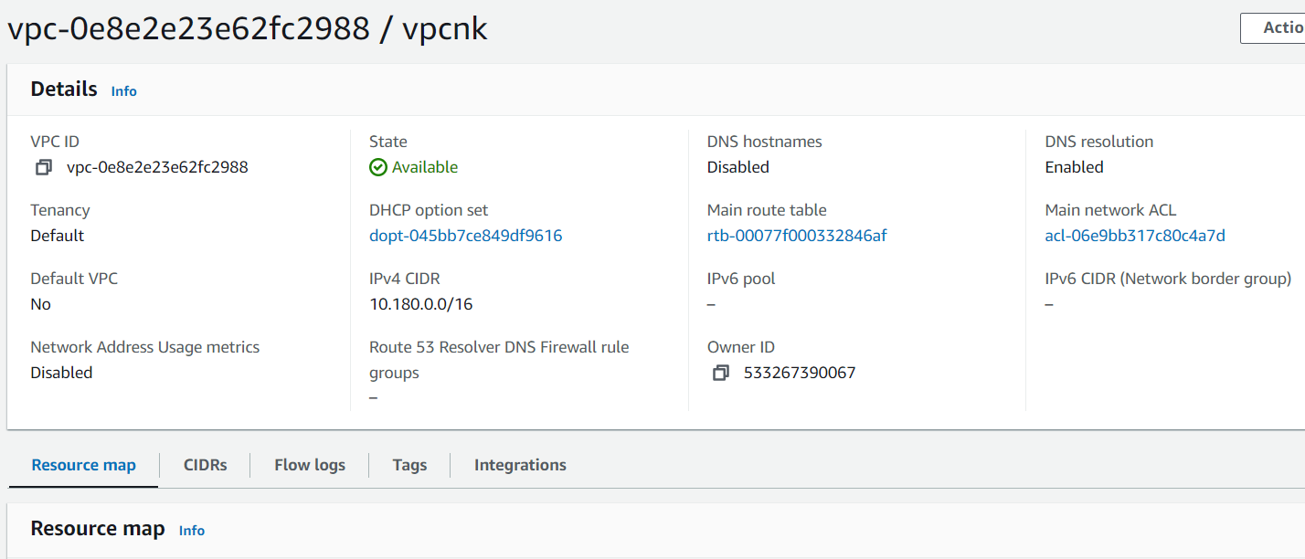

1. CLICK ON INTERNET GATEWAY OPTION

AND CREATE INTERNET GATEWAY

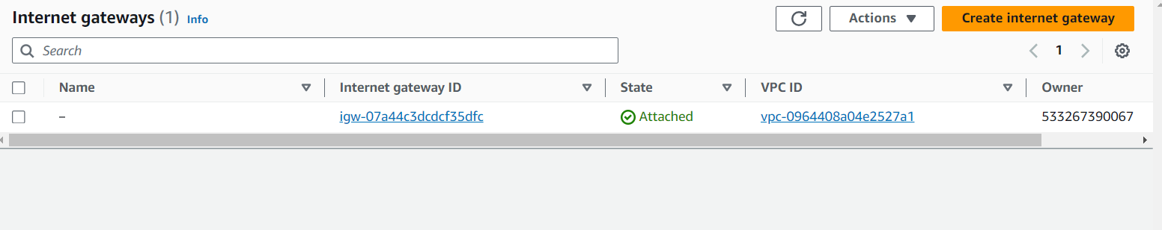

GIVE YOUR IGW NAME AND CREATE

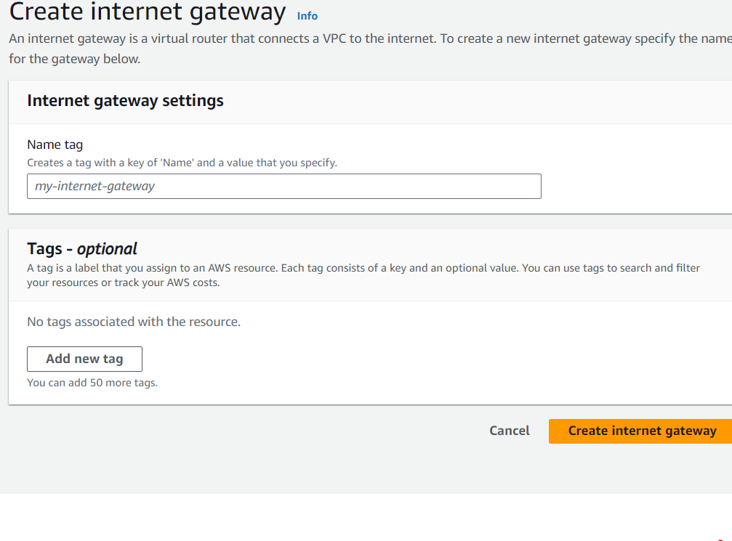

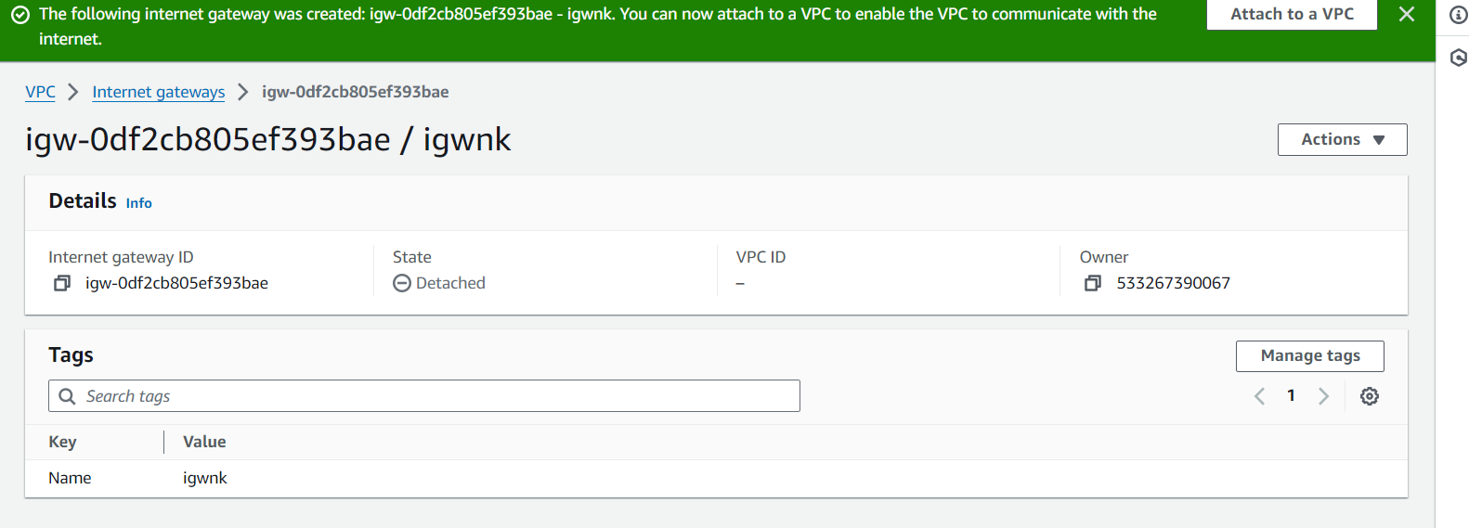

1. ATTACH THE IGW TO YOUR VPC

CLICK ON Attach to VPC OPTION

GIVE YOUR CRATED VPC

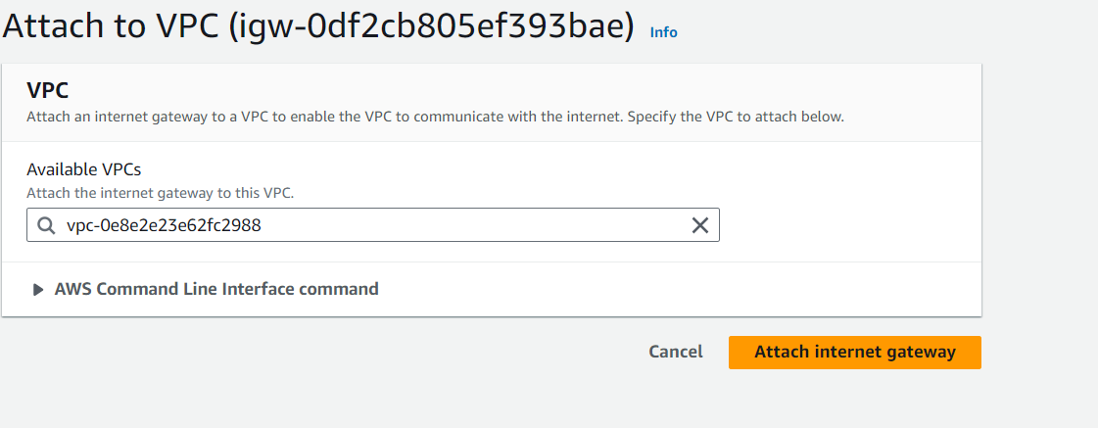

ATTATCH INTERNET GATEWAY

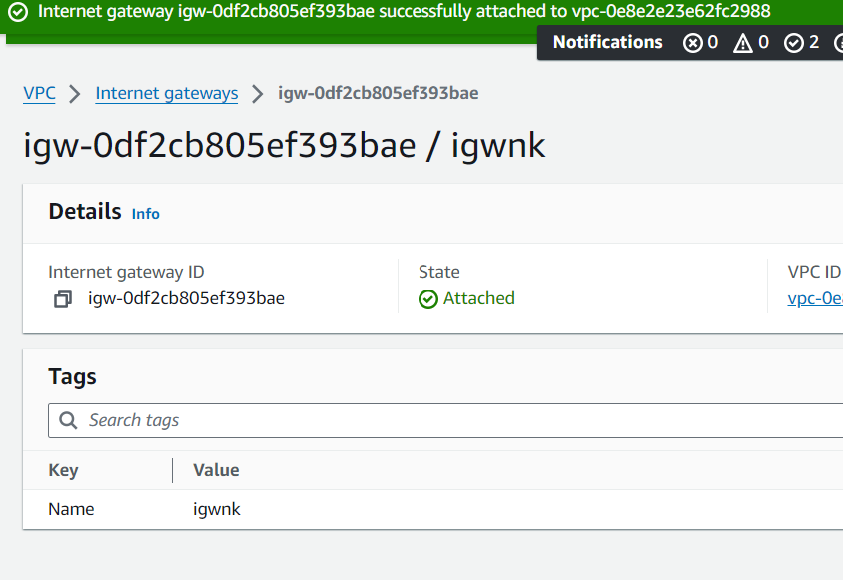

1. CLICK ON SUBNET OPTION AND CLICK CREATE SUBNET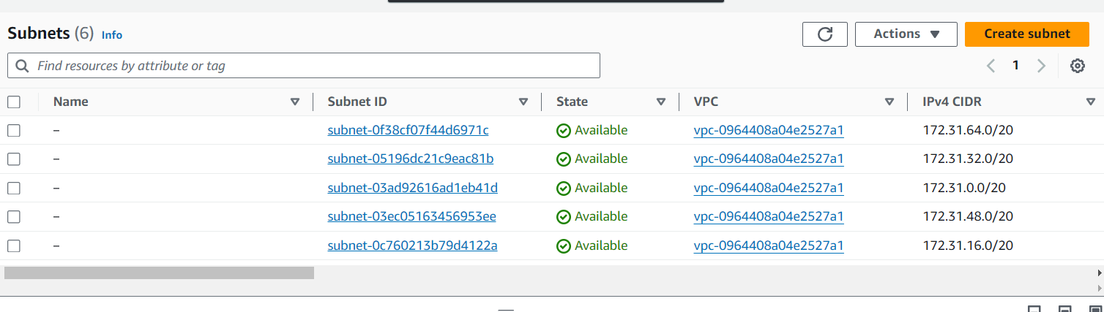

SELECT YOUR VPC

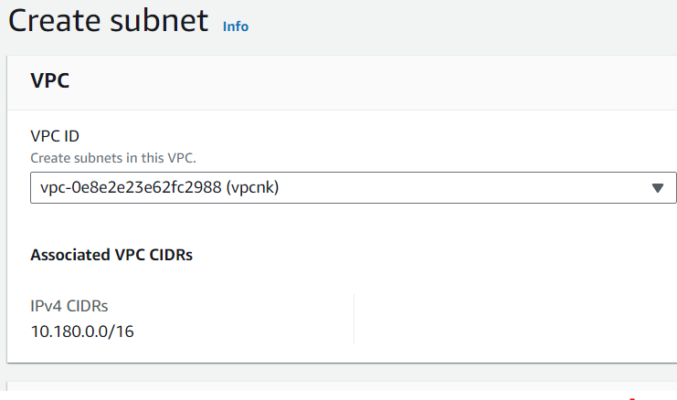

CREATE FIRST SUBNET (PUBLIC – 10.180.0.0/24)

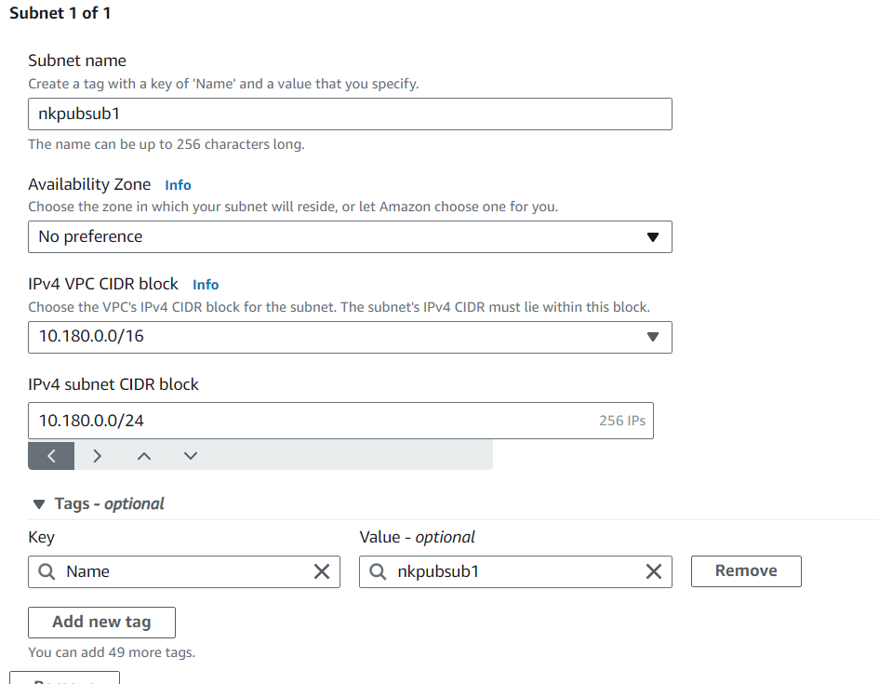

CLICK ON ADD NEW SUBNET  
ADD SECOND SUBNET (PUBLIC – 10.180.1.0/24)

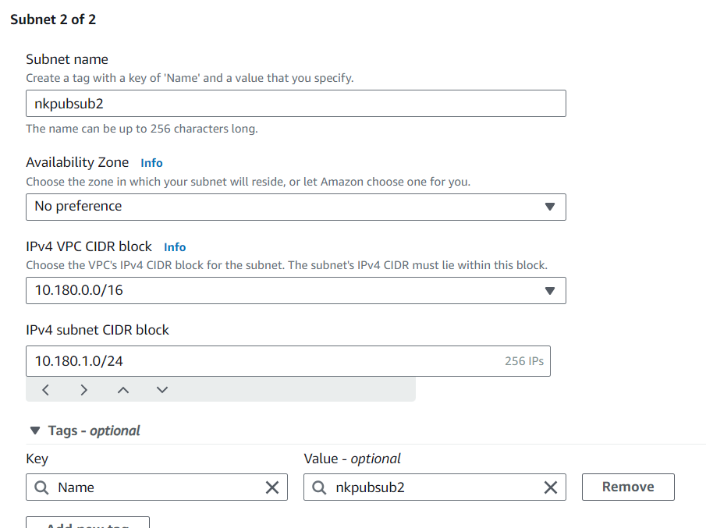

CLICK ON ADD NEW SUBNET  
CREATE THIRD SUBNET (PRIVATE – 10.180.2.0/24)

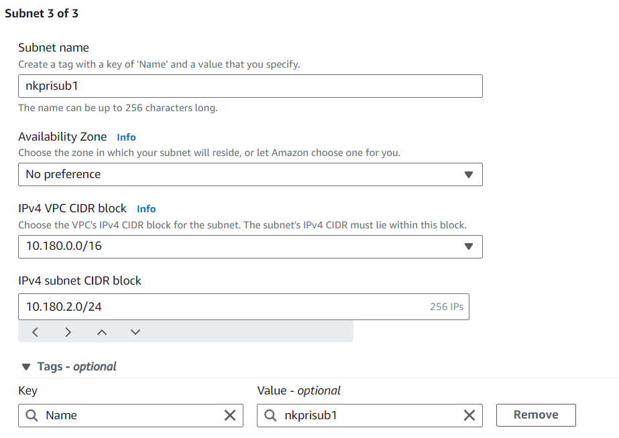

CLICK ON ADD NEW SUBNET  
CREATE FOURTH SUBNET (PRIVATE – 10.180.3.0/24)

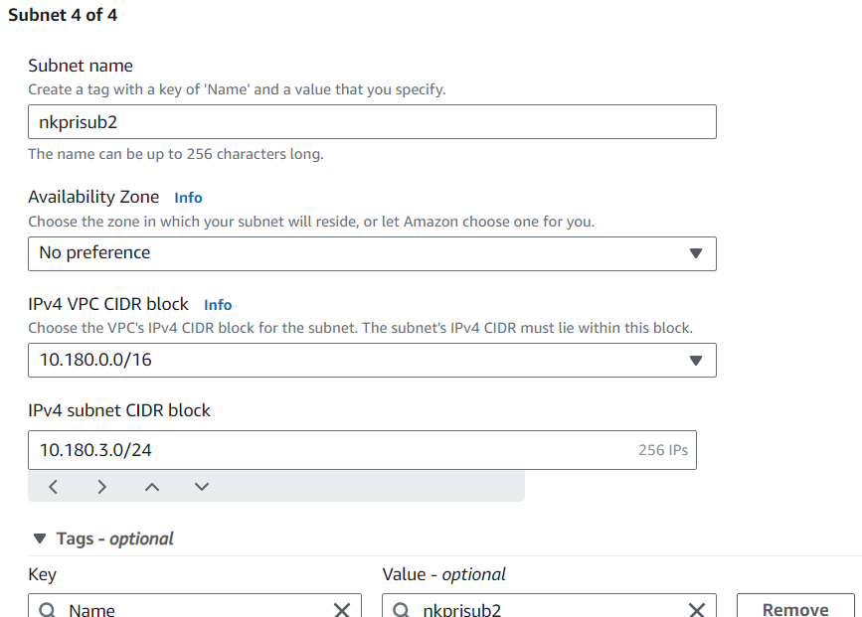

CLICK CREATE SUBNET

ALL 4 SUBNETS HAVE BEEN CREATED

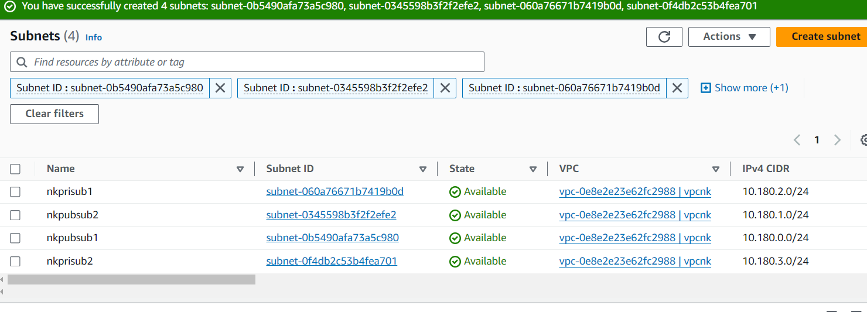

1. GO TO ROUTE TABLES OPTION AND CLICK CREATE NEW ROUTE TABLE

GIVE YOUR RTB NAME AND SELECT THE CREATED VPC (PUBLIC)

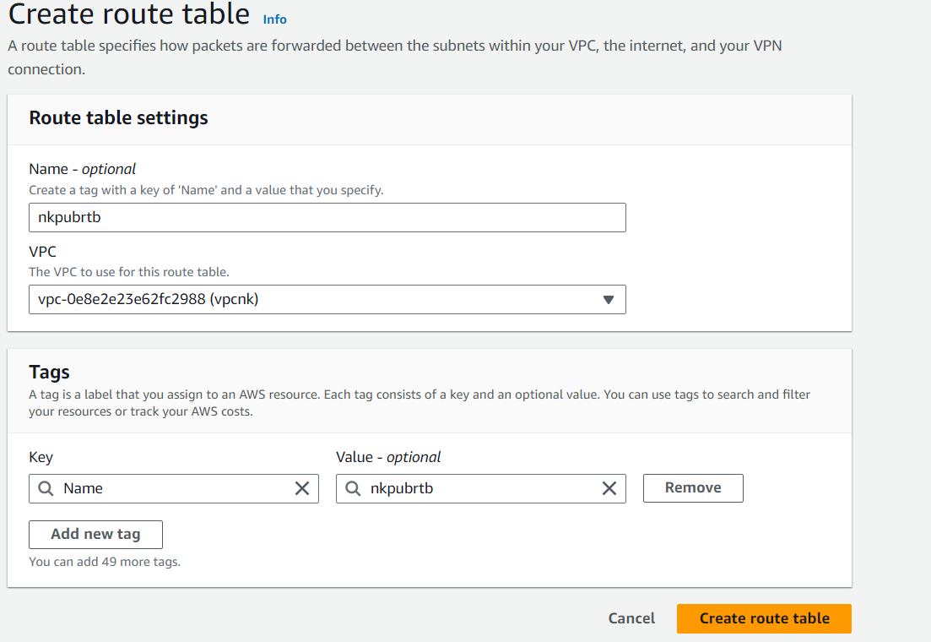

CREATE ANOTHER ROUTE TABLE (PRIVATE)

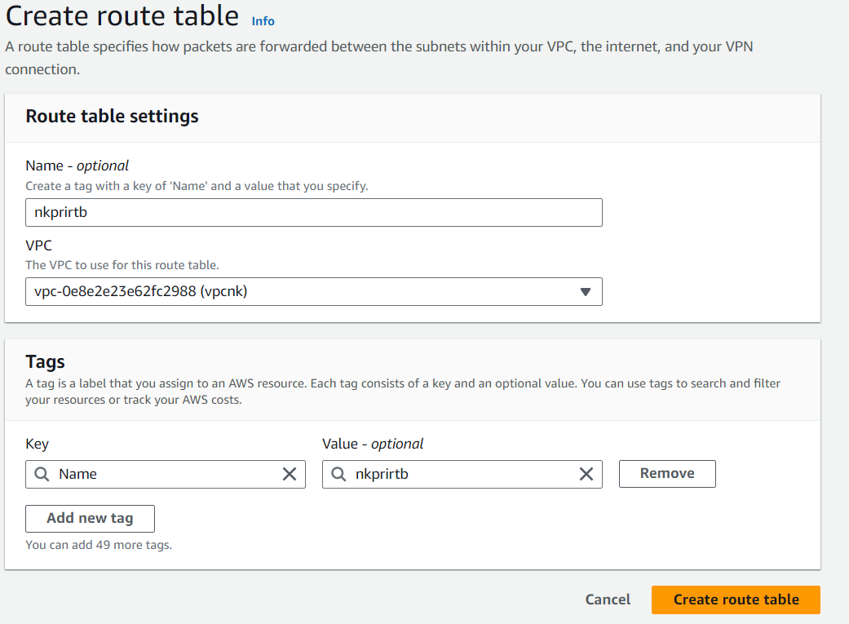

ONCE, CREATED IT WILL BE SEEN

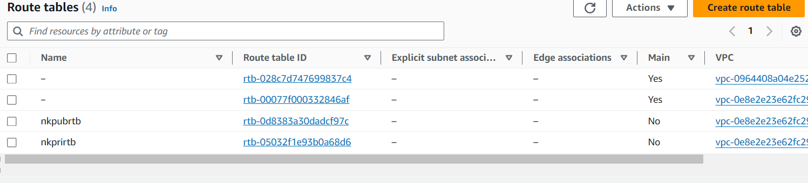

1. GO TO YOUR PUBLIC ROUTE TABLE  
   SELECT SUBNET ASSOCIATION OPTION  
   CLICK EDIT SUBNET ASSOCIATIONS  
   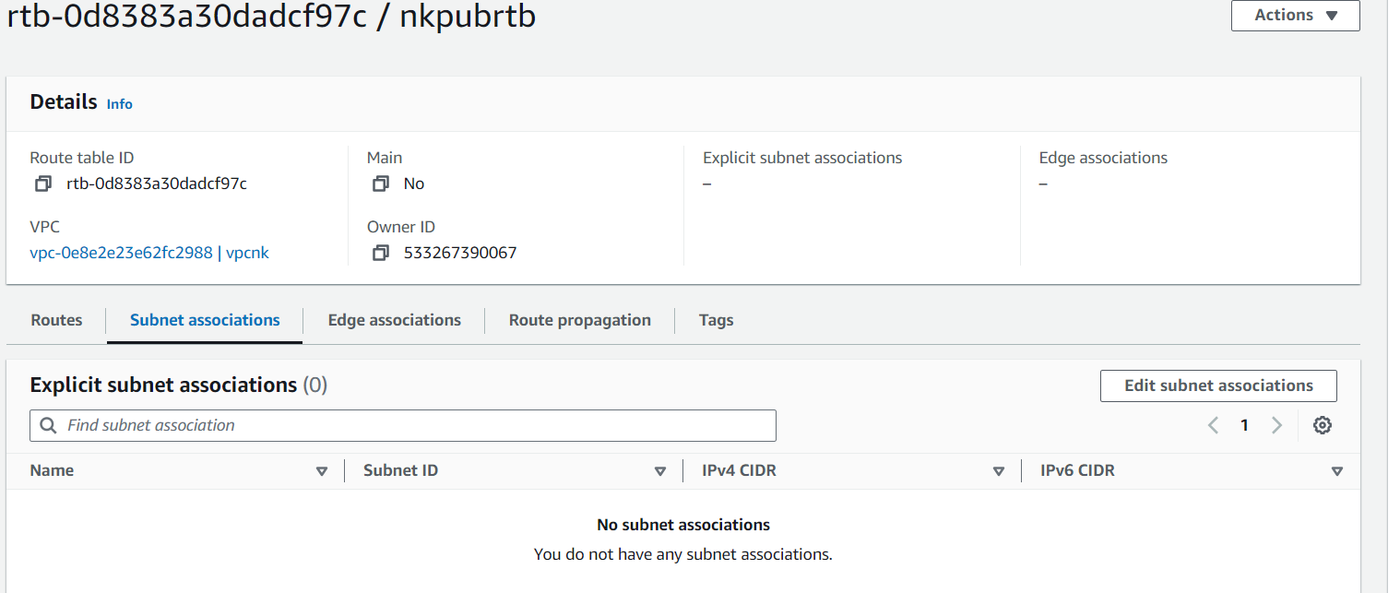  
     
     
   SELECT ONLY THE PUBLIC SUBNETS AND SAVE ASSOCIATIONS  
   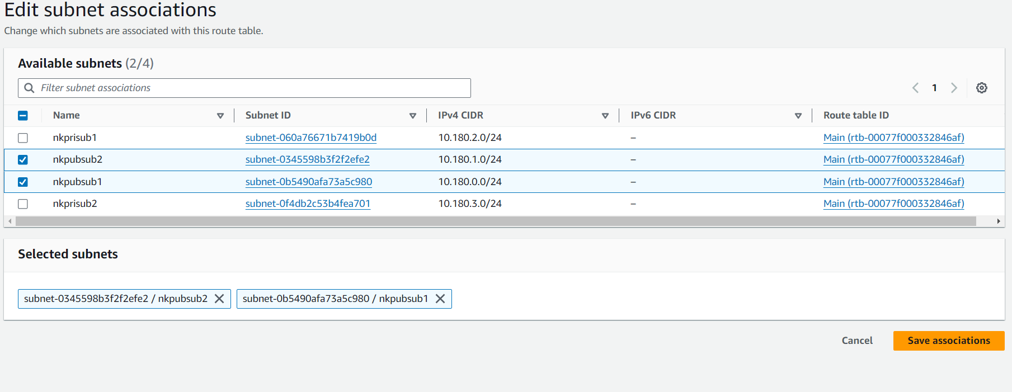  
     
     
     
     
     
     
     
   GO TO YOUR PRIVATE ROUTE TABLE  
   SELECT SUBNET ASSOCIATION OPTION  
   CLICK ON EDIT SUBNET ASSOCIATION  
   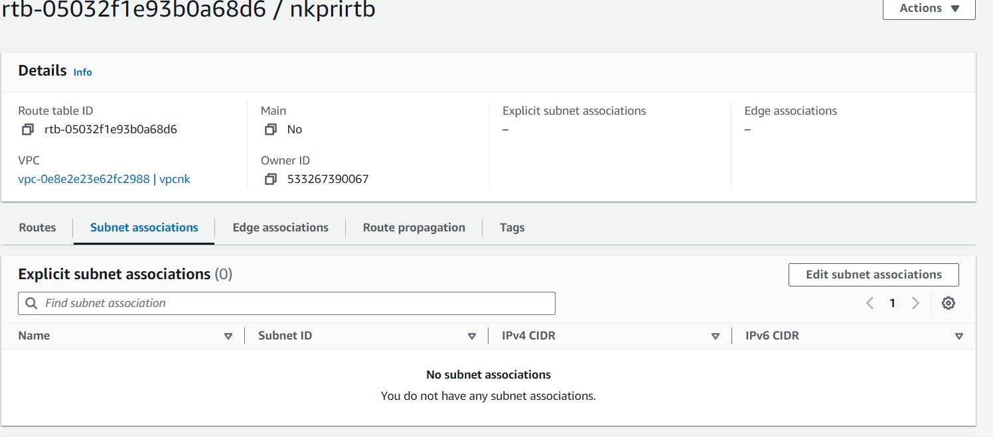  
     
   SELECT ONLY PRIVATE SUBNETS AND CREATE ASSOCIATION  
   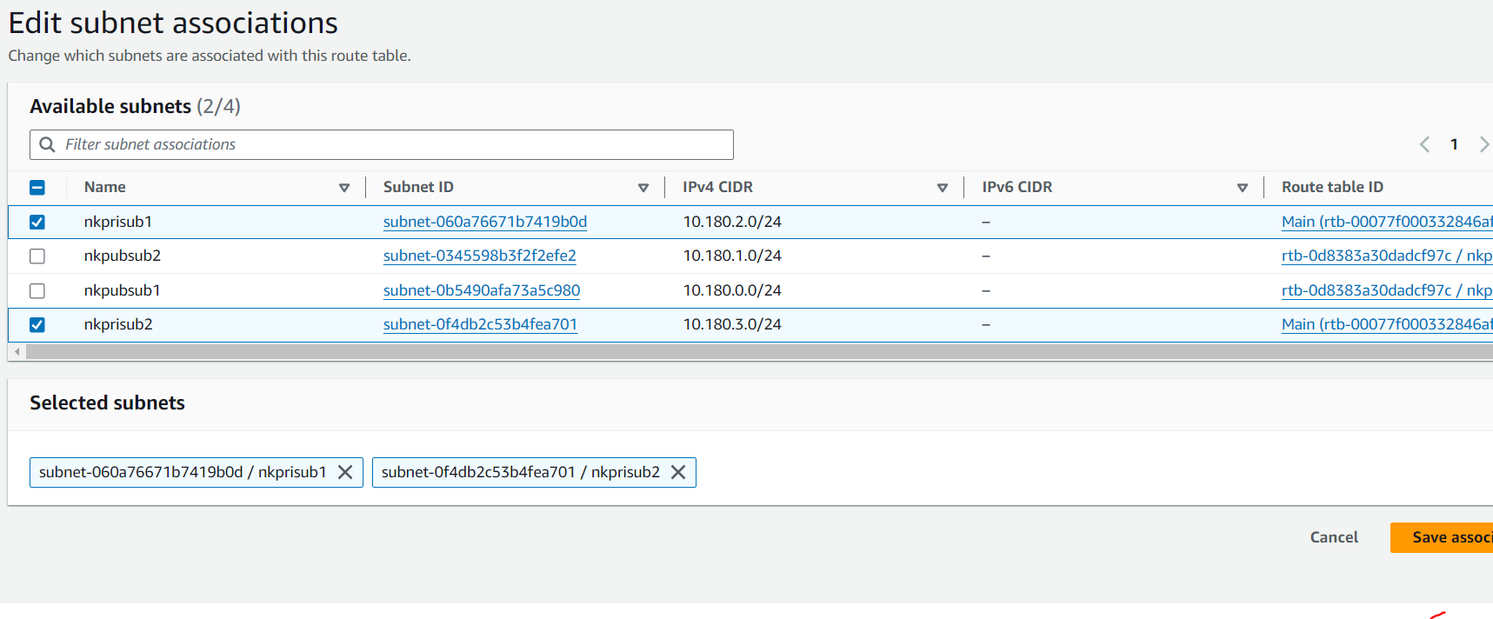  
     
     
     
   8. GO TO YOUR PUBLIC ROUTE TABLE  
   IN THE ROUTE OPTION, CLICK ON EDIT ROUTE  
   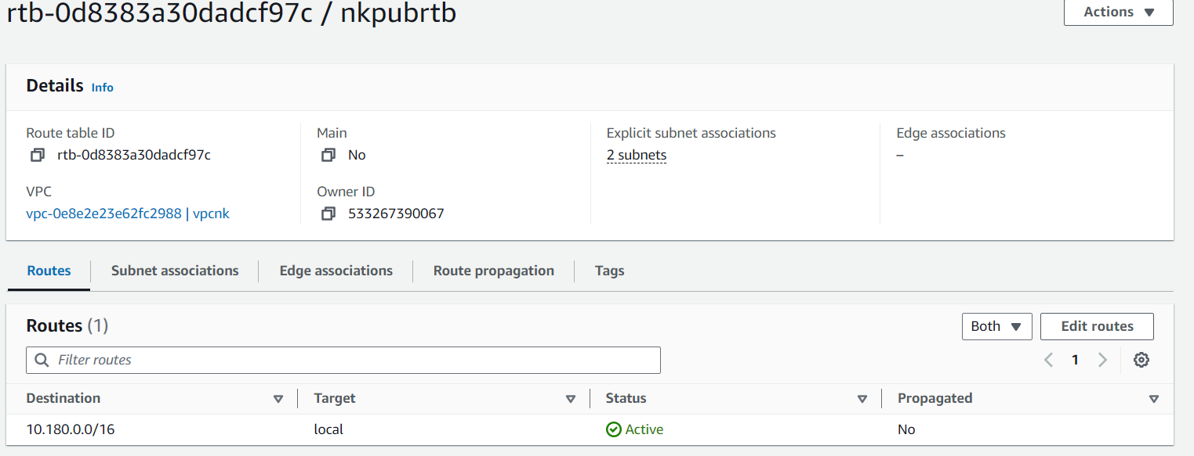

CLICK ON INTERNET GATEWAY AS TARGET AND CHOOSE YOUR CREATED IGW WITH DESTINATION 0.0.0.0  
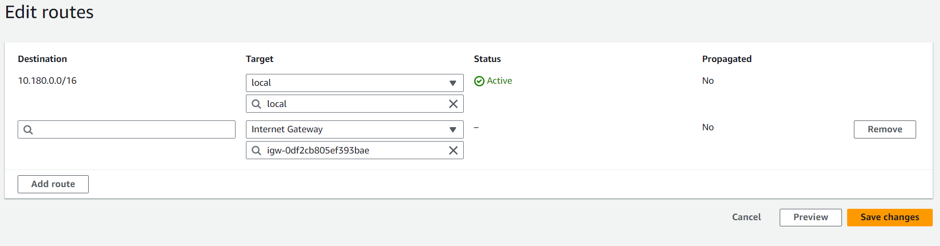

ONCE SAVED, IT IS ACTIVE FOR INTERNET  
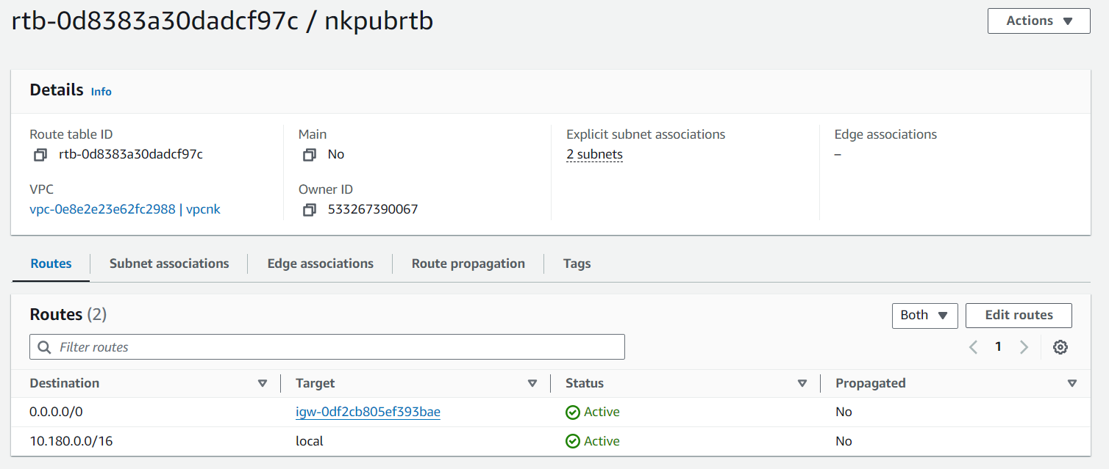

9.GO TO EC2 AND UNDER INSTANCES, CLICK LAUNCH INSTANCES

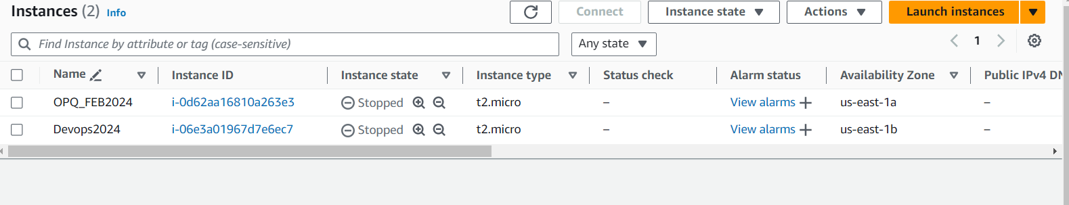

GIVE A NAME  
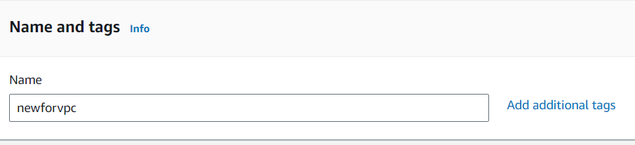  
  
SELECT A KEY PAIR  
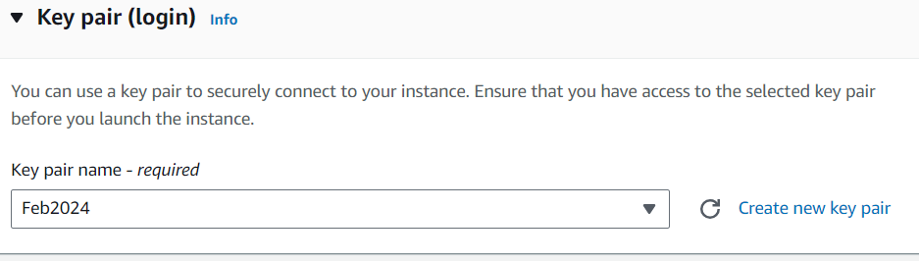  
  
IN NETWORK SETTINGS, CLICK ON EDIT  
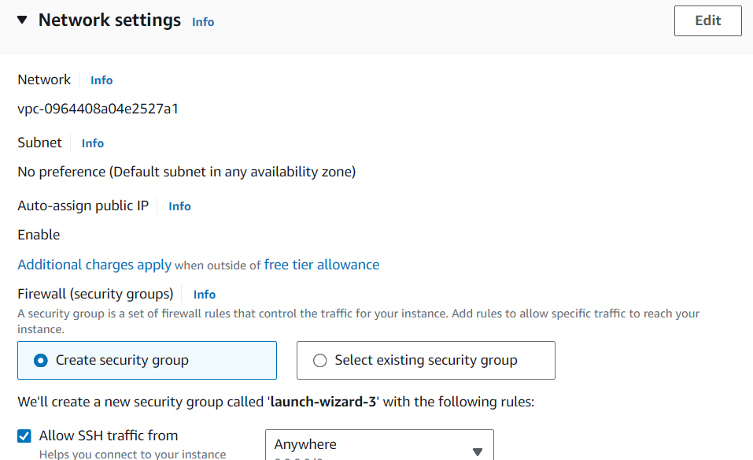

SELECT YOUR VPC AND CHOOSE YOUR PUBLIC SUBNET  
  
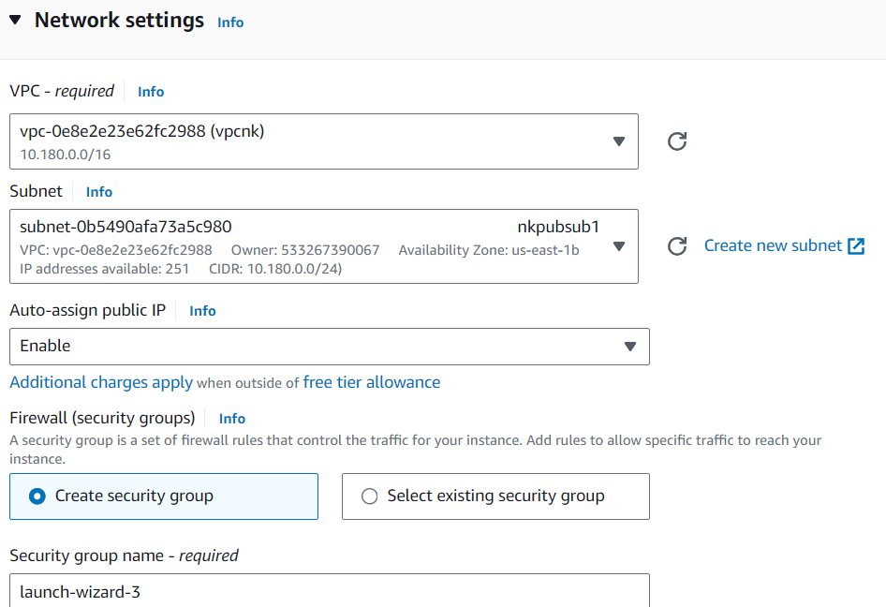  
  
  
CLICK LAUNCH INSTANCE  
  
  
YOUR NEW INSANCE IS RUNNING  
