**Experiment No.: 2**

**Aim**

Familiarisation of Linux commands

**CO2**

Perform System Administration tasks.

**Procedure**

Date 14032023

$ grep marks | grep 90



grep searchitem filename

Search for particular content in a file

$ grep 90 marks



grep -i

Displaying a particular item from the file (case insensitive search)

$ grep -i English marks



grep -i searchitem filename

Search for particular item and to display it (case insensitive search)

$ grep -i English marks



grep -v serachitem filename

Display the items in the file except the item specified

$ grep -v English marks



grep -A1 searchitem filename

Display the item searched along with a line after that particular item

$ grep -A1 English marks



grep -B1 searchitem filename

Display a particular item along with a line before that line

$ grep -B1 English marks



grep -C1 searchitem filename

Display a particular item along with a line before and after that line

$ grep -C1 English marks



head filename

To display first 10 line o the file specified

$ head demo

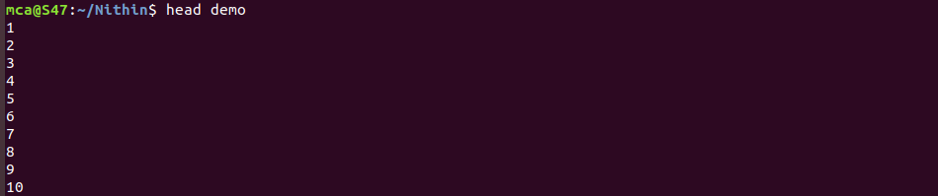

head -5 filename

Display first specified number of lines of the file

$ head -5 demo

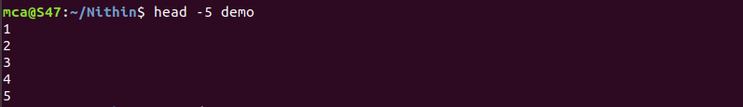

tail filename

Display last 10 lines of content of the file specified

$ tail demo

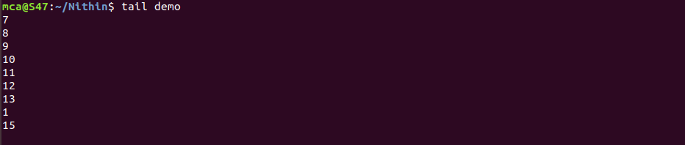

tail -5 filename

Display last specified number of lines of content of the file

$ tail -5 demo

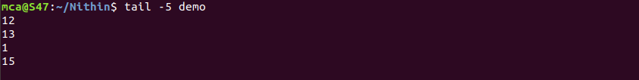

mv file1 file2

To move the contents of the file1 to file2. File1 is deleted and file2 will be overwritten.

$ mv demo marks

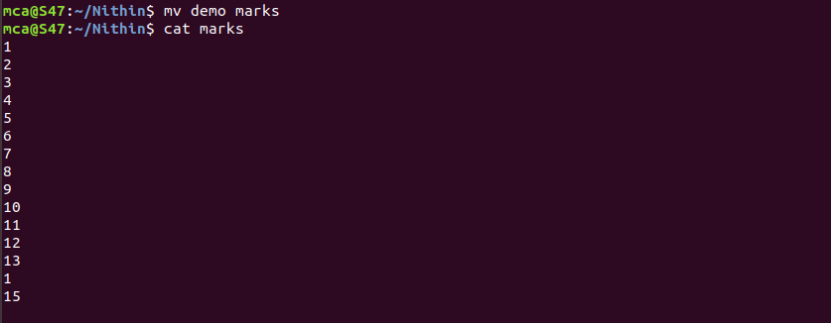

mv -b file1 file2

To move and backup the contents of the file1 to file2 and backup to file2~

$ mv -b marks profile



mv -i file1 file2

To move the content of file1 to file2 with a prompt to the user for confirmation.

$ mv -i profile profile1



**Result**

The program was executed and the result was successfully obtained. Thus CO2 was obtained.