Pre-requisites
- Local docker registry for storing docker images. Storing customer application in docker hub registry is not advisable for security reasons.

Development Environment
Layout would be a single apache container which houses the static content and a single tomcat container which houses the J2EE web application. Both the containers run on a single VM

Requirements:
1 RHEL7 64 VM with minimum 50GB Disk capacity for / partition and minimum of 8GB RAM and minimum of 2 core CPU.
- The httpd dockerfile installs the required binaries for httpd with ssl to function, along with tomcat connector for connecting to apache tomcat application server.
- Apache container exposes ports 80 and 443.
- Mod jk is enabled for load balancing and the worker.properties defines the workers.
- All incoming traffic on port 443 is channeled to tomcat container in which the tomcat server running on port 8009.
- The tomcat dockerfile pulls RHEL 7 VM, installs apache tomcat, places the ROOT.war into the webapps folder of tomcat and starts the server.

UAT/SIT Environment
Refer figure 1 below
The architecture showcases 2 horizontally scaled apache containers running on a swarm on 2 different VMs/servers which load balances incoming requests to horizontally scaled tomcat containers on a separate swarm on 3 different VMs/servers. This environment setup mirrors the production environment albeit on a smaller scale.

Requirements:
2 RHEL7 64 VM with minimum 50GB Disk capacity for / partition and minimum of 8GB RAM and minimum of 2 core CPU.

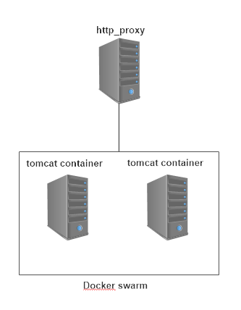
Figure 1

Production environment
Refer figure 2 below
The prod environment has 2 docker swarms: the web docker swarm runs the apache containers with ssl configured and the app docker swarm runs the tomcat containers. Load is distributed in round robin fashion. The 2 docker swarms are segregated physically and logically. Communication between the swarms happens by configuring service and enabling ports on the leader nodes on both the swarms.

Requirements:
5 RHEL7 64 VM with minimum 50GB Disk capacity for / partition and minimum of 8GB RAM and minimum of 2 core CPU.

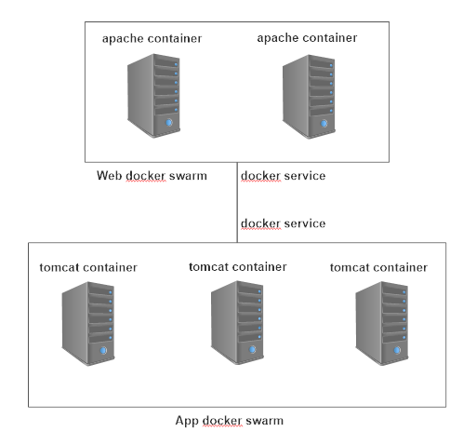
Figure 2

Swarm setup
docker swarm init --advertise-addr node_ip_address
docker swarm join --token your_swarm_token manager_node_ip_address:2377
docker stack deploy --compose-file=docker-compose.yml sample

Scaling
For vertical scaling, docker service scale should suffice.
For horizontal scaling new servers can be added and swarm can be expanded using docker swarm join command.

