CS4700/CS4705 Project Definition Form for MSc Dissertation

Student Name, Number and Email:  Nithin Mathew Joseph, 210199723, and 210199723@aston.ac.uk | Degree programme: MSc in  MSc Artificial Intelligence with Business Strategy
Project title: Question and answer reasoning on legal text, why and how it can be enhanced
Supervisor Name and Email:
Abinaya Sowriraghavan and a.sowriraghavan@aston.ac.uk
What is the project about?

An interactive tool wherein the user punches in a single query of legal context. The machine learning model understands the context of the query and provide the article of interest which contains the answer to the query and can be disseminated to non-technical experts.
Why should the project be carried out?

There is already research in the name of “answering legal questions by learning neural attentive text representation” by Phi Manh Kien et al. The motivation for this project is to build a model like theirs and try improving its performance if possible, alongside adding additional layers such as explainability. The benefits would be as follows:
- Implement an ablation study based on the stages present in the model.
- Build a GUI for the user that is simple to interact with.
- The project can be converted into a product that can be marketed in general as an educational tool for the illiterate to use.
- Also be introduced as an application to big corporations that are battling legal issues as an initial tool to handle standard queries instead of approaching law firms which would be a waste of time and money
- Legal text interpretation using this model can help individuals battling legal wars with lawyers who are well versed in the domain.
- Aid lawyers to work efficiently and reduce the time taken for them to reach a conclusion for a case
- Used as a steppingstone for future applications or models that will be researched on further may it be domain specific or general interest to learn it.

What is the project deliverable?

- An executable that provides the GUI which generates a portal for the user to input their query.
- The model built after regress training that can be dissected later for further applications on the legal context.
What are the main challenges of the project?

In this project the plan is to create a named entity recognizer (NER) using convolutional neural network. The NER needs to identify the legal features in the statements provided. It will be deployed for both the query and the articles. This NER model needs to indicate the features it extracts from the query in the GUI so that the user can comprehend how the application works. This helps the user build better queries that the model can interpret. NER will be the initial setup followed by a model that uses the output generated from the NER to identify the article which matches closely to the query. For this the foresight is to utilise concepts on which techniques like Google’s page rank, Topic model and retrieval techniques are based on. There is also a plan to add additional features that will involve further expansion of the model. Like identifying the jurisdiction of law or identifying lawyers nearby for further consultation.

Requirement involves the language of the input information, which is still under consideration. The data collection for educating the model will be based on the availability of legal corpus in that specific language. Will need to access legal documents that are digitized as input for training the model. These need to be vetted for confidentiality before utilizing them. One of the research studies discussed implemented a similar build. Which gives confidence on the feasibility of this project. If a strict timeline on building the different stages of the model is followed. The proposed project can be accomplished within the deadline provided.

Ethical implications involve the data that is collected for training the model, which needs to go through the right channels before it is accessed for educating the model. Meaning if the data is not accessible publicly it is under confidentiality. So, in such cases the proper procedure would be to identify the parties in charge of the data and request access before utilising it.

Timetable showing main stages in work plan:

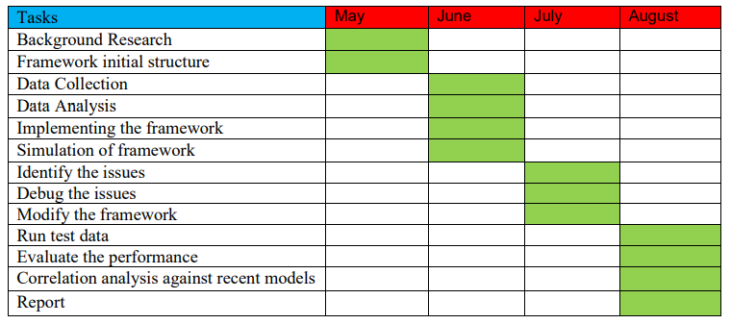

Student’s signature Nithin Mathew Joseph Date 01/06/2022

Supervisor’s signature Abinaya Sowriraghavan Date 01/06/2022
Notes: (1) The layout of this form may be adjusted as necessary to fit the needs of your project.
(2) Everything except the signatures and dates should be entered using word processing.
(3) You can remove these notes from your final project definition.

