Retail Sales & Profit Analysis
Final Internship Project Submission | Mentor: Tarun Kumar
Prepared by: Nithin Medipelly | Date: June 30, 2026

1. Project Objective
The objective of this project is to analyze a retail sales dataset, clean the data, calculate business KPIs, identify sales and profit patterns, and create a dashboard-style analysis file for business decision-making. The project demonstrates core Data Analyst skills including data cleaning, KPI development, business insight generation, and dashboard creation.

2. Dataset Overview
The cleaned dataset contains 8,399 records covering orders, sales, discount, shipping cost, profit, customer segment, region, product categories, product names, and shipment information.
Dataset Feature | Description
Date Fields | Order Date and Ship Date
Financial Fields | Sales, Profit, Discount, Unit Price, Shipping Cost
Customer Fields | Customer Name, Province, Region, Customer Segment
Product Fields | Product Category, Sub-Category, Product Name, Product Container, Product Base Margin
Order Fields | Order ID, Order Priority, Order Quantity, Ship Mode

3. Data Cleaning Process
Cleaning Step | Action Completed
Duplicate records | 0 duplicate rows removed
Missing values | 63 missing values detected before cleaning
Product Base Margin | 63 blanks filled using median value 0.52
Date formatting | Order Date and Ship Date converted to yyyy-mm-dd format
Numeric formatting | Sales, Profit, Discount, Shipping Cost, Unit Price, and Product Base Margin formatted correctly
Column names | Column names standardized for consistency and readability

4. KPI Summary
KPI | Value
Total Sales | $14,915,600.82
Total Profit | $1,521,767.98
Total Orders | 5,496
Average Discount | 4.97%
Total Shipping Cost | $107,831.04
Profit Margin | 10.20%

5. Business Insights
Which region generates the highest sales?
West generated the highest sales with $3,597,549.28.
Which product category is the most profitable?
Technology is the most profitable category with $886,313.52 in profit.
Which products generate the highest revenue?
The top revenue product is Global Troyª Executive Leather Low-Back Tilter, generating $275,941.52.
Which customer segment contributes the most profit?
Corporate contributes the most profit with $599,746.00.
What is the monthly sales trend?
Sales fluctuate month by month, with the strongest month being 2010-09 at $463,269.22. The lowest month was 2012-08 at $183,279.71.

6. Dashboard Visuals

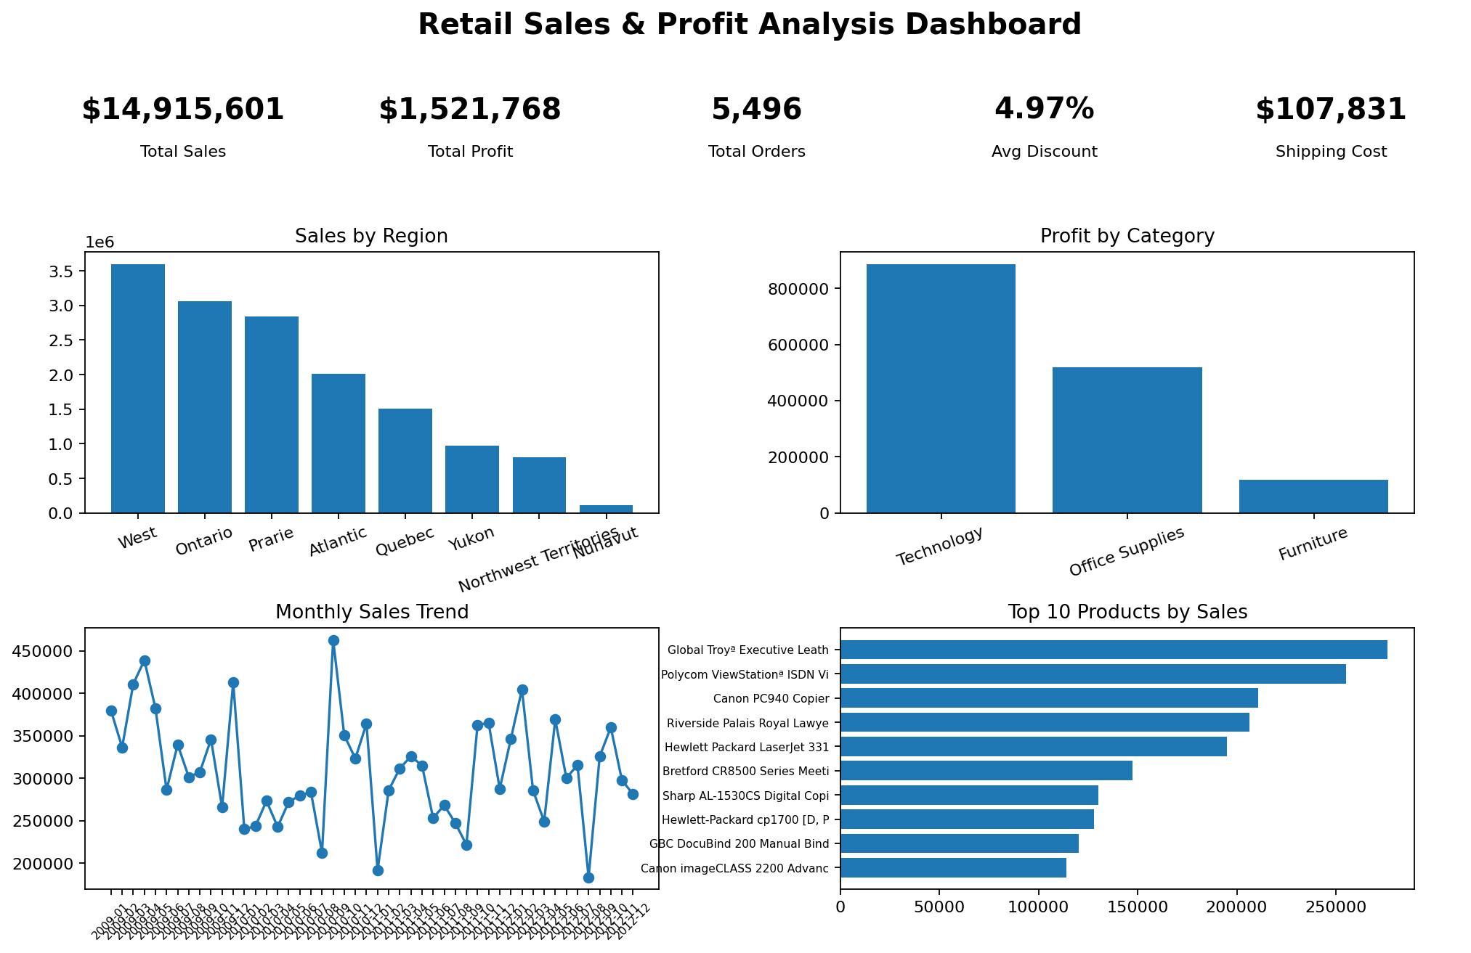
Dashboard overview with KPIs and key charts

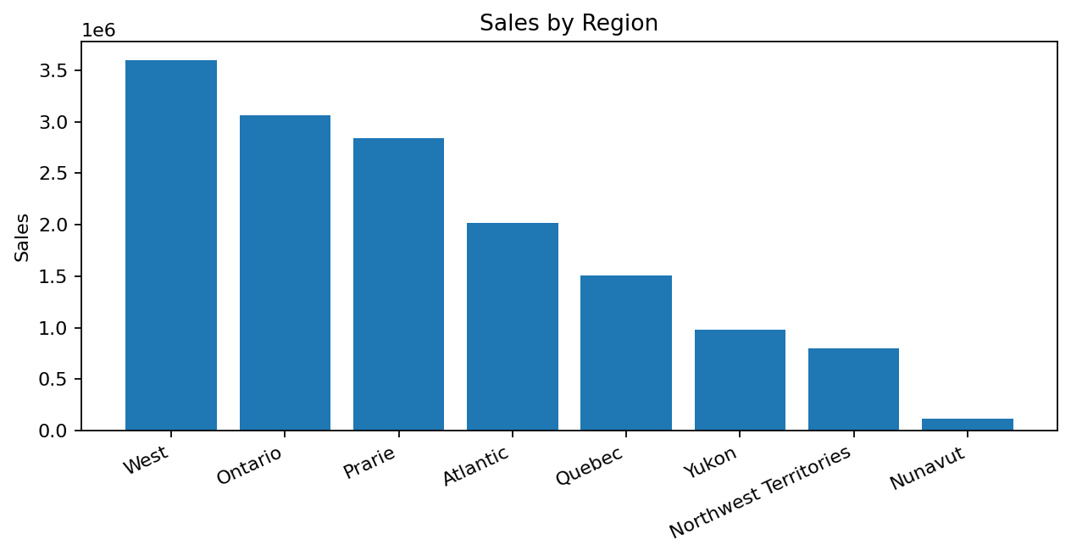
Sales by Region

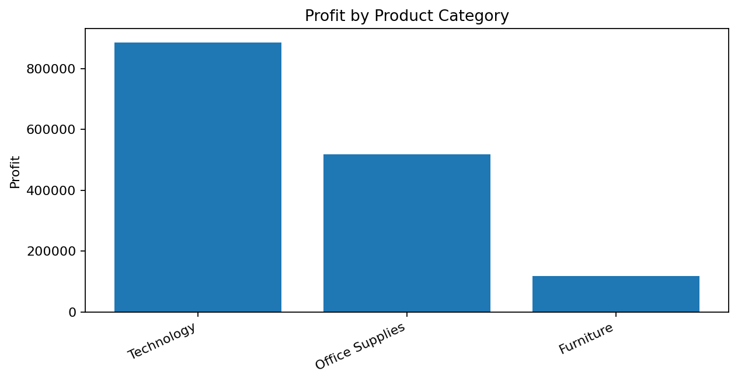
Profit by Product Category

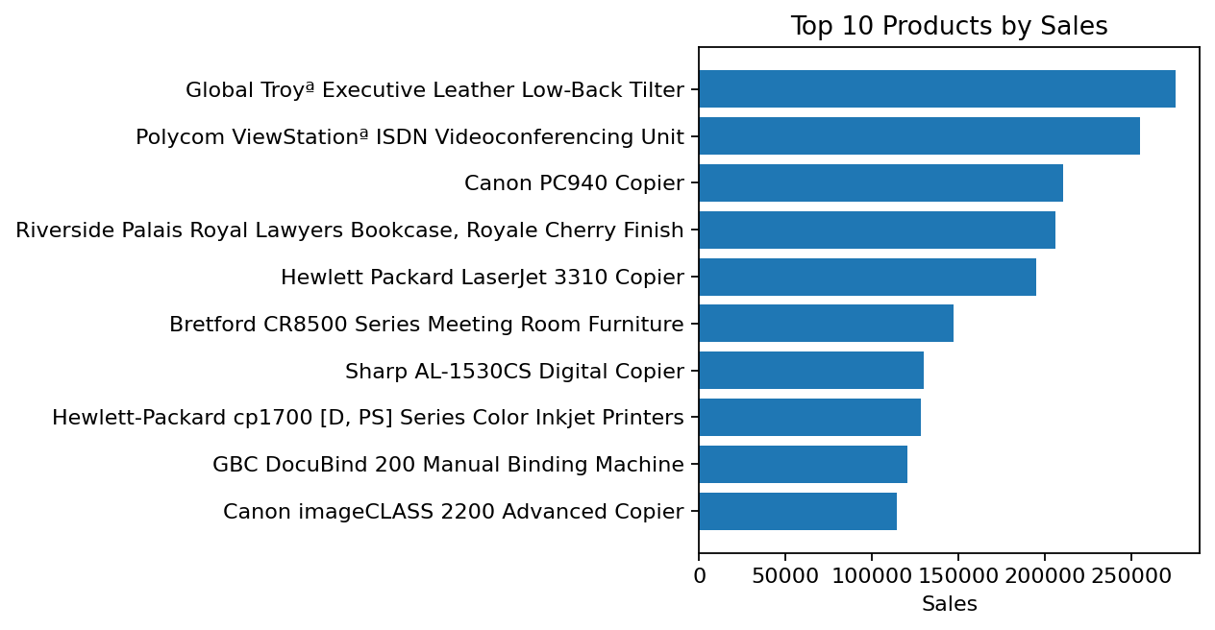
Top 10 Products by Sales

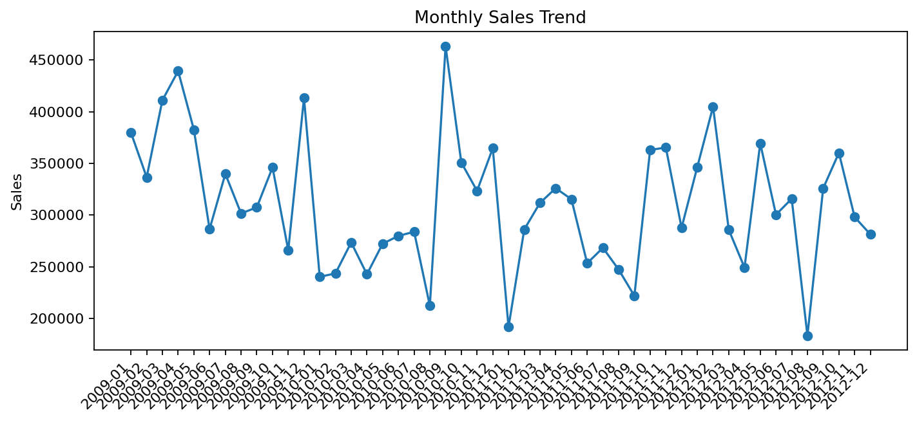
Monthly Sales Trend

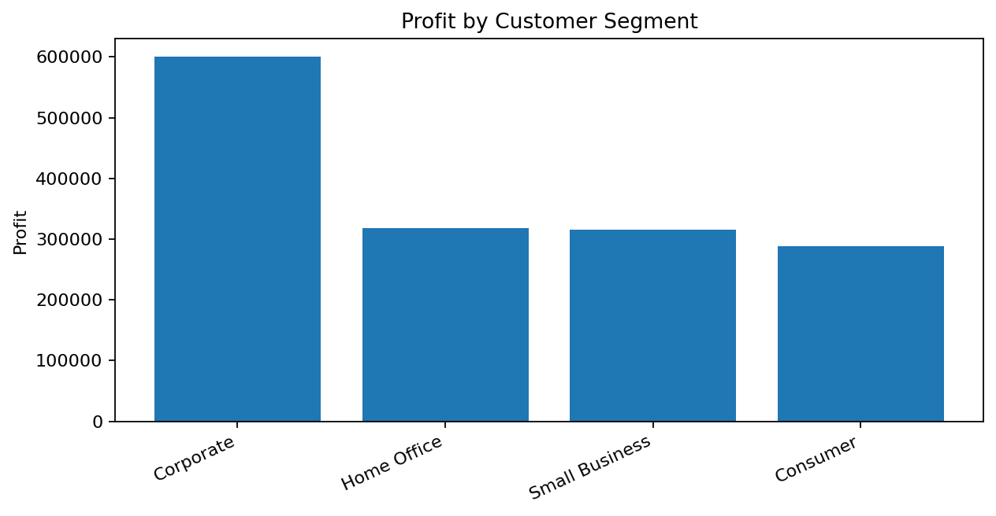
Profit by Customer Segment

7. Important Details to Keep in Mind
- Use distinct Order ID count for Total Orders because each order can contain multiple product rows.
- Date fields must be converted before building monthly trend charts.
- Profit should be evaluated along with sales because high sales do not always mean high profitability.
- Discount and shipping cost can reduce profitability, so they should be monitored carefully.
- Region and category slicers are recommended in Power BI for interactive analysis.

8. Hurdles Faced and How They Were Solved
Mixed date formats: Some dates appeared as text while others appeared as Excel serial values. The dates were converted into a consistent yyyy-mm-dd format.
Missing Product Base Margin values: Blank Product Base Margin values were filled using the median value to avoid losing records.
Multiple rows per order: Total Orders was calculated using distinct Order IDs rather than raw row count.
Dashboard design clarity: The dashboard was organized into KPI cards first, followed by business charts for region, category, products, monthly trend, and customer segment.

9. Recommendations
- Focus growth strategies on the West region while investigating lower-performing regions for improvement opportunities.
- Prioritize Technology because it delivers the strongest profit contribution.
- Review products with high sales but low or negative profit to improve pricing, discounting, and shipping cost control.
- Use customer segment targeting, especially for the Corporate segment, to improve profitability.
- Monitor monthly sales trends to plan inventory, promotions, and staffing around peak demand periods.

10. Conclusion
This project successfully completed the required retail sales analysis workflow: cleaning the dataset, calculating KPIs, generating business insights, building an Excel dashboard, and preparing supporting files for Power BI dashboard creation. The final submission package is ready for internship mentor review and certificate processing.

