GALAXY S25
First Power-On Guide
Everything you need to go from a sealed box to a fully set-up phone: unboxing, connecting to Wi-Fi, signing in, setting up email, and the basic gestures you'll use every day.

What's in the box
Before you begin, lay out the contents so nothing gets lost in the packaging.

- Galaxy S25 phone
- USB-C charging cable
- SIM ejector pin
- Quick start guide

Step 1 Insert your SIM card
Push the ejector pin into the small hole on the top edge of the phone to pop out the SIM tray. Seat a physical SIM if you have one. The S25 also supports eSIM, which you can add later entirely from software, so this step is optional if your carrier uses eSIM only.
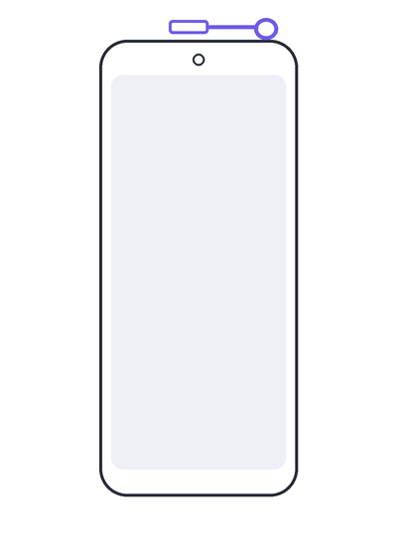
Tip: No ejector pin handy? A tightly bent paperclip works just as well.

Step 2 Turn on your phone
Press and hold the power button on the right edge for a few seconds until the screen lights up. The first boot can take a minute or two — let it run without interrupting.
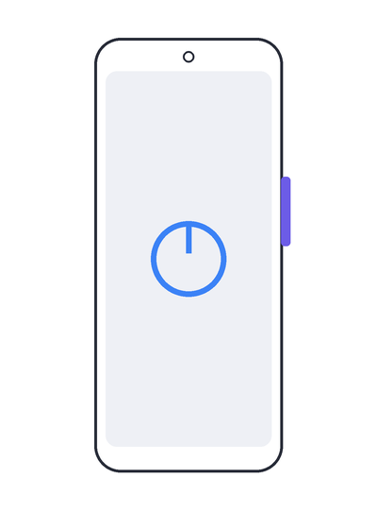

Step 3 Choose your language
The welcome screen asks you to pick a display language and offers accessibility options such as larger text or screen readers. You can change any of this later in Settings.
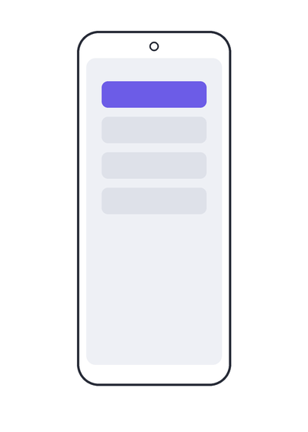

Step 4 Connect to Wi-Fi
Select a network from the list and enter its password. A working connection here lets the phone check for software updates before you finish setup, and it's needed if you plan to restore data over Wi-Fi.
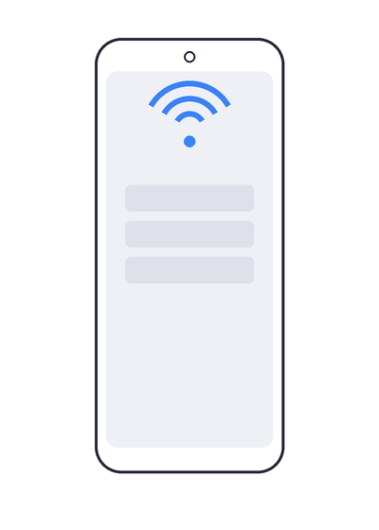
Tip: No Wi-Fi nearby? You can continue using mobile data instead if your SIM is active.

Step 5 Transfer data from your old phone
Choose Smart Switch to copy apps, photos, contacts, and settings from an old Android or iPhone, or select "Set up as new" to start with a clean phone.
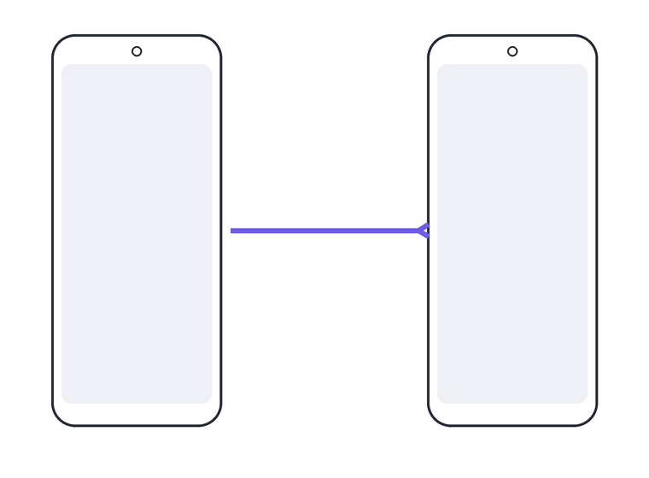
- Smart Switch: keep both phones nearby, unlocked, and charged
- Set up as new: the fastest path to the home screen

Step 6 Sign in to your Google and Samsung accounts
Your Google account brings the Play Store, Photos backup, and Gmail. Your Samsung account unlocks Galaxy-specific features like Find My Mobile and SmartThings. Both are optional but recommended, and you can sign in with an existing account or create a new one on the spot.
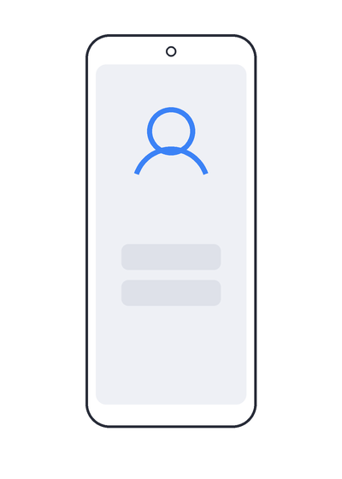

Step 7 Set up your email
Once you're signed in to Google, Gmail is ready to use automatically. To add a second address — a work account or another provider — open the Email app, tap Add account, and enter the address and password. Most major providers configure themselves automatically after that.
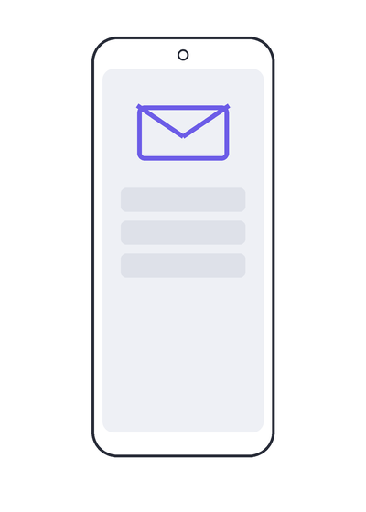
- Gmail: syncs automatically once you sign in to your Google account
- Outlook, Yahoo, or work email: add it from the Email app or Settings > Accounts
Tip: For a work or school account, have your IT department's server details ready in case automatic setup doesn't complete.

Step 8 Set a screen lock and biometrics
Choose a PIN, pattern, or password, then register a fingerprint and face recognition for faster unlocking. This also protects Samsung Pay and any secured apps.
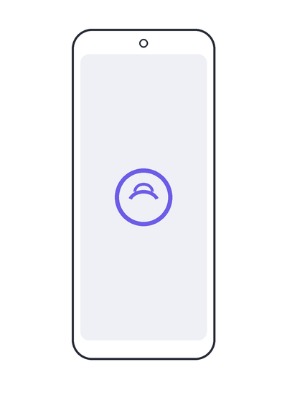

Step 9 Review privacy and terms
Scroll through the Google and Samsung service agreements, then choose your preferences for location access, diagnostic data sharing, and personalized advertising before continuing.
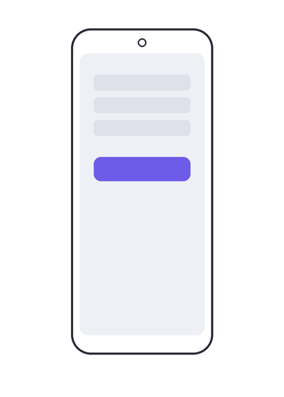

Step 10 Install the latest software update
Go to Settings > Software update > Download and install, so the phone starts on the newest, most secure version of One UI before you install other apps.
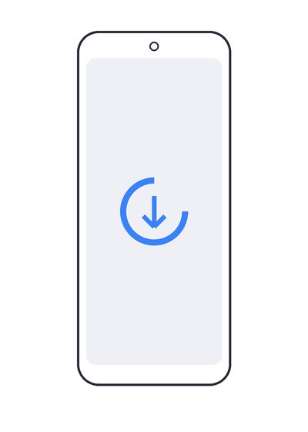

Basics to get you started
Setup is finished — here are the everyday gestures and shortcuts worth knowing right away.

Learn the basic gestures
Swipe up from the bottom of the screen to open the apps list. Swipe up and hold to see all open apps. From inside any app, swipe up from the very bottom edge to return home.
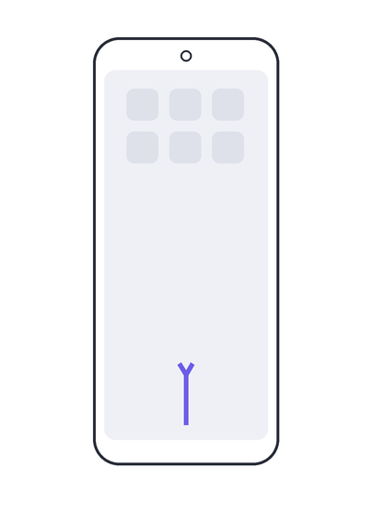

Open Quick settings and notifications
Swipe down from the top of the screen once to see notifications, and swipe down again (or with two fingers) to open Quick settings, where Wi-Fi, Bluetooth, flashlight, and brightness controls live.
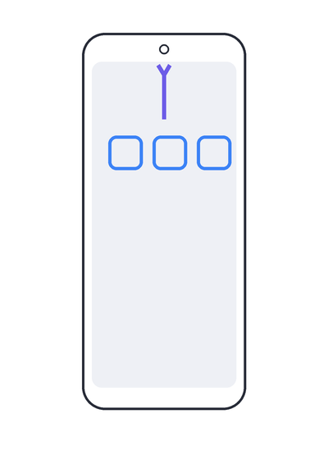

A few more things worth knowing
- Volume buttons: on the left edge, press up or down to adjust ringtone and media volume
- Screenshot: press the power and volume-down buttons together
- Camera shortcut: quickly press the power button twice to jump straight to the camera
- Battery saver: found in Quick settings or Settings > Battery, useful for longer days away from a charger
- Find My Mobile: turn this on early, from your Samsung account settings, in case the phone is ever lost

