GETTING STARTED

Creating Your TaskFlow Account and Workspace
Category | Getting Started
Audience | New users
Difficulty | Beginner
Read time | 4 min read
Last updated | July 2026

IN THIS ARTICLE
1. What you'll need before you start
2. Step 1: Sign up with your work email
3. Step 2: Verify your email address
4. Step 3: Create your workspace
5. Step 4: Invite your team
6. Step 5: Start your first project
7. Troubleshooting sign-up issues
8. Frequently asked questions

Overview
This article walks you through creating a TaskFlow account, setting up your first workspace, and inviting teammates so you can start managing projects in minutes. The whole process takes about five minutes and requires no credit card for the Free plan.

What you'll need
- A work or personal email address you can access
- A supported browser (Chrome, Firefox, Safari, or Edge, latest version)
- 5 minutes of uninterrupted time
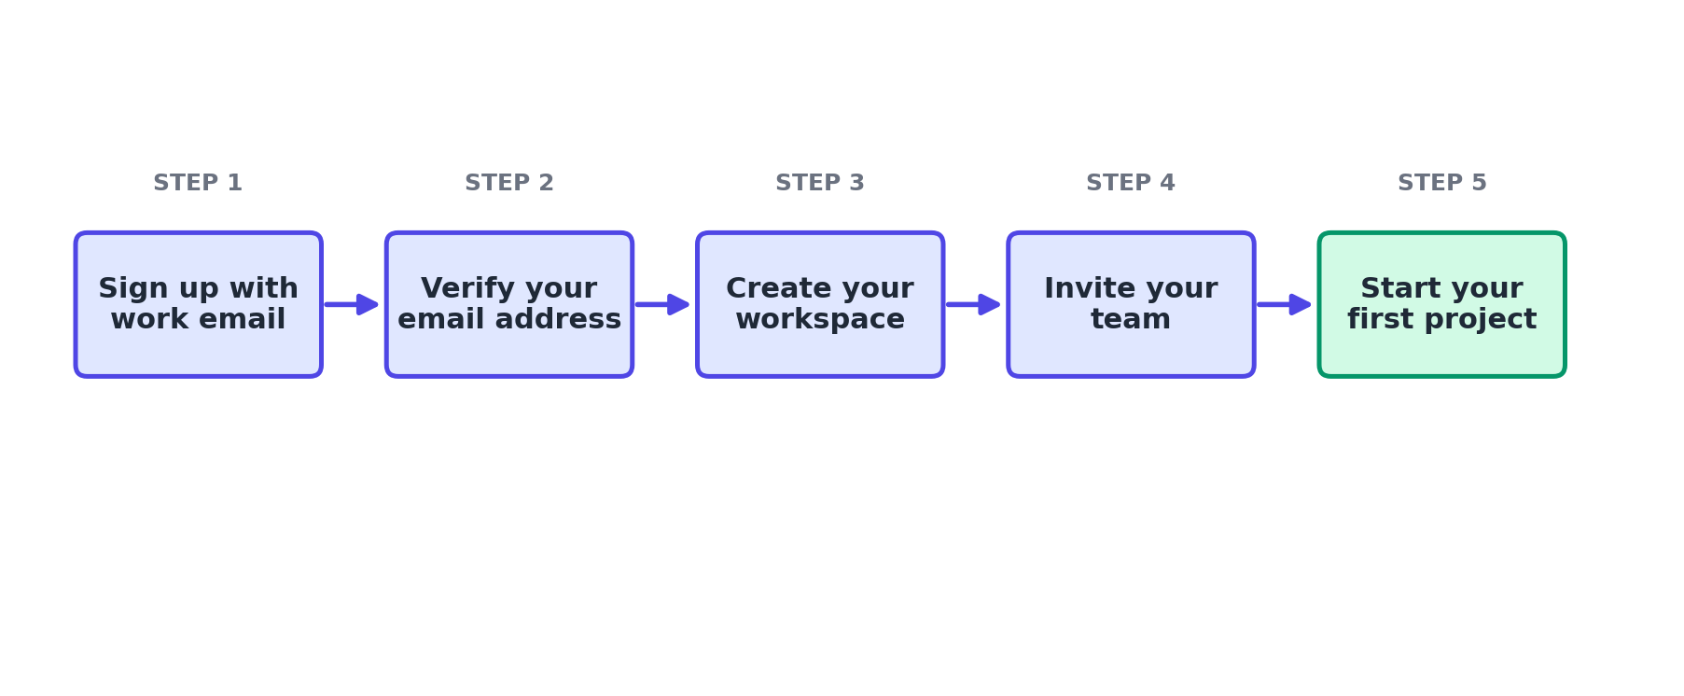
Figure 1. The account and workspace creation flow, from sign-up to your first project.

Step 1: Sign up with your work email
Go to app.taskflow.example and select Sign Up. You can register with an email address and password, or use Single Sign-On with Google or Microsoft if your organization has it enabled.
- Navigate to app.taskflow.example/signup.
- Enter your full name, work email, and a password of at least 10 characters.
- Select Create Account.

Step 2: Verify your email address
TaskFlow sends a six-digit verification code to the email you provided. This confirms the account belongs to you and activates full access.
- Open the email from TaskFlow titled "Confirm your email address."
- Copy the 6-digit code.
- Return to the browser tab and paste the code into the verification field.
- Select Verify Email.
NOTE: The code expires after 15 minutes. If it expires, select Resend Code on the verification screen.

Step 3: Create your workspace
A workspace is the top-level container for your organization's projects, members, and settings. Most companies use a single workspace, though larger organizations sometimes create separate workspaces per department.
- Enter a workspace name, such as your company or team name.
- Choose a workspace URL (for example, acme.taskflow.example).
- Select your primary use case (Product, Marketing, Engineering, Operations, or Other) so TaskFlow can recommend a starter template.
- Select Continue.

Step 4: Invite your team
You can invite teammates immediately or skip this step and invite people later from Settings > Members.
- Enter up to 10 email addresses, separated by commas.
- Choose a default role for the invitees (Member or Admin).
- Select Send Invites, or select Skip for now.

Step 5: Start your first project
TaskFlow creates a sample project automatically so you can explore the interface. To start your own project instead, select New Project on the workspace home screen and choose a template or start from a blank board.

Troubleshooting
Issue | Likely cause | Fix
I never received the verification email | The message may be delayed or filtered by your email provider. | Check your spam or junk folder. If it isn't there after 5 minutes, select Resend Code. Add no-reply@taskflow.example to your safe sender list.
"Workspace URL already taken" error | Another organization has already claimed that workspace name. | Add a distinguishing word or number, such as acme-hq or acmeinc.
Invited teammates did not receive an invite | Typos in the email address, or the invite landed in spam. | Go to Settings > Members, find the pending invite, and select Resend. Confirm the email address is spelled correctly.

Frequently asked questions
Q: Do I need a credit card to sign up?
A: No. The Free plan requires no payment method. You can add billing details later if you upgrade.
Q: Can I change my workspace name later?
A: Yes. Workspace owners can rename the workspace at any time from Settings > Workspace > General.
Q: Can one email be part of multiple workspaces?
A: Yes. You can belong to multiple TaskFlow workspaces and switch between them from the workspace switcher in the top-left corner.

Related articles
- Creating and Managing Projects in TaskFlow
- Understanding User Roles and Permissions
- Managing Billing, Plans, and Invoices

Was this article helpful? Contact support@taskflow.example if you still need a hand.

