PROJECTS

Creating and Managing Projects in TaskFlow
Category | Projects
Audience | All users
Difficulty | Beginner
Read time | 5 min read
Last updated | July 2026

IN THIS ARTICLE
1. Understanding the project hierarchy
2. Step 1: Create a new project
3. Step 2: Add tasks and subtasks
4. Step 3: Organize with sections and labels
5. Step 4: Set project visibility
6. Archiving and deleting projects
7. Troubleshooting
8. Frequently asked questions

Overview
Projects are where your team's work actually happens. This article explains how TaskFlow organizes work into workspaces, projects, tasks, and subtasks, and shows you how to create, structure, and manage a project from start to finish.

What you'll need
- Membership in a TaskFlow workspace
- Member role or higher (Guests cannot create projects)
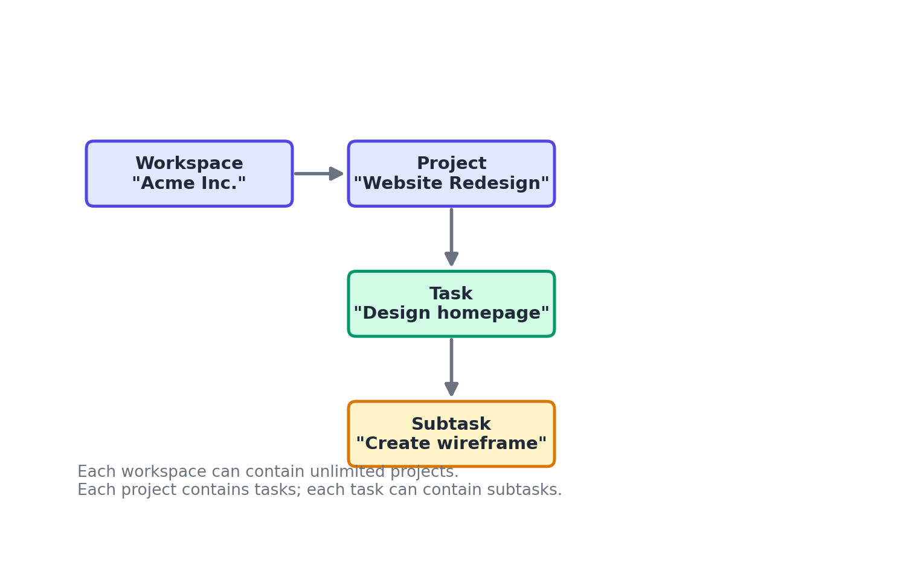
Figure 1. The TaskFlow work hierarchy: Workspace > Project > Task > Subtask.

Step 1: Create a new project
- From the workspace sidebar, select the + icon next to Projects.
- Choose a starting point: Blank Project, or one of the built-in templates (Sprint Board, Content Calendar, Product Launch, Bug Tracker).
- Name the project and, optionally, assign it to a team.
- Select Create Project.

Step 2: Add tasks and subtasks
Tasks are the individual units of work inside a project. Subtasks break a task into smaller checklist-style steps.
- Inside the project, select + Add Task and enter a task name.
- Open the task and select Add Subtask to break it into smaller steps.
- Assign an owner, due date, and priority from the task detail panel.

Step 3: Organize with sections and labels
Sections group related tasks within a project (for example, To Do, In Progress, Done). Labels are cross-cutting tags you can apply across tasks, such as Bug, Design, or Urgent.
- Select + Section to add a new column or grouping.
- Drag tasks between sections to update their status.
- Select the label icon on a task to apply one or more labels.
- Filter the project view by label using the Filter control in the top toolbar.

Step 4: Set project visibility
Project owners control who can see and join a project.
- Open Project Settings from the ... menu at the top of the project.
- Under Visibility, choose Public (visible to the whole workspace), Private (invite-only), or Shared with specific teams.
- Select Save.

Troubleshooting
Issue | Likely cause | Fix
I can't see a project a teammate mentioned | The project is set to Private and you have not been added. | Ask the project owner to add you as a member from Project Settings > Members.
Dragging tasks between sections doesn't save | A temporary sync issue, often caused by an unstable connection. | Refresh the page. If the problem persists, check status.taskflow.example for any ongoing incidents.
Deleted a task by accident | N/A | Open the project, select the ... menu, then Recently Deleted, and restore the task within 30 days.

Frequently asked questions
Q: Is there a limit to how many tasks a project can hold?
A: No hard limit on paid plans. The Free plan supports up to 3 active projects at a time.
Q: Can I convert a task into its own project?
A: Yes. Open the task, select the ... menu, and choose Convert to Project.
Q: Can I duplicate a project as a template for future work?
A: Yes. Select Duplicate Project from the project's ... menu, then choose whether to include task assignees and due dates.

Related articles
- Creating Your TaskFlow Account and Workspace
- Building Automations with Workflow Rules
- Importing and Exporting Project Data (CSV/Excel)

Was this article helpful? Contact support@taskflow.example if you still need a hand.

