ACCOUNT & SECURITY

Understanding User Roles and Permissions
Category | Account & Security
Audience | Workspace admins and owners
Difficulty | Intermediate
Read time | 4 min read
Last updated | June 2026

IN THIS ARTICLE
1. Overview of TaskFlow roles
2. Role comparison matrix
3. Step 1: Assign a role when inviting a member
4. Step 2: Change an existing member's role
5. Step 3: Configure guest access
6. Troubleshooting
7. Frequently asked questions

Overview
TaskFlow uses role-based access control so the right people have the right level of access. This article explains the four built-in roles, what each one can do, and how to assign and change roles for members of your workspace.

What you'll need
- Admin or Owner role in the workspace
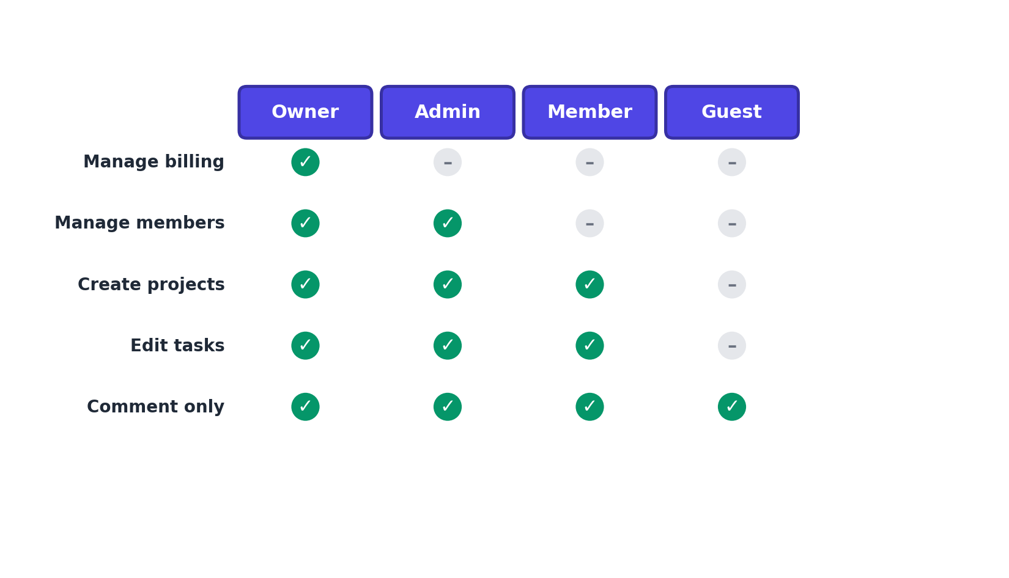
Figure 1. Permission matrix comparing what each role can do.

Step 1: Assign a role when inviting a member
- Go to Settings > Members.
- Select Invite Members.
- Enter the email address and choose a role from the dropdown: Admin, Member, or Guest.
- Select Send Invite.
NOTE: Only workspace owners can grant the Owner role, and there is always exactly one Owner per workspace.

Step 2: Change an existing member's role
- Go to Settings > Members.
- Find the member in the list and select the role dropdown next to their name.
- Choose the new role.
- Confirm the change in the dialog that appears.

Step 3: Configure guest access
Guests are useful for clients, contractors, or partners who only need visibility into a single project.
- Open the specific project and select Project Settings > Members.
- Select Invite Guest and enter their email.
- Guests can comment and view tasks but cannot create projects, invite others, or access billing.

Troubleshooting
Issue | Likely cause | Fix
A Member can't invite new people | By design, only Admins and Owners can send workspace invitations. | Ask an Admin or the Owner to send the invite, or request a role upgrade.
"Only one Owner allowed" error when changing roles | You're trying to assign Owner to a second person. | Use Settings > Members > Transfer Ownership instead, which moves ownership and demotes the previous Owner to Admin.
A Guest can see more than expected | The guest may have been added to multiple projects individually. | Review each project's Member list and remove the guest from any project they shouldn't access.

Frequently asked questions
Q: How many Admins can a workspace have?
A: There is no limit. You can have as many Admins as your plan's member count allows.
Q: Do Guests count toward my billed seats?
A: On most plans, Guests are billed at a reduced rate or are free up to a limit. Check Settings > Billing > Plan Details for your plan's specifics.
Q: Can I create custom roles beyond the four built-in ones?
A: Custom roles with granular permissions are available on the Business plan under Settings > Members > Custom Roles.

Related articles
- Creating Your TaskFlow Account and Workspace
- Managing Billing, Plans, and Invoices
- Troubleshooting Login and Two-Factor Authentication Issues

Was this article helpful? Contact support@taskflow.example if you still need a hand.

