INTEGRATIONS

Setting Up Integrations: Slack, Google Drive & Calendar
Category | Integrations
Audience | All users
Difficulty | Beginner
Read time | 5 min read
Last updated | July 2026

IN THIS ARTICLE
1. Supported integrations overview
2. Step 1: Open the integrations panel
3. Step 2: Connect Slack
4. Step 3: Connect Google Drive
5. Step 4: Connect Google Calendar
6. Managing and disconnecting integrations
7. Troubleshooting
8. Frequently asked questions

Overview
TaskFlow connects to the tools your team already uses, so updates flow automatically instead of requiring manual copy-pasting. This article covers connecting Slack, Google Drive, and Google Calendar, plus how to manage those connections afterward.

What you'll need
- Admin role for workspace-wide integrations, or Member role for personal integrations
- An active account with the third-party service you want to connect
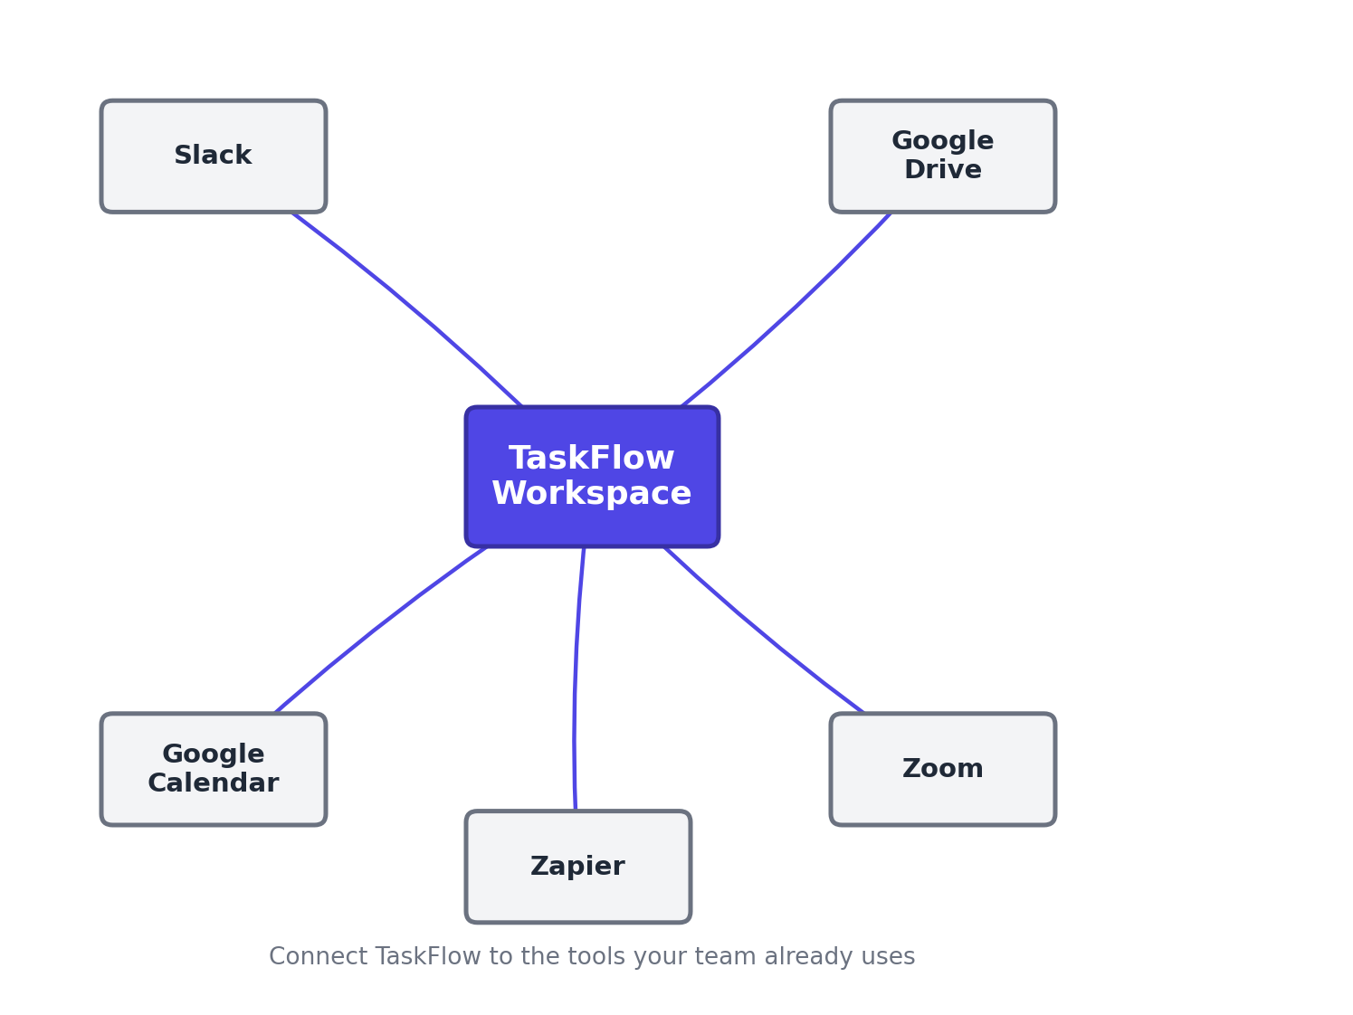
Figure 1. TaskFlow acts as a hub connecting to Slack, Google Drive, Calendar, Zoom, and Zapier.

Step 1: Open the integrations panel
- Select your workspace name in the top-left corner.
- Go to Settings > Integrations.
- Browse the available integrations, organized by category (Communication, Storage, Calendar, Automation).

Step 2: Connect Slack
- Select Slack from the integrations list, then select Connect.
- You'll be redirected to Slack to authorize TaskFlow.
- Choose the Slack workspace to connect and select Allow.
- Back in TaskFlow, choose which channel receives project notifications, or enable per-project channel mapping.

Step 3: Connect Google Drive
- Select Google Drive, then Connect.
- Sign in with the Google account you want linked and grant the requested permissions.
- Once connected, use Attach File > Google Drive on any task to link documents without leaving TaskFlow.

Step 4: Connect Google Calendar
- Select Google Calendar, then Connect.
- Authorize access and choose which calendar tasks with due dates should sync to.
- Toggle Two-way sync if you want changes made in Google Calendar to update the task's due date in TaskFlow.
NOTE: Personal integrations (like your own Google Calendar) are visible only to you. Workspace integrations (like the Slack connection) apply to everyone unless restricted by an Admin.

Troubleshooting
Issue | Likely cause | Fix
Slack messages aren't arriving | The bot may have been removed from the target channel, or the channel mapping is outdated. | Go to Settings > Integrations > Slack and re-invite the TaskFlow bot to the channel with /invite @TaskFlow.
"This app is blocked" when connecting Google Drive | Your organization's Google Workspace admin has restricted third-party app access. | Ask your Google Workspace admin to approve TaskFlow in the Google Admin console under Security > API Controls.
Calendar events show the wrong time zone | TaskFlow is using your workspace's default time zone instead of your personal one. | Go to Settings > Profile > Time Zone and set your personal time zone, which overrides the workspace default.

Frequently asked questions
Q: Can I connect more than one Slack workspace?
A: Only one Slack workspace can be connected per TaskFlow workspace at a time.
Q: Will disconnecting an integration delete existing links or files?
A: No. Disconnecting stops future syncing, but previously attached files and links remain on their tasks.
Q: Is Microsoft Teams supported?
A: Yes, Microsoft Teams and Outlook Calendar are available under the same Settings > Integrations panel.

Related articles
- Building Automations with Workflow Rules
- Configuring Notifications and Alert Preferences
- Getting Started with the TaskFlow REST API

Was this article helpful? Contact support@taskflow.example if you still need a hand.

