ACCOUNT & SECURITY

Troubleshooting Login and Two-Factor Authentication Issues
Category | Account & Security
Audience | All users
Difficulty | Beginner
Read time | 4 min read
Last updated | July 2026

IN THIS ARTICLE
1. Before you begin
2. Issue: "Invalid password" error
3. Issue: Account temporarily locked
4. Issue: Not receiving your 2FA code
5. Issue: Lost access to your authenticator app
6. When to contact support
7. Frequently asked questions

Overview
Can't get into your TaskFlow account? This article walks through the most common login and two-factor authentication (2FA) problems in order, so you can resolve them yourself in a couple of minutes without waiting on support.

What you'll need
- Access to the email address on your TaskFlow account
- Your phone, if you use an authenticator app for 2FA
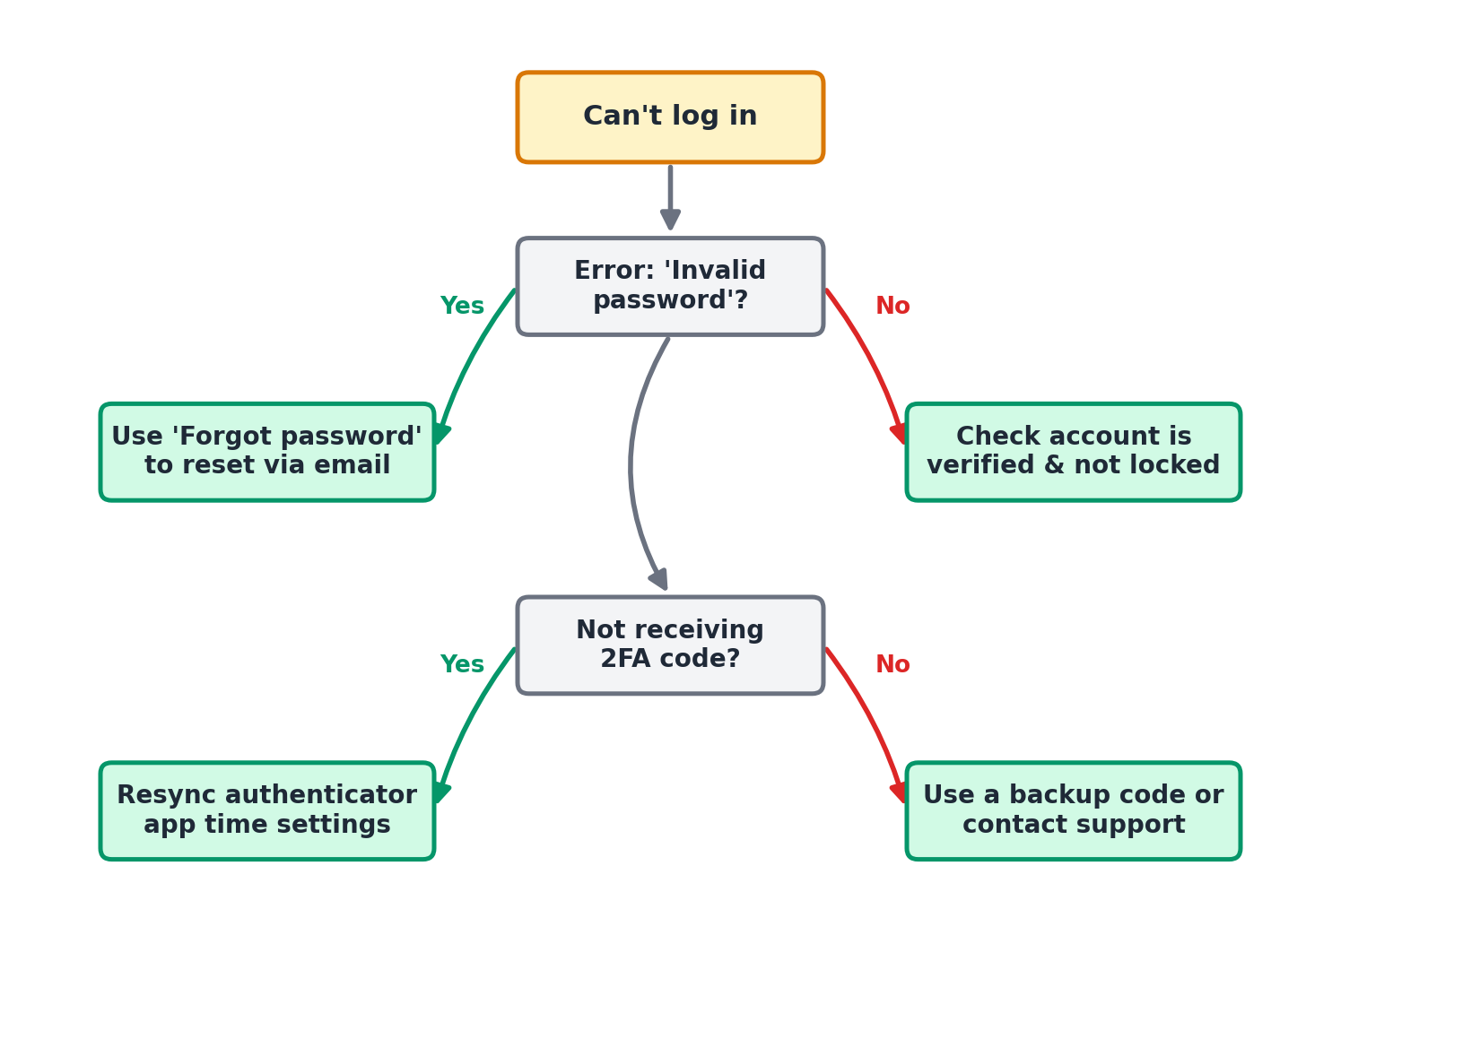
Figure 1. Decision tree for diagnosing login issues.

Issue: "Invalid password" error
- Confirm Caps Lock is off and there's no leading or trailing space in the password field.
- Select Forgot Password on the login screen.
- Enter your account email and select Send Reset Link.
- Open the reset email and choose a new password of at least 10 characters.

Issue: Account temporarily locked
TaskFlow locks an account for 15 minutes after 5 consecutive failed login attempts, as a security measure against automated attacks.
- Wait 15 minutes and try again, or
- Select Forgot Password to reset immediately, which also clears the lock.

Issue: Not receiving your 2FA code
- If using SMS, confirm your phone has signal and the number on file is correct under Settings > Security.
- If using an authenticator app (Google Authenticator, Authy, 1Password), check that your phone's clock is set to automatic/network time. 2FA codes are time-based and drift if the clock is off.
- Select Resend Code, and check that you're reading the most recently generated code, not an expired one.

Issue: Lost access to your authenticator app
If you changed phones or uninstalled your authenticator app, you can regain access using a backup code.
- On the 2FA screen, select Use a backup code instead.
- Enter one of the 10 backup codes you saved when you first set up 2FA.
- Once logged in, go to Settings > Security > Two-Factor Authentication to re-enroll a new device and generate a fresh set of backup codes.

Troubleshooting
Issue | Likely cause | Fix
No backup codes and no access to authenticator app | Both recovery paths are unavailable. | Contact support at support@taskflow.example from the email on file. Identity verification typically takes 1-2 business days.
"Too many reset requests" message | Rate limiting after multiple password reset attempts in a short period. | Wait 30 minutes before requesting another reset link.
Reset link says it expired | Reset links expire 60 minutes after being sent. | Request a new reset link; only the most recently sent link is valid.

Frequently asked questions
Q: How long does an account lockout last?
A: 15 minutes, or it can be cleared immediately by completing a password reset.
Q: Can I disable 2FA entirely?
A: Individual users can disable 2FA under Settings > Security unless your workspace Admin has made it mandatory for all members.
Q: Is SMS or an authenticator app more secure?
A: Authenticator apps are generally more secure since they aren't vulnerable to SIM-swapping attacks. TaskFlow supports both.

Related articles
- Understanding User Roles and Permissions
- Creating Your TaskFlow Account and Workspace
- Configuring Notifications and Alert Preferences

Was this article helpful? Contact support@taskflow.example if you still need a hand.

