BILLING

Managing Billing, Plans, and Invoices
Category | Billing
Audience | Workspace owners and admins
Difficulty | Beginner
Read time | 5 min read
Last updated | June 2026

IN THIS ARTICLE
1. Plan overview
2. Step 1: View your current plan and usage
3. Step 2: Upgrade or downgrade your plan
4. Step 3: Update your payment method
5. Step 4: Download invoices
6. Understanding proration
7. Troubleshooting
8. Frequently asked questions

Overview
This article explains TaskFlow's three pricing plans and shows workspace owners and admins how to view usage, change plans, update payment details, and access past invoices for accounting or expense purposes.

What you'll need
- Owner or Admin role
- A valid payment method if upgrading from Free
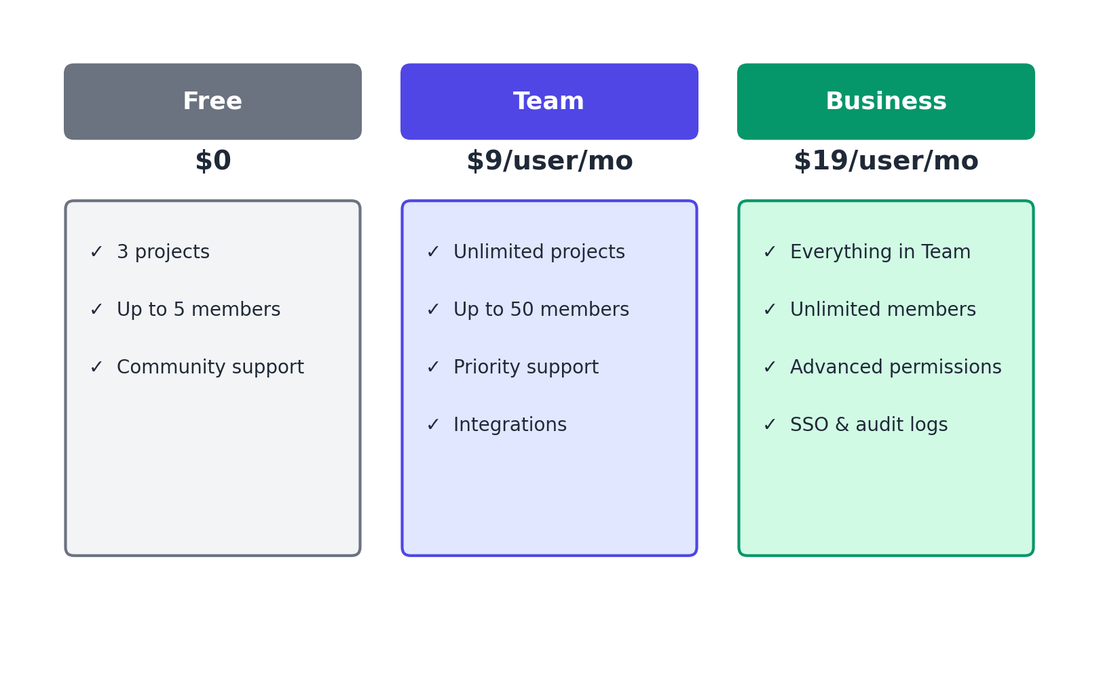
Figure 1. Comparison of the Free, Team, and Business plans.

Step 1: View your current plan and usage
- Go to Settings > Billing.
- Review your current plan, billed seat count, and next billing date at the top of the page.
- Scroll down to Usage to see active projects, storage used, and automation runs this month.

Step 2: Upgrade or downgrade your plan
- From Settings > Billing, select Change Plan.
- Choose Team or Business, and select monthly or annual billing (annual billing saves roughly 20%).
- Review the prorated charge shown on screen.
- Select Confirm Upgrade to apply the change immediately, or Confirm Downgrade to apply it at the end of the current billing cycle.

Step 3: Update your payment method
- Go to Settings > Billing > Payment Method.
- Select Edit and enter your new card details, or add a secondary card as backup.
- Select Save.

Step 4: Download invoices
- Go to Settings > Billing > Invoice History.
- Select the download icon next to any invoice to save it as a PDF.
- Use Export All as CSV to get a summary of all invoices for your accounting system.
NOTE: Only Owners can cancel a subscription. Admins can change plans and update payment methods but cannot close the account.

Troubleshooting
Issue | Likely cause | Fix
Payment failed and my workspace was downgraded | The card on file was declined, expired, or had insufficient funds. | Update the payment method under Settings > Billing, then select Retry Payment to restore your previous plan without losing data.
Invoice shows an unexpected amount | Usually caused by a mid-cycle seat change or plan upgrade, which is prorated. | Check the line-item breakdown on the invoice PDF, which itemizes prorated charges separately from the base subscription.
Can't find the Change Plan button | You may not have Owner or Admin permissions. | Ask your workspace Owner to make the change, or request an Admin role.

Frequently asked questions
Q: What happens to my data if I downgrade to Free?
A: Your data is retained, but you'll be limited to 3 active projects and 5 members going forward. Nothing is deleted automatically.
Q: Can I get a receipt for a specific date range?
A: Yes, use the date filter in Settings > Billing > Invoice History before exporting.
Q: Do you offer nonprofit or education discounts?
A: Yes. Contact billing@taskflow.example with proof of nonprofit or education status to apply for a discount.

Related articles
- Creating Your TaskFlow Account and Workspace
- Understanding User Roles and Permissions

Was this article helpful? Contact support@taskflow.example if you still need a hand.

