AUTOMATION

Building Automations with Workflow Rules
Category | Automation
Audience | Project managers and admins
Difficulty | Intermediate
Read time | 6 min read
Last updated | July 2026

IN THIS ARTICLE
1. How automation rules work
2. Step 1: Open the automation builder
3. Step 2: Choose a trigger
4. Step 3: Add conditions
5. Step 4: Define actions
6. Step 5: Test and activate the rule
7. Example automations to try
8. Troubleshooting
9. Frequently asked questions

Overview
Automation rules let TaskFlow handle repetitive work for you, following an if-this-then-that structure: a trigger starts the rule, optional conditions narrow when it applies, and one or more actions carry it out. This article shows you how to build your first rule.

What you'll need
- Member role or higher within the project
- Automations are available on the Team and Business plans
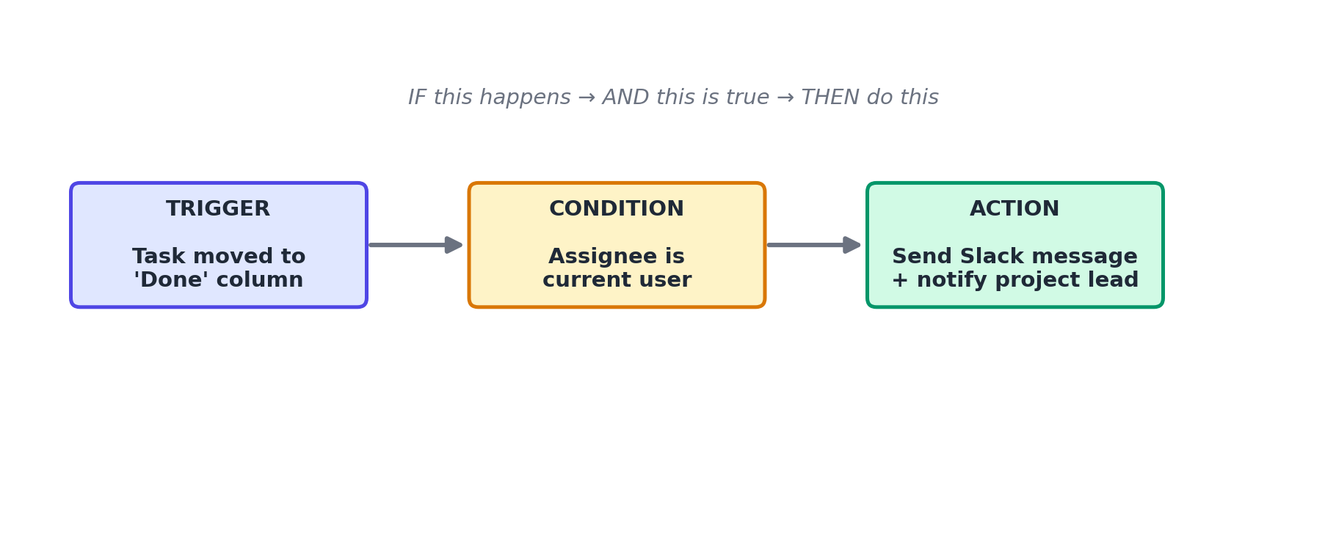
Figure 1. The anatomy of a workflow rule: Trigger, Condition, and Action.

Step 1: Open the automation builder
- Open the project where you want the automation to run.
- Select the Automate tab at the top of the project.
- Select + New Rule.

Step 2: Choose a trigger
The trigger determines what starts the automation. Common triggers include:
- Task created
- Task moved to a specific section or column
- Due date arrives or passes
- A specific label is added
- A form is submitted

Step 3: Add conditions
Conditions are optional filters that must all be true for the rule to run. For example, you might only want a rule to apply when the assignee is a specific person, or when the task has a certain priority.
- Select + Add Condition.
- Choose a field (Assignee, Priority, Label, Due Date, etc.).
- Choose an operator (is, is not, contains, is before, is after).
- Repeat to add multiple conditions; all conditions must be true (AND logic) by default.

Step 4: Define actions
Actions are what happens when the trigger fires and all conditions pass.
- Move task to a section
- Assign to a person
- Add or remove a label
- Send a Slack or email notification
- Post a comment on the task
- Create a follow-up task

Step 5: Test and activate the rule
- Select Test Rule to run it against an existing task without saving a permanent change.
- Review the simulated result shown in the preview panel.
- Select Activate to turn the rule on. You can toggle it off at any time from the Automate tab.
NOTE: Each workspace has a monthly automation run limit based on plan tier. Check Settings > Billing > Usage if rules stop firing unexpectedly.

Troubleshooting
Issue | Likely cause | Fix
Rule isn't triggering | The rule may be inactive, or a condition isn't matching as expected. | Confirm the toggle on the Automate tab is set to Active, then use Test Rule against a task that should qualify to see which condition fails.
Rule ran but the action didn't apply | The automation may lack permission to perform the action (for example, assigning to someone outside the project). | Check that the target user or section referenced in the action still exists and is accessible to the automation.
"Monthly automation limit reached" banner | Your workspace has exceeded its plan's monthly automation run quota. | Upgrade your plan under Settings > Billing, or wait until the quota resets at the start of the next billing cycle.

Frequently asked questions
Q: Can one rule have multiple actions?
A: Yes, a single rule can trigger several actions in sequence, such as moving a task and posting a Slack message.
Q: Can automations run across multiple projects?
A: Workspace-level automations, available on the Business plan, can apply across all projects. Project-level rules apply only within that project.
Q: Is there a limit on how many rules a project can have?
A: Up to 20 active rules per project on the Team plan, and unlimited on the Business plan.

Related articles
- Creating and Managing Projects in TaskFlow
- Setting Up Integrations: Slack, Google Drive & Calendar
- Getting Started with the TaskFlow REST API

Was this article helpful? Contact support@taskflow.example if you still need a hand.

