DATA MANAGEMENT

Importing and Exporting Project Data (CSV/Excel)
Category | Data Management
Audience | All users
Difficulty | Beginner
Read time | 5 min read
Last updated | May 2026

IN THIS ARTICLE
1. Supported file formats
2. Step 1: Prepare your file
3. Step 2: Start the import wizard
4. Step 3: Map columns to TaskFlow fields
5. Step 4: Review and confirm the import
6. Exporting your data
7. Troubleshooting
8. Frequently asked questions

Overview
Whether you're migrating from a spreadsheet or another tool, or you need a backup copy of your data, TaskFlow makes it straightforward to bulk import and export tasks. This article covers both directions of data movement.

What you'll need
- Admin or Member role in the destination project
- A CSV or Excel (.xlsx) file with a header row
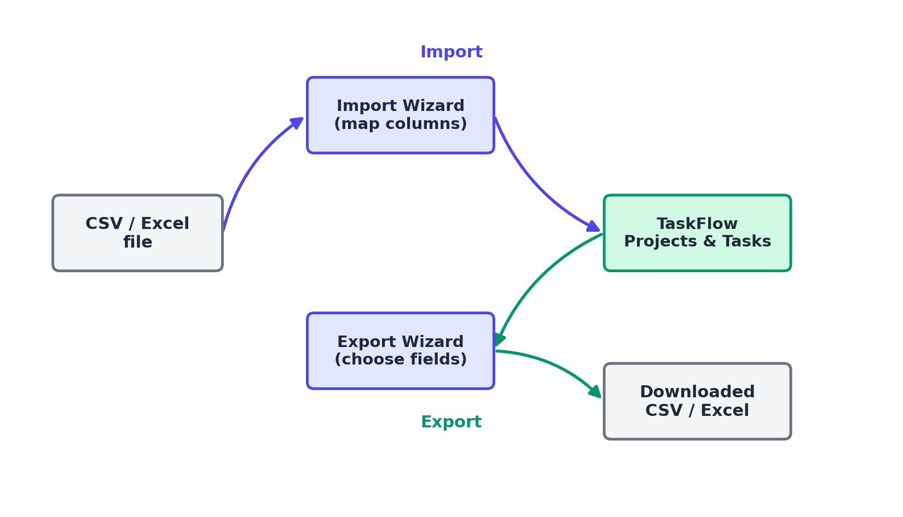
Figure 1. Data flow for importing and exporting project data.

Step 1: Prepare your file
TaskFlow reads the first row of your file as column headers. Recommended columns include:
- Task Name (required)
- Description
- Assignee (email address)
- Due Date (YYYY-MM-DD format)
- Priority (Low, Medium, High, Urgent)
- Section or Status
- Labels (comma-separated)

Step 2: Start the import wizard
- Open the destination project.
- Select the ... menu, then Import Data.
- Choose CSV or Excel and select Upload File.

Step 3: Map columns to TaskFlow fields
- The wizard displays each column from your file next to a dropdown of TaskFlow fields.
- Match each column to the correct field, or choose Ignore this column to skip it.
- TaskFlow auto-detects common column names like "Task" or "Owner" and pre-fills the mapping where possible.

Step 4: Review and confirm the import
- Review the preview table showing the first 10 rows as they'll appear in TaskFlow.
- Select Import to bring in all rows, or Cancel to make changes to your source file first.
- Once complete, TaskFlow shows a summary of how many tasks were created and any rows that were skipped.

Exporting your data
- Open the project and select the ... menu, then Export.
- Choose CSV or Excel format.
- Select which fields to include, or choose Select All.
- Select Export, and the file downloads to your browser's default download location.

Troubleshooting
Issue | Likely cause | Fix
"Invalid date format" errors during import | Dates aren't in the expected YYYY-MM-DD format. | Reformat the date column in your spreadsheet application before re-uploading. Most spreadsheet tools have a custom date format option.
Assignees weren't set after import | The email addresses in the file don't match any workspace member's email exactly. | Confirm the assignee column contains the exact email address used for each member's TaskFlow account, then re-import or bulk-edit the affected tasks.
Import seems stuck at "Processing" | Very large files (over 5,000 rows) can take several minutes. | Wait up to 10 minutes for large files. If it's still processing after that, refresh the page; the import continues in the background and you'll see a completion notification.

Frequently asked questions
Q: What's the maximum file size for import?
A: 25 MB, or roughly 50,000 rows for a typical CSV file.
Q: Does exporting include comments and attachments?
A: CSV and Excel exports include task fields but not comments or file attachments. For a full backup including those, use the Business plan's full workspace export.
Q: Can I import subtasks?
A: Yes, add a Parent Task column matching the exact name of an existing task in the same file to nest rows as subtasks.

Related articles
- Creating and Managing Projects in TaskFlow
- Getting Started with the TaskFlow REST API

Was this article helpful? Contact support@taskflow.example if you still need a hand.

