SETTINGS

Configuring Notifications and Alert Preferences
Category | Settings
Audience | All users
Difficulty | Beginner
Read time | 3 min read
Last updated | June 2026

IN THIS ARTICLE
1. Notification channels overview
2. Step 1: Open notification settings
3. Step 2: Choose channels per event type
4. Step 3: Set quiet hours
5. Step 4: Manage project-level overrides
6. Troubleshooting
7. Frequently asked questions

Overview
Too many notifications can be as unproductive as too few. This article shows you how to fine-tune exactly which TaskFlow events notify you, through which channel, and when, so you stay informed without the noise.

What you'll need
- A TaskFlow account (no special role required — these are personal settings)
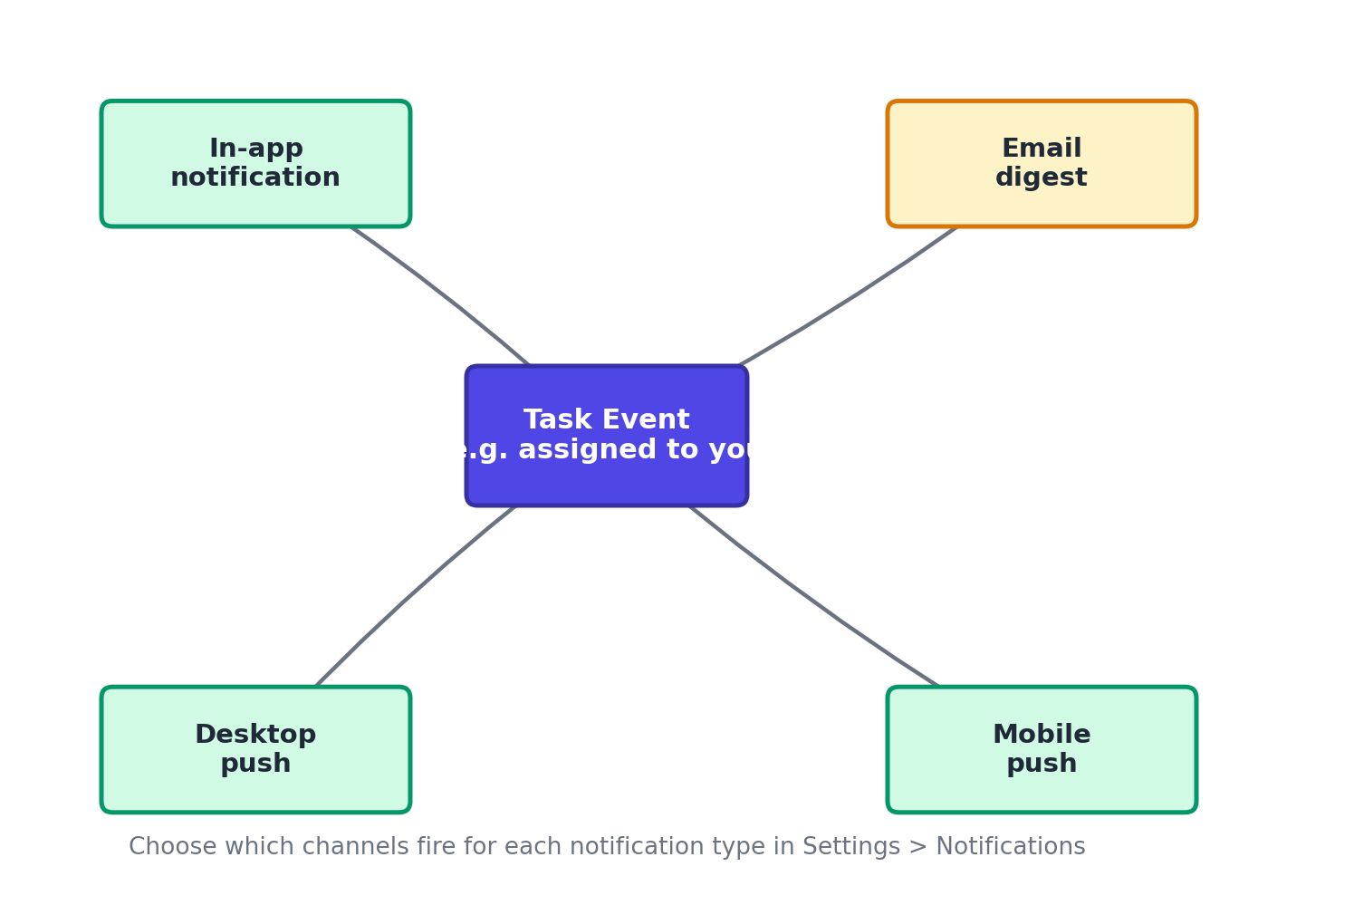
Figure 1. A single task event can be routed to in-app, email, desktop, and mobile channels.

Step 1: Open notification settings
- Select your avatar in the top-right corner.
- Choose Settings > Notifications.

Step 2: Choose channels per event type
Each event type has its own row with toggles for In-App, Email, Desktop Push, and Mobile Push.
- Assigned to a task
- Mentioned in a comment
- Due date approaching (24 hours before)
- Task status changed on tasks you follow
- Weekly project digest
Toggle each channel on or off per event type to build your preferred combination.

Step 3: Set quiet hours
- Scroll to the Quiet Hours section.
- Toggle Enable Quiet Hours on.
- Set a start and end time (for example, 7:00 PM to 8:00 AM) and select which days it applies to.
- During quiet hours, push and desktop notifications are held and delivered as a batch when quiet hours end. In-app notifications still appear when you open TaskFlow.

Step 4: Manage project-level overrides
You can mute or boost notifications for a specific project without changing your global settings.
- Open the project.
- Select the bell icon in the top-right of the project view.
- Choose All Activity, Only Mentions & Assignments, or Muted.

Troubleshooting
Issue | Likely cause | Fix
Not receiving desktop push notifications | Browser notification permissions may be blocked. | Check your browser's site settings for app.taskflow.example and confirm notifications are set to Allow, then refresh the page.
Getting too many emails | Multiple event types have email enabled individually. | Go to Settings > Notifications and select Turn Off All Email, then re-enable only the specific events you want by email.
Mobile push notifications delayed | The mobile OS may be limiting background refresh for the app. | On iOS or Android, check that Background App Refresh (or equivalent) is enabled for TaskFlow in your device settings.

Frequently asked questions
Q: Do quiet hours apply across time zones for a team?
A: No, quiet hours are a personal setting based on your own time zone from Settings > Profile.
Q: Can I get a daily summary instead of real-time alerts?
A: Yes, enable the Daily Digest option under Settings > Notifications, which bundles all activity into one email sent each morning.
Q: Will muting a project hide it from my task list?
A: No, muting only silences notifications. The project and its tasks remain fully visible everywhere else.

Related articles
- Setting Up Integrations: Slack, Google Drive & Calendar
- Troubleshooting Login and Two-Factor Authentication Issues

Was this article helpful? Contact support@taskflow.example if you still need a hand.

