DEVELOPER

Getting Started with the TaskFlow REST API
Category | Developer
Audience | Developers
Difficulty | Intermediate
Read time | 7 min read
Last updated | July 2026

IN THIS ARTICLE
1. API overview
2. Step 1: Generate an API token
3. Step 2: Authenticate your first request
4. Step 3: Make a GET request
5. Step 4: Handle pagination and rate limits
6. Common error codes
7. Frequently asked questions

Overview
The TaskFlow REST API lets you read and write projects, tasks, and comments programmatically, so you can build integrations, dashboards, or automations beyond what the built-in Automate feature supports. This article covers authentication and your first successful request.

What you'll need
- Admin role or a personal API token
- Basic familiarity with HTTP requests and JSON
- curl, Postman, or a similar HTTP client
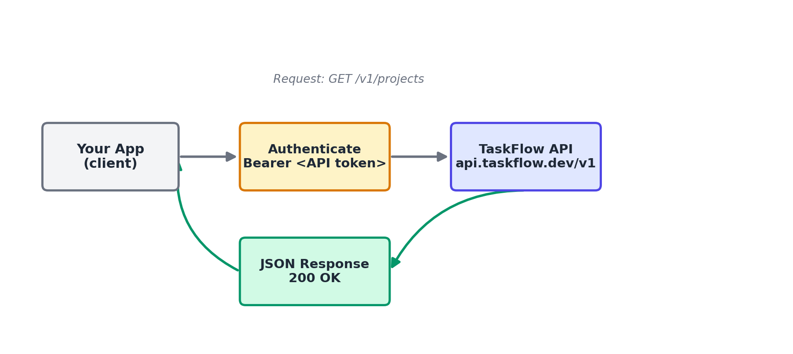
Figure 1. Request flow: client authenticates with a bearer token, then calls the TaskFlow API.

Step 1: Generate an API token
- Go to Settings > Developer > API Tokens.
- Select + Generate Token.
- Name the token something descriptive, such as "Reporting Dashboard."
- Choose the scopes the token needs (Read Only, or Read & Write).
- Select Generate, and copy the token immediately — it is only shown once.
NOTE: Treat your API token like a password. Never commit it to source control or share it in plain text.

Step 2: Authenticate your first request
TaskFlow uses bearer token authentication. Include your token in the Authorization header of every request.
curl https://api.taskflow.dev/v1/projects \
-H "Authorization: Bearer YOUR_API_TOKEN"

Step 3: Make a GET request
The example below fetches all projects in your workspace.
GET /v1/projects
Host: api.taskflow.dev
Authorization: Bearer YOUR_API_TOKEN

A successful call returns a 200 status with a JSON array of project objects, each including an id, name, visibility, and created_at timestamp.

Step 4: Handle pagination and rate limits
List endpoints return a maximum of 50 results per page.
- Use the ?page= and ?per_page= query parameters to paginate through results.
- Check the has_more field in the response body to know whether additional pages exist.
- The API allows 100 requests per minute per token. If exceeded, you'll receive a 429 status; back off using the Retry-After header value, given in seconds.

Troubleshooting
Issue | Likely cause | Fix
401 Unauthorized on every request | The token is missing, malformed, or was revoked. | Confirm the header reads exactly "Authorization: Bearer <token>" with no extra quotes or line breaks, and check the token still exists under Settings > Developer > API Tokens.
403 Forbidden on write requests | The token was created with Read Only scope. | Generate a new token with Read & Write scope. Existing tokens' scopes cannot be edited after creation.
429 Too Many Requests | The per-minute rate limit was exceeded. | Implement exponential backoff and respect the Retry-After header before retrying.

Frequently asked questions
Q: Is there a sandbox or test environment?
A: Yes, api-sandbox.taskflow.dev mirrors the production API and lets you test without affecting real workspace data.
Q: Does the API support webhooks?
A: Yes. Configure webhook endpoints under Settings > Developer > Webhooks to receive real-time POST notifications for task and project events.
Q: Where can I find the full API reference?
A: The complete endpoint reference, including request and response schemas, is available at developers.taskflow.example.

Related articles
- Building Automations with Workflow Rules
- Setting Up Integrations: Slack, Google Drive & Calendar
- Importing and Exporting Project Data (CSV/Excel)

Was this article helpful? Contact support@taskflow.example if you still need a hand.

