Windows 11
Clean Installation — Technical User Guide
A complete, step-by-step walkthrough covering requirements,
bootable media creation, installation, and post-setup configuration.

Table of Contents
Table of Contents 1
1. Introduction 1
2. System Requirements 1
3. Preparation Before Installation 1
3.1 Back Up Your Data 1
3.2 Gather Information and Drivers 1
3.3 Create Bootable Installation Media 1
4. Step-by-Step Installation Process 1
4.1 Boot From the Installation Media 1
4.2 Choose Language and Regional Settings 1
4.3 Enter Product Key 1
4.4 Accept License Terms 1
4.5 Choose Installation Type 1
4.6 Select and Prepare the Target Drive 1
4.7 Automated Installation 1
4.8 Out-of-Box Experience (OOBE) Setup 1
5. Post-Installation Configuration 1
6. Common Installation Issues 1
"Windows cannot be installed on this drive" 1
USB Drive Not Recognized as a Boot Option 1
TPM 2.0 or Secure Boot Not Detected 1
Installation Freezes or Restarts Repeatedly 1
7. Frequently Asked Questions 1

1. Introduction
This guide explains how to perform a clean installation of Windows 11 on a desktop or laptop computer. A clean installation erases the target drive and installs Windows 11 from scratch, which resolves persistent software issues, removes accumulated bloatware, and gives the best long-term performance compared with an in-place upgrade.
This document is intended for IT administrators, technicians, and experienced users who are comfortable working with BIOS/UEFI firmware, disk partitioning, and bootable USB media.
Note: A clean install permanently erases all data on the selected drive. Complete the backup steps in Section 3 before proceeding.

2. System Requirements
Before you begin, confirm that the target device meets the official Windows 11 minimum hardware requirements:
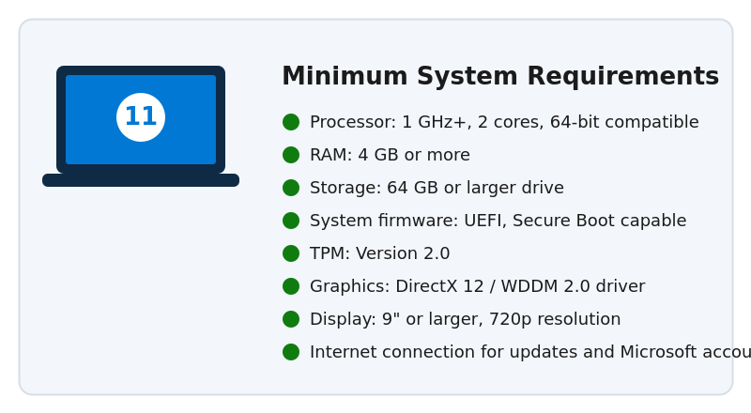
Figure 1: Windows 11 minimum hardware requirements
- Processor: 1 GHz or faster with 2 or more cores, on a compatible 64-bit processor or System on a Chip (SoC)
- Memory (RAM): 4 GB or greater
- Storage: 64 GB or larger storage device
- System firmware: UEFI, Secure Boot capable
- TPM: Trusted Platform Module (TPM) version 2.0
- Graphics card: Compatible with DirectX 12 or later, with a WDDM 2.0 driver
- Display: High definition (720p) display, greater than 9" diagonally, 8 bits per color channel
- Internet connection: Required for updates, downloads, and to use some features; a Microsoft account is required for Home edition setup
Note: Use the PC Health Check app or the Get-ComputerInfo PowerShell cmdlet to verify TPM and Secure Boot status before proceeding.

3. Preparation Before Installation

3.1 Back Up Your Data
Because a clean install formats the destination drive, back up all personal files, application settings, browser bookmarks, and license keys for paid software to an external drive or cloud storage before continuing.

3.2 Gather Information and Drivers
- Note down product keys for Windows and any licensed applications.
- Download chipset, storage (RAID/AHCI), network, and graphics drivers for your exact model from the manufacturer's website and copy them to a second USB drive.
- Confirm your device is connected to a power source (for laptops, plug in the charger).

3.3 Create Bootable Installation Media
Use a USB flash drive of at least 8 GB to create bootable Windows 11 installation media using the Media Creation Tool.
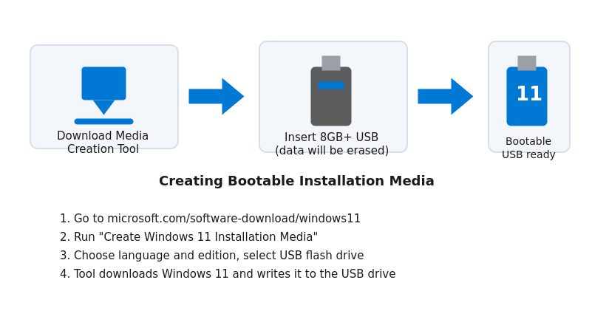
Figure 2: Creating bootable Windows 11 installation media
- On a working Windows PC, go to microsoft.com and download the "Windows 11 Installation Media" tool.
- Run the tool, accept the license terms, and choose "Create installation media for another PC."
- Select language, edition, and architecture (64-bit).
- Choose "USB flash drive" as the media type and select your inserted drive.
- Wait for the tool to download Windows 11 and write it to the USB drive, then select Finish.
Warning: All existing data on the USB flash drive will be erased during this process.

4. Step-by-Step Installation Process

4.1 Boot From the Installation Media
Insert the bootable USB drive into the target computer, restart it, and enter the boot menu or firmware setup by pressing the manufacturer-specific key (commonly F2, F10, F12, Esc, or Delete) during startup. Select the USB drive from the boot menu.
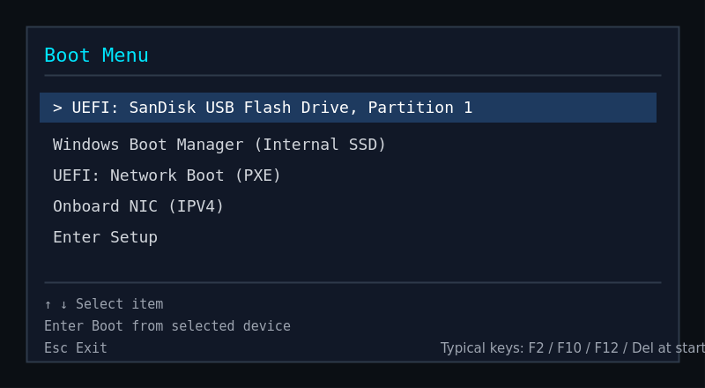
Figure 3: Selecting the USB drive from the firmware boot menu
Note: If the USB drive does not appear, disable "Fast Boot" and confirm "Secure Boot" and "UEFI mode" are enabled in firmware settings, then save and restart.

4.2 Choose Language and Regional Settings
When the "Windows Setup" screen appears, select the language to install, time and currency format, and keyboard or input method, then select Next, followed by Install now.
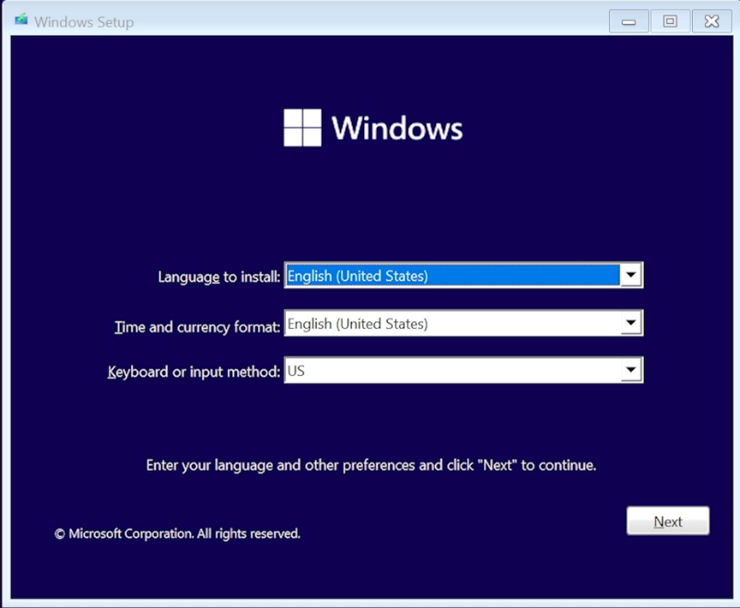
Figure 4: Windows Setup language and regional preferences screen

4.3 Enter Product Key
Enter your 25-character Windows 11 product key, or select "I don't have a product key" to continue and activate later from within Windows using a digital license or key tied to your Microsoft account.
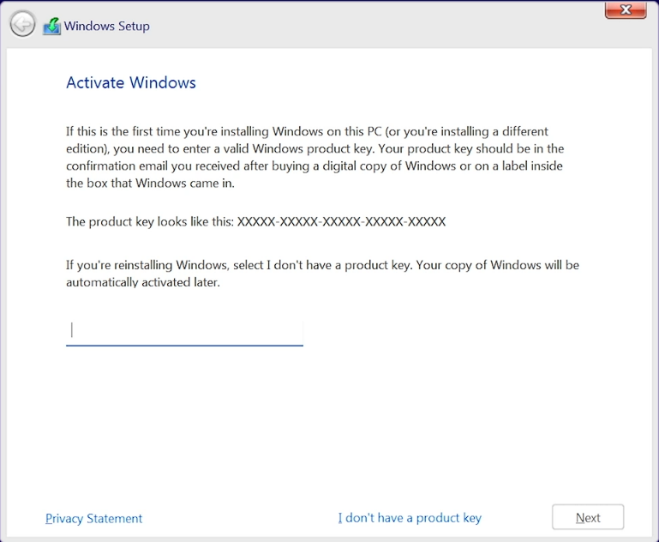
Figure 5: Product key entry screen

4.4 Accept License Terms
Review the Microsoft Software License Terms, check the acceptance box, and select Next.

4.5 Choose Installation Type
Select "Custom: Install Windows only (advanced)" to perform a clean installation rather than an in-place upgrade.

4.6 Select and Prepare the Target Drive
On the partition screen, select each existing partition on the target drive and choose Delete to remove it, consolidating the space into "Unallocated Space." Then select the unallocated space and choose Next; Windows Setup will automatically create the required partitions (System, MSR, and Primary).
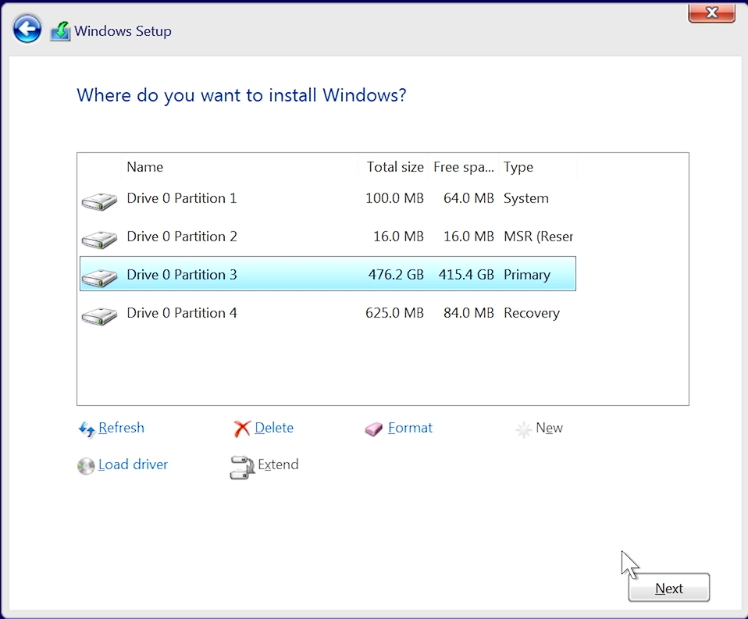
Figure 6: Disk partition selection and preparation screen
Warning: Deleting a partition permanently erases all data it contains. Verify you have selected the correct physical drive, especially on systems with multiple disks.

4.7 Automated Installation
Windows Setup copies files, installs features, applies updates, and completes the installation automatically. The computer restarts several times during this stage; do not power off the device or remove the USB drive until setup finishes.
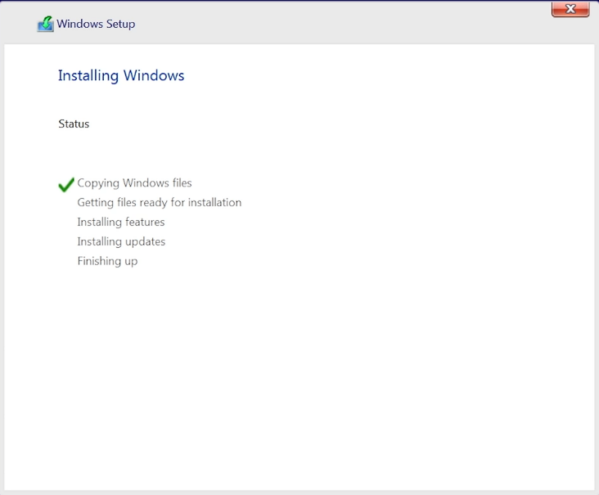
Figure 7: Automated installation progress screen

4.8 Out-of-Box Experience (OOBE) Setup
After the final restart, complete the initial setup wizard:
- Select your region and keyboard layout.
- Connect to a Wi-Fi network or Ethernet (required for Home edition).
- Sign in with a Microsoft account, or select "Sign-in options" for a local account (Pro/Enterprise editions).
- Configure privacy settings for location, diagnostics, and personalization.
- Wait for Windows to finish applying final settings and reach the desktop.
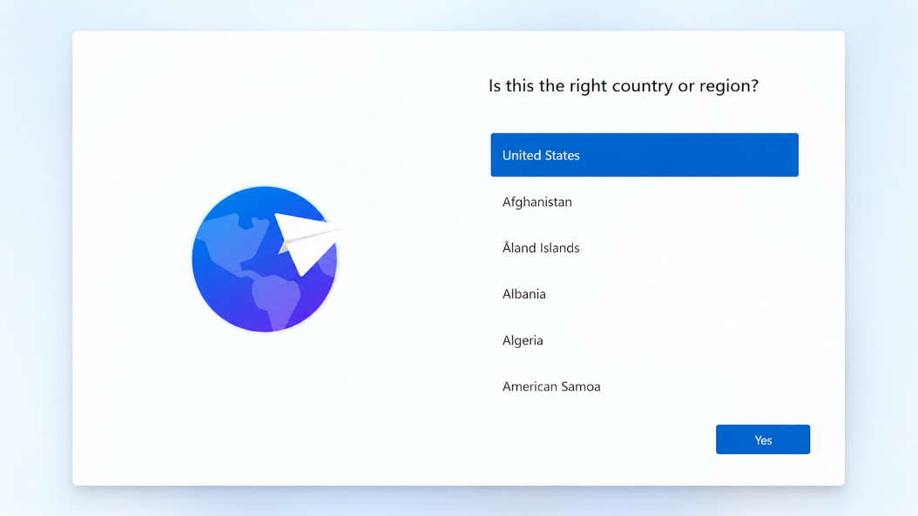
Figure 8: Out-of-box experience (OOBE) region selection screen

5. Post-Installation Configuration
- Go to Settings > Windows Update and install all available updates, including optional driver updates.
- Install chipset, graphics, network, and audio drivers from the manufacturer, or via Windows Update.
- Activate Windows under Settings > System > Activation if it did not activate automatically.
- Restore backed-up files and reinstall required applications.
- Configure Windows Security (Defender), BitLocker, and Windows Update settings according to your organization's policy.
- Create a system restore point or full backup image once configuration is complete.

6. Common Installation Issues

"Windows cannot be installed on this drive"
This typically occurs when the drive is formatted as MBR and the firmware is in UEFI mode, or vice versa. Delete all partitions on the target drive to let Setup create a fresh GPT layout, or convert the disk using diskpart's "convert gpt" command from the Setup repair environment.

USB Drive Not Recognized as a Boot Option
Recreate the installation media using the Media Creation Tool, try a different USB port (preferably USB 2.0), and confirm Secure Boot and UEFI settings in firmware.

TPM 2.0 or Secure Boot Not Detected
Enter firmware setup and enable TPM (sometimes labeled PTT for Intel or fTPM for AMD) and Secure Boot. Some older devices may require a firmware update from the manufacturer.

Installation Freezes or Restarts Repeatedly
Disconnect non-essential peripherals and secondary drives, reseat RAM modules, and verify the installation media checksum by re-downloading the ISO if issues persist.

7. Frequently Asked Questions
Q: What is the difference between a clean installation and an in-place upgrade?
A: A clean installation erases the target drive and installs Windows 11 from scratch, while an in-place upgrade preserves existing files, applications, and settings by installing over the current Windows version.
Q: Do I need a product key to install Windows 11?
A: No. You can select "I don't have a product key" during setup and activate later. Windows 11 will also auto-activate if the device was previously activated and is tied to the same hardware or Microsoft account.
Q: Can I perform a clean installation without a Microsoft account?
A: Windows 11 Pro and Enterprise editions allow a local account via "Sign-in options" during OOBE. Windows 11 Home requires an internet connection and a Microsoft account to complete initial setup.
Q: What happens to my files during a clean installation?
A: All files on the selected/deleted partitions are permanently erased. Always back up important data to an external drive or cloud storage before starting.
Q: My PC does not meet the TPM 2.0 or Secure Boot requirement. Can I still install Windows 11?
A: Microsoft does not officially support installation on devices that do not meet minimum requirements. Unsupported installation methods exist but may result in missing updates and are not recommended for production or business environments.
Q: How long does a clean installation typically take?
A: On modern hardware with an SSD, the automated installation phase usually takes 20 to 40 minutes, plus additional time for driver installation, updates, and OOBE setup.
Q: Should I install Windows 11 from a USB drive or a DVD?
A: A USB flash drive is recommended because it is faster and most modern computers, especially laptops, no longer include an optical drive.
Q: Can I reuse my existing Windows 10 product key?
A: Yes, most valid Windows 10 product keys and digital licenses can activate Windows 11 on eligible, compatible hardware.
Q: What should I do if Setup does not detect any drives?
A: Load the appropriate storage/RAID controller driver during setup using the "Load driver" option, obtained from the motherboard or laptop manufacturer's website.
Q: Is it necessary to update BIOS/UEFI firmware before installing?
A: It is not strictly required, but updating firmware to the latest version beforehand can resolve compatibility issues with Secure Boot, TPM, and storage controllers.

