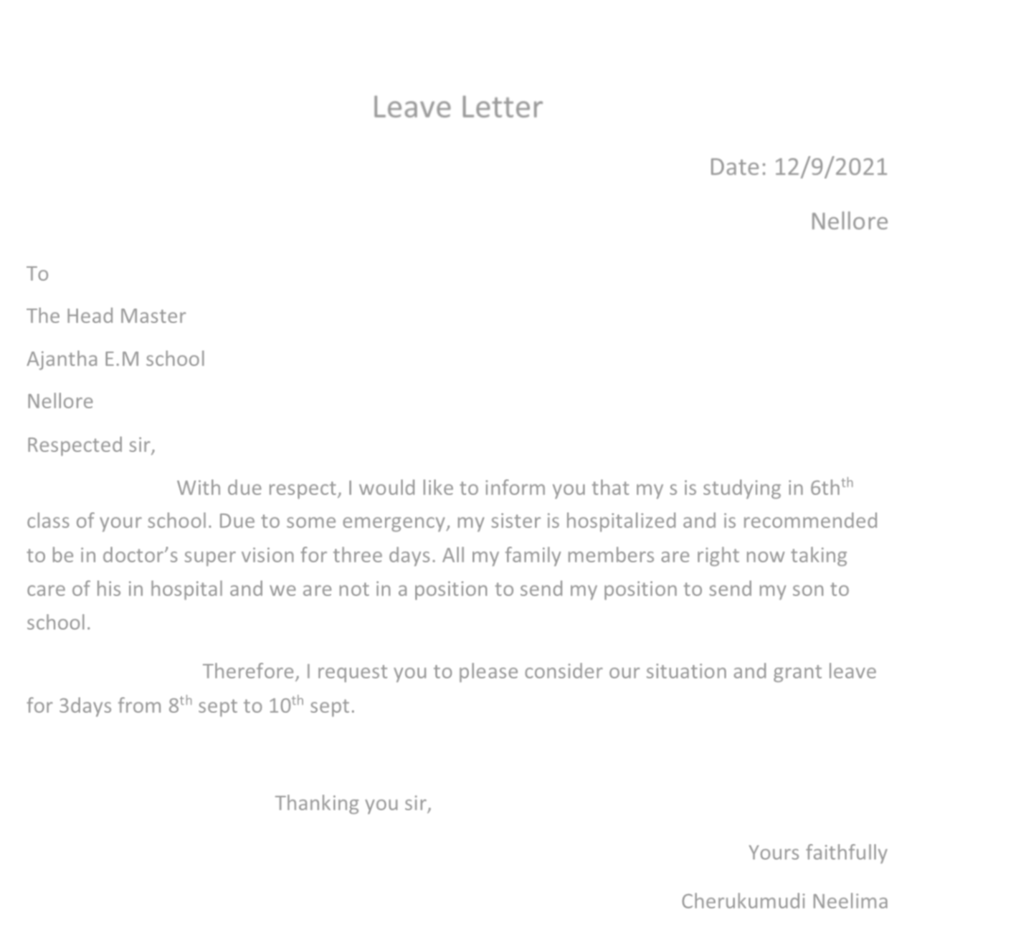

Leave Letter

Date: 12/9/2021

Nellore

To

The Head Master

Ajantha E.M school

Nellore

Respected sir,

With due respect, I would like to inform you that my s is studying in 6th^{th} class of your school. Due to some emergency, my sister is hospitalized and is recommended to be in doctor’s super vision for three days. All my family members are right now taking care of his in hospital and we are not in a position to send my position to send my son to school.

Therefore, I request you to please consider our situation and grant leave for 3days from 8th sept to 10th sept.

Thanking you sir,

Yours faithfully

Cherukumudi Neelima

