SKILL HIVE
PROBLEM STATEMENT
In rural and semi-urban areas, the process of finding skilled workers is often unorganized, relying heavily on personal networks, leading to delays and inefficiencies. Skilled workers face difficulty in reaching potential clients due to the absence of a centralized platform. The proposed Village Skill Directory (Skill Hive) aims to bridge this gap by providing a database-driven system that enables efficient worker registration, service request management, and time-slot based job allocation. This solution ensures improved accessibility, transparency, and streamlined coordination between workers and users.
ENTITIES
- User – Represents individuals who request skilled services.
- Skill_Worker – Represents registered workers who provide skilled services.
- Skill_Type – Represents categories of skills (e.g., plumber, carpenter, electrician).
- Work_Request – Represents service requests made by users.
- Worker_Availability – Represents available time slots and request details of workers.
- Feedback – Represents feedback given by users to workers after service completion.
- Notification – Represents system notifications sent to users and workers about updates.
RELATIONSHIPS
- User ↔ Work_Request (Posts): A user can post one or more work requests.
- Skill_Worker ↔ Work_Request (Accepts): A worker can accept one or more work requests.
- Skill_Worker ↔ Worker_Availability (Available): A worker can have one or more availability records.
- Skill_Worker ↔ Skill_Type (Has_Skill): A worker has exactly one skill type.
- User ↔ Feedback ↔ Skill_Worker (Gives_Feedback): A user can give feedback for a worker after a request is completed.
- User ↔ Notification (Receives): A user can receive one or more notifications.
- Skill_Worker ↔ Notification (Receives): A worker can receive one or more notifications.

ATTRIBUTES
User
- user_id (PK)
- name:
  - first_name
  - last_name
- email
- password
- phone_numbers
Skill_Worker
- worker_id (PK)
- name:
  - first_name
  - last_name
- address:
  - door_no
  - street_name
  - area
  - city
  - pincode
- experience_years
- available_status (boolean – available/unavailable)
- phone_numbers
Skill_Type
- skill_type_id (PK)
- skill_name
Work_Request
- request_id (PK)
- description
- request_date
- status
- location:
  - door_no
  - street_name
  - area
  - city
  - pincode
Worker_Availability
- request_details
Feedback
- feedback_id (PK)
- comments
- rating

Notification
- notification_id (PK)
- message
- date
- status (read/unread)
ER DIAGRAM

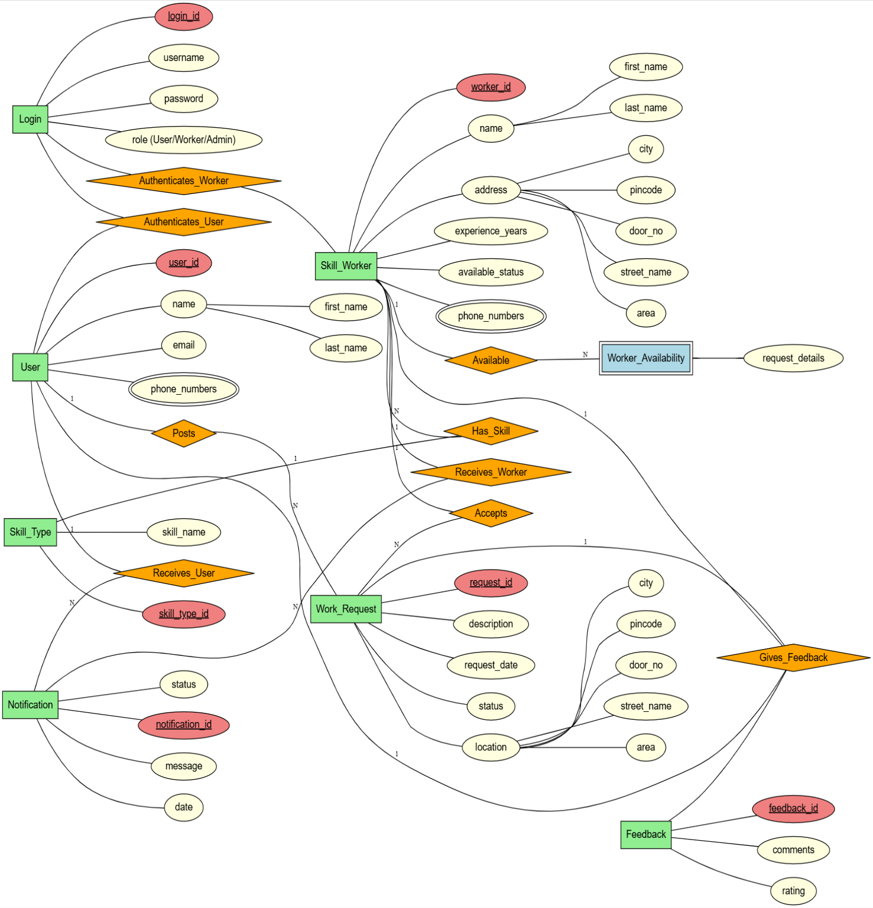

DATABASE CREATION
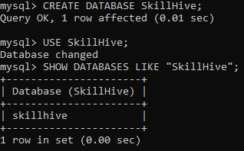
TABLE CREATION
Entity Tables
Table Login
Schema: Login (login_id, username, password, role)
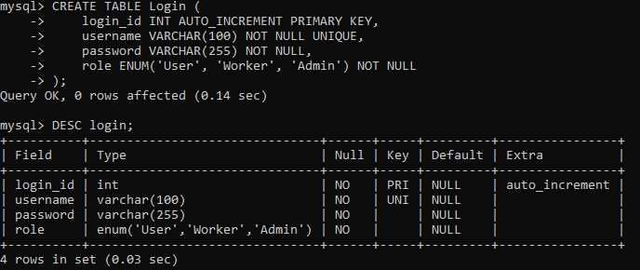

Login Table Sample Data Insertion
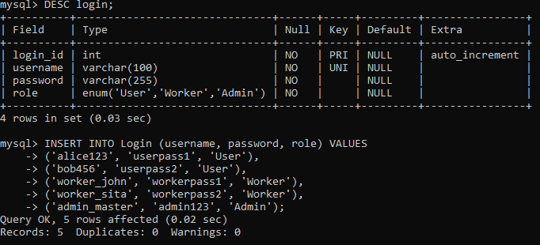
Login Table Contents
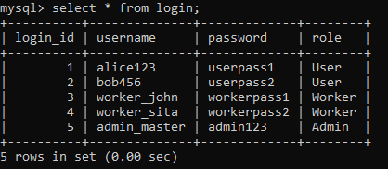
Table User
Schema: User (user_id, first_name, last_name, email, password, phone_no1, phone_no2)
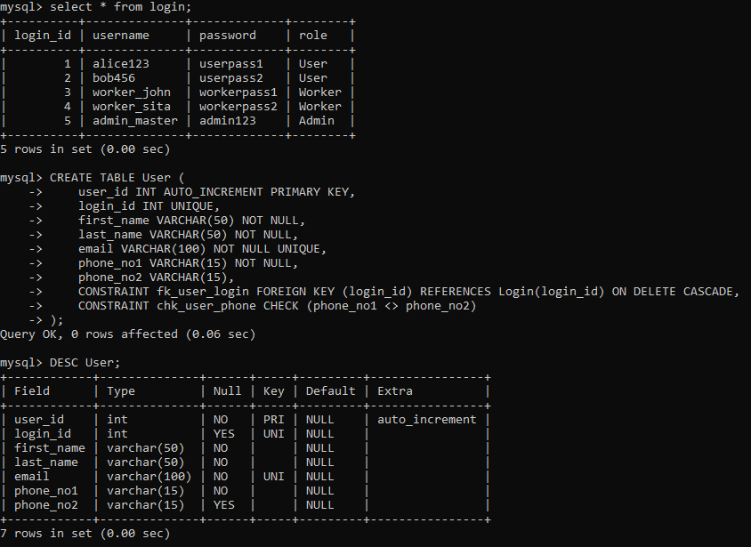
User Table Sample Data Insertion
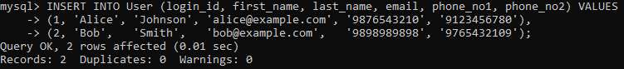
User Table Contents
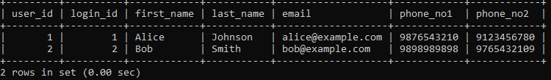

Table Skill Worker
Schema: Skill_Worker (worker_id, first_name, last_name, door_no, street_name, area, city, pincode, experience_years, available_status, phone_number1, phone_number2)
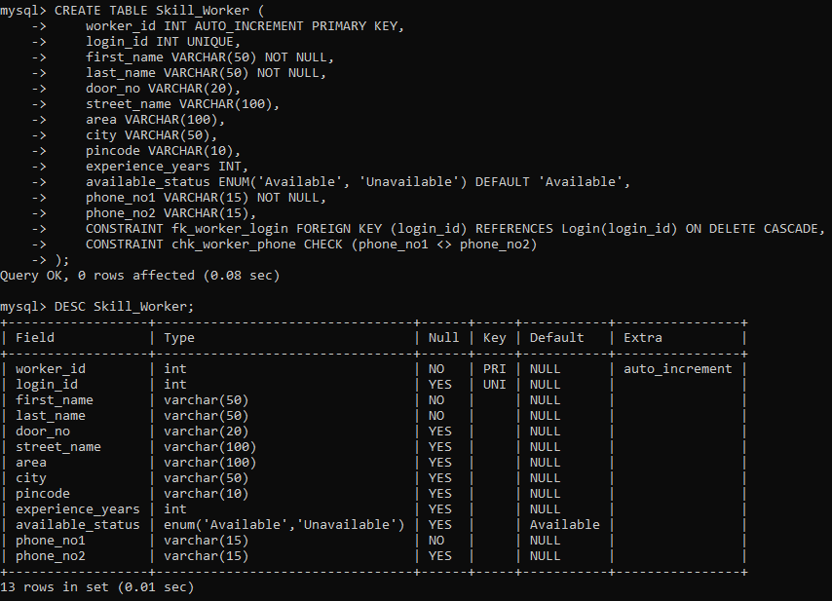
Skill Worker Table Sample Data Insertion
Skill Worker Table Contents
Table Skill Type
Schema: Skill_Type (skill_type_id, skill_name)
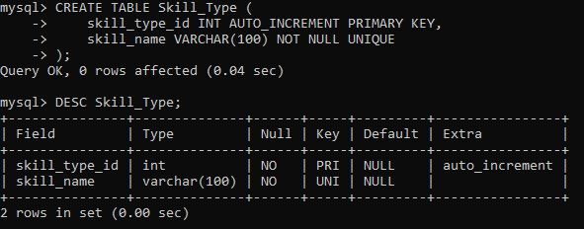
Skill Type Table Sample Data Insertion
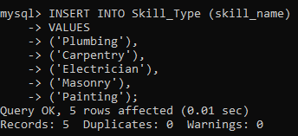
Skill Type Table Contents
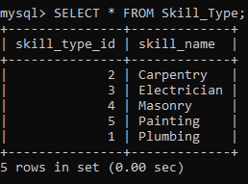

Work Request
Schema: Work_Request (request_id, description, status, request_date, door_no, street_name, area, city, pincode)
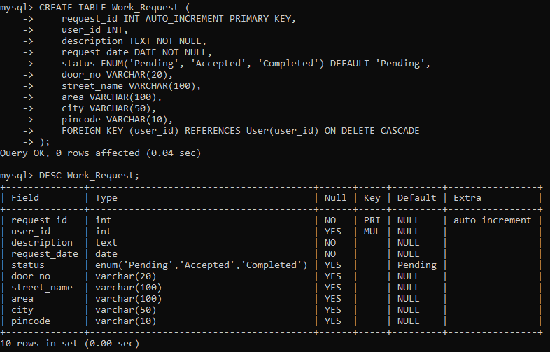
Work Request Table Sample Data Insertion
Work Request Table Contents
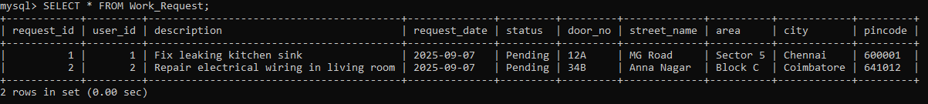

Feedback
Schema: Feedback (feedback_id, comments, rating)
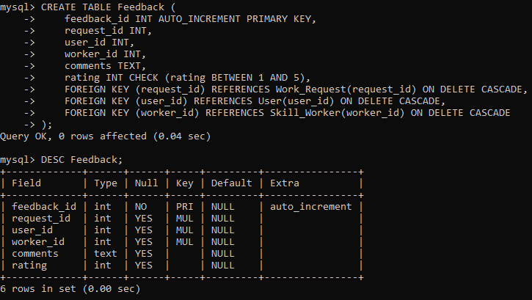
Feedback Table Sample Data Insertion
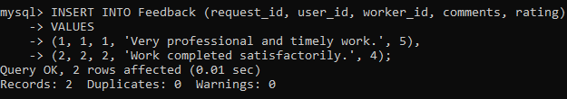
Feedback Table Contents
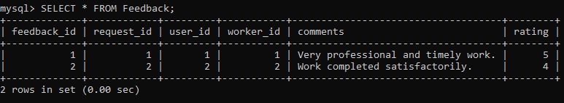

Worker Availability
Schema: Worker_Availability (availability_id, request_details)
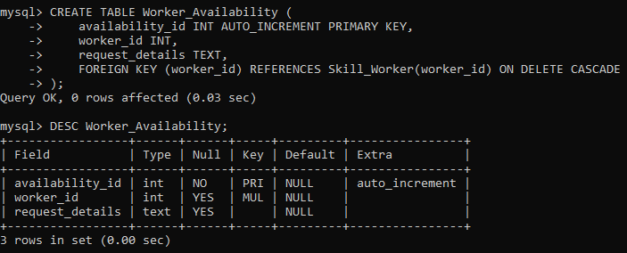
Worker Availability Sample Data Insertion
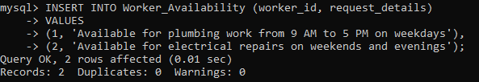
Worker Availability Table Contents
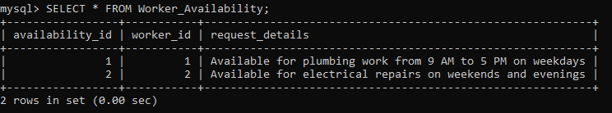

Notification
Schema: Notification (notification_id, message, date, status)
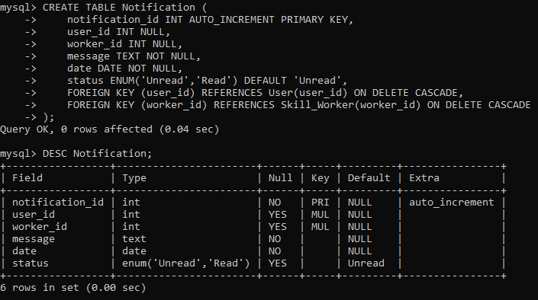
Notification Sample Data Insertion
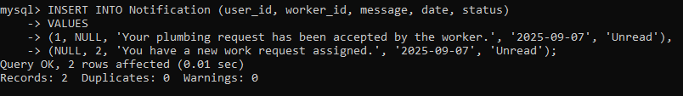
Notification Table Contents
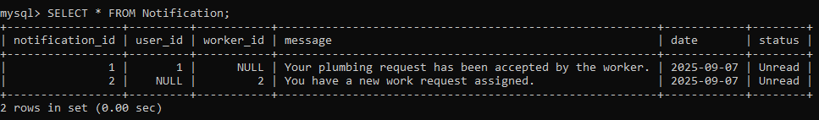

Relationship Table
Relation: Accepts
Schema: Accepts (worker_id, request_id)
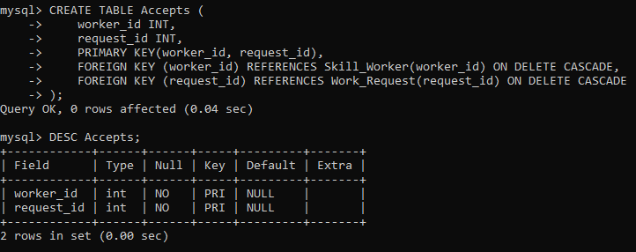
Accepts Sample Data Insertion
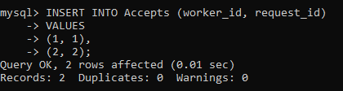
Accepts Table Contents
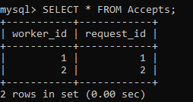

Relation: Has Skill
Schema: Has_Skill (worker_id, skill_type_id)
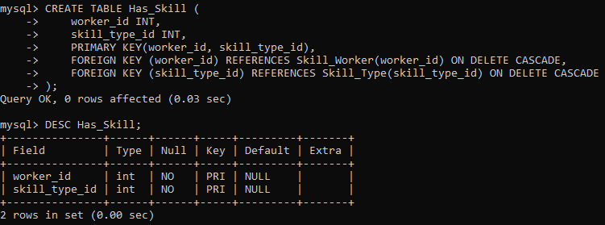
Has Skill Sample Data Insertion
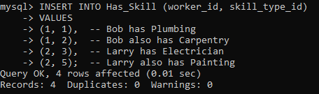
Has Skill Table Contents
