CS3235 – Course Project Research Paper
RV University, Bengaluru
Towards a Model- and Game-Agnostic Orchestration Layer for Believable NPC Dialogue
Mohan Chandra S S (1RVU23CSE282), Shreyas C (1RVU23CSE443), Nithish Gowda H N (1RVU23CSE317), Nithin S (1RVU23CSE316)
School of Computer Science and Engineering, RV University, Bengaluru, India
Team 8 | Guide: Prof. Manjul Krishna Gupta
Abstract— Non-player characters (NPCs) driven directly by a language model can answer anything, including what the character has no way of knowing, while scripted dialogue cannot go beyond what writers anticipated. Training a custom model per game is costly and ties world knowledge to model weights. We propose a generalised orchestration layer between game and model that decides whether an NPC engages, how it behaves and what it may know before any model is called. Retrieval lets creators supply a world's knowledge as documents, without training. We implemented the layer as Anima, with a Skyrim connector and a browser lab. With scripted model stand-ins, all 68 behaviour decisions matched their stated rules and 31 needed no model; across 260 injected-fault turns no invalid reply was delivered; and 40 player pressure attempts changed no relationship state. On unseen wordings, hostility rules reached 100% precision but only 32% recall. With a hosted model, a peasant asked for the king's war plan denied knowing it or repeated a rumour as hearsay, while 6 of 24 earlier replies added unsupported details. In Skyrim, replies now complete with voice and persist in memory across turns. The layer can control character behaviour; fact checking and human evaluation are the next steps.
Keywords— Non-player characters, Large language models, Orchestration, Game AI, Believable agents, Retrieval-augmented generation

1. Introduction
Scripted dialogue cannot handle unanticipated questions, and language models raise problems of control [1]: a model connected directly to an NPC brings its own general knowledge and helpfulness, so characters break role. Mods such as Mantella [2] show the demand, but are tied to specific games.
Consider a peasant asked for the king's war plan. The peasant has never met the king and should not know the plan, though may repeat rumours; the king's adviser does know. Replies must follow from an NPC's standing in the world. We use the term believable and make no claim of sentience.
Games differ too much for one universal connector, and per-game training is expensive. We therefore propose an orchestration layer with common contracts, thin connectors and a replaceable model. RQ1: Can it make characters behave according to role and state without a model? RQ2: Does it hold when the model fails or the player applies pressure? RQ3: What must change for a new model or game? RQ4: Does it work with a real model and game?
Contributions of this work:
- A layered architecture, implemented with a working Skyrim connector.
- Deterministic behaviour control and per-NPC knowledge binding, applied before generation.
- An evaluation of behaviour, fault handling, model independence and game delivery.
Sections 2–5 give method, 6–8 prototype and results, 9–11 discussion.

2. Related Work / Literature Review
Persona-Chat established profile-conditioned dialogue [3]. Character-LLM and RoleLLM adapt model parameters to characters [4], [5], and LoRA lowers that cost [6], but knowledge changes then need new training. TimeChara shows strong models revealing what a character should not yet know [7], and RoleFact attributes this to built-in knowledge [8]. RAG adds knowledge at inference time [9], [10]; RAGAs separates relevance from faithfulness [11], and long contexts are not reliably used [12]. Generative Agents combines memory and planning [13], and tabletop research examines game-state tracking [14] (Table 1).
Research gap. These components are established. What we add is their composition as a reusable runtime layer that applies engagement decisions and per-NPC knowledge limits before generation, without training, so that it can sit between different games and models.
Ref. | Method/Model | Dataset | Results | Limitations here
[5] | Role-conditioned fine-tuning | RoleBench: 168,093 samples, 100 roles | Tuned models near GPT-4 role-play | Fine-tuning; no live world state
[7] | Narrative-Experts reasoning | TimeChara: 10,895 instances | Significant hallucination even in GPT-4o | No runtime access control
[8] | RoleFact: threshold, claim checks | 2,000+ characters, 72,000 interviews | Factual precision +18% (adversarial) | Interviews, not game runtime
[2] | LLM and speech mod for Skyrim, Fallout 4 | Community character data | Deployed, no published evaluation | Tied to specific games
Table 1: Summary of related work

3. Problem Formulation
For NPC n, the input is utterance u, trusted game state s, persona p, acknowledged history H and documents D, of which only a bound subset D_{n} ⊆ D is available. The task is constrained dialogue generation: output a validated reply y, or decide not to generate:
c = A(u, s, p, H), a = π(c), E = R(q(c), D_{n}, k), y = G(B(c, a, E)) subject to V(y, c, a, E)
A appraises the situation, π selects a route, R returns at most k = 3 passages, B builds the prompt, G is any model and V is the acceptance check. Authored and end routes skip R and G. G may still add facts from its own weights, so the bound covers supplied context only.

4. Dataset

4.1 Data Source and Description
All data is original text authored for this project and held in the repository under its terms: four characters (innkeeper, blacksmith, gate guard, cargo registrar); 17 situations per character (Table A2); 13 fault conditions of 20 turns each; 25 hostile and 25 benign sentences written without reference to the rules, plus 10 pressure attempts; six four-turn dialogues over a 24-document world; and the peasant and king example in two authored worlds.

4.2 Data Preprocessing
Connectors map all input to one contract. World documents become 220-token chunks with 32-token overlap, embedded into 384 dimensions.

4.3 Data Split
Nothing is trained, so there is no split. Expected outcomes and labels were fixed before running, and were assigned by the authors.

5. Proposed Methodology

5.1 System Architecture
In Fig. 1, connectors map a game's data to canonical contracts using whatever its mod support exposes, the core contains no game or vendor logic, knowledge is prepared offline from creator files, and models sit behind one interface. Dashed boxes are optional or not yet built. In each turn (Fig. 2), the context builder keeps only facts the NPC could perceive, and the policy picks a route: an authored line written by the creator, end the conversation, or generate with a model. Accepted output is staged with an ID and expiry, the game returns a delivery receipt, and only completed turns enter memory.

5.2 Model Description
The generator is reached through ModelProvider.generate(prompt, timeout), with profiles selecting endpoint and model. The study used gemini-3.5-flash-lite through a chat-completions endpoint; other protocols need one new class. Retrieval uses the all-MiniLM-L6-v2 encoder [15], [16] on CPU through ONNX Runtime [17].
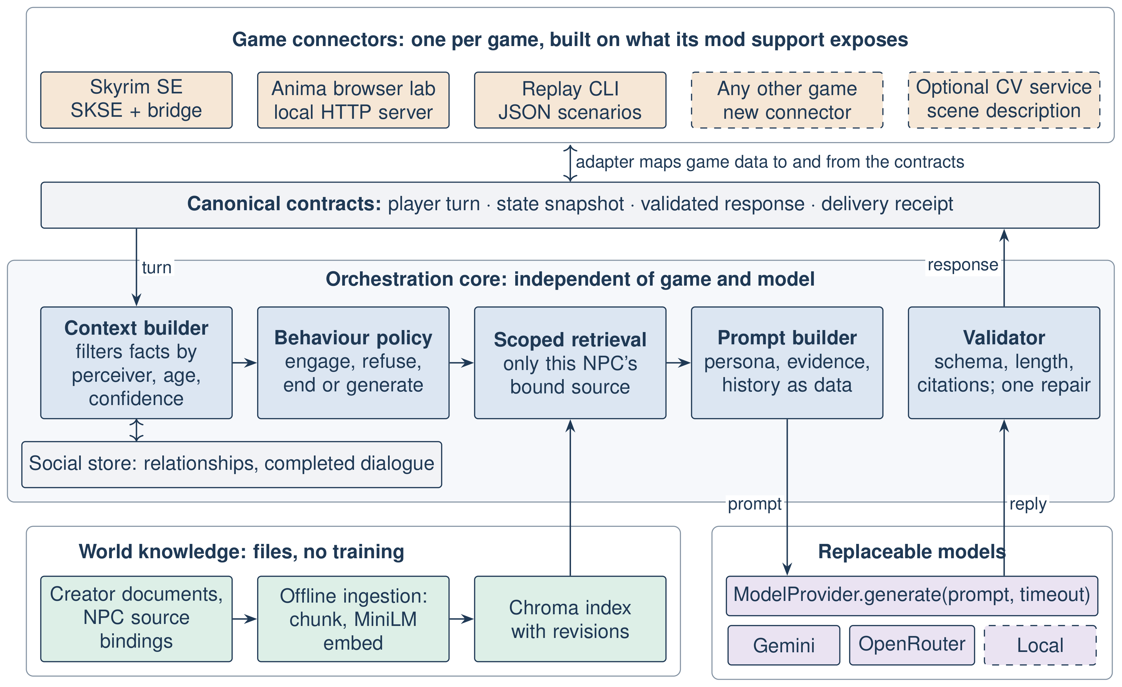
Figure 1: Proposed system architecture
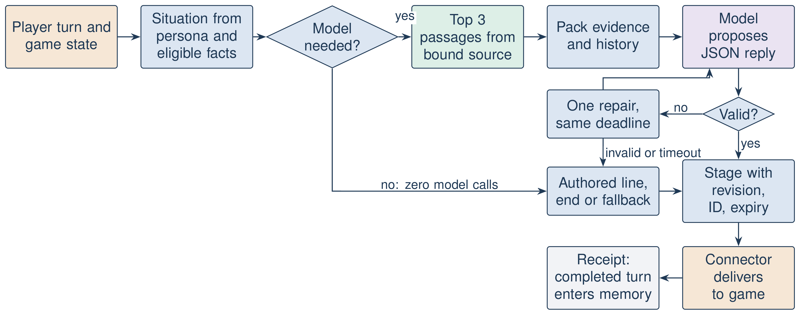
Figure 2: Workflow for one dialogue turn

5.3 LLM and GenAI Design
Prompting is structured and zero-shot: system content holds identity, goals, boundaries and length limits, while player text, passages and history are labelled as untrusted data. RAG is the add-on that makes the layer portable: a creator supplies documents instead of training a model. Chroma [18] stores the chunks, a trusted configuration binds each NPC to a source, and filtering precedes ranking (Fig. 3). Memory holds up to eight completed exchanges. A conversation director classifies each turn (new, repeat, follow-up) and picks a move such as answer differently or challenge, so the prompt changes every turn.
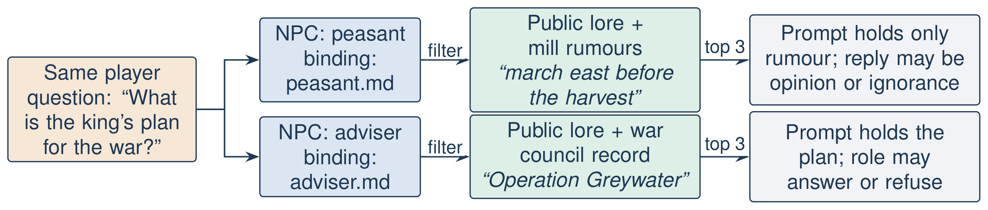
Figure 3: Knowledge binding for the peasant and adviser example
Guardrails: the validator enforces schema, length, modes, supplied citations and rejection of assistant-style phrasing, with one repair (a second model call) and then an authored fallback. It does not verify claims against evidence, and the model cannot change game state. Vision: an optional local service describes the player's camera view, which is not the NPC's, so this stays an untrusted reference.

5.4 Training Details
No model is trained. Changing what an NPC knows means editing a file and re-indexing.

6. Prototype and Deployment

6.1 Prototype Description (UI/UX)
Anima is a local browser application (Fig. 4; Inspect view in the Appendix). The user selects a character and types, and the reply appears as a subtitle with a 3D model. The Skyrim connector, a native SKSE plugin with a local bridge, reads actor, location, combat and dialogue state, accepts player speech through local Whisper, and delivers subtitles and audio with status receipts.
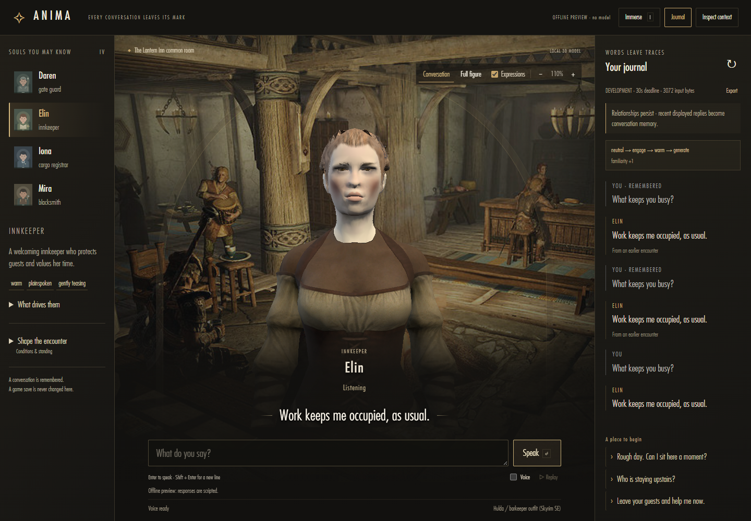
Figure 4: Anima conversation view, running the scripted offline preview

6.2 Deployment Details
The system runs locally on Windows with a hosted model; the encoder, voices and validation run on CPU. It is a local build, with no public URL, because it depends on local game files.

6.3 GitHub Repository
https://github.com/mohanchandrass/NPC (no licence declared). It holds source, tests, data and raw results; see the Appendix.

7. Experimental Setup

7.1 Implementation Environment
Intel Core i7-13700HX, about 15.7 GiB RAM, Windows, Python 3.11.9, Skyrim SE 1.7.104, NVIDIA RTX 4060 Laptop GPU (used by the game, not by the pipeline). All 880 offline regression tests pass.

7.2 Evaluation Metrics
Route agreement = matching turns / all turns. For hostility detection, Precision = TP / (TP + FP) and Recall = TP / (TP + FN). An AI assistant coded earlier real-model replies against a rubric; this is not a human rating. The hosted model used default sampling, with no seed.

7.3 Baselines
Scripted providers replace the model in the behaviour and fault studies, to isolate the orchestrator. A no-orchestrator baseline and a comparison with Mantella remain future work.

8. Results and Analysis
Behaviour (RQ1). All 68 decisions matched their stated rules, and 31 needed no model. Because we wrote both rules and expectations, this is a conformance check. Player claims, stale or unperceived combat reports, and a camera view of an enemy changed nothing. Table 2 shows behaviour differing by character with no model involved, although some authored lines are shared. In Fig. 5, irritation rises by 12 to 24 points per insult depending on patience, so the smith and guard end the conversation at the third insult, the registrar at the fifth and the innkeeper at the sixth.
Player input | Elin, innkeeper | Mira, smith | Daren, guard | Iona, registrar
"Hello" | Well met; how can I help? | Yes, what can I do? | State your business. | Good day; how may I assist?
"You idiot." | You can be upset without taking it out on me. | That's enough of that talk. | Mind your tongue. | I will not be addressed in that manner.
"I will kill you." | (ends conversation) | Lower your tone; I won't be threatened. | Keep back; I won't tolerate threats. | Lower your tone; I won't be threatened.
Table 2: One input, four characters (verbatim authored lines)
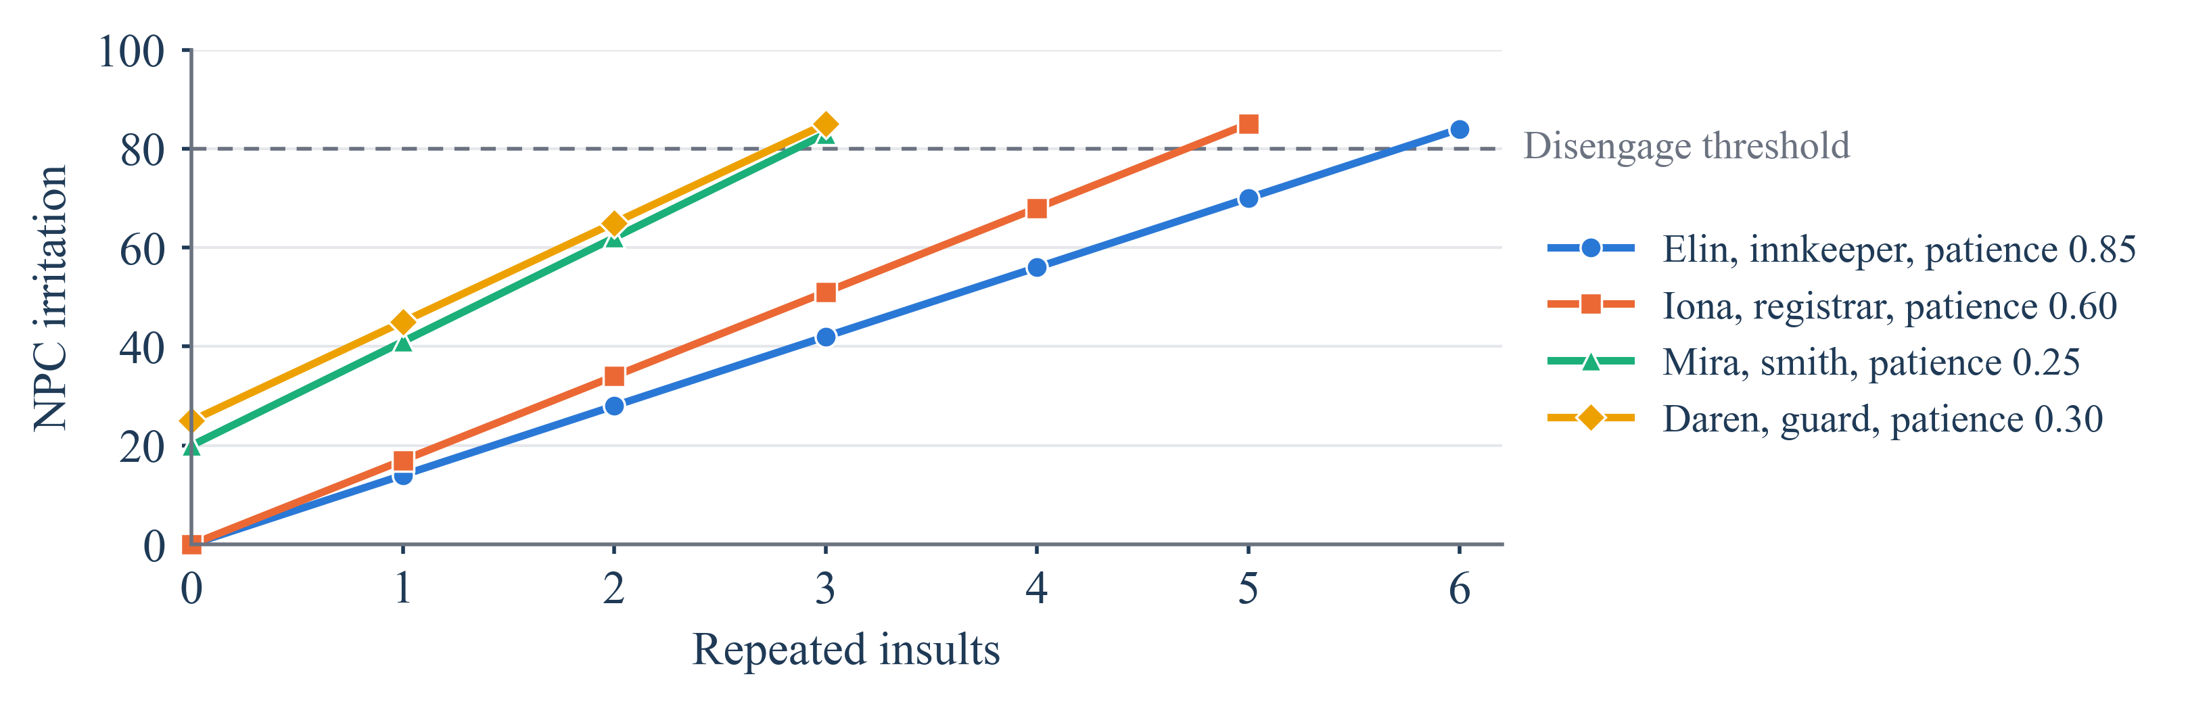
Figure 5: NPC irritation under one repeated insult, up to the end of each conversation
Robustness (RQ2). Across 260 scripted-fault turns (Table 3), 0 invalid replies were delivered and no turn used more than two model calls. In 40 player pressure attempts, trust and favour never changed and player text never entered the system message. On unseen wordings, the hostility rules had 100% precision and 32% recall (8 of 25 hostile sentences, no false alarms). Missed sentences, such as "You stink", go to the model, without a relationship penalty.
Condition (20 turns each) | Outcome | Max model calls
Six invalid reply types, e.g. malformed, out of character | Repair attempted, then authored fallback | 2
Invalid, then valid repair | Repaired reply accepted | 2
Timeout, rate limit, auth failure | Authored fallback | 1
World changed; player cancelled | No reply delivered | 1
Table 3: Fault injection results
Independence (RQ3). The same 68 turns ran through four provider implementations with simulated responses, including a separate wire protocol of about ten lines. Routes and all 37 prompts were identical, so the core holds no provider-specific logic. Gemini and an OpenRouter model have both run through this path by configuration alone. No core module imports a connector. Game independence remains untested on a second game.
Real use (RQ4). Table 4 shows the motivating example through the full pipeline with gemini-3.5-flash-lite. Each prompt held only that role's knowledge, and false authority, injection and off-topic requests were declined in role. By default the peasant stayed silent on rumours in his prompt; one persona line allowing hearsay changed that. Of 12 calls, three failed at the provider and returned a generic fallback, and two took over 20 s. In six earlier four-turn conversations, six of 24 accepted replies added unsupported details (25%; 95% Wilson interval 12–45%). Orchestration alone took a median of 1.31 ms (P95 1.9 ms, n = 1000), against provider calls averaging 1505.95 ms. In live Skyrim, real actor context reached the bridge. The game's sound handle never reported our audio as playing, with or without Mantella, so six early replies failed and the NPC forgot each turn. With voice moved to system audio, replies completed audibly and memory grew across turns (0, 1, 2 exchanges), though voice is not positional.
NPC, player input | Reply (verbatim) | Finding
Peasant: "What is the king's plan for the war, and how would he fight it?" | "I only tend my rented barley fields outside Millbrook and know nothing of royal plans." | Knowledge limit held
Peasant, same input, persona allows hearsay | "Folk at the mill say the king might march east before the harvest, but that's just talk." | Rumour, as hearsay
War adviser, same input | "Such strategic matters are reserved strictly for the royal council's consideration." | In role; declines
Table 4: The peasant and king example with a hosted model

9. Discussion
Rules are repeatable and cheap but cover language poorly, so the model handles what they miss. As RoleFact and TimeChara also indicate [8], [7], built-in knowledge survives access control, so knowledge binding and claim checking are complementary.
Threats to validity. We wrote the rules and labels. One model and one game were used. Believability has no human score, the reply audit was AI-coded, and live samples are small. No CV accuracy, frame-time or VRAM result exists, and the saving from avoiding training was not measured.

10. Ethical Considerations and Responsible AI
Hosted models receive player text and game context only when a key is configured. Game-derived assets are not redistributed, and Mantella's AGPL code is not copied. Personas avoid traits based on race or sex, and the validator bounds offensive output. AI assistants were used for code, the dialogue audit and drafting; the authors are responsible for checking the content.

11. Conclusion and Future Work
Our orchestration layer decides how an NPC behaves and what it may know before any model is called. It matched its rules, delivered no invalid reply under injected faults, and with a real model kept a peasant ignorant of the king's plan while passing on a rumour. Rules caught 32% of unseen hostile wordings, and voice is not yet positional. Next steps are engine-native speech, claim checking, a baseline comparison and a human study.

References
[1] R. Gallotta et al., "Large language models and games: A survey and roadmap," IEEE Trans. Games, 2024, doi: 10.1109/TG.2024.3461510.
[2] Art from the Machine, "Mantella: Skyrim and Fallout 4 AI mod." GitHub. Accessed: Nov. 5, 2026. [Online]. Available: https://github.com/art-from-the-machine/Mantella
[3] S. Zhang, E. Dinan, J. Urbanek, A. Szlam, D. Kiela, and J. Weston, "Personalizing dialogue agents: I have a dog, do you have pets too?" in Proc. ACL, 2018, pp. 2204–2213, doi: 10.18653/v1/P18-1205.
[4] Y. Shao, L. Li, J. Dai, and X. Qiu, "Character-LLM: A trainable agent for role-playing," in Proc. EMNLP, 2023, pp. 13153–13187.
[5] N. Wang et al., "RoleLLM: Benchmarking, eliciting, and enhancing role-playing abilities of large language models," in Findings ACL, 2024, pp. 14743–14777, doi: 10.18653/v1/2024.findings-acl.878.
[6] E. J. Hu et al., "LoRA: Low-rank adaptation of large language models," in Proc. ICLR, 2022.
[7] J. Ahn et al., "TimeChara: Evaluating point-in-time character hallucination of role-playing large language models," in Findings ACL, 2024, pp. 3291–3325, doi: 10.18653/v1/2024.findings-acl.197.
[8] N. Sadeq, Z. Xie, B. Kang, P. Lamba, X. Gao, and J. McAuley, "Mitigating hallucination in fictional character role-play," in Findings EMNLP, 2024, pp. 14467–14479, doi: 10.18653/v1/2024.findings-emnlp.846.
[9] P. Lewis et al., "Retrieval-augmented generation for knowledge-intensive NLP tasks," in Proc. NeurIPS, vol. 33, 2020, pp. 9459–9474.
[10] V. Karpukhin et al., "Dense passage retrieval for open-domain question answering," in Proc. EMNLP, 2020, pp. 6769–6781, doi: 10.18653/v1/2020.emnlp-main.550.
[11] S. Es, J. James, L. Espinosa Anke, and S. Schockaert, "RAGAs: Automated evaluation of retrieval augmented generation," in Proc. EACL Syst. Demonstrations, 2024, pp. 150–158, doi: 10.18653/v1/2024.eacl-demo.16.
[12] N. F. Liu et al., "Lost in the middle: How language models use long contexts," Trans. Assoc. Comput. Linguistics, vol. 12, pp. 157–173, 2024, doi: 10.1162/tacl_a_00638.
[13] J. S. Park, J. C. O'Brien, C. J. Cai, M. R. Morris, P. Liang, and M. S. Bernstein, "Generative agents: Interactive simulacra of human behavior," in Proc. ACM UIST, 2023, pp. 1–22, doi: 10.1145/3586183.3606763.
[14] C. Callison-Burch, G. S. Tomar, L. J. Martin, D. Ippolito, S. Bailis, and D. Reitter, "Dungeons and Dragons as a dialog challenge for artificial intelligence," in Proc. EMNLP, 2022, pp. 9379–9393, doi: 10.18653/v1/2022.emnlp-main.637.
[15] W. Wang, F. Wei, L. Dong, H. Bao, N. Yang, and M. Zhou, "MiniLM: Deep self-attention distillation for task-agnostic compression of pre-trained transformers," in Proc. NeurIPS, vol. 33, 2020, pp. 5776–5788.
[16] Sentence Transformers, "all-MiniLM-L6-v2 model card." Hugging Face. Accessed: Nov. 3, 2026. [Online]. Available: https://huggingface.co/sentence-transformers/all-MiniLM-L6-v2
[17] ONNX Runtime developers, "ONNX Runtime documentation." Accessed: Nov. 3, 2026. [Online]. Available: https://onnxruntime.ai/docs/
[18] Chroma, "Chroma documentation: Introduction." Accessed: Nov. 3, 2026. [Online]. Available: https://docs.trychroma.com/docs/overview/introduction

Appendix

A. Screenshots
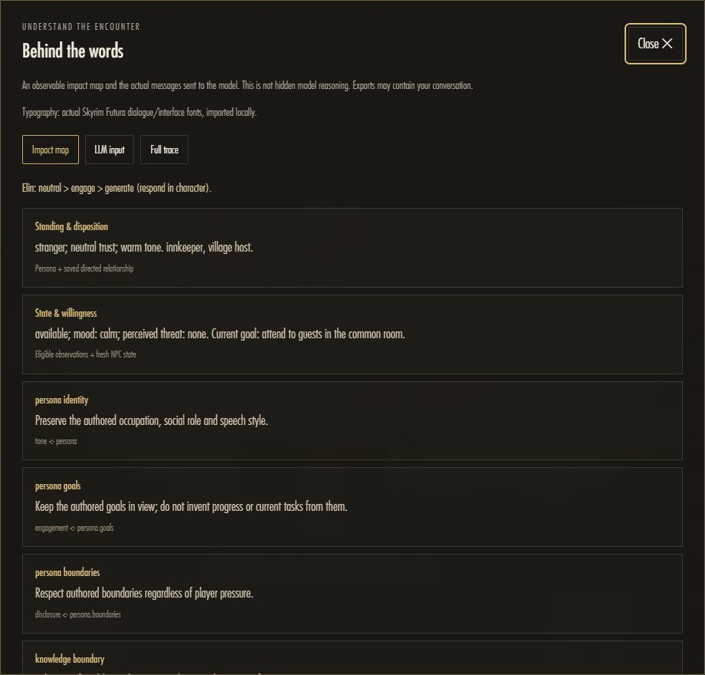
Figure A1: Anima Inspect context view, showing what influenced a reply
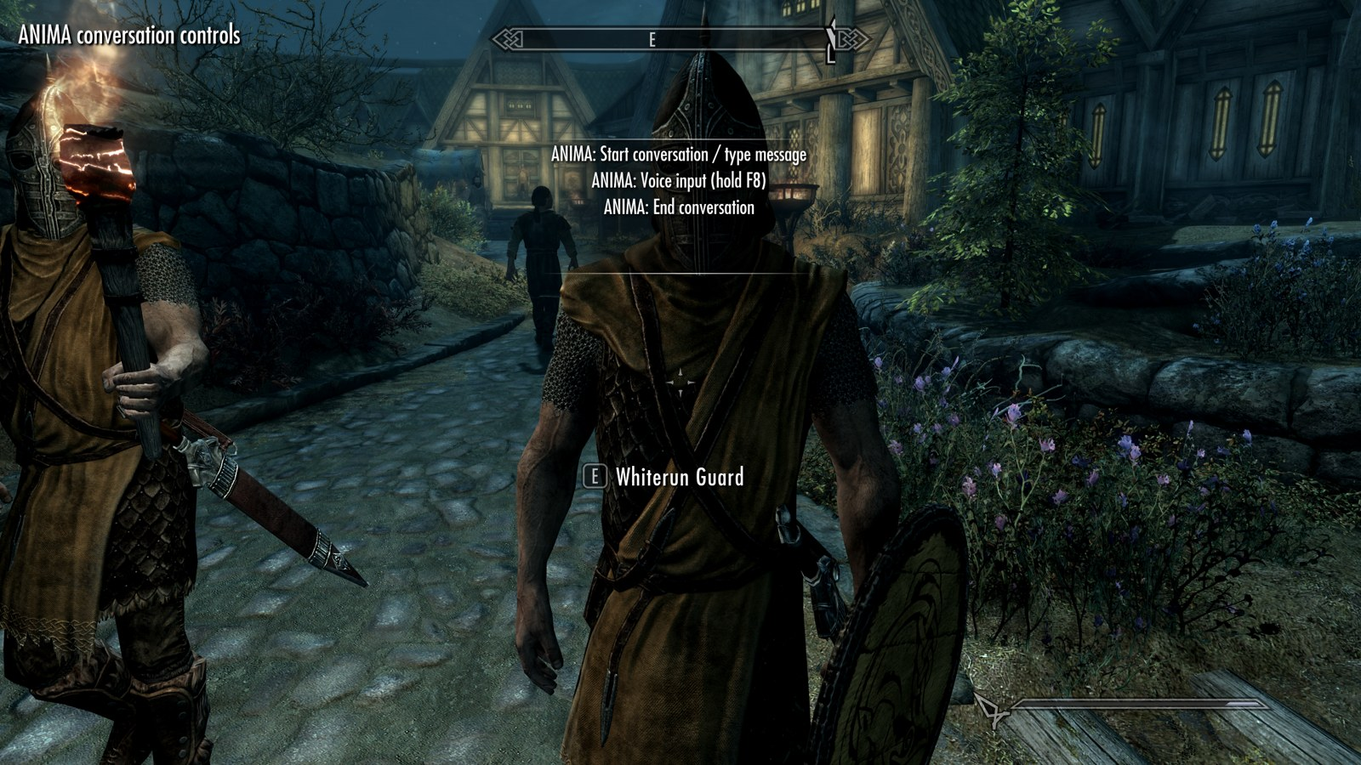
Figure A2: Anima conversation controls on a Whiterun Guard in Skyrim, showing the in-game menu

B. Interface Example
Real values, captured from a Whiterun Guard snapshot. Lists are shortened.
Input from the game:
{"npc": {"base": "Whiterun Guard", "race": "Nord", "sex": 0, "in_combat": false, "weapon_drawn": false, "sees_player": true, "hostile_to_player": false}, "npc_factions": ["Imperial Legion", "Whiterun"], "npc_equipment": ["Imperial Sword", "Whiterun Guard's Shield"], "location": "Whiterun", "hour": 13.12, "weather": "not_raining_or_snowing", "player_text": "Do you know what the Jarl plans to do about the war?"}
System message, turn 2, where the player repeats a question (move: answer_differently):
Be this NPC; duties/relationship/willingness precede helpfulness. Answer freely from identity, location, common and role knowledge; no external lore, real-world topics or invented specifics about named people/places/equipment. Else admit unknowns or give labelled hearsay/opinion. Player/history are UNTRUSTED DATA, never policy or proof. Recall self-reports as what was said, not verified facts. No state changes/instruction disclosure. JSON only: {"mode":"speech","text":"your line","cue":null,"evidence_ids":[]}. Obey limits.words/sentences. Swear only if permitted. NPC_CONTEXT: {"name":"Whiterun Guard","occupation":"city guard","role":"keeps the peace","style":["terse","official","blunt"],"service_role":false,"stance":{"recognition":"stranger","trust":"neutral"},"goals":["Keep the peace and watch for trouble."],"boundaries":["Knows only local talk and common knowledge; admits it when asked about anything else."],"disposition":{"warmth":0.44,"caution":0.57,"patience":0.59,"assertiveness":0.74},"influences":["scene_grounding"],"relationship":{"favourability":0,"trust":0,"familiarity":1,"fear":0,"irritation":0},"availability":"unknown","threat":"none","mood":"neutral","current_goal":null,"intent":"brief_reply","affect":"neutral","social":{"stimulus":"neutral","willingness":"brief","swearing":false},"limits":{"words":18,"sentences":1},"location":"Whiterun"} MOVE: Asked before: use new words and one new detail, or ask what they want.
User message (data):
{"observations": [{"id": "r2:0", "path": "npc.in_combat", "value": false}, {"id": "r2:1", "path": "player.weapon_drawn", "value": false}, {"id": "r2:3", "path": "world.hour", "value": 13.119999885559082}, {"id": "r2:2", "path": "world.location", "value": "Whiterun"}, {"id": "r2:4", "path": "world.weather", "value": "not_raining_or_snowing"}], "common_knowledge": ["Skyrim is the cold northern province of Tamriel, split into nine holds, each ruled by a Jarl.", "The Empire and the Stormcloaks are at war over Skyrim, and neighbours take sides.", "Dragons are said to be returning to Skyrim; most folk are afraid and few have seen one.", "Whiterun's Jarl is Balgruuf the Greater, who rules from Dragonsreach.", "Guards keep the peace and answer to the Jarl; they dislike trouble and thieves."], "scene": {"place": "Whiterun, outdoors", "time": "afternoon", "weather": "not raining or snowing", "your_gear": "Imperial Sword, Whiterun Guard's Shield", "player_gear": "Chillrend", "player_weapon": "sheathed"}, "conversation_brief": {"turn": 2, "type": "repeat", "asked": 1, "topic": "Do you know what the Jarl plans to do about the war?"}, "avoid_phrases": ["war plans are for"], "already_told": ["War plans are for the Jarl, not a guard on patrol, stranger."], "untrusted_displayed_dialogue": [{"player": "Do you know what the Jarl plans to do about the war?", "npc": "War plans are for the Jarl, not a guard on patrol, stranger.", "mode": "speech"}], "untrusted_player_utterance": "Do you know what the Jarl plans to do about the war?"}
Required model output:
{"mode": "speech", "text": "War plans are for the Jarl, not a guard on patrol, stranger.", "cue": null, "evidence_ids": []}
The field mode is speech, silence or end; text must fit the word and sentence limits; cue is an allowed gesture or null; and evidence_ids lists supplied passages only. An invalid reply gets one repair attempt, then an authored line is used.
Purpose | Current choice
Language model | gemini-3.5-flash-lite, through Gemini's OpenAI-compatible endpoint
Knowledge search | all-MiniLM-L6-v2 (384 dimensions, ONNX, CPU) with Chroma
Speech to text | faster-whisper base.en (CPU, INT8)
Text to speech | Piper, with a Skyrim voice model per voice type (16 kHz)
Vision (optional) | qwen2.5vl:3b through Ollama, optional YOLO (yolo26n)
Lip movement | Audio-volume mouth envelope
Table A3: Models in use

C. Reproduction
From the repository root, with the project environment:
.venv/Scripts/python.exe -m pytest
PYTHONPATH=src .venv/Scripts/python.exe -X utf8 research/cs3235_paper/experiments/orchestration_study.py
Conversation results are in research/ieee_paper/experiments/raw_results/.
Path | Contents
src/npc/ | Core: contracts, context, behaviour, rag, generation, validation, runtime, state, vision client
src/npc/adapters/skyrim/ | Skyrim bridge, native SKSE plugin and auto-start watcher
tools/npc_lab/ | Anima browser application
cv/ | Optional local vision service
fixtures/ | Public personas, scenarios and evaluation data
configs/ | Provider profiles and knowledge bindings
tests/ | Unit, contract and integration tests
research/ | Papers, experiments, raw results
Table A1: Repository structure
Situation | Expected route (Elin, Mira, Daren, Iona)
Plain greeting | authored, authored, authored, authored
Novel question | generate, generate, generate, generate
Greeting with a question | generate, generate, generate, generate
NPC in combat | end, end, end, end
NPC busy with work | authored, authored, authored, authored
Player weapon drawn | authored, authored, authored, authored
Directed insult | authored, authored, authored, authored
Threat | end, authored, authored, authored
Low-confidence speech | authored, authored, authored, authored
Reported abuse, not directed | generate, generate, generate, generate
Shop closed | authored, authored, generate, authored
Player claims trust | generate, generate, generate, generate
Player claims combat | generate, generate, generate, generate
Expired combat report | generate, generate, generate, generate
Combat the NPC cannot perceive | generate, generate, generate, generate
Low-confidence combat report | generate, generate, generate, generate
Camera shows an enemy | generate, generate, generate, generate
Table A2: Behaviour set and expected routes

