AI ASSISTED CODING

LAB-5.1

NAME: Nithin Goli

ENROLL.NO:2403A52121

BATCH-04

**TASK-01:**

Use an AI tool to generate a Python program that connects to a  
weather API.

**PROMPT:**

Generate a python program that connects to a weather API and displays the climate of the particular city.

**Code:**

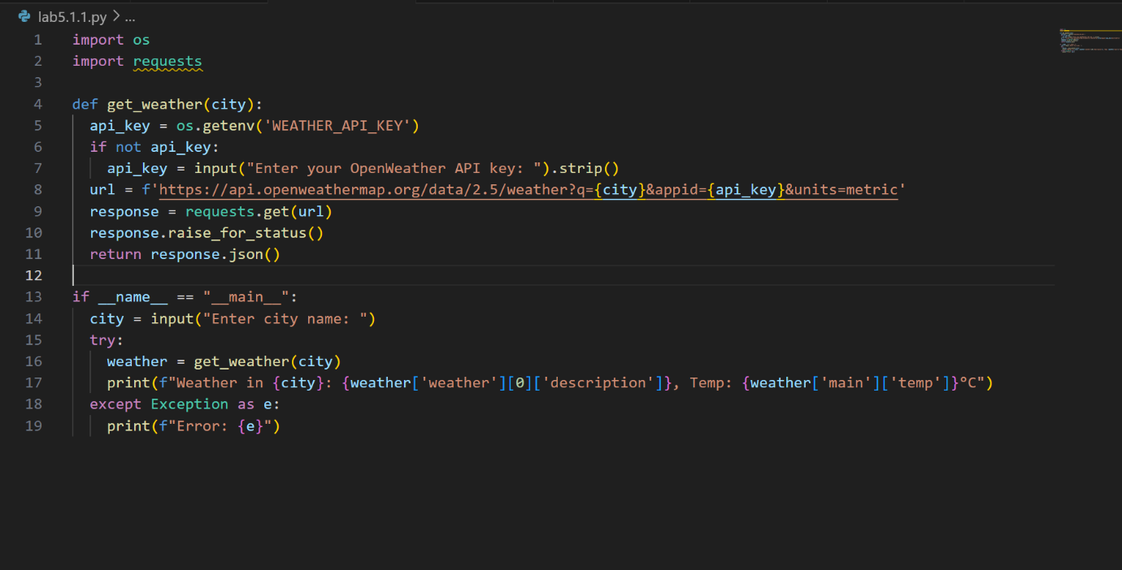

**Output:**

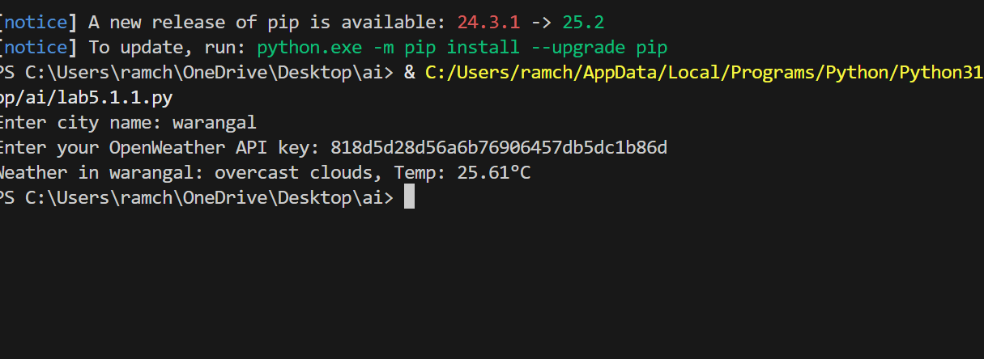

**Observation:**

The code generated by the github copilot is to check the weather of a particular city or village by entering its name and it asks for the API key which is generated in Open WeatherApp.

**TASK-02:**

Use an AI tool to generate a Python script that stores user data  
(name, email, password) in a file.

**PROMPT:**

Write a python program to store the users data in a file.

**CODE:**

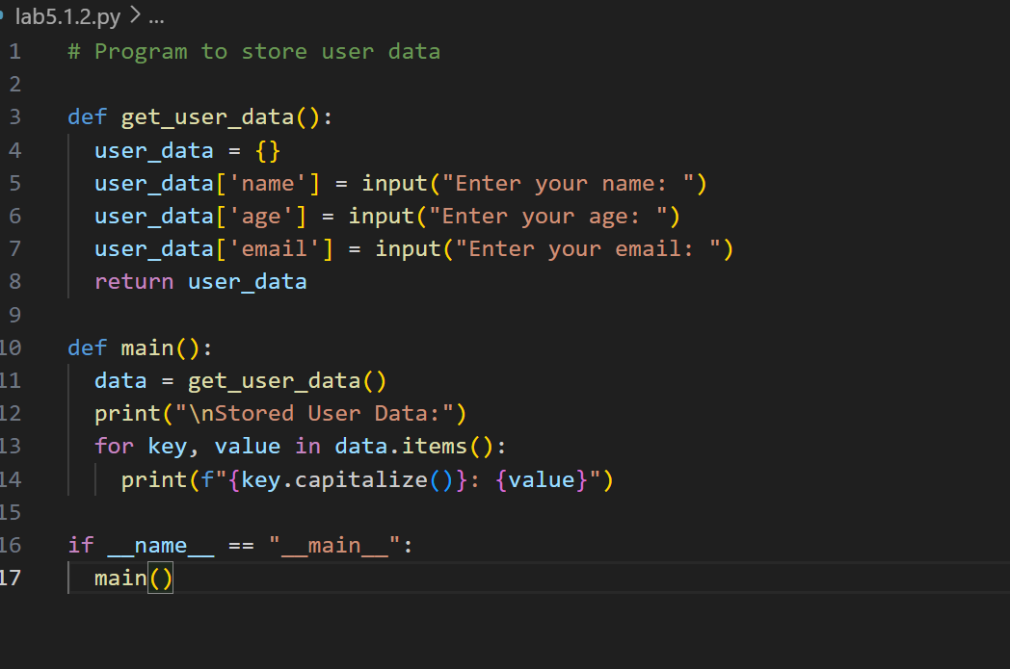

**OUTPUT:**

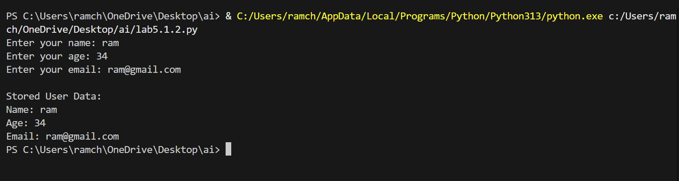

**OBSERVATION:**

The code takes the input as name , age, email and stores them in a file which is created by it by asking several permissions.

**TASK-03:**

Use AI to generate an Armstrong number checking function  
with comments and explanations

**PROMPT:**

Write a python function to check whether the given number is Armstrong or not also provide clear explanation using comments.

**CODE:**

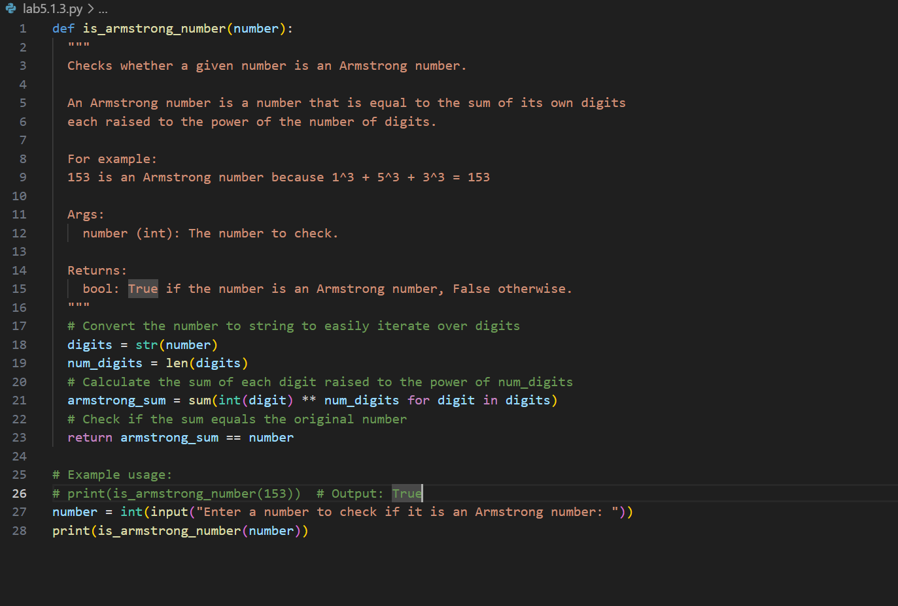

**OUTPUT:**

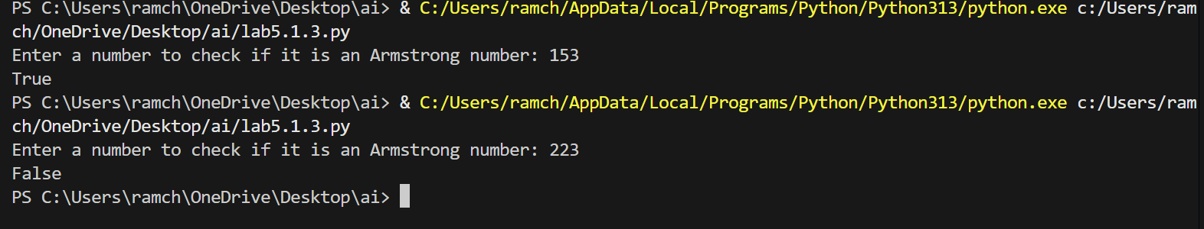

**OBSERVATIONS:**

The code is about the python function which accepts a number as an input and checks whether the given number is Armstrong or not. The copilot gave a clear explanation using comments.

**TASK-04:**

Use AI to implement two sorting algorithms (e.g., QuickSort and  
BubbleSort).

**PROMPT:**

Generate Python code for QuickSort and BubbleSort, and include  
comments explaining step-by-step how each works and where they  
differ.

**CODE:**

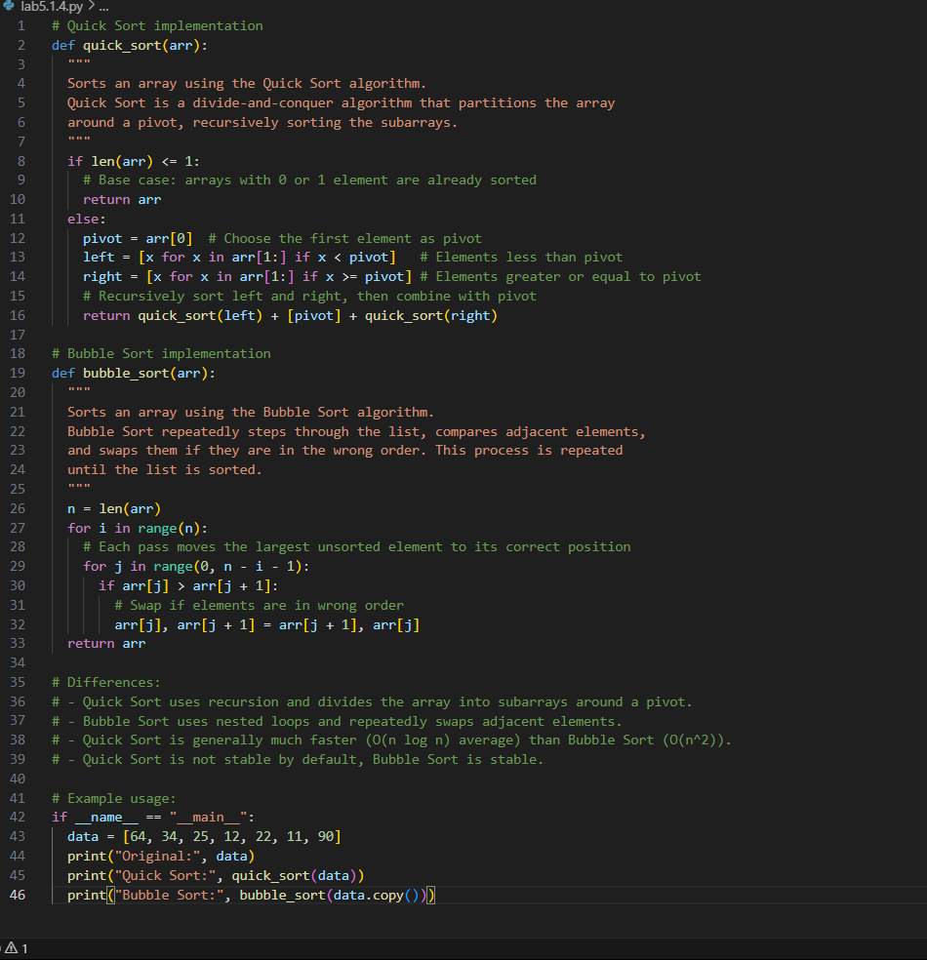

OUTPUT:

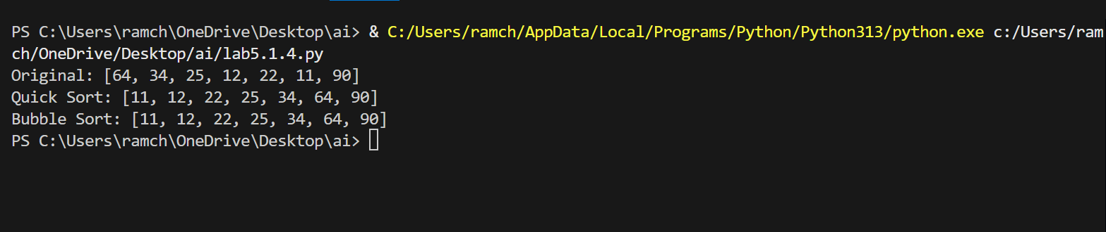

OBSERVATION:

The code generated by the copilot is the technique quick sort and bubble sort of the array and the code is explained step-by-step using comments.

TASK-05:

Use AI to create a product recommendation system

PROMPT:

Generate a recommendation system that also provides reasons for  
each suggestion.

CODE:

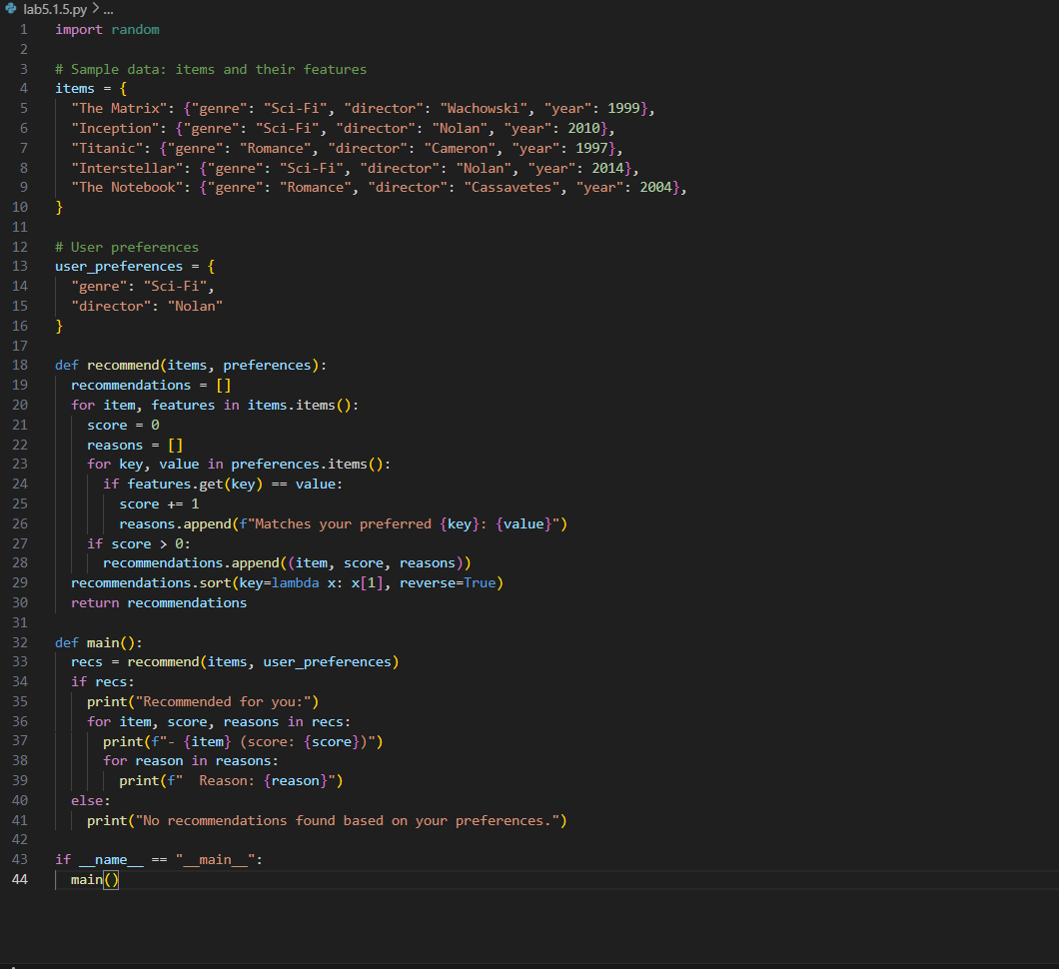

**OUTPUT:**

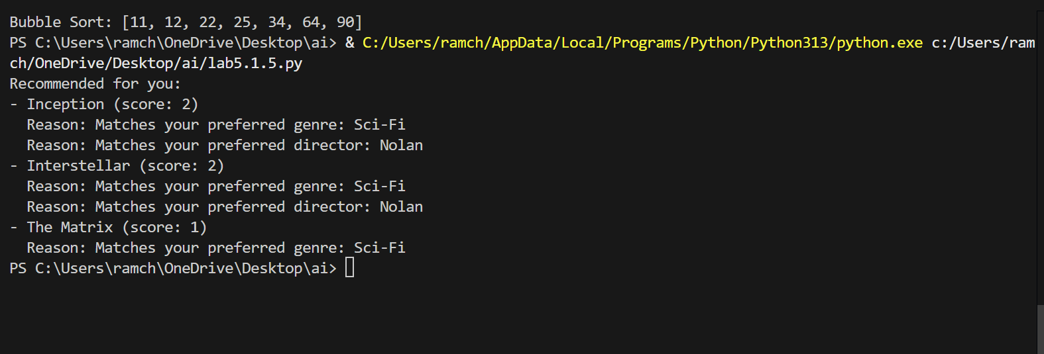

**OBSERVATION:**

The code is about the product recommendation system and it also explains the reason why the product is recommended for you.

**TASK-06:**

Ask AI to generate a Python function for calculating factorial  
using recursion

**PROMPT:**

Generate a recursive factorial function with comments that explain  
each line and a final summary of the algorithm’s flow.

**CODE:**

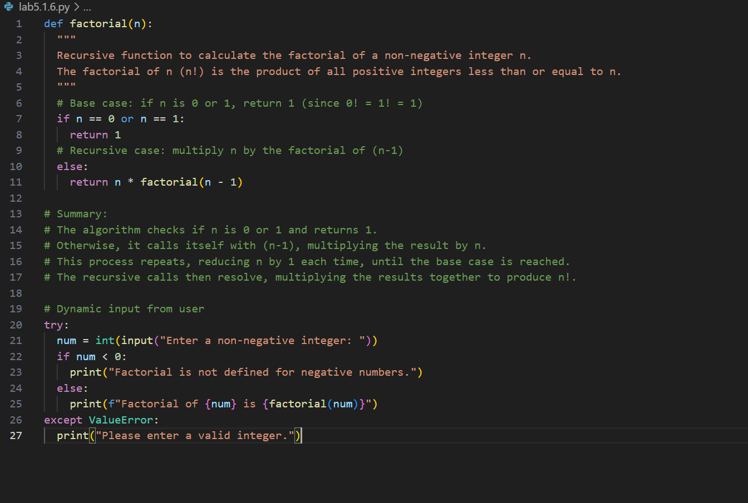

**OUTPUT:**

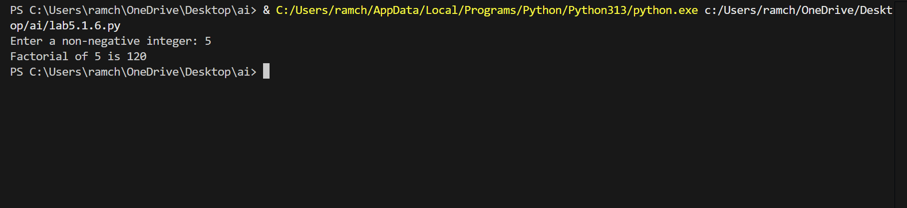

**OBSERVATION:**

The code is to find the factorial of the given number by using recursive function. It also explains how the algorithm works in comments.

**TASK-07:**

def support_reply(name,gender):

if gender.lower() == “male”:

prefix = “Mr.”

else:

prefix = “Mrs.”

return f”Dear{prefix} {name},we have resolved the problem.”

Regenerate the code so that support messages use neutral language (e.g.,  
“Dear {name}”) and optionally accept preferred titles

**PROMPT:**

Regenerate the code to accept the neutral comments and give the appropriate output.

**CODE:**

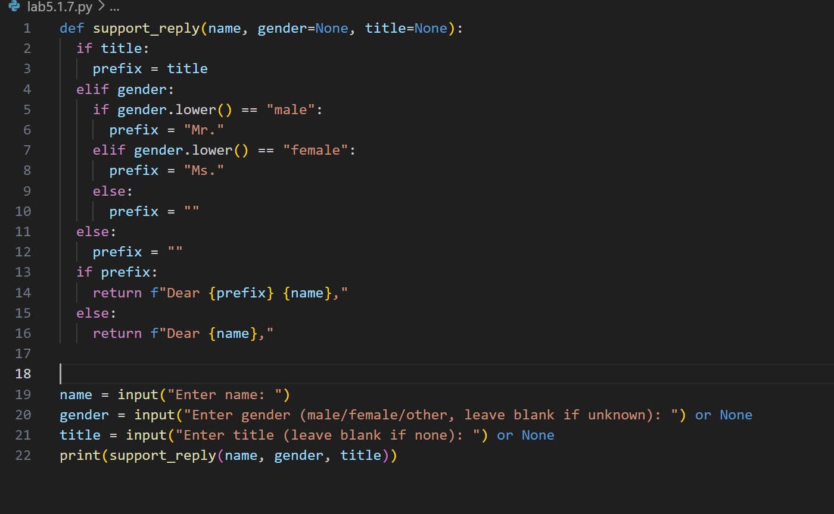

**OUTPUT:**

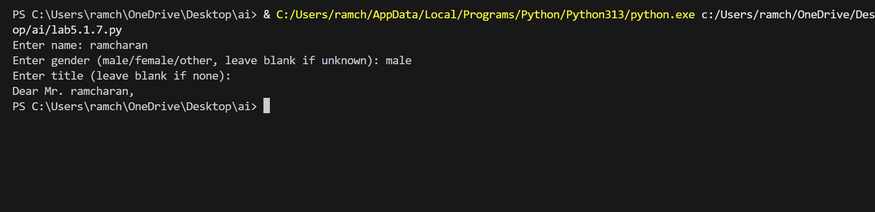

**OBSERVATION:**

The code is about generating message based on their gender and greet the person in an appropriate way. The copilot generated very well without creating any nuisense.